

Requirement & Design Specification
EduPath AI - Adaptive AI-Assisted Learning Platform for High School Students
Version: 1.0

– DaNang, June 2026 –

Record of Changes
Version | Date | A*  M, D | In charge | Change Description
V1.0 | 15/6/2026 | A | group1
v1.1 | 19/07/2026 | M | ĐìnhHuy | Added UC57-UC68, refactored database to layered architecture, and updated code package structure.
*A - Added M - Modified D - Deleted

Contents
Record of Changes 2
Contents… 3
I. Overview 8
1. User Requirements 8
1.1 Actors 8
1.2 Use Cases 8
2. Overall Functionalities 24
2.1 Screens Flow 24
2.2 Screen Descriptions 26
2.3 Screen Authorization 30
2.4 Non-UI Functions 32
3. System High Level Design 34
3.1 Database Design 42
3.2 Code Packages 36
II. Requirement Specifications 45
1.Guest Operations & Authentication 45
1.1 UC-01_View Ranking… 45
1.2 UC-02_View Course Information.. 46
1.3 UC-03_Forgot Password.. 47
1.4 UC-04_Register.. 49
1.5 UC-05_Login.. 50
1.6 UC-06_Login via Google.. 51
1.7 UC-07_Logout .. 53
2. Profile & User Operations Dashboard 54
2.1 UC-08_Update Profile.. 54
2.2 UC-09_Change Password.. 56
2.3 UC-10_Download Documents.. 57
2.4 UC-11_View Notifications .. 58
3. Student Learning Workspace & Interaction 60
3.1 UC-12_Watch Lecture Videos.. 60
3.2 UC-13_View AI Analysis Results.. 62
3.3 UC-14_View Learning Materials.. 64
3.4 UC-15_Rate Course .. 66
3.5 UC-65_Manage Study Group .. 68
3.6 UC-66_Share Group Resources .. 70
3.7 UC-67_Track Learning Streak .. 71
3.8 UC-68_Reward Badges .. 73
4. Interactive Examination & AI Assistance 75
4.1 UC-16_Take Test.. 75
4.2 UC-17_View Detailed Answers.. 77
4.3 UC-18_View Test History.. 79
4.4 UC-19_Receive AI Learning Suggestions .. 80
4.5 UC-63_Log Proctoring Violation .. 82
4.6 UC-64_Auto-Submit via Focus Lock .. 84
5. Course Enrollment & Communication Flow 85
5.1 UC-20_Purchase Course.. 85
5.2 UC-21_Make Payment.. 87
5.3 UC-22_Communicate with Teacher.. 88
5.4 UC-23_Communicate with AI .. 89
5.5 UC-57_Apply Voucher .. 90
5.6 UC-58_Manage Vouchers .. 91
5.7 UC-59_Register Affiliate .. 93
5.8 UC-60_Track Referral Link .. 95
5.9 UC-61_Request Payout .. 96
6. Instructor Portal & Curriculum Management 98
6.1 UC-24_Create Course.. 98
6.2 UC-25_Create Test.. 99
6.3 UC-26_Edit Test.. 100
6.4 UC-27_Delete Test.. 102
6.5 UC-28_View Test.. 103
6.6 UC-29_Create Question.. 104
6.7 UC-30_Edit Question.. 106
6.8 UC-31_Delete Question.. 108
6.9 UC-32_View Question.. 109
6.10 UC-33_Edit Course Content.. 110
6.11 UC-34_Delete Course Content.. 112
6.12 UC-35_View Course Statistics .. 114
7.Platform Administrative Control Panel 115
7.1 UC-36_Monitor System Activities.. 115
7.2 UC-37_Lock/Unlock Account.. 116
7.3 UC-38_Approve Course.. 118
7.4 UC-39_Create Subject.. 120
7.5 UC-40_Edit Subject.. 121
7.6 UC-41_Delete Subject.. 123
7.7 UC-42_View Subject.. 124
7.8 UC-43_Delete Exam.. 126
7.9 UC-44_View Exam… 127
7.10 UC-45_Send Notifications.. 129
7.11 UC-46_View Revenue Statistics… 130
7.12 UC-47_View Reports.. 132
7.13 UC-48_Approve Teacher Requests.. 133
7.14 UC-49_Configure System.. 135
7.15 UC-50_View/Delete Comments .. 136
7.16 UC-62_Approve Payout Requests.. 138
8. AI Core Engine Background Processing 140
8.1 UC-51_Analyze Learning Performance.. 140
8.2 UC-52_Recommend Learning Path.. 142
8.3 UC-53_Suggest Suitable Lessons.. 143
8.4 UC-54_Generate Practice Questions.. 145
8.5 UC-55_Generate Mock Exams Automatically.. 147
8.6 UC-56_Generate Learning Progress Reports .. 149
III. Design Specifications 150
- Guest Operations.. 150
1.1 View Ranking.. 150
1.2 View Course Information.. 153
- Authentication.. 155
2.1 Forgot Password.. 157
2.2 Register.. 158
2.3 Login.. 159
2.4 Login via Google.. 162
2.5 Logout.. 165
- Profile Management.. 168
3.1 Update Profile.. 168
3.2 Change Password.. 171
- User Operations.. 174
4.1 Download Documents.. 174
4.2 View Notifications.. 177
- Learning.. 179
5.1 Watch Lecture Videos.. 179
5.2 View AI Analysis Results.. 182
5.3 View Learning Materials.. 185
- Course Interaction.. 188
6.1 Rate Course.. 188
- Examination.. 191
7.1 Take Test.. 194
7.2 View Detailed Answers.. 196
7.3 View Test History. 197
- AI Assistance.. 200
8.1 Receive AI Learning Suggestions.. 200
- Course Enrollment.. 203
9.1 Purchase Course.. 203
9.2 Make Payment.. 207
- Communication.. 212
10.1 Communicate with Teacher.. 212
10.2 Communicate with AI.. 215
10.3 Send Notifications.. 219
- Course Management.. 224
11.1 Create Course.. 224
11.2 Edit Course Content.. 227
11.3 Delete Course Content.. 229
11.4 View Course Statistics.. 231
- Exam Management.. 234
12.1 Create Test.. 234
12.2 Edit Test.. 237
12.3 Delete Test.. 240
12.4 View Test.. 243
- Question Bank.. 245
13.1 Create Question.. 245
13.2 Edit Question.. 249
13.3 Delete Question.. 252
13.4 View Question.. 255
- System & Account Administration.. 257
14.1 Monitor System Activities.. 260
14.2 Lock/Unlock Account.. 263
14.3 Configure System.. 265
- Subject Administration.. 268
15.1 Create Subject.. 268
15.2 Edit Subject.. 270
15.3 Delete Subject.. 271
15.4 View Subject.. 273
- Exam Administration.. 275
16.1 Delete Exam.. 275
16.2 View Exam.. 277
- Moderation & Workflow Approval.. 280
17.1 Approve Course.. 280
17.2 Approve Teacher Requests.. 283
17.3 View/Delete Comments.. 286
- Reporting.. 290
18.1 View Revenue Statistics.. 290
18.2 View Reports.. 292
- AI Core System Logic.. 295
19.1 Analyze Learning Performance.. 295
19.2 Recommend Learning Path.. 298
19.3 Suggest Suitable Lessons.. 302
19.4 Generate Practice Questions.. 305
19.5 Generate Mock Exams Automatically.. 308
19.6 Generate Learning Progress Reports.. 313
IV. Appendix 316
1. Assumptions & Dependencies 316
2. Limitations & Exclusions 316
3. Business Rules 317
4. .Application Messages List. 318

I. Overview

1. User Requirements

1.1 Actors
# | Actor | Description
1 | Guest | Guest users can browse and view information without logging into the system.
2 | User | The User actor serves as the base actor, containing common attributes and functionalities such as logging in, managing accounts, and viewing notifications. Guest, Student, Teacher, and Admin are specialized actors that inherit from or are associated with User.
3 | Student | Students enroll in courses, take quizzes and examinations, and interact directly with the AI learning assistant.
4 | Teacher | Teachers create courses, upload learning materials and lecture videos, and manage question banks and examinations.
5 | Admin | Administrators manage the entire system, moderate and approve content, configure system settings, and manage user permissions and roles. .
6 | AI System | The AI Recommendation System automatically analyzes learning data, generates personalized learning paths, and provides study recommendations.
7 | Payment System | The Payment Gateway System is an external third-party system responsible for processing financial transactions and payments securely.

1.2 Use Cases

a. Diagram(s)

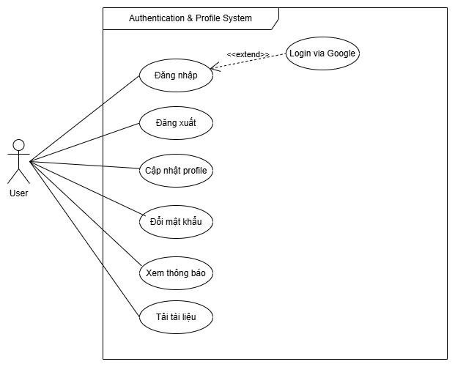

Figure 1. Authentication use case diagram
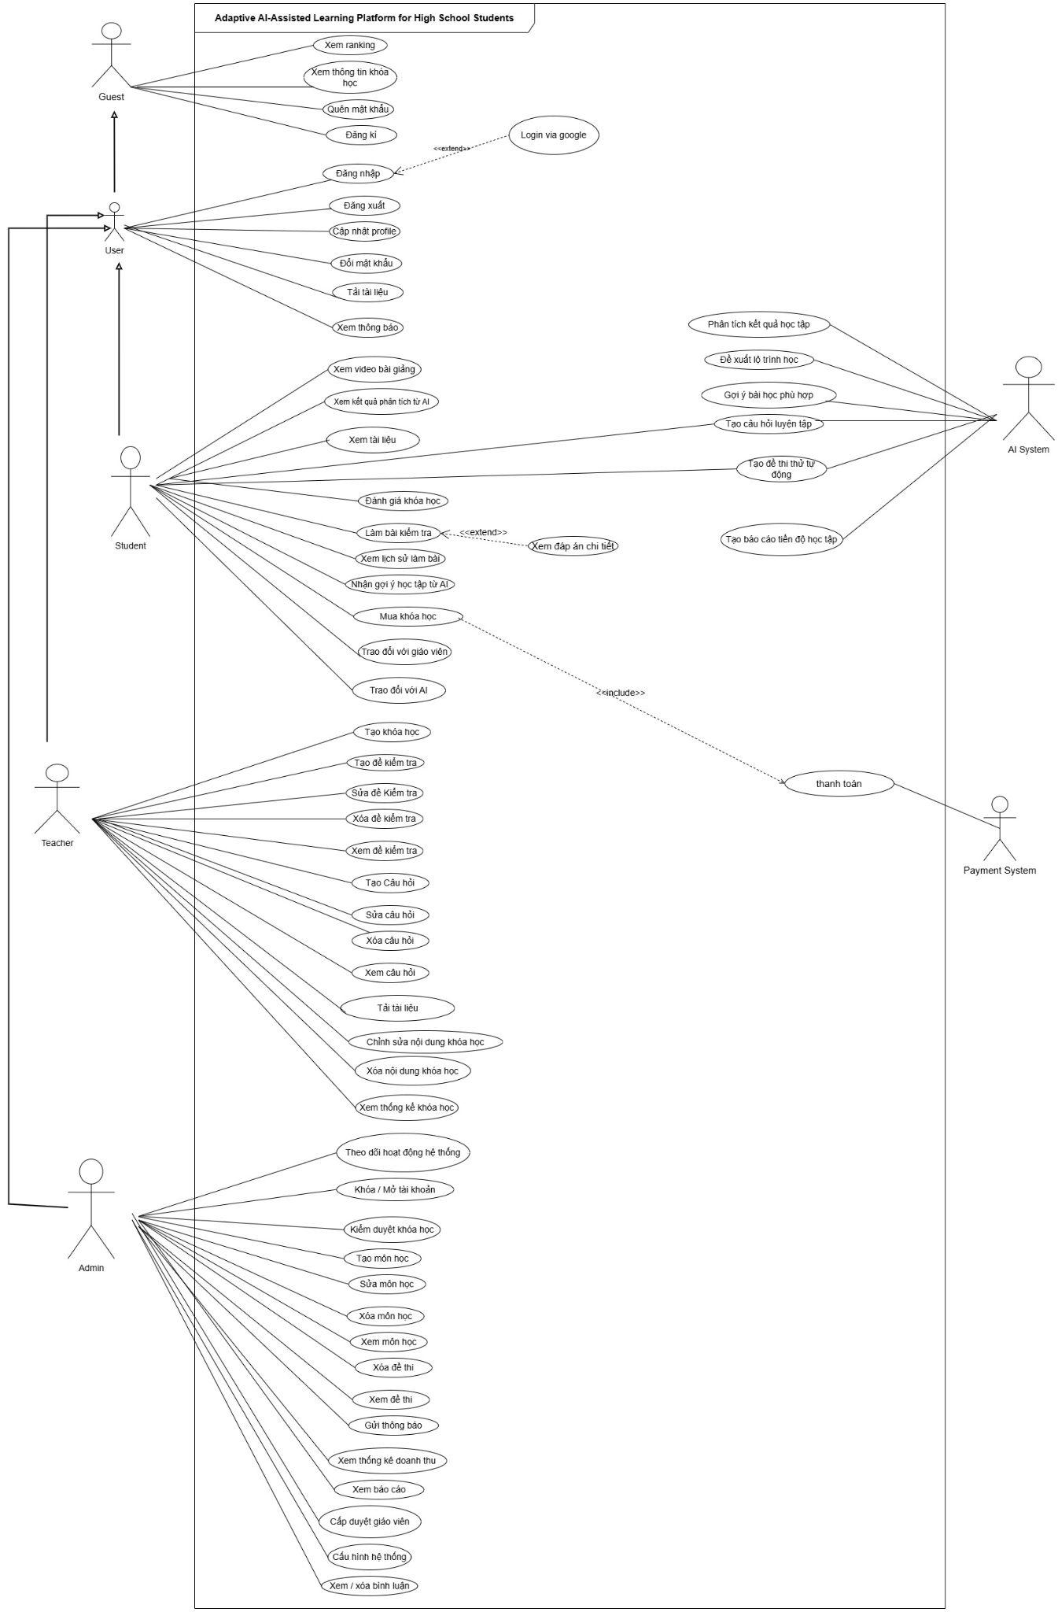
Figure 2. Overview use case diagram
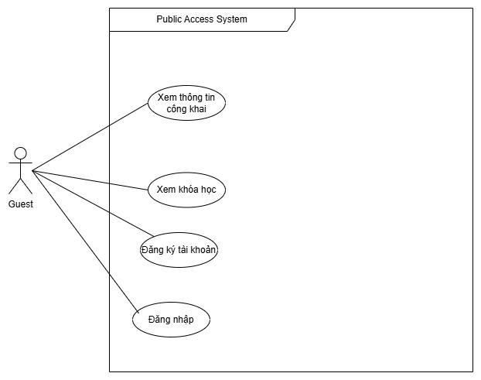
Figure 3. Guest use case diagram
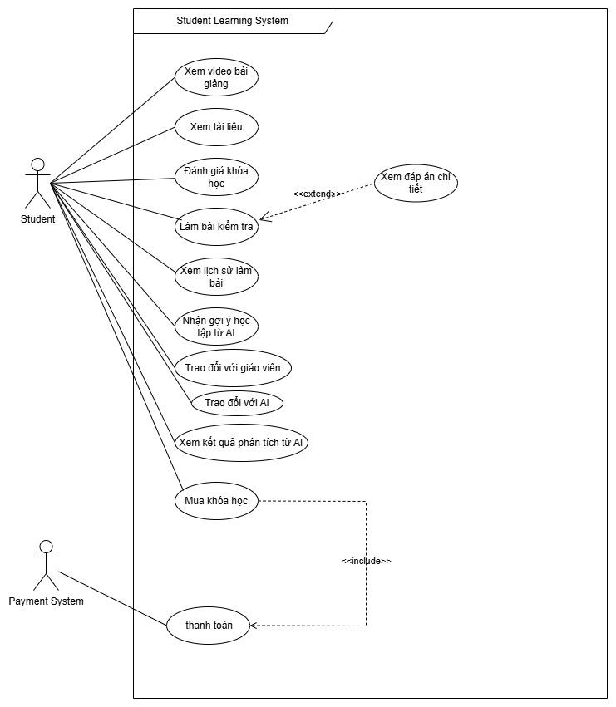
Figure 4. Student use case diagram
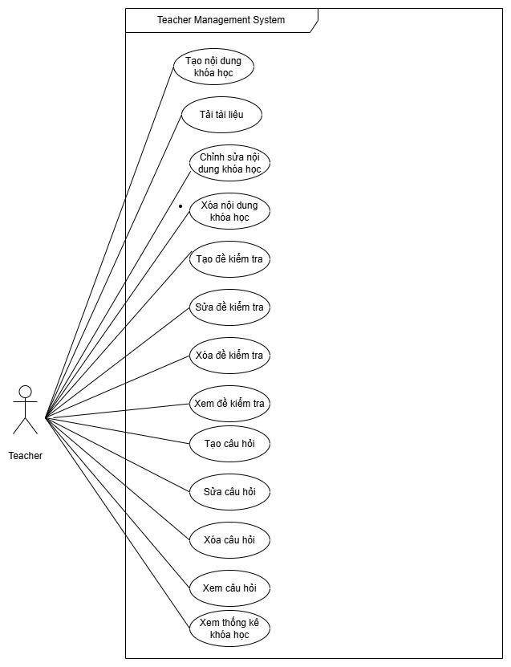
Figure 5. Teacher use case diagram
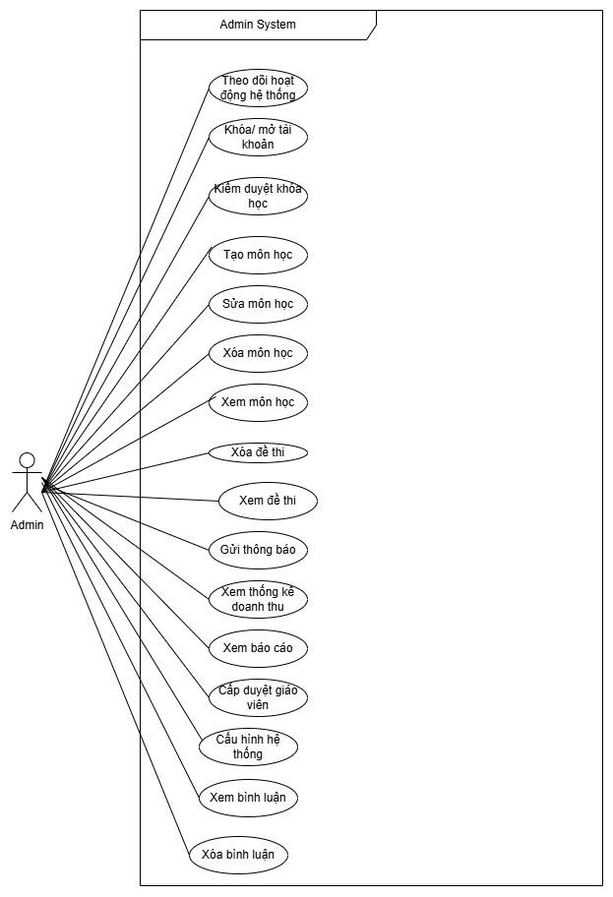
Figure 6. AI System use case diagram

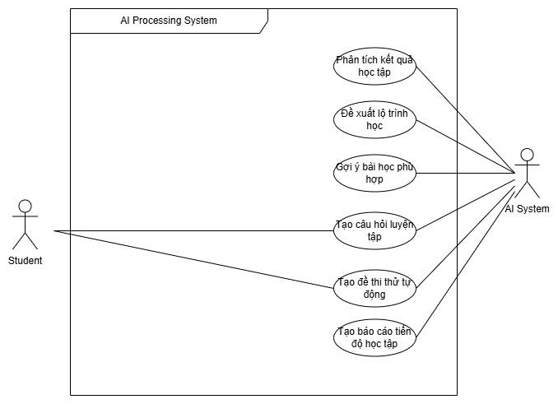

b. Descriptions

ID | Feature | Use Case | Use Case Description
UC01 | Guest Operations | View Ranking | Allows guests to view the academic performance leaderboard.
UC02 | Guest Operations | View Course Information | Displays general information about courses available on the system.
UC03 | Authentication | Forgot Password | Helps users recover their password when they forget it.
UC04 | Authentication | Register | Allows guests to create a new account and become a user.
UC05 | Authentication | Login | Allows users to access the system.
UC06 | Authentication | Login via Google | Extended feature that enables quick login using a Google account.
UC07 | Authentication | Logout | Ends the user's current session on the system.
UC08 | Profile Management | Update Profile | Allows users to edit their personal information.
UC09 | Profile Management | Change Password | Allows users to change their current password.
UC10 | User Operations | Download Documents | Allows users to download documents permitted by the system.
UC11 | User Operations | View Notifications | Displays notifications from the system or teachers.
UC12 | Learning | Watch Lecture Videos | Provides a video player for course lesson content.
UC13 | Learning | View AI Analysis Results | Displays competency assessment reports generated by the AI system.
UC14 | Learning | View Learning Materials | Allows learners to read and view study materials.
UC15 | Course Interaction | Rate Course | Allows learners to rate and review a course.
UC16 | Examination | Take Test | Enables learners to complete exams or quizzes.
UC17 | Examination | View Detailed Answers | Extended feature allowing learners to view solutions after submitting a test.
UC18 | Examination | View Test History | Displays a list of completed tests and their results.
UC19 | AI Assistance | Receive AI Learning Suggestions | Provides recommendations for learning paths or next lessons.
UC20 | Course Enrollment | Purchase Course | Allows learners to enroll in and purchase new courses.
UC21 | Course Enrollment | Make Payment | Processes transactions through the payment system.
UC22 | Communication | Communicate with Teacher | Provides a direct communication channel between learners and teachers.
UC23 | Communication | Communicate with AI | AI chatbot support for answering learners’ questions.
UC24 | Course Management | Create Course | Allows teachers to create a new course.
UC25 | Exam Management | Create Test | Allows teachers to create a new test.
UC26 | Exam Management | Edit Test | Allows teachers to modify test information.
UC27 | Exam Management | Delete Test | Allows teachers to remove a test from the system.
UC28 | Exam Management | View Test | Displays detailed information about a test.
UC29 | Question Bank | Create Question | Adds a new question to the question bank.
UC30 | Question Bank | Edit Question | Modifies the content of an existing question.
UC31 | Question Bank | Delete Question | Removes a question from the question bank.
UC32 | Question Bank | View Question | Displays detailed information about a question.
UC33 | Course Management | Edit Course Content | Updates or modifies course videos and learning materials.
UC34 | Course Management | Delete Course Content | Removes lessons or materials from a course.
UC35 | Course Management | View Course Statistics | Displays reports on student enrollment and course performance.
UC36 | System Admin | Monitor System Activities | Monitors system status and activity logs.
UC37 | Account Admin | Lock/Unlock Account | Manages user account activation status.
UC38 | Course Admin | Approve Course | Reviews and approves course content before publication.
UC39 | Subject Admin | Create Subject | Adds a new subject category to the system.
UC40 | Subject Admin | Edit Subject | Modifies subject category information.
UC41 | Subject Admin | Delete Subject | Removes a subject category from the system.
UC42 | Subject Admin | View Subject | Displays detailed information about subjects.
UC43 | Exam Admin | Delete Exam | Administrative privilege to remove invalid or inappropriate exams.
UC44 | Exam Admin | View Exam | Administrative privilege to preview all exam content.
UC45 | Communication | Send Notifications | Creates and sends mass notifications to users.
UC46 | Reporting | View Revenue Statistics | Displays financial reports from course sales.
UC47 | Reporting | View Reports | Displays consolidated system reports.
UC48 | Account Admin | Approve Teacher Requests | Approves user requests to upgrade to teacher accounts.
UC49 | System Admin | Configure System | Customizes platform operating parameters and settings.
UC50 | Moderation | View/Delete Comments | Manages and moderates reviews and comments.
UC51 | AI Core | Analyze Learning Performance | AI collects data and analyzes learners’ strengths and weaknesses.
UC52 | AI Core | Recommend Learning Path | AI automatically designs personalized learning paths.
UC53 | AI Core | Suggest Suitable Lessons | AI matches lesson content with the learner’s current ability level.
UC54 | AI Core | Generate Practice Questions | AI automatically creates practice questions.
UC55 | AI Core | Generate Mock Exams Automatically | AI randomly selects and structures questions into a complete mock exam.
UC56 | AI Core | Generate Learning Progress Reports | AI summarizes learning data into visual progress reports.
UC57 | Voucher System | Apply Voucher | Allows students to input and apply a valid promotional coupon code (VoucherCode) to deduct the total payment amount before completing the checkout process.
UC58 | Voucher System | Manage Vouchers | Allows Admins or Instructors to create, update, and configure parameters such as quantity, minimum order value, and expiration dates for vouchers on the platform.
UC59 | Affiliate & Referral | Register Affiliate | Allows users (Students/Instructors) to register for the affiliate marketing program to receive an exclusive affiliate ID and custom referral links.
UC60 | Affiliate & Referral | Track Referral Link | The system automatically tracks cookies, records clicks, tracks user sign-ups, and calculates commissions (Commission) for the affiliate partner when a referred user purchases a course.
UC61 | Affiliate & Referral | Request Payout | Allows affiliate partners to submit a withdrawal request to transfer their accumulated commission balance to their personal bank accounts once the minimum threshold is met.
UC62 | Affiliate & Referral | Approve Payout Requests | Allows Admins to verify the validity of affiliate transactions, and approve or reject payout requests (Payout) submitted by partners.
UC63 | Exam Proctoring | Log Proctoring Violation | The frontend system monitors the student's exam behavior (counting tab switches, copy/paste attempts, and full-screen exits) and automatically sends event logs to the backend via WebSockets.
UC64 | Exam Proctoring | Auto-Submit via Focus Lock | The system automatically locks the practice exam screen, recalculates the proctoring trust score (examTrustScore), and forces an automatic submission of the exam when the student exceeds the violation limits.
UC65 | Study Groups | Manage Study Group | Allows students or instructors to create new study groups, manage group members (StudyGroupMember), and generate invitation codes for other users to join.
UC66 | Study Groups | Share Group Resources | Allows group members to participate in group discussions, post announcements, and share links to educational resources (ResourceShare) within the group.
UC67 | Gamification Mechanics | Track Learning Streak | The system automatically tracks daily student attendance (LearningAttendance) and calculates the consecutive active learning streak for specific subjects (SubjectStreark).
UC68 | Gamification Mechanics | Reward Badges | The system automatically calculates daily contribution points (DailyContribution) and awards special achievements and badges (Badge) to users when milestone goals are achieved.

2. Overall Functionalities

2.1 Screens Flow

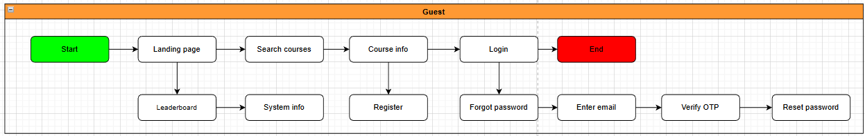
Figure 7. Screen flow Diagram – Guest
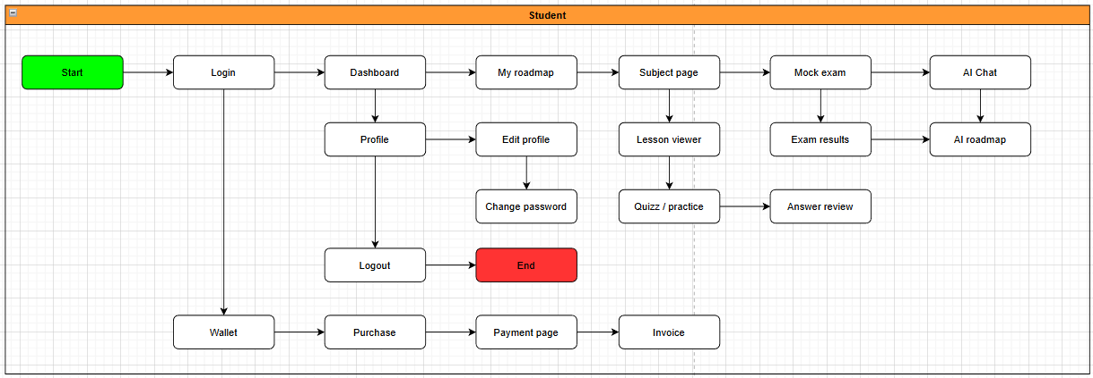
Figure 8. Screen flow Diagram – Student

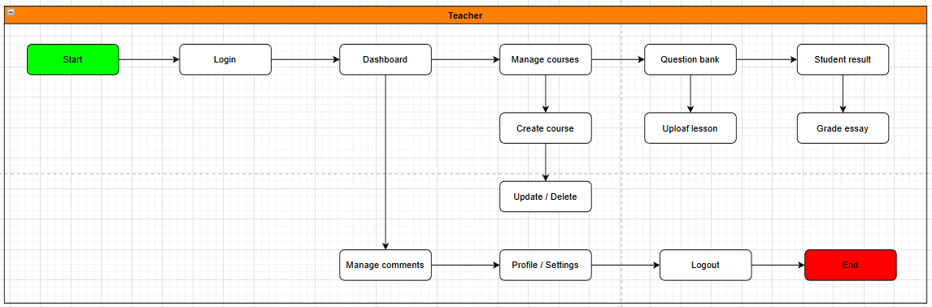
Figure 9. Screen flow Diagram – Teacher

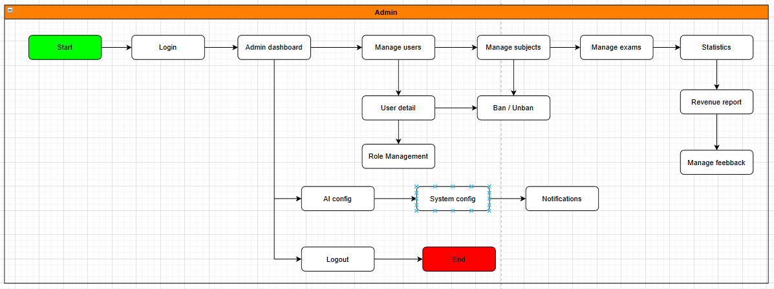
Figure 10. Screen flow Diagram – Admin
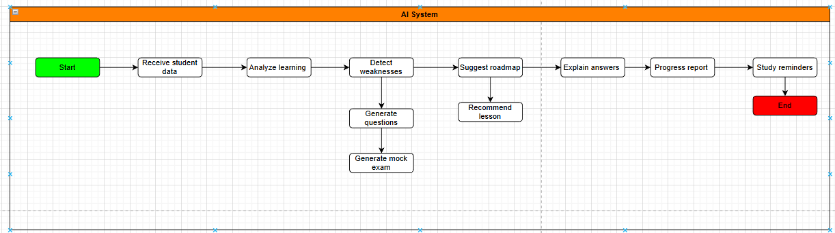
Figure 11. Screen flow Diagram – AI System
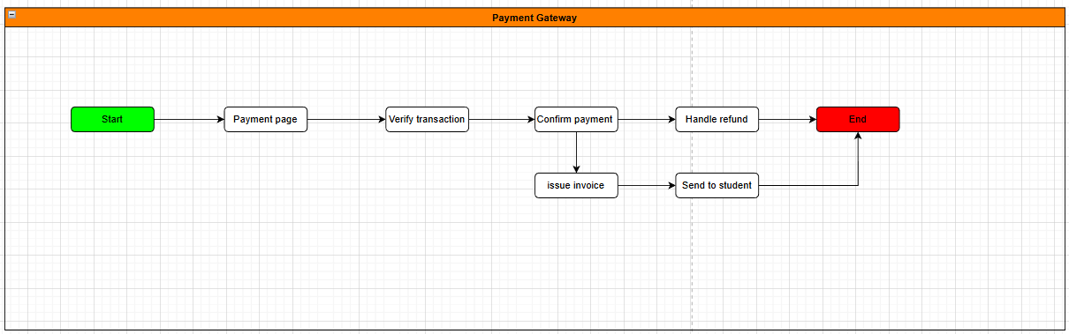
Figure 12. Screen flow Diagram – Payment Gateway

2.2 Screen Descriptions
# | Feature | Screen | Description
1 | Register | Register | Allows guests to create a new account by entering their email, selecting a role (Student / Teacher), and filling in basic personal information.
2 | Login | Login | Allows users to sign in using their email and password or via OAuth2 (Google / Facebook) to access the platform.
3 | Logout | Logout | Allows users to securely log out of the system, terminating the current session.
4 | Forgot Password | Forgot Password | Allows users to recover their account by submitting their registered email and verifying identity via an OTP code.
5 | OTP Verification | Verify OTP | Allows users to enter the OTP sent to their email to verify identity for password reset or account registration confirmation.
6 | View Profile | Profile | Allows users to view their personal information, profile picture, assigned role, and learning goals within the system.
7 | Edit Profile | Edit Profile | Allows users to update their personal details, profile picture, and learning objectives stored in the system.
8 | Change Password | Change Password | Allows users to change their current password after verifying the existing one.
9 | Home Page | Home Page | Displays an overview of the platform including featured courses, the leaderboard, subject search, and system announcements — accessible to all users.
10 | Student Dashboard | Student Dashboard | The student's personal overview page showing their learning roadmap, completion progress, AI suggestions, and daily learning streak.
11 | Select Subject | Subject List | Allows students to browse and select subjects by exam cluster (A01, D01, B00) to begin their personalized learning path.
12 | View Course | Course Detail | Displays detailed course information including description, lesson list, attached materials, and student reviews.
13 | View Lesson | Lesson View | Allows students to view lesson content directly on the platform, including text, images, and supplementary documents.
14 | Watch Video Lecture | Video Lecture | Allows students to watch online video lectures with playback controls, speed adjustment, and personal note-taking.
15 | View Document | Document View | Supports viewing and downloading learning materials such as PDFs and images directly within the platform.
16 | Learning Roadmap | Learning Roadmap | Displays an AI-personalized learning path tailored to each student's current ability level and stated learning goals.
17 | Multiple Choice Practice | Practice Quiz | Allows students to complete topic-based multiple choice exercises to reinforce knowledge, with no time limit.
18 | Quick Quiz | Quick Quiz | Provides short 5–10 question quizzes to help students quickly review material after completing a lesson.
19 | Mock Exam | Mock Exam | Simulates the National High School Exam (THPTQG) with an official exam structure, countdown timer, and automatic grading upon submission.
20 | Submit Exam | Submit Exam | Displays a confirmation screen before submission showing the number of answered and unanswered questions, with a warning for blank items.
21 | Answer Review | Answer Review | Displays correct answers, detailed solutions, and AI-generated error analysis for each question after the exam is submitted.
22 | Exam History | Exam History | Stores and displays the student's complete history of practice sessions and mock exams, including scores and completion times.
23 | Progress Tracking | Progress Tracking | Displays the student's roadmap completion rate, score trends over time, and consecutive learning day streaks.
24 | Leaderboard | Leaderboard | Displays a ranking of students based on scores and completed exercises to motivate continued engagement.
25 | AI Chat | AI Chat | Allows students to ask academic questions and receive detailed explanations from the AI learning assistant through a chat interface.
26 | Skill Analysis | AI Skill Analysis | The AI analyzes exam scores and answer behaviors to identify each student's strengths and weaknesses across individual subject topics.
27 | AI Recommendation | AI Recommendation | The AI suggests a tailored list of lessons, documents, and practice sets aligned with the student's current proficiency level.
28 | Personalized Exam | AI Generated Exam | The AI automatically generates a personalized practice exam based on the student's learning history and identified weak topics.
29 | Lesson Comments | Lesson Comments | Allows students to post comments, ask questions, and engage in discussion with instructors and peers in the lesson comment section.
30 | Course Rating | Course Rating | Allows students to rate the quality of a course using a star system and written review after completing it.
31 | Report Content | Report Content | Allows users to report incorrect questions, erroneous documents, or inappropriate content for Admin to review and action.
32 | Premium Checkout | Premium Checkout | Allows students to upgrade to a Premium account via VNPay or MoMo payment gateway to unlock advanced features and content.
33 | Invoice Detail | Invoice Detail | Displays full details of a payment invoice including the service plan, amount charged, payment method, and transaction status.
34 | Transaction History | Transaction History | Allows students to view their complete payment transaction history on the platform, sorted by date.
35 | Course Management | Course Management | Allows instructors to create, edit, publish, and delete courses on the platform.
36 | Question Bank | Question Bank | Allows instructors to add, edit, delete, and categorize questions in the exam question bank by subject and difficulty level.
37 | Create Exam | Create Exam | Allows instructors to build an exam by selecting questions from the question bank and configuring time limits and difficulty settings.
38 | Upload Video Lecture | Upload Lecture | Allows instructors to upload video lectures to the platform, assign topic tags, and link them to the corresponding lesson.
39 | View Student Results | Student Results | Allows instructors to view exam results, learning progress, and statistical summaries for individual students or across the entire class.
40 | User Management | User Management | Allows Admin to view the full list of users (Students and Teachers), search, filter, and perform account management actions.
41 | Account Detail | Account Detail | Allows Admin to view detailed information for a specific user account, including activity history and related transactions.
42 | Ban / Unban User | Ban / Unban User | Allows Admin to ban an account that violates platform policies or reinstate access for a previously banned user upon review.
43 | Content Management | Content Management | Allows Admin to review, edit, or remove courses, exams, and documents before they are published to the platform.
44 | AI Management | AI Management | Allows Admin to configure AI parameters, review model output quality, and enable or disable individual AI features across the platform.
45 | Statistics & Reports | Statistics & Reports | Displays consolidated reports on user counts, study sessions, exam results, platform revenue, and system activity over a selected time period.

2.3 Screen Authorization
Screen | Guest | Student | Teacher | Admin
Authentication
Register | X
Login | X | X | X | X
Logout |  | X | X | X
Forgot Password | X | X | X | X
Verify OTP | X | X | X | X
Profile |  | X | X | X
Edit Profile |  | X | X | X
Change Password |  | X | X | X
General
Home Page | X | X | X | X
Course Detail | X | X | X
Learning
Student Dashboard |  | X
Subject List |  | X
Lesson View |  | X | X
Video Lecture |  | X | X
Document View |  | X | X
Learning Roadmap |  | X
Practice & Exam
Practice Quiz |  | X
Quick Quiz |  | X
Mock Exam |  | X
Submit Exam |  | X
Answer Review |  | X | X
Exam History |  | X
Progress Tracking |  | X | X
Leaderboard | X | X | X
AI Support
AI Chat |  | X
AI Skill Analysis |  | X
AI Recommendation |  | X
AI Generated Exam |  | X
Interaction
Lesson Comments |  | X | X
Course Rating |  | X
Report Content |  | X | X
Payment
Premium Checkout |  | X
Invoice Detail |  | X
Transaction History |  | X |  | X
Teacher
Course Management |  |  | X
Question Bank |  |  | X
Create Exam |  |  | X
Upload Lecture |  |  | X
Student Results |  |  | X
Admin
User Management |  |  |  | X
Account Detail |  |  |  | X
Ban / Unban User |  |  |  | X
Content Management |  |  |  | X
AI Management |  |  |  | X
Statistics & Reports |  |  |  | X

2.4 Non-UI Functions
# | Feature | System Function | Description
1 | Authentication & Security | Cryptographic Password Hashing | Automatically intercept plaintext user credentials during registration (UC04) or password modifications (UC09), and enforce secure one-way salted encoding (BCrypt/SHA256) before storing records into the database.
2 | Authentication & Security | Stateful Session Token Revocation | Instantly intercept a secure logout command (UC07) or administrative suspension event (UC37), add the current active JSON Web Token (JWT) signature to the global cluster blacklist queue, and forcefully kill distributed device access clearance bounds.
3 | Authentication & Security | Automated Brute-Force Rate Limiting | Background daemon continuously counts consecutive failed authorization requests bound to a unique IP address or email address. Upon registering exactly 5 mismatches within a 10-minute rolling frame, it automatically toggles the user profile status to locked and dispatches an inbox validation link (BR-AUTH-01).
4 | LMS Multimedia Core | Anti-Scraping Hotlink Stream Protection | Intercept student requests to load lecture video streaming pipelines (UC12), bypass direct asset URL visibility flags on the client framework, and dynamically compute short-lived tokenized media chunk indices (HLS/DASH paired with signed cookies) that expire automatically.
5 | LMS Multimedia Core | Asynchronous Heartbeat Progress Aggregation | Continuously collect multi-device client heartbeat pings dispatched every 15 seconds during video lecture viewing windows (UC12). It debounces input/output data queries and updates incremental progress values inside the LessonProgress relational database rows without throttling server memory capacity.
6 | LMS Multimedia Core | Linear Progression Validation Interceptor | Run sequential relational checking routines when a student initializes a learning node. If the course enforces a rigid structure policy (BR-LEARN-01), it blocks media stream packet compilation if any preceding lesson row index remains uncompleted (is_completed = false).
7 | Interactive Examination | Proctoring Violation WebSocket Telemetry Logger | Real-time backend handler processing stream telemetry packets pushed from active exam client interceptors (UC63). It programmatically logs focus losses, window resizing, or keyboard copy shortcuts, and increments infraction counters inside the target TestAttempt schema row.
8 | Interactive Examination | Automated Forced Exam Submission | Instantly executes if the proctoring log check engine detects that the active tabSwitchCount or copyPasteCount satisfies a greater-than-or-equal relationship with the maximum limit threshold (Exactly 3 events). It freezes client inputs, calculates the final examTrustScore, runs grading logic, and commits records as completed (UC64).
9 | Interactive Examination | Server-Side Exam Countdown Session Guard | Background timer daemon instantiated on the backend architecture when a test session is authorized (UC16). It tracks accurate elapsed durations independently of client system clocks and forcefully triggers a timeout submission transaction (submission_type = 'timeout') when the clock matches zero.
10 | Interactive Examination | Immutable Review Conditional Interceptor | Intercept requests to fetch detailed solution sheets (UC17). It blocks the query execution thread if a background scanner detects that the target exam profile solution_release_type is restricted or the global examination window has not officially expired yet.
11 | Adaptive AI System | Cognitive Skill Mastery Matrix Parser | Background background worker running upon test attempt completions (UC51). It scans raw UserAnswers logs, cross-references question micro-subject taxonomy classification rows, and recomputes multidimensional percentage mastery vectors inside the AILearningAnalyses repository.
12 | Adaptive AI System | Dynamic Prerequisite Roadmap Re-Indexer | Automated background compilation pipeline invoked upon manual user request or diagnostic score mutations (UC52). It evaluates stated target exam scores (StudentProfiles) and weakness matrix records, selecting a balanced prioritized sequence of learning items written directly into the RoadmapNodes table.
13 | Adaptive AI System | Daily Behavioral Cron-Job Reminder Engine | System-wide automated scheduler running daily at specified hours (08:00 AM and 07:00 PM). It checks the gap since the last user login session and evaluates roadmap deadlines, automatically compiling motivational notification payloads pushed via WebSockets or SMTP email services (UC56).
14 | Financial & Coupon System | Voucher Escrow Hold Reservation Daemon | Instantly allocates a temporary data line inside the VoucherReservation table when a student applies a valid promo code on checkout (UC57). It decrements available quantities and locks the slot for exactly 15 minutes, automatically releasing it if no completed payment callback matches the invoice ID.
15 | Financial & Coupon System | Affiliate Link Cookie Origin Tracker | Automatically tracks inbound referral traffic payload signatures from browser storage elements when a guest navigates the portal, binding the unique tracking code properties for exactly 30 days to compute commission balances inside the financial ledgers upon order completion (UC60).
16 | Financial & Coupon System | Payout escrow Double-Withdrawal Guard | Runs an atomic ledger transactional script the exact second an affiliate partner submits a withdrawal request (UC61). It locks the request value inside an escrow state row within the payout table and subtracts it from available balances to systematically block parallel double-payout exploits.
17 | Moderation & Community | Cascading Hidden Comment Content Filter | Automatically propagates data restrictions when an administrator flags a parent comment row context as hidden (is_hidden = true) inside the Comments or ForumReplies data structures, systematically concealing all nested children replies containing matching parent_id indices (UC50).
18 | Data Architecture Vetting | Soft-Delete Data Retention Enforcer | Interceptor framework overriding administrative or instructor delete command attempts (UC27, UC31, UC34). It blocks absolute SQL physical row drops (DELETE FROM operations) and dynamically rewrites processing routines into status parameter modifications (status = 'Archived') to secure relational reporting histories.

3. System High Level Design

3.1 Database Design

a. Database Schema

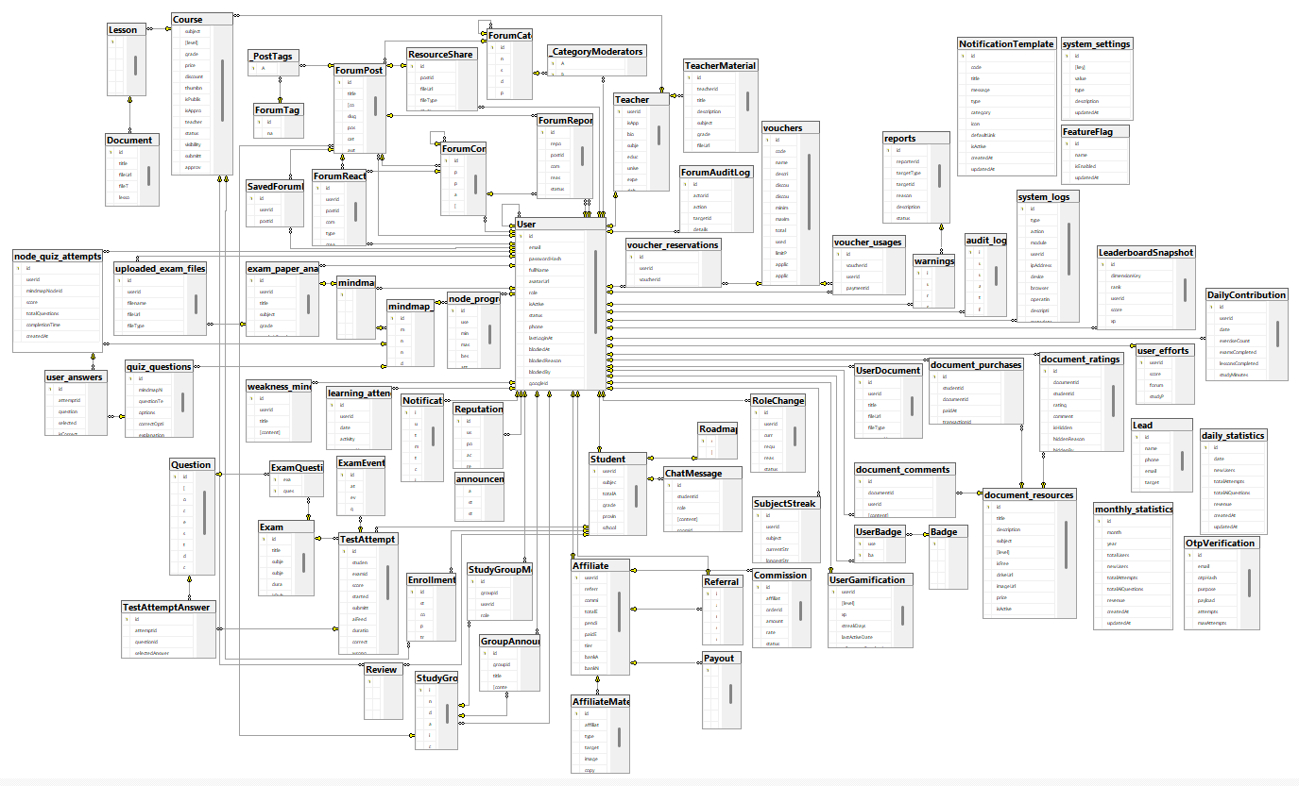

b. Table Descriptions

No | Table | Description
01 | User | Represents the core user entity in the ecosystem, storing credentials, profile metadata, role allocations (STUDENT, TEACHER, ADMIN, AFFILIATE), and account statuses.  • Primary Key: id (Auto-incrementing Integer)  • Foreign Keys: referredBy references User(id) (Self-referential relationship for affiliate tracking).
02 | Student | Extends the base User entity to maintain student-specific profiles, educational milestones, and AI adaptive learning configurations.  • Primary Key: userId (Integer, acts as a shared Primary Key and Foreign Key)  • Foreign Keys: userId references User(id) with Cascade deletion.
03 | Teacher | Extends the base User entity to store professional portfolios, validation credentials, teaching specialties, and platform approval status.  • Primary Key: userId (Integer, acts as a shared Primary Key and Foreign Key)  • Foreign Keys: userId references User(id) with Cascade deletion.
04 | Course | Stores learning course offerings published by approved educators, detailing academic subjects, price values, level groupings, and approval cycles.  • Primary Key: id (Auto-incrementing Integer)  • Foreign Keys: teacherId references Teacher(userId) with Cascade deletion.
05 | Lesson | Represents individual learning units structured sequentially within a course, mapping instruction topics to videos and learning resources.  • Primary Key: id (Auto-incrementing Integer)  • Foreign Keys: courseId references Course(id) with Cascade deletion.
06 | Enrollment | Tracks premium course registration transactions, financial values paid, and active user learning progression percentage.  • Primary Key: id (Auto-incrementing Integer)  • Foreign Keys: courseId references Course(id), studentId references Student(userId) (both with Cascade deletion).
07 | Question | Maintains the centralized academic question bank. Houses question contents, option arrays, correct answers, explanations, topics, and difficulty values.  • Primary Key: id (Auto-incrementing Integer)
08 | Exam | Represents structured mock and official national examinations, containing metadata like durations, target groups, and administrative states.  • Primary Key: id (Auto-incrementing Integer)
09 | ExamQuestion | A junction table establishing a many-to-many relationship between Exam and Question, enforcing sequential question ordering.  • Primary Key: Composite key (examId, questionId)  • Foreign Keys: examId references Exam(id), questionId references Question(id) (both with Cascade deletion).
10 | TestAttempt | Stores execution logs of examinations taken by students.  • Adaptive Learning & Integrity Controls: Houses key cheating-prevention telemetry fields: tabSwitchCount (logs focus losses), copyPasteCount (logs copy-paste operations), fullscreenExitCount (detects screen-splitting or window-resizing), and examTrustScore (a derived metric showing attempt validity). It also hosts aiFeedback, which contains detailed AI-generated evaluations of strength/weakness areas and revision strategies based on correct and incorrect counts.  • Primary Key: id (Auto-incrementing Integer)  • Foreign Keys: examId references Exam(id), studentId references Student(userId) (both with Cascade deletion).
11 | ExamEvent | Logs real-time client-side interactive events during exam sittings to support the Proctoring system.  • Primary Key: id (Auto-incrementing Integer)  • Foreign Keys: attemptId references TestAttempt(id) with Cascade deletion.
12 | TestAttemptAnswer | Records the specific options selected by a student for individual questions during an exam attempt, tracking correctness.  • Primary Key: id (Auto-incrementing Integer)  • Foreign Keys: attemptId references TestAttempt(id), questionId references Question(id) (both with Cascade deletion).
13 | Roadmap | Stores personalized, AI-generated curriculum roadmaps dynamically built to match a student's weak areas and learning targets.  • Primary Key: studentId (Integer)  • Foreign Keys: studentId references Student(userId) with Cascade deletion.
14 | ChatMessage | Stores message logs exchanged in the interactive AI chatbot support system.  • Primary Key: id (Auto-incrementing Integer)  • Foreign Keys: studentId references Student(userId) with Cascade deletion.
15 | Notification | Stores notification logs dispatched to users, categorized by priority and context.  • Primary Key: id (Auto-incrementing Integer)  • Foreign Keys: userId references User(id) with Cascade deletion.
16 | NotificationTemplate | Stores reusable system templates for structural notification rendering.  • Primary Key: id (Auto-incrementing Integer)
17 | Review | Houses course rating scores and pedagogical comments written by enrolled students.  • Primary Key: id (Auto-incrementing Integer)  • Foreign Keys: courseId references Course(id), studentId references Student(userId) (both with Cascade deletion).
18 | Document | Manages official learning attachments and supplementary PDF/docx resources associated with lessons.  • Primary Key: id (Auto-incrementing Integer)  • Foreign Keys: lessonId references Lesson(id) with Cascade deletion.
19 | UserDocument | Manages files uploaded privately by users for reference during study.  • Primary Key: id (Auto-incrementing Integer)  • Foreign Keys: userId references User(id) with Cascade deletion.
20 | OtpVerification | Manages ephemeral authentication OTP tokens, tracking purposes, expiry constraints, and verification attempts.  • Primary Key: id (Auto-incrementing Integer)
21 | RoleChangeRequest | Manages student/teacher requests for role upgrades, tracking rationales and administrator approval state.  • Primary Key: id (Auto-incrementing Integer)  • Foreign Keys: userId references User(id) with Cascade deletion.
22 | ForumCategory | Manages community discussion categories, supporting parent-child structural hierarchies.  • Primary Key: id (Auto-incrementing Integer)  • Foreign Keys: parentId references ForumCategory(id) with Cascade deletion.
23 | ForumPost | Manages discussion threads, QA topics, and shared resources in community boards.  • Primary Key: id (Auto-incrementing Integer)  • Foreign Keys: categoryId references ForumCategory(id), authorId references User(id) (both with Cascade deletion), studyGroupId references StudyGroup(id) (with SetNull fallback).
24 | ForumComment | Stores user replies and solutions to forum posts, supporting nested hierarchies.  • Primary Key: id (Auto-incrementing Integer)  • Foreign Keys: postId references ForumPost(id), parentId references ForumComment(id), authorId references User(id) (all with Cascade deletion).
25 | ForumReaction | Manages reaction symbols (likes, upvotes) given by users to posts or comments.  • Primary Key: id (Auto-incrementing Integer)  • Foreign Keys: userId references User(id), postId references ForumPost(id), commentId references ForumComment(id) (all with Cascade deletion).
26 | SavedForumPost | Maps saved bookmarks for posts marked by users.  • Primary Key: id (Auto-incrementing Integer)  • Foreign Keys: userId references User(id), postId references ForumPost(id) (both with Cascade deletion).
27 | ForumTag | Stores labels (hashtags) mapped to forum posts for indexing.  • Primary Key: id (Auto-incrementing Integer)
28 | StudyGroup | Manages private or public peer-to-peer study groups created by users.  • Primary Key: id (Auto-incrementing Integer)  • Foreign Keys: creatorId references User(id).
29 | StudyGroupMember | A junction table managing study group memberships, roles, and join timetables.  • Primary Key: id (Auto-incrementing Integer)  • Foreign Keys: groupId references StudyGroup(id), userId references User(id) (both with Cascade deletion).
30 | GroupAnnouncement | Stores formal board announcements broadcasted in study groups.  • Primary Key: id (Auto-incrementing Integer)  • Foreign Keys: groupId references StudyGroup(id) (with Cascade deletion), authorId references User(id).
31 | ResourceShare | Tracks document attachments uploaded inside forum posts, logging download counts and approval states.  • Primary Key: id (Auto-incrementing Integer)  • Foreign Keys: postId references ForumPost(id) (with Cascade deletion), reviewedById references User(id).
32 | ReputationHistory | Logs points awarded or deducted for gamified actions (likes, answers accepted).  • Primary Key: id (Auto-incrementing Integer)  • Foreign Keys: userId references User(id) with Cascade deletion.
33 | Badge | Stores unlockable achievement badges, outlining visual iconography and rules.  • Primary Key: id (Auto-incrementing Integer)
34 | UserBadge | A junction table mapping earned badges to users.  • Primary Key: Composite key (userId, badgeId)  • Foreign Keys: userId references User(id), badgeId references Badge(id) (both with Cascade deletion).
35 | UserGamification | Maintains experience points (XP), academic streaks, active levels, and milestones.  • Primary Key: userId (Integer)  • Foreign Keys: userId references User(id) with Cascade deletion.
36 | ForumReport | Manages moderation flags raised against posts or comments, tracking resolution logs.  • Primary Key: id (Auto-incrementing Integer)  • Foreign Keys: reporterId references User(id), postId references ForumPost(id), commentId references ForumComment(id) (all with Cascade deletion), resolvedById references User(id).
37 | ForumAuditLog | Tracks moderator and administrative actions performed on the community forum.  • Primary Key: id (Auto-incrementing Integer)  • Foreign Keys: actorId references User(id).
38 | document_resources | Maps downloadable curriculum sheets and practice documents available for purchase.  • Primary Key: id (Auto-incrementing Integer)
39 | document_comments | Stores student feedback and queries regarding specific document resources.  • Primary Key: id (Auto-incrementing Integer)  • Foreign Keys: userId references User(id), documentId references document_resources(id) (both with Cascade deletion).
40 | mindmaps | Stores structure definitions of node-based interactive study maps.  • Primary Key: id (Auto-incrementing Integer)  • Foreign Keys: userId references User(id) with Cascade deletion.
41 | Lead | Tracks user registration request coordinates submitted for consultancy callback.  • Primary Key: id (Auto-incrementing Integer)
42 | FeatureFlag | Controls feature toggles dynamically across the application runtime.  • Primary Key: id (String)
43 | DailyContribution | Stores daily user performance stats (activities completed, study minutes, XP earned) to build heatmaps.  • Primary Key: id (Auto-incrementing Integer)  • Foreign Keys: userId references User(id) with Cascade deletion.
44 | SubjectStreak | Tracks active daily study streaks and historical high milestones grouped by individual academic subjects.  • Primary Key: id (Auto-incrementing Integer)  • Foreign Keys: userId references User(id) with Cascade deletion.
45 | LeaderboardSnapshot | Caches historical rankings of students on dashboards based on performance metrics.  • Primary Key: id (Auto-incrementing Integer)  • Foreign Keys: userId references User(id) with Cascade deletion.
46 | mindmap_nodes | Manages node elements embedded in mindmaps, mapping academic concept notes.  • Primary Key: id (Auto-incrementing Integer)  • Foreign Keys: mindmapId references mindmaps(id) with Cascade deletion.
47 | node_progress | Tracks student mastery percentages and quiz performance at the individual mindmap node level.  • Primary Key: id (Auto-incrementing Integer)  • Foreign Keys: userId references User(id), mindmapNodeId references mindmap_nodes(id) (both with Cascade deletion).
48 | quiz_questions | Stores quiz items linked directly to specific mindmap nodes for micro-assessments.  • Primary Key: id (Auto-incrementing Integer)  • Foreign Keys: mindmapNodeId references mindmap_nodes(id) with Cascade deletion.
50 | user_answers | Logs selected answers for quiz items under mindmap node attempts.  • Primary Key: id (Auto-incrementing Integer)  • Foreign Keys: attemptId references node_quiz_attempts(id), questionId references quiz_questions(id) (both with Cascade deletion).
51 | weakness_mindmaps | Caches customized cognitive maps pinpointing specific structural concept deficits identified during exam evaluations.  • Primary Key: id (Auto-incrementing Integer)  • Foreign Keys: userId references User(id) with Cascade deletion.
52 | exam_paper_analyses | Tracks cognitive breakdown results of exam papers uploaded by users.  • Primary Key: id (Auto-incrementing Integer)  • Foreign Keys: userId references User(id) with Cascade deletion, mindmapId references mindmaps(id) with SetNull fallback.
53 | uploaded_exam_files | Manages raw files uploaded for exam script review.  • Primary Key: id (Auto-incrementing Integer)  • Foreign Keys: userId references User(id) (with Cascade deletion), analysisId references exam_paper_analyses(id) (with Cascade deletion).
54 | audit_logs | Logs core admin and moderator events for compliance and security auditing.  • Primary Key: id (Auto-incrementing Integer)  • Foreign Keys: userId references User(id) with Cascade deletion.
55 | Affiliate | Stores affiliate portal coordinates, commission values, tiers, bank credentials, and status.  • Primary Key: userId (Integer, acts as shared Primary Key and Foreign Key)  • Foreign Keys: userId references User(id) with Cascade deletion.
56 | Referral | Tracks referred users, click timestamps, campaign coordinates, and conversion states.  • Primary Key: id (Auto-incrementing Integer)  • Foreign Keys: affiliateId references Affiliate(userId), referredUserId references User(id) (both with Cascade deletion).
57 | Commission | Manages earned payouts mapped to referrals, showing status (PENDING, APPROVED, PAID, CANCELLED).  • Primary Key: id (Auto-incrementing Integer)  • Foreign Keys: affiliateId references Affiliate(userId) with Cascade deletion.
58 | Payout | Manages payments sent to affiliates, tracking payout status and receipts.  • Primary Key: id (Auto-incrementing Integer)  • Foreign Keys: affiliateId references Affiliate(userId) with Cascade deletion.
60 | TeacherMaterial | Manages educational materials published independently by teachers, including view and download counters.  • Primary Key: id (Auto-incrementing Integer)  • Foreign Keys: teacherId references Teacher(userId) with Cascade deletion.
63 | reports | Manages formal compliance violations reported by users, tracking audit statuses.  • Primary Key: id (Auto-incrementing Integer)  • Foreign Keys: reporterId references User(id) (with Cascade deletion), reviewedBy references User(id) (with SetNull fallback).
65 | system_logs | Logs low-level runtime server activity, device profiles, and exceptions.  • Primary Key: id (Auto-incrementing Integer)  • Foreign Keys: userId references User(id) with SetNull fallback.
67 | user_efforts | Evaluates and tracks user participation points across community and academic activities.  • Primary Key: userId (Integer)  • Foreign Keys: userId references User(id) with Cascade deletion.
69 | vouchers | Manages vouchers, discount rates, limit conditions, and applicability types.  • Primary Key: id (Auto-incrementing Integer)
70 | voucher_usages | Logs redemptions of vouchers during checkout processes.  • Primary Key: id (Auto-incrementing Integer)  • Foreign Keys: voucherId references vouchers(id), userId references User(id) (both with Cascade deletion).

3.2 Code Packages

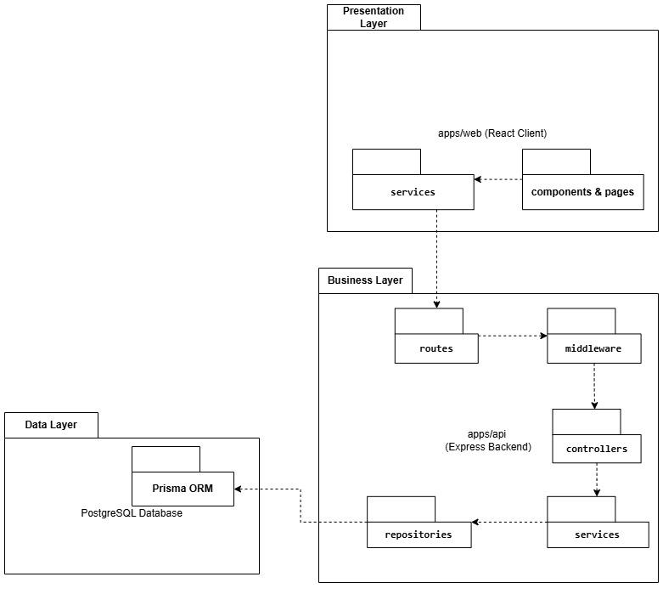

Package descriptions

No | Package | Description
1 | Presentation Layer (apps/web) | The presentation layer (Frontend Client) is responsible for building the entire interactive user interface for all system actors (Students, Teachers, Admins) utilizing the React v19 library, managing client-side application states, and handling secure network communication with the backend API.
1.1 | components & pages | Contains the main functional screen pages (Home, Exam Room, Adaptive Roadmap, AI Chat, Mindmap) and shared UI components. It utilizes the recharts library for academic progress visualization, framer-motion for smooth UI transitions, and tesseract.js for Client-side OCR text extraction from captured images to dynamically generate learning flashcards.
1.2 | services (Frontend) | Manages all API call functions (HTTP Requests) using the Axios library to establish communication with the Backend. It appends JWT Tokens to the HTTP Authorization Headers for secure session verification and maintains real-time socket connections via socket.io-client.
2 | Business Layer (apps/api) | The central business logic layer (Backend API Server) built on Node.js and the Express framework. It is responsible for intercepting HTTP requests from the frontend, enforcing strict security controls, executing adaptive AI algorithms, and coordinating overall system workflows.
2.1 | routes | Declares and manages all secure API Endpoints (URLs) of the backend system. It routes incoming HTTP requests (GET, POST, PUT, DELETE) through defensive Middleware filters before dispatching them to the corresponding Controller.
2.2 | middleware | Intermediary security filtering layer. It decodes and validates JWT tokens to authenticate user identity, enforces role-based access control (RBAC), validates request body payloads (Input Validation), and provides centralized exception catching (Global Error Handler).
2.3 | controllers | The orchestration and routing dispatcher layer. It extracts incoming request parameters (body, query, params), delegates tasks to the corresponding Service layer for logical execution, and packages results into JSON responses alongside appropriate HTTP status codes.
2.4 | services (Backend) | The heart of the backend system executing core business logic. It handles test scoring, calculates cheating telemetry metrics (examTrustScore), communicates with OpenRouter API (Gemini 2.5-Flash) to generate LaTeX-based adaptive questions / personalized roadmaps / weakness mindmaps, and manages payment checkouts (VNPAY/SePay), vouchers, and affiliate commissions.
2.5 | repositories | Direct data access object (DAO) layer. It utilizes Prisma Client to execute optimized database queries and mutations, separating data persistence from business logic while eliminating the risk of SQL Injection attacks.
3 | Data Layer | The physical data persistence layer of the system. It leverages the PostgreSQL relational database engine integrated with Prisma ORM to securely persist core system entities (User, Exam, TestAttempt, Voucher, Affiliate) while maintaining foreign key constraints and strict relational data integrity.

II. Requirement Specifications
1. Guest Operations & Authentication
1.1 UC01_View_Ranking

a. Functionalities
UC ID and Name: | UC01_View_Ranking
Created By: | Lê Ngọc Hoàng | Date Created: | 13/06/2026
Primary Actor: | Guest, User (Student) | Secondary Actors:
Trigger: | Guest or User clicks on the "Bảng xếp hạng" (Ranking/Leaderboard) menu located on the navigation bar.
Description: | As a guest or student, I want to view the learning achievement ranking board so that I can see the top-performing students and their scores on the platform.
Preconditions: | PRE-1: The system database must contain learning records and scores of students to generate the ranking.
Postconditions: | POST-1: The system successfully displays the ranking board to the user.
Normal Flow: | 1.0 View Ranking process  - Guest navigates to the platform and clicks on the "Bảng xếp hạng" menu.  - System queries the database to calculate and retrieve the top students based on their accumulated scores or exam results.  - System displays the Ranking screen, showing a list of top students (including Avatar, Name, and Total Score).
Alternative Flows: | 1.1 Filter ranking by specific subject  - In step 3 of the normal flow, the Guest selects a specific subject from the filter dropdown menu.  - System queries the database for the top students in that specific subject only.  - System updates the Ranking screen to display the filtered list.
Exceptions: | 1.0.E1 No ranking data available  - In step 2 of the normal flow, the system detects that there are no learning records available to generate a ranking list.  - System displays the Ranking screen with an informational message ("Chưa có dữ liệu xếp hạng").
Priority: | Low, Could Have
Frequency of Use: | Medium
Business Rules: | BR-08
Other Information:
Assumptions:

b. Business Rules
Provide the business rules those are applied only to the use case
ID | Business Rule | Business Rule Description
BR-08 | Data Privacy Rule | The system must not display sensitive contact information (like Email or Phone number) of the top students on the public ranking board to protect user privacy.

1.2 UC02_View_Course_Information

a. Functionalities
UC ID and Name: | UC02_View_Course_Information
Created By: | Lê Ngọc Hoàng | Date Created: | 13/06/2026
Primary Actor: | Guest, User (Student) | Secondary Actors:
Trigger: | Guest clicks on a specific course card from the Course Catalog screen.
Description: | As a guest, I want to view the detailed information of a course (such as syllabus, instructor details, and price) so that I can decide whether to register and enroll in it.
Preconditions: | PRE-1: The selected course must exist in the database and have a "Public" (Approved) status.
Postconditions: | POST-1: The system successfully displays the detailed course page.
Normal Flow: | 2.0 View Course Information process  - Guest navigates to the platform's Course Catalog and clicks on a specific course.  - System retrieves the detailed information of the selected course from the database (Title, Description, Instructor, Price, Curriculum outline).  - System displays the Course Detail screen with all the retrieved information.
Alternative Flows:
Exceptions: | 2.0.E1 Course no longer available  - In step 2 of the normal flow, the system detects that the requested course has been deleted or its status changed to "Hidden/Locked" by the Admin.  - System redirects the Guest to an Error page.  - System displays an error message ("Khóa học không tồn tại hoặc đã bị gỡ").  - System provides a button to return to the Course Catalog.
Priority: | High, Must Have
Frequency of Use: | High
Business Rules: | BR-09
Other Information:
Assumptions:

b. Business Rules
ID | Business Rule | Business Rule Description
BR-09 | Course Visibility Rule | System must only display courses to Guests that have been explicitly approved by the Course Admin. Draft or unapproved courses must return a "Not Found" exception.

1.3 UC03_Forgot_Password

a. Functionalities
UC ID and Name: | UC03_Forgot_Password
Created By: | Lê Ngọc Hoàng | Date Created: | 13/06/2026
Primary Actor: | Guest | Secondary Actors: | Email System
Trigger: | Guest clicks on the "Quên mật khẩu" (Forgot Password) link located on the Login screen.
Description: | As a guest, I want to reset my password through a verified email link so that I can regain access to my account if I forget my login credentials.
Preconditions: | PRE-1: The Guest must have an existing registered email address in the system database.
Postconditions: | POST-1:The user's password is successfully updated with the new value in the database. POST-2: The system logs the password reset event for security auditing.
Normal Flow: | 3.0 Forgot Password process  - Guest clicks the "Quên mật khẩu" link on the Login screen.  - System displays a form requesting the registered email address.  - Guest enters their email address and clicks the "Gửi yêu cầu" (Send request) button.  - System validates that the entered email exists in the database.  - System generates a secure, time-limited reset token and requests the Email System to send a password reset link.  - System displays a confirmation message notifying the Guest to check their inbox.  - Guest opens the email and clicks on the reset link.  - System verifies the token's validity and displays the "Đặt lại mật khẩu" (Reset Password) screen.  - Guest enters a new password, confirms the new password, and clicks "Lưu" (Save).  - System validates the new password against security policies.  - System updates the database with the newly encoded password and redirects the Guest to the Login screen with a success message.
Alternative Flows:
Exceptions: | 3.0.E1 Email does not exist  - In step 4 of the normal flow, the system detects that the email is not registered.  - System displays the error message MSG-04 ("Email không tồn tại trong hệ thống").  - System prompts the Guest to try a different email or register a new account.  3.0.E2 Reset token expired or invalid  - In step 8 of the normal flow, the system detects the token has expired (e.g., past 15 minutes) or is invalid.  - System redirects the Guest to an error page displaying MSG-05 ("Đường dẫn đã hết hạn hoặc không hợp lệ").  - System prompts the Guest to request a new password reset link.  3.0.E3 Invalid new password format  - In step 10 of the normal flow, the system detects the new password does not meet complexity requirements.  - System displays the error message MSG-02 ("Mật khẩu mới không hợp lệ").  - System clears the password fields and prompts the Guest to re-enter.
Priority: | High, Must Have
Frequency of Use: | Low
Business Rules: | BR-04, BR-05, BR-06
Other Information:
Assumptions: | The external Email System (e.g., SMTP server) is configured and operational.

b. Business Rules
ID | Business Rule | Business Rule Description
BR-04 | Email Verification Rule | The system must not reveal whether an email exists or not directly on the UI to prevent enumeration attacks, but for this specific academic project scope, MSG-04 is displayed for clarity.
BR-05 | Token Expiration Rule | The password reset token generated by the system must automatically expire 15 minutes after generation.
BR-06 | Password Encoding | User's new password must be encoded with hashing (e.g., MD5 or bcrypt) before being saved to the database.

1.4 UC04_Register
a. Functionalities
UC ID and Name: | UC04_Register
Created By: | Lê Ngọc Hoàng | Date Created: | 13/06/2026
Primary Actor: | Guest | Secondary Actors: | SMTP Mail Server, Core Database
Trigger: | The user navigates to the Registration page and inputs sign-up credentials. Description: Coordinates secure self-service registration of new student accounts, enforcing email ownership verification through OTP validation before persisting the active profile.
Description: | As a guest, I want to register an account successfully so that I can log in, become a User, and use the system’s AI-assisted learning features.
Preconditions: | PRE-1: - The guest must provide a unique email address that does not currently exist in the active "User" table.
Postconditions: | POST-1: - A new user account row is successfully created in the "User" database table with the default role parameter assigned as 'STUDENT'.  POST-2: A corresponding academic profile row is created in the "Student" extension table.
Normal Flow: | 4.0 Register process  1. The guest enters their Full Name, Email, Password, and Password Confirmation on the signup form.  2. The guest clicks "Register".  3. The system checks if the email is unique. If unique, the system generates a secure 6-digit verification code.  4. The system saves the hashed verification code to the "OtpVerification" table (purpose as "REGISTRATION") and triggers an asynchronous SMTP email dispatch carrying the raw OTP code.  5. The system displays an overlay modal asking the guest to enter the verification code sent to their email.  6. The guest inputs the OTP code and submits.  7. The system decrypts and validates the code, checking expiration and attempt limits.  8. Upon successful validation, the system commits a transaction to the database: a. Inserts a new row in the "User" table (hashing the password via bcrypt, setting role to 'STUDENT', and status to 'ACTIVE'). b. Inserts a matching row in the "Student" table referencing the newly generated userId.  9. The system destroys the verification session, logs the user in automatically, and redirects them to the "Onboarding" setup screen.
Alternative Flows: | - Alternative Flow 7a: OTP Verification Fails  1. The system detects an invalid or expired OTP code, displays a warning: "Invalid registration code."  2. The database transaction is held, and no account is created.
Exceptions: | Exception 3a: Email Already Registered 1. If the email address provided is already registered, the system stops the process and alerts: "This email address is already associated with an active account."
Priority: | High, Must Have
Frequency of Use: | High (For all new system registrations)
Business Rules: | BR-05 (OTP expires after 15 minutes);  BR-11 (Default role registration parameter must be GUEST/STUDENT).
Other Information:
Assumptions:

b. Business Rules
ID | Business Rule | Business Rule Description
FR1 | Password Encoding | User’s password must be encoded with MD5 hashing

1.5 UC05_Login

a. Functionalities
UC ID and Name: | UC05_Login
Created By: | Lê Ngọc Hoàng | Date Created: | 13/06/2026
Primary Actor: | User (Student, Teacher, Admin) | Secondary Actors:
Trigger: | User enters their account credentials and clicks the "Login" button on the authentication interface.
Description: | This use case allows registered users to authenticate their identity using an email and password combination to securely access the platform ecosystem.
Preconditions: | PRE-1: The user must possess a pre-registered account record inside the system database.
Postconditions: | POST-1: A secure authentication session token (JWT/Session Cookie) is successfully instantiated.  POST-2: The user workspace is securely routed to their corresponding role-based landing dashboard layout.
Normal Flow: | 05. Login  1. User navigates to the system login interface layout viewport.  2. User inputs their registered email string and corresponding password characters into the input fields.  3. User clicks the primary "Login" action button.  4. System validates that the inbound fields satisfy basic text length and string formatting structures.  5. System executes a backend database query to match the email, performs a cryptographic verification check on the salted password hash, and verifies that the account state is marked as active.  6. System generates a secure stateful session token tracking data array, maps user role permissions, and grants entry access clearance.
Alternative Flows:
Exceptions: | 05.0.E1 Input credential combination mismatch or record not found:  - Occurrence point: Occurs at Step 5 of the Normal Flow during server-side password hash validation routines.  1. The system identifies that the input email does not match any row entity or the computed password hash fails the cryptographic comparison verification.  2. The authentication service terminates token serialization loops immediately.  3. The user interface clears the password field container, highlights an inline warning text component: "Incorrect email or password string. Please review your credentials and try again."  05.0.E2 Target account identity is flagged as suspended or locked:  - Occurrence point: Occurs at Step 5 of the Normal Flow during profile authorization state scans.  1. The backend engine discovers that the corresponding account index row holds a lifecycle status attribute explicitly configured to suspended or locked.  2. The platform aborts session generation tracking structures cleanly and rolls back processing queues.  3. The client application renders a modal dialog box detailing the access block: "Access Denied. Your user account identity is currently restricted by platform administration. Please reach out to administrative support vectors."
Priority: | High, Must Have.
Frequency of Use: | Extremely High (Utilized continuously as the primary security gateway for all authenticated roles on the network platform).
Business Rules: | BR-AUTH-01
Other Information: | The token generation framework incorporates security layer tracking metrics to block active user sessions if parallel login footprints are detected simultaneously from conflicting geographical environments.
Assumptions: | The client browser framework allows standard encryption cookies or web local storage access to hold the active payload token securely throughout the session lifetime.

b. Business Rules
ID | Business Rule | Business Rule Description
BR-AUTH-01 | Brute Force Protection Threshold | If a single distinct account identification record registers exactly 5 consecutive failed authentication attempts within a rolling 10-minute window frame, the security subsystem must automatically switch the user state profile status to locked and trigger an automated account unlocking validation link to the user's verified inbox.

1.6 UC06_Login via google

a. Functionalities
UC ID and Name: | UC06: Login via Google
Created By: | Lê Ngọc Hoàng | Date Created: | 13/06/2026
Primary Actor: | Unauthenticated User (Guest) | Secondary Actors: | Backend System, Google OAuth 2.0 Authentication Service
Trigger: | The user clicks on the "Login with Google" or "Continue with Google" icon/button on the login or registration form system.
Description: | This use case allows users to quickly sign into the system using their Google account credentials.
Preconditions: | PRE-1: User possesses a valid Google account.  PRE-2: System has an active connection with the Google OAuth API.
Postconditions: | POST-1: User is successfully authenticated and redirected to the home dashboard.  POST-2: A valid user session is initialized.
Normal Flow: | 06. Login via Google  1. User navigates to the login page.  2. User clicks the "Login with Google" button.  3. System redirects the viewport to the secure Google Authentication interface.  4. User enters their Google credentials and authorizes the platform access.  5. Google returns a valid authentication token payload to the backend callback endpoint.  6. System verifies the token, maps the email address to the database account, and logs the user in.
Alternative Flows: | None (there are no other successful alternative flows for this specific transaction process).
Exceptions: | 06.0.E1 Google authentication rejected or canceled:  1. User cancels the login process or Google service returns an error token.  2. System handles the exception, routes back to the login screen, and displays: "Google authentication failed. Please try again."
Priority: | High, Should Have
Frequency of Use: | Extremely High (Users inherently prefer quick, one-click social login solutions to access their courses seamlessly).
Business Rules: | BR-AUTH-03
Other Information:
Assumptions: | Assumes that Google's OAuth 2.0 API gateway remains structurally stable and that the localized configuration parameters (Client ID / Client Secret) are accurately defined on our servers.

b. Business Rules
ID | Business Rule | Business Rule Description
BR-AUTH-03 | Third-Party Identity Synchronization | Each unique Google account can only be linked and mapped to a single unique user identification entity (user_id) inside the system database cluster to eliminate potential security vulnerabilities and protect learning material ownership rights.

1.7 UC07: Log Out
a. Functionalities
UC ID and Name: | UC07: Log Out
Created By: | Lê Ngọc Hoàng | Date Created: | 13/06/2026
Primary Actor: | Authenticated User (Student, Teacher, Admin) | Secondary Actors: | Backend System
Trigger: | The user clicks on the "Log Out" button or link in the account options menu.
Description: | This use case allows the user to terminate their active session on the system securely.
Preconditions: | PRE-1: User is logged into an active account session.
Postconditions: | POST-1: Active session token or cookie is completely invalidated.  POST-2: User is redirected back to the system landing page.
Normal Flow: | 7.0 Normal Flow:  1. The User clicks the "Log Out" button on the system interface.  2. The system captures the request and transmits the current session identification token to the Backend.  3. The Backend System records the revocation of this token (or adds the JWT to a token blacklist if using a stateless JWT security mechanism).  4. The client-side application automatically clears all locally cached session storage info (Local Storage, Session Storage, or HttpOnly Cookies).  5. The system displays a successful logout notification and automatically redirects the user back to the public landing page or login screen.
Alternative Flows: | None (there are no other successful alternative flows for this transaction process).
Exceptions: | 7.0.E1 Loss of network connectivity during session teardown:  - Occurrence point: Occurs at Step 3 of the Normal Flow.  1. No logical exceptions break the flow because even if local network connectivity to the Backend server drops, the client-side system is programmed to automatically erase tokens from the local device storage (Step 4) to protect user credentials immediately.
Priority: | High, Must Have
Frequency of Use: | High (Occurs every time a user concludes their learning, teaching, or administrative activities on the system to secure the device).
Business Rules: | BR-07
Other Information: | The active session will also automatically trigger a background logout routine (Auto-logout) if the authorization JWT token expires based on default system lifetime parameters (e.g., after 7 days of inactivity).
Assumptions: | Clicking the back button in the browser post-logout will not grant access to previously cached authenticated pages.

b. Business Rules
ID | Business Rule | Business Rule Description
BR-07 | Immediate Token Revocation | The exact second a logout request is processed, the associated authentication token must be completely blacklisted on the server side to block any unauthorized session reuse.

2.Profile & User Operations Dashboard
2.1 UC08: Update Profile

a. Functionalities
UC ID and Name: | UC08: Update Profile
Created By: | Lê Ngọc Hoàng | Date Created: | 13/06/2026
Primary Actor: | Authenticated User (Student, Teacher, or Administrator) | Secondary Actors: | Backend System, Cloud Storage Service (e.g., AWS S3 / Cloudinary)
Trigger: | User clicks the "Save Changes" or "Update Profile" button within the profile settings panel.
Description: | Allows authenticated users to proactively edit and update their basic personal details (such as Full Name, Phone Number, Date of Birth, Nickname, Gender, Bio, and Avatar Image) to ensure information accuracy and consistency across the entire online learning platform.
Preconditions: | PRE-1: The user must be successfully logged into the system .  PRE-2: The user account is active, and the viewport is currently focused on the "Edit Personal Profile" setup layout.
Postconditions: | POST-1:The personal identity records within the relational entity tables (Users, StudentProfiles, or TeacherProfiles) are correctly updated with the new values in the persistent database cluster .  POST-2:The platform immediately synchronizes and reflects the newly saved information on the client interface application workspace.
Normal Flow: | 8.0 Normal Flow:  1. The user alters their textual identity metadata on the edit profile workspace form (e.g., modifying Full Name, Date of Birth, or providing a new Phone Number).  2. The user clicks on the "Save Changes" execution command element.  3. The Backend System receives the text payload array and executes structural validation processes (Format validation) across all incoming data input fields.  4. The Backend System runs a secure update statement transaction (Update Query) to commit the modified attributes into the corresponding database tables.  5. The system serves a visual "Profile updated successfully!" pop-up notification on the user interface screen and reloads the fresh profile dataset onto the layout viewport.
Alternative Flows: | 8.1 User updates account Avatar Image:  - Branching point: Occurs at Step 1 of the Normal Flow when the user triggers the file picker element and uploads a new image file as their avatar .  - Flow variations: The system temporarily halts the standard local text database write sequence; it handles an asynchronous multi-part upload call targeting the external Cloud Storage Service API. Once the cloud engine concludes hosting processing and returns an absolute, secure public asset URL string, the local application intercepts the link and assigns it directly to the user profile's avatar_url attribute .  - Rejoin point: Advances straight to Step 2 of the Normal Flow to let the user commit all modifications together into the system database.
Exceptions: | 8.0.E1 Phone number format is invalid or conflicts with a pre-existing account duplicate:  - Occurrence point: Occurs at Step 3 of the Normal Flow during server-side format verification routines.  1. The application finds the phone string fails regex constraints or is already bound to another profile identity row inside the DB.  2. The transaction block aborts the storage save routine cleanly (triggers a complete database Rollback).  3. The client captures the validation exception and highlights the input block with an immediate inline warning: "The phone number format is invalid or is already registered under another account profile. Please check again" .  8.1.E1 Avatar file type is unsupported or exceeds file system payload constraints:  - Occurrence point: Occurs at Alternative Flow 8.1 during localized pre-upload client structural inspections.  1. The engine identifies that the target file formatting violates permitted mime types or the asset size exceeds the cloud maximum.  2. The platform terminates the cloud pipeline transfer and retains the older asset file safely in place.  3. The system prints a descriptive warning toast banner: "Image upload failed. The file format must be a standard image extension type (.jpg, .png, .webp) and total size must remain strictly under 5MB".
Priority: | Medium, Should Have
Frequency of Use: | Low to Medium (Typically triggered exclusively during onboarding cycles or when real-world contact parameters change).
Business Rules: | BR-PROF-01
Other Information: | If network connectivity drops or timeouts occur during the Cloud Storage transfer or relational database updates, a complete application transactional rollback must be executed. This step prevents broken image layouts or orphaned asset records, keeping the profile data clean and uncorrupted.
Assumptions: | It is assumed that editing personal background profile metadata executes independently and cannot manipulate or dynamically bypass predefined system access authorization levels (role).

b. Business Rules
ID | Business Rule | Business Rule Description
BR-PROF-01 | Avatar File Type and Capacity Size Limits | All files uploaded to serve as a profile picture must belong to a verified image formatting category supported by the web framework, specifically limited to: .jpg, .jpeg, .png, or .webp. Additionally, the individual file size boundary is limited to a maximum threshold of 5MB to protect database bandwidth and page loading speeds.

2.2 UC09: Change Password

a. Functionalities
UC ID and Name: | UC09: Change Password
Created By: | Lê Ngọc Hoàng | Date Created: | 13/06/2026
Primary Actor: | Authenticated User | Secondary Actors: | Backend System
Trigger: | The user clicks on the "Change Password" menu option within the personal account security configurations layout.
Description: | Provides a routine security maintenance utility enabling authenticated users to change their active account login password by verifying their current password and establishing a compliant new password to optimize overall profile safety.
Preconditions: | PRE-1: The user must be successfully logged into a valid platform session.  PRE-2: The user account must have been established using local registration (possesses an internal hashed password, not directly applicable to third-party federated social log-ins that have not yet set up native credentials).
Postconditions: | POST-1: The newly provided password string is successfully hashed and committed over the existing entry within the Users database table.  POST-2: The platform automatically revokes all pre-existing authorization session tokens across other connected client hardware to require clean re-authentication.
Normal Flow: | 9.0 Normal Flow:  1. The user opens the "Change Password" interface module.  2. The application serves a targeted form requesting three mandatory input fields: Current Password, New Password, and Confirm New Password.  3. The user inputs their data strings into the corresponding fields and executes "Update Password".  4. The Backend System captures the payload array and validates the entered current password by hashing it and matching the result against the encrypted hash string persisted in the database.  5. The system performs security policy strength checks on the new password string and verifies its matching equivalence with the confirmation entry field.  6. The Backend System bams the compliant new password securely, commits the database update transaction, and pushes a successful modification toast banner onto the client layout.
Alternative Flows: | None (this action proceeds along a singular successful confirmation flow path).
Exceptions: | 9.0.E1 Verification fails due to incorrect current password input:  - Occurrence point: Occurs at Step 4 of the Normal Flow during database cryptographic hash matching check routines.  1. The engine completely blocks the database transaction update path.  2. The UI renders a red validation warning message indicator: "The current password entered is incorrect. Please check and try again."  9.0.E2 New password matches the active current password entry:  - Occurrence point: Occurs at Step 5 of the Normal Flow during server-side programmatic safety rule checks.  1. The transaction process halts before database persistence.  2. The interface surfaces an immediate inline validation restriction warning: "Your new password cannot be identical to the password currently in use. Please select a different, more secure password configuration."
Priority: | High, Must Have
Frequency of Use: | Low (Typically executed strictly on a periodic cycle or when a user encounters security concerns).
Business Rules: | BR-AUTH-01 (Relies on the standard cryptographic one-way hashing rule established in the authentication block).
Other Information: | Following a verified password modification transaction, the system should trigger an automated notification email to the user's primary inbox confirming the change. This helps users quickly notice and report any unauthorized background account changes.
Assumptions: | It is assumed that the active user accurately remembers their existing current password credentials to satisfy the verification flow criteria.

b. Business Rules
This specific use case inherits the strict security compliance rules defined under BR-AUTH-01 (Cryptographic Password Hashing) inside the shared application authentication framework, generating no standalone business rules matrix.
2.3 UC10_Download Documents

a. Functionalities
UC ID and Name: | UC10: Download Documents
Created By: | Lê Ngọc Hoàng | Date Created: | 13/06/2026
Primary Actor: | Authenticated User (Student, Teacher) | Secondary Actors:
Trigger: | The user clicks on the "Download" icon or button attached to a document file within a lesson workspace or resource repository.
Description: | Allows authenticated users to safely download permitted supplementary learning materials (such as PDFs, lecture slides, sample source code, and assignment files) to their local device storage for offline study and reference.
Preconditions: | PRE-1: The user must be successfully logged into an active platform session.  PRE-2: The user must possess a valid entitlement/ownership record for the course containing the document (or the asset is configured as a public free preview item).
Postconditions: | POST-1: The requested file asset is successfully downloaded to the user's local hardware platform in its original, uncorrupted binary file format.
Normal Flow: | 10.0 Normal Flow:  1. The user navigates to the target lesson workspace or file index, spots the required document attachment, and clicks "Download".  2. The client application dispatches the unique identifier (document_id) along with the user's active session authorization token to the Backend System.  3. The Backend System captures the request and executes an ownership verification lookup against the enrollment database logs.  4. Upon verifying valid access permissions, the Backend invokes the secure File Storage Server API to instantly generate a time-locked, cryptographically signed download path (Signed URL).  5. The Backend System passes this temporary Signed URL back to the client application, which automatically forces the web browser's native download manager to pull the file, concluding the workflow.
Alternative Flows: | None (this processing pipeline relies on a singular successful validation delivery mechanism).
Exceptions: | 10.0.E1 User is not enrolled or lacks permission context for the source course:  - Occurrence point: Happens at Step 3 of the Normal Flow during database permission checks.  1. The backend security interceptor blocks further processing and cancels the file-fetching pipeline.  2. The system declines the generation of a cryptographic Signed URL asset path.  3. The backend returns an authorization exception token to the client layout, prompting a visible error modal banner: "Access denied. You must purchase or enroll in this course to download its supplementary materials."
Priority: | High, Must Have
Frequency of Use: | High (Learners routinely download problem worksheets, text handouts, or source code samples concurrently while playing video lectures).
Business Rules: | BR-DOC-01
Other Information: | To mitigate the risk of continuous automated scraping and unauthorized direct-link sharing outside the application ecosystem, all cryptographic Signed URLs computed during Step 4 must expire automatically within 30 seconds of creation.
Assumptions: | It is assumed that all digital assets uploaded by instructors are checked for compliance, free of harmful malware strings, and the remote object storage subsystem guarantees continuous availability.

b. Business Rules
ID | Business Rule | Business Rule Description
BR-DOC-01 | Permitted Learning Material Formats | The application framework restricts asset interactions to a curated registry of secure standard office and data container file extensions, specifically limited to: .pdf, .docx, .pptx, .xlsx, .zip, and .rar to maintain infrastructure safety.

2.4 UC11: View Notifications

a. Functionalities
UC ID and Name: | UC11: View Notifications
Created By: | Lê Ngọc Hoàng | Date Created: | 13/06/2026
Primary Actor: | Authenticated User (Student, Teacher, Administrator) | Secondary Actors: | Backend System
Trigger: | The user clicks the notification bell icon or accesses the centralized notification management page.
Description: | Displays a list of personalized or system-wide notifications automatically generated by the system or created by teachers, such as exam reminders, new lesson updates, grading results, and discussion feedback. The system allows users to read notification details and automatically updates the notification status when viewed.
Preconditions: | PRE-1: The user has successfully logged into the system.
Postconditions: | POST-1: The notification list is retrieved and displayed accurately in real time based on the authenticated user account.  POST-2: The notification status changes from "Unread" to "Read" immediately after the user opens the notification details.
Normal Flow: | 11.0 Normal Flow:  1. The user clicks on the notification bell component icon located on the primary navigation menu layout.  2. The client application dispatches the unique target identifier (user_id) through an API call to the Backend System.  3. The Backend System queries the database repository to retrieve the latest notice entities matching this account ID, sorted in descending chronological order by creation time.  4. The interface populates a contextual dropdown layout containing the top 5–10 recent notice records, showcasing: Title, content snippet summary, relative timestamp, and status indicator (Unread / Read).  5. The user clicks on a targeted notification item within the provided view stack.  6. The system executes a persistent update script to toggle the status flag (is_read = true) inside the relational database, and dynamically routes the client viewport directly to the linked entity object page (e.g., examination feedback grid, course discussion forum).
Alternative Flows: | 11.1 Access full centralized notification manager view:  - Branching point: Occurs at Step 4 of the Normal Flow when the user selects the "View All Notifications" action element.  - Flow variations: The application routes the client viewport into a dedicated full-screen notification inbox workspace, enabling server-side pagination blocks and advanced structural filters (All, Unread, Read) for clean organization.  11.2 Mark all notifications as read synchronously:  - Branching point: Triggered directly inside the active layout interface (either Dropdown Step 4 or Central Inbox 11.1).  - Flow variations: The user clicks the "Mark all as read" processing utility button. The Backend System handles a batch database request, running an optimal override command to reset is_read = true across all unread notices bound to that user context, and immediately flashes the header alert badge indicator down to 0.  - Rejoin point: Concludes the transaction process flow cleanly right after interface state synchronization.
Exceptions: | 11.0.E1 Notification state transaction update synchronization failure:  - Occurrence point: Happens at Step 6 of the Normal Flow if a network timeout or resource deadlock aborts the database write block.  1. The system catches the data pipeline interruption and prints an error log inside the server console without freezing the user viewport framework.  2. The client runtime continues to handle deep-linking route redirects to deliver the target content page seamlessly.  3. The notification entity status remains visually flagged as "Unread" locally until a subsequent data alignment loop catches up.
Priority: | High, Must Have
Frequency of Use: | Very High (The system automatically generates notifications, and users frequently check notifications during platform interactions.)
Business Rules: | BR-NOTI-01
Other Information: | The system should integrate a real-time notification mechanism using WebSocket technology (e.g., Socket.IO) to instantly push notifications to users without requiring a page refresh.
Assumptions: | The system's deep-linking mechanism is correctly configured so that users are redirected directly to the corresponding target content when clicking a notification.

b. Business Rules
ID | Business Rule | Business Rule Description
BR-NOTI-01 | Strict Notification Ownership Boundary | The data management engine must enforce strict identity row isolation; an authenticated user_id is exclusively authorized to fetch, review, or manipulate notification objects containing their specific user ownership assignments. Cross-tenant data polling or status mutation scripts are explicitly intercepted and dropped at the API gateway layer.

3.Student Learning Workspace & Interaction
3.1 UC12: Watch Lecture Videos

a. Functionalities
UC ID and Name: | UC12: Watch Lecture Videos
Created By: | Nguyễn Văn Định | Date Created: | 13/06/2026
Primary Actor: | Student | Secondary Actors:
Trigger: | The student clicks on a specific lecture item or play icon inside the active course curriculum syllabus panel.
Description: | Renders the embedded platform video player component inside the classroom environment, executes streaming authentication protocols, tracks continuous watching timelines, and continuously updates progression logs in the data tier.
Preconditions: | PRE-1: The student must be successfully logged into an active account session.  PRE-2: The student must hold an active entitlement record for this course item inside the CourseEnrollments table (or the lesson is flagged as a public preview item).
Postconditions: | POST-1: The target encrypted media chunk stream initializes and plays back smoothly via a secure player workspace container.  POST-2: Real-time playback metadata metrics (watched_time, is_completed) are dynamically synchronized and committed to the LessonProgress database schema.
Normal Flow: | 12.0 Normal Flow:  1. The student navigates through the course classroom workspace sidebar, unfolds a specific chapter accordion, and clicks on a video lesson item.  2. The client application dispatches the unique index handle (lesson_id) alongside the active session token to the Backend System.  3. The Backend System validates the student's active enrollment data clearance bounds within the database records.  4. The Backend handles an asynchronous authorization handshake request to the Video Hosting Server to query the raw source and compile a single-use streaming security token.  5. The Backend wraps this secure stream data payload block and forwards it back down to the calling client viewport layout application.  6. The client framework injects the stream token data context safely into the platform custom player module container, initializing background heartbeat tracking listeners.  7. The student watches the lecture video, and the embedded tracking script automatically dispatches tiny progress payload updates (heartbeat pings) to the server every 15 seconds to update current watch locations.
Alternative Flows: | 12.1 Auto-advance trigger sequence upon milestone completion:  - Branching point: Triggered automatically at Step 7 when the internal tracking algorithm detects that the video timeline position passes the completion threshold rule boundary (e.g., reaching 90% or 100% video runtime markers).  - Flow variations: The browser player context executes a synchronous save script setting is_completed = true in the DB, recalculates global course progress values (progress_pct), displays a contextual checkmark badge on the curriculum menu tree, and automatically slides the viewport to play the next logical lesson node entry seamlessly.  - Rejoin point: Concludes the alternative pipeline cleanly, returning back to a fresh instance step loop of Step 1 for the upcoming lesson node.
Exceptions: | 12.0.E1 Access blocked due to incomplete course prerequisite conditions:  - Occurrence point: Happens at Step 3 of the Normal Flow when the system runs a sequential validation scan.  1. If the course enforces a rigid sequential lock policy (BR-LEARN-01) and the tracking module discovers prior required lessons remain incomplete, database video retrieval tasks abort cleanly.  2. The client system displays an inline locked dialog overlay modal stating: "Lesson locked. You must successfully complete all previous required tasks to unlock this lecture video topic."  12.0.E2 Streaming token validation error or missing video source file item:  - Occurrence point: Happens at Step 5 of the Normal Flow if cloud media storage paths become broken or broken token hashes mismatch.  1. The player element intercepts the delivery disruption event, preventing raw server infrastructure failure prints on screen.  2. The interface drops the media area loader and renders a fallback placeholder card saying: "Media loading failure. The stream cannot be verified or the asset is temporarily unavailable. Please try reloading or alert support."
Priority: | High, Must Have
Frequency of Use: | Critically High (The absolute core operational interaction engine across the entire interactive LMS architecture stack).
Business Rules: | BR-LEARN-01, BR-LEARN-02
Other Information: | To maintain low server infrastructure resource cost overheads, progress log database execution calls must be throttled or debounced (using client heartbeats) rather than executing an I/O database write on every single video time-tick event.
Assumptions: | Assumes student endpoint display hardware supports standard media decoding runtimes and has adequate internet bandwidth speeds to pull media chunks efficiently.

b. Business Rules
ID | Business Rule | Business Rule Description
BR-LEARN-01 | Linear Progression Enforcement | When a course's operational rule flag is set to linear study path mode, the system programmatically restricts random navigation accesses. A video lecture cannot be loaded or played unless all preceding lessons in the sequential database indexing catalog are marked as completed (is_completed = true).
BR-LEARN-02 | Anti-Scraping Media Hotlinking Protection | Raw source video URLs (direct file links) must never be transmitted or exposed to the client interface layout. All media must utilize temporary, tokenized adaptive bitrate chunk streaming paths (such as HLS or DASH formats paired with signed cookies) that naturally expire within short intervals, preventing illegal link sharing and video harvesting.

3.2 UC13: View AI Performance Analysis

a. Functionalities
UC ID and Name: | UC13: View AI Performance Analysis
Created By: | Nguyễn Văn Định | Date Created: | 13/06/2026
Primary Actor: | Student | Secondary Actors: | Backend System, AI Core Engine (Machine Learning Analytics Service)
Trigger: | The student clicks on the "AI Insights", "Skill Report", or "Performance Analysis" tab within their learning dashboard panel.
Description: | Renders a personalized, comprehensive cognitive data analysis report computed by the AI Core. The interface visualizes the student's proficiency ratings across subject subtopics, pinpoints explicit knowledge gaps, measures accuracy trends, and forecasts future milestones based on historical quiz and exam datasets.
Preconditions: | PRE-1: The student must be successfully logged into an active account session.  PRE-2: The student must have completed at least one graded activity (e.g., quiz, exercise, or mock exam) to generate baseline metrics for the AI processing framework.
Postconditions: | POST-1: The custom analytical competence metrics are successfully compiled and rendered dynamically on the user dashboard interface layout.
Normal Flow: | 13.0 Normal Flow:  1. The student navigates to their personal profile dashboard area and selects the "AI Analytics" data section.  2. The client application transmits the contextual validation header containing the user_id to the Backend System.  3. The Backend System fetches raw relational learning logs (such as time-on-task distribution charts, question categories, correctness histories) and invokes the internal AI Core Engine data parser pipeline.  4. The AI Core Engine processes the operational inputs using data classification metrics, structures the predictive scoring models, and returns an analytical JSON data schema to the Backend.  5. The Backend delivers the formatted evaluation payload array back down to the client-side UI application layer.  6. The client framework feeds the metrics seamlessly into interactive layout elements, displaying multi-dimensional spider charts, weakness matrix tags, progression timelines, and overall readiness scores.
Alternative Flows: | None (this analytical process flows down a singular data calculation routing path).
Exceptions: | 13.0.E1 Insufficient empirical historical learning data to formulate an analysis:  - Occurrence point: Happens at Step 3 of the Normal Flow when the database scanner finds the student has not completed enough module exams.  1. The AI module halts active processing loops to prevent charting broken null values or skewed charts.  2. The client application suppresses the statistical chart wrappers.  3. The UI presents an informative placeholder view state containing action hooks: "AI Performance Analysis Pending. Please complete more mock tests or lesson assignments to unlock your automated core competency roadmap mapping report."
Priority: | High, Should Have
Frequency of Use: | Medium (Typically triggered periodically by active students looking to review their comprehensive academic skill growth trends).
Business Rules: | BR-AI-01
Other Information: | All data visualization components (charts, progress matrices) must be fully mobile-responsive and support print layouts. To minimize infrastructure costs and inference engine strain, complex AI computation payloads should be cached daily rather than executing server-intensive computations on every single page initialization event.
Assumptions: | It is assumed that all question entities are accurately tagged with corresponding micro-subject skill metadata matrix parameters so the backend scoring nodes can classify knowledge scores appropriately.

b. Business Rules
ID | Business Rule | Business Rule Description
BR-AI-01 | Strict Personal Analytics Data Isolation | Performance evaluation vectors, machine learning prediction statistics, and individual profile score analytics tables are strictly bound to the generating user_id. Cross-account diagnostic query actions or horizontal tenant tampering attempts are rigorously caught and locked at the security API server gate layer to guarantee strict user data isolation.

3.3 UC14: View Learning Materials

a. Functionalities
UC ID and Name: | UC14: View Learning Documents
Created By: | Nguyễn Văn Định | Date Created: | 13/06/2026
Primary Actor: | Student | Secondary Actors:
Trigger: | The student clicks on a specific text document lesson or lecture file (PDF, Slide) inside the course curriculum path.
Description: | Allows students to read and view supplementary learning materials online directly through an integrated reader on the platform interface without forcing them to download the raw file onto their local device storage, thereby protecting digital material copyrights.
Preconditions: | PRE-1: The student must be successfully logged into an active account session  PRE-2: The student must hold a valid operational entitlement record for this course item inside the CourseEnrollments table.
Postconditions: | POST-1: The secure inline document reader component mounts successfully and visualizes the uncorrupted learning material context safely.  POST-2: The system automatically synchronizes and commits the learning progress state (is_completed = true) to the LessonProgress database schema.
Normal Flow: | 14.0 Normal Flow:  1. The student clicks on a document-formatted lesson node within the interactive course curriculum tree layout.  2. The client application dispatches the unique identifier (document_id) along with the active session authorization token to the Backend System.  3. The Backend System captures the request and executes an enrollment validation check against the student's active logs inside the CourseEnrollments table.  4. Upon verifying valid access rights, the Backend invokes the remote File Storage Server API to dynamically compute a temporary, time-locked cryptographically signed path (Signed URL).  5. The Backend System passes this computed temporary Signed URL metadata back down to the calling client application layer.  6. The client framework injects the URL safely into the customized inline viewing component (PDF/Syllabus Viewer) to render the document structure seamlessly for the user.  7. Once the student scrolls down to the final page of the asset or maintains the minimum required reading duration context, the client runtime automatically dispatches a progress command setting the completion milestone inside the LessonProgress database.
Alternative Flows: | None (this direct file rendering transaction proceeds along a singular successful viewing pathway).
Exceptions: | 14.0.E1 Access blocked due to missing or invalid course enrollment parameters:  - Occurrence point: Happens at Step 3 of the Normal Flow during database lookups.  1. The backend security interceptor blocks further processing and cancels the file-fetching pipeline.  2. The system declines the generation of a cryptographic Signed URL asset path.  3. The backend returns an authorization exception token to the client layout, prompting a visible error banner: "Access denied. You must purchase or register for this course to unlock this supplementary document node resource."  14.0.E2 Document asset is structurally corrupted or missing from cloud storage servers:  - Occurrence point: Happens at Step 6 of the Normal Flow when the client inline viewer fails to safely parse the target file container stream.  1. The platform safely drops the corrupted layout wrapper to prevent UI freeze conditions.  2. The system serves an informative placeholder view state: "Document viewing failure. The target file is corrupted or has been unlinked from the server. Please reload the viewport or notify your course instructor."
Priority: | High, Must Have
Frequency of Use: | Very High (Learners routinely read text handouts, lecture syllabus trees, and reference slide items continuously across every conceptual chapter node).
Business Rules: | BR-DOC-02
Other Information: | The inline document view engine should exploit lazy loading mechanics (fetching only active viewport pages) to economize user bandwidth metrics and speed up visualization times when processing hefty textbook files containing hundreds of pages.
Assumptions: | It is assumed that the user's browser runtime platform fully supports native HTML5 compilation layers to properly preserve text alignment and asset structures.

b. Business Rules
ID | Business Rule | Business Rule Description
BR-DOC-02 | Anti-Copy and Learning Asset Copyright Safeguard Mechanics | While a student reads instructional resources inside the online workspace viewer, the client framework must systematically disable right-click interactions (Context Menu interception), intercept and block global printing/copy shortcuts (Ctrl+C, Ctrl+P, Cmd+C), prohibit interactive text selection highlighting blocks, and entirely obfuscate the root cloud storage bucket source URL parameters to comprehensively minimize direct unauthorized asset harvesting and piracy leaks.

3.4 UC15: Rate Course

a. Functionalities
UC ID and Name: | UC15: Rate Course
Created By: | Nguyễn Văn Định | Date Created: | 13/06/2026
Primary Actor: | Student | Secondary Actors:
Trigger: | The student clicks on the "Write a Review" button within the course dashboard, or finishes the last lesson node and triggers an automated completion review prompt.
Description: | Allows students who are actively enrolled in a course to submit a numerical star rating accompanied by a qualitative text review. The system saves the evaluation record, dynamically recalculates the course's global aggregate rating metrics, and renders the entry public.
Preconditions: | PRE-1: The student must be successfully logged into an active platform session.  PRE-2: The student must have an active and verified enrollment record for the targeted course within the CourseEnrollments database schema.
Postconditions: | POST-1: A new feedback record is instantiated inside the CourseReviews table containing the star count, descriptive commentary text, timestamp, and the student's user_id.  POST-2: The targeted course’s cumulative tracking columns (average_rating and total_reviews) are dynamically recomputed and updated inside the Courses table.
Normal Flow: | 15.0 Normal Flow:  1. The student navigates to the "Reviews and Ratings" segment of the active course workspace panel.  2. The student clicks on the "Write a Review" interaction element.  3. The platform opens a modular interface form presenting a 1-to-5 star rating selector tool and an optional multiline text area for open-ended comments.  4. The student selects their score rating, drafts their text commentary, and clicks the "Submit Review" action element.  5. The Backend System captures the payload array and validates structural constraints (e.g., verifying the score falls within valid bounds and the text length stays within acceptable limits).  6. The system executes a database transaction to insert the new feedback entry into the CourseReviews table and triggers an asynchronous recalculation function to update the course's global score profile.  7. The interface updates the layout to append the student's review to the public stack and pops up a "Thank you for your valuable feedback!" success notification banner.
Alternative Flows: | 15.1 Modifying a previously submitted course review:  - Branching point: Occurs at Step 2 of the Normal Flow.  - Flow variations: If the database tracking layer detects that the active user_id has already filed a review entry for this specific course_id, the system swaps the empty creation layout for an "Edit Your Review" space pre-filled with their historical data. The student alters the stars or updates the text copy and clicks "Update Review". The backend switches the operation to an SQL update command rather than a new record insertion.  - Rejoin point: Advances directly to Step 6 of the Normal Flow to recompute values and finalize the interface state.
Exceptions: | 15.0.E1 Enrollment checking routine reveals an unverified or illegal access request:  - Occurrence point: Happens at Step 5 of the Normal Flow during backend parameter matching routines.  1. The backend API engine interceptor drops the write operation immediately to prevent arbitrary review spoofing.  2. The client intercepts the restriction code and displays a localized alert banner: "Submission rejected. Only active, registered students of this course are permitted to evaluate the material."  15.0.E2 Automated keyword validation intercepts restricted or profane language entries:  - Occurrence point: Happens at Step 5 of the Normal Flow during payload content validation scanning loops.  1. The platform safety layer flags blacklisted terminology patterns within the text field string and halts database serialization.  2. The interface retains the input values locally but prevents submission, highlighting the text boundary with a warning: "Your review contains terms that violate platform community standard rules. Please adjust your text and resubmit."
Priority: | Medium, Should Have
Frequency of Use: | Low to Medium (Typically fired strictly once per course deployment by any unique individual student entity).
Business Rules: | BR-REV-01, BR-REV-02
Other Information: | To avoid data corruption or mathematical discrepancies due to concurrent review submissions on popular courses, the mathematical updating function for average_rating must execute within an isolated transactional database block or process through a systematic background worker task queue.
Assumptions: | It is assumed that students possess a genuine background with the instructional material prior to submitting quantitative scoring logs.

b. Business Rules
ID | Business Rule | Business Rule Description
BR-REV-01 | Singular Evaluation Footprint Constraint | A unique student user account identification string (user_id) is strictly confined to a single active feedback record entry per individual course_id entity. Any additional evaluation actions targeting the same entity path must systematically modify the historical row index rather than generating duplicate lines.
BR-REV-02 | Rating Numerical Boundary Conditions | The integer value passed to represent the evaluation score must strictly adhere to a bounded numerical range scale of 1 to 5 inclusive, where 1 signifies the minimum acceptable tier and 5 represents top-tier structural quality.

3.5 UC-65_Manage Study Group
a. Functionalities
UC ID and Name: | UC-65_Manage Study Group
Created By: | Nguyễn Đình Huy | Date Created: | 18/07/2026
Primary Actor: | Student, Instructor | Secondary Actors: | None
Trigger: | A student or instructor clicks on the Create Group or Group Settings option inside the centralized platform community hub portal.
Description: | Allows users to instantiate new study group clusters, configure membership access policies, edit group structural metadata, and maintain group participant lists.
Preconditions: | PRE-1: The user has successfully logged into an active platform session.  PRE-2: The user profile state is configured as active inside the core data tier.
Postconditions: | POST-1: A fresh study group entity row is successfully populated inside the study group table registry.  POST-2: The creator identity token is automatically granted owner permissions inside the studygroupmember junction table.
Normal Flow: | Processing a study group creation loop  - The user navigates to the Study Groups workspace section and clicks the Create Group button.  - The system loads the Group Configuration Form demanding parameters Group Name, Domain Subject taxonomy selection, Group Bio text, and Access Type selection (Public / Private).  - The user populates the mandatory data fields and clicks the Confirm Creation button.  - The system runs backend sanitization filters to verify that the group name does not violate active community text policies.  - The system commits a transactional write block to serialize the master record row inside the studygroup table cluster.  - The system automatically computes a unique alphanumeric access password string for private groups, appends the creator row inside the studygroupmember mapping layer, and opens the fresh group dashboard layout viewport.
Alternative Flows: | Removing a member from an owned study group. Branching Point at step 3 of the Normal Flow, instead of initializing a creation workflow, an existing group owner navigates to their active group roster list panel. Flow Variations The owner selects a specific row index matching a participant identifier inside the studygroupmember grid. The owner clicks the Remove Member action link. The backend handles an atomic transaction statement to delete or archive the target mapping row context, immediately revoking the member classroom workspace visibility bounds.
Exceptions: | 65.0.E1 Missing critical subject taxonomy mapping parameters Occurrence Point Step 4 of the Normal Flow during structure checks. System Action The database constraint checker flags that a required domain category field has been left blank. Data row serialization stops, triggering an automatic SQL rollback sequence to prevent saving orphaned records. The UI highlights the missing parameter container layout.
Priority: | Medium, Should Have
Frequency of Use: | Medium
Business Rules: | BR-GRP-01, BR-GRP-02.
Other Information: | To secure database integrity, removing an entire study group master row context must systematically cascade down to soft-archive child resource links to prevent data fragmentation.
Assumptions: | It is assumed that creating a study group cluster does not bypass or dynamically mutate the baseline profile billing permissions assigned to individual student accounts.

b. Business Rules
ID | Business Rule | Business Rule Description
BR-GRP-01 | Unique Alphanumeric Invitation Code Generation | The data tier logic must automatically calculate a completely unique 6-character uppercase alphanumeric invitation string parameter whenever a private group row is instantiated. This key maps direct entity registration routing pathways across external user search requests.
BR-GRP-02 | Group Membership Roster Capacity Ceiling | The total count of active relational data lines bound to a single study group identifier inside the studygroupmember junction table must not exceed a strict maximum capacity constraint limit of exactly 100 entries to optimize server processing bandwidth weights.

3.6 UC-66_Share Group Resources
a. Functionalities
UC ID and Name: | UC-66_Share Group Resources
Created By: | Nguyễn Đình Huy | Date Created: | 18/07/2026
Primary Actor: | Student, Instructor | Secondary Actors:
Trigger: | A group member clicks on the Share Resource or Upload Link button inside their active study group dashboard panel.
Description: | Allows authorized members of a study group to share educational web links, files, or reference materials by appending resource records to the group discussion stream.
Preconditions: | PRE-1: The user has successfully authenticated into the platform.  PRE-2: The user possesses a verified active membership row inside the studygroupmember junction table for the targeted group.
Postconditions: | POST-1: A fresh resource row is successfully initialized and serialized within the resourceshare table space.  POST-2: The shared asset link becomes instantly visible to all participant viewports mapped to that study group.
Normal Flow: | Processing a resource sharing transaction  - The user opens their specific study group dashboard and navigates to the shared resources tab layout.  - The user clicks the Share Resource button.  - The system loads a Resource Submission Form requesting metadata, Resource Title, Asset URL link string, and an optional Description body text.  - The user inputs the tracking data fields and clicks the Publish to Group button.  - The system executes backend validation checking to ensure the input URL parameters satisfy correct hyper-reference link formatting patterns.  - The system commits an atomic transaction statement to write the fresh data row into the resource share table, updating the real-time group stream interface canvas cleanly.
Alternative Flows: | 1.1 Removing a shared resource row item. Branching Point at step 1 of the Normal Flow, the user who originally published the item (or the study group owner) views the historical resource index listing grid. Flow Variations The publisher clicks the Delete Resource action link. The backend intercepts the execution token, verifies ownership permissions, and updates the visibility state flag to hidden directly inside the database, removing the asset layout card from the collective peer view screen.
Exceptions: | 66.0.E1 Invalid web link parameter structure  Occurrence Point Step 5 of the Normal Flow during format sanitization scans. System Action: The backend parser flags that the provided resource link string fails basic regex URL matching rules. The creation transaction pipeline stops, executing an SQL rollback loop. The UI displays an inline validation warning toast near the input box container.
Priority: | Medium, Should Have
Frequency of Use: | High
Business Rules: | BR-GRP-03.
Other Information: | To protect user privacy and project system data isolation boundaries, non-member account endpoints are completely blocked from pulling data streams from this use case.
Assumptions: | It is assumed that all external hyperlinks or shared asset metadata pointers provided by group members stay active and hosted safely on remote server engines.

b. Business Rules
ID | Business Rule | Business Rule Description
BR-GRP-03 | Resource URL Validation Sanitization | The system data tier must strictly reject any resource data rows if the target asset link field does not begin with standard secure transmission layer prefixes, specifically requiring http:// or https:// parameters to block malicious scripting injection risks.

3.7.UC-67_Track Learning Streak
a. Functionalities
UC ID and Name: | UC-67_Track Learning Streak
Created By: | Nguyễn Đình Huy | Date Created: | 18/07/2026
Primary Actor: | AI System | Secondary Actors: | Student
Trigger: | A student logs into the platform, completes an instructional video lesson, reads a text material, or submits an exam.
Description: | The system automatically logs daily student attendance records and dynamically updates consecutive active learning days to manage gamification metrics and student engagement data inside the database.
Preconditions: | PRE-1: The student has successfully authenticated into an active session. PRE-2: The student account lifecycle status is configured as active inside the core data tier.
Postconditions: | POST-1: A fresh history entry line is successfully appended directly to the learningattendance table.  POST-2: The streak counters are incremented or synchronized inside the subjectstreak and usergamification database rows.
Normal Flow: | Processing a daily learning streak calculation loop  - The student logs into the platform or concludes an active learning task node.  - The AI System catches the tracking event trigger and queries the learningattendance table to scan recent entry records matching the userid.  - The system checks the timestamp boundary gap between the current time and the last logged attendance row.  - The system detects that the last attendance was recorded on the previous calendar day, validating a continuous streak.  - The system automatically increments the continuous tracking counter column inside the subjectstreak and usergamification tables by exactly 1.  - The frontend layout catches the updated progress state token, displays an active streak flame badge, and triggers a congratulatory notification msg31.
Alternative Flows: | 1.1 Initializing a broken streak parameter row  Branching Point at step 4 of the Normal Flow, the system check mechanism evaluates the timestamp gap and discovers that the user has missed more than 48 hours since their last learning session. Flow Variations The tracking engine flags a broken sequence. Instead of incrementing the old tracking values, the backend executes an atomic transaction statement to reset the current streak counter parameter row back to exactly 1, initializing a fresh continuous tracking loop cleanly.
Exceptions: | 67.0.E1 Attendance timestamp synchronization collision check failure Occurrence Point Step 3 of the Normal Flow. System Action The database constraint checker flags that an attendance log row context has already been successfully committed for the active userid within the current calendar day boundary. To prevent duplicate streak calculation exploits, the transaction processing pipeline drops the overlapping event update cleanly and exits the thread.
Priority: | Medium, Should Have
Frequency of Use: | Extremely High
Business Rules: | BR-GAM-01, BR-GAM-02.
Other Information: | Streak tracking database queries utilize soft processing queues separated from core application landing loops to preserve instant viewport rendering speeds.
Assumptions: | It is assumed that server-side time calculations strictly utilize synchronized global Network Time Protocol configurations to ensure calendar date changes are calculated uniformly.

b. Business Rules
ID | Business Rule | Business Rule Description
BR-GAM-01 | Attendance Calendar Interval Isolation Boundary | An individual student user identification key is strictly permitted to log a maximum of exactly 01 attendance row index inside the learningattendance schema space per single 24-hour calendar day window. Overlapping requests within the same date boundary are systematically ignored by the data handler.
BR-GAM-02 | Streak Maintenance Expiration Policy | The automated tracking script enforces a strict 48-hour maximum time-on-gap constraint limit between consecutive learning activity markers. If the difference between the current system execution clock stamp and the latest completed row exceeds this boundary, the active streak value is reset to baseline.

3.8 UC-68_Reward Badges
a. Functionalities
UC ID and Name: | UC-68_Reward Badges
Created By: | Nguyễn Đình Huy | Date Created: | 18/07/2026
Primary Actor: | AI System | Secondary Actors: | Student
Trigger: | A student satisfies specific gamification milestones, such as logging a milestone daily contribution point accumulation or achieving a targeted continuous subject streak.
Description: | The system background gamification engine automatically evaluates historical activity logs, verifies milestone parameter completions, creates fresh badge allocation entries, and synchronizes the user profile layout.
Preconditions: | PRE-1: The student holds an active, non-suspended account registry inside the database.  PRE-2: Baseline contribution data rows exist inside the dailycontribution or subjectstreak tracking tables.
Postconditions: | POST-1: A fresh reward assignment row is successfully serialized inside the userbadge junction table space.  POST-2: The awarded milestone badge becomes instantly visible on the student's public profile and the gamification dashboard layout.
Normal Flow: | Processing an automated badge reward distribution loop  - The student completes an educational objective, triggering automated data calculations across gamification ledgers.  - The AI System catches the update event and scans the dailycontribution or subjectstreak rows to verify accumulated totals.  - The system checks if the newly calculated metrics meet or exceed the predefined milestone criteria rules mapped in the master badge table.  - The system detects that the total metrics satisfy a target threshold condition, validating a new milestone reward.  - The system performs an isolation check inside the userbadge table to ensure the student does not already own the specific badge row identifier.  - The system opens an atomic transaction block, inserts a fresh assignment row into the userbadge table mapping the userid and badgeid, and dispatches a realtime notification to sync the frontend flame indicators.
Alternative Flows: | None
Exceptions: | 68.0.E1 Duplicate badge award interception Occurrence Point Step 5 of the Normal Flow. System Action The database constraint checker flags that a record row matching the unique compound keys (userid, badgeid) is already active inside the userbadge table ledger. To preserve system data integrity and prevent redundant script processing loops, the system drops the insert statement cleanly and terminates the execution thread thread.
Priority: | Medium, Should Have
Frequency of Use: | High
Business Rules: | BR-GAM-03, BR-GAM-04.
Other Information: | Badge distribution functions execute entirely within detached asynchronous processing threads to ensure that core questionnaire grading routines or video lecture transitions face zero processing latency.
Assumptions: | It is assumed that all master badge reward criteria models, image url paths, and naming conventions are accurately pre-populated inside the badge database tier prior to user execution triggers.

b. Business Rules
ID | Business Rule | Business Rule Description
BR-GAM-03 | Badge Mapped Entity Uniqueness Guard | The data handling layer must systematically prevent the duplicate creation of matching rows inside the userbadge mapping table for non-repeatable milestone types. An individual student userid can only possess exactly 01 live relational row link per unique standard badgeid handle.
BR-GAM-04 | Contribution Tracking Point Compilation | The gamification engine must calculate the exact aggregate sum of rows within the daily contribution table to verify achievement thresholds. Points are computed using strict non-negative integer coefficients, and manual parameter injection scripts are explicitly intercepted and dropped at the API gateway layer.

4.Interactive Examination & AI Assistance
4.1 UC16: Take Test

a. Functionalities
UC ID and Name: | UC16: Take Test
Created By: | Nguyễn Văn Định | Date Created: | 13/06/2026
Primary Actor: | Student | Secondary Actors:
Trigger: | The student clicks on the "Start Exam", "Take Quiz", or "Attempt Test Now" button within a course module or designated assessment dashboard.
Description: | Evaluates and processes a student's attempt at an online quiz or examination. The platform renders the testing workspace, enforces strict server-side time boundaries, continuously logs question response states, and computes immediate performance grading upon completion or countdown timeout.
Preconditions: | PRE-1: The student must be successfully logged into an active platform session.  PRE-2: The student must hold a valid enrollment or access permission mapping for the course or assessment track hosting the exam.  PRE-3: The current request timestamp must fall within the exam's active availability window, and the student's historical attempt count must be strictly below the maximum allowed attempts configuration.
Postconditions: | POST-1: The complete finalized answer array state payload is securely saved into the ExamSubmissions repository table linked with the student's user_id.  POST-2: A graded performance entry (raw score, accuracy percentage, pass/fail status) is generated and logged in the analytics logs.  POST-3: The active attempt count token associated with the student for this specific examination identifier is incremented by 1.
Normal Flow: | 16.0 Normal Flow:  1. The student navigates to the target examination launch page and clicks "Start Exam".  2. The system serves a modal summary overlay detailing explicit test parameters: Time duration, question count, grading rules, and maximum attempt limits, requiring the user to click "Confirm Start".  3. The system generates a unique transaction entity inside the database, initializes a server-side countdown timer block, and extracts the randomized exam question bank data block.  4. The interface loads the testing workspace, rendering an interactive question navigation panel and displaying the initial problem layout set.  5. The student evaluates the prompts, selects multiple-choice options or inputs text answers, and the client application automatically dispatches silent background heartbeat patches to update temporary state logs on the backend every 30 seconds.  6. The student completes their evaluations, navigates to the final question page, clicks the primary "Submit Exam" button, and verifies their final choice on a secondary confirmation prompt.  7. The Backend System locks the test instance, halts the active countdown session, commits the final answer array payload, runs the automated grading matrix script, and displays the preliminary score overview card on the screen.
Alternative Flows: | 16.1 Automated transaction submission upon timer expiration (Timeout):  - Branching point: Occurs at any point during active test execution (Steps 4–5) the exact second the tracking countdown timer matches zero.  - Flow variations: The client-side runtime environment executes an immediate lockout overlay across the viewport, disabling all input nodes. It automatically compiles all currently marked response states, bypasses manual submission confirmation dialog prompts, and forcefully pushes the payload to the Backend server flagged with a structural submission_type = 'timeout' parameter attribute.  - Rejoin point: Transitions instantly to Step 7 of the Normal Flow to process final grading and secure persistence.
Exceptions: | 16.0.E1 Network connectivity disruption during active assessment window:  - Occurrence point: Occurs during the iterative answering loops (Step 5).  1. The client application interceptor detects a failure to communicate with the core backend gateway API nodes.  2. The UI pushes a non-blocking floating alert banner warning: "Connection dropped. Retrying network link... Your current inputs are securely cached in local browser storage memory."  3. The system programmatically blocks the explicit "Submit Exam" action button until a valid ping response restores gateway connectivity, preventing data loss caused by broken HTTP POST transmissions.  16.0.E2 Maximum attempt allotment exhaustion error:  - Occurrence point: Occurs at Step 1 of the Normal Flow when parsing the initial initialization click event.  1. The backend tracking query finds that the user's historical submission logs match or exceed the strict limit threshold rule (BR-EXAM-01).  2. The initialization engine throws an access exception, blocking question data packet rendering.  3. The system returns an access error modal to the viewport: "Action denied. You have already exhausted the maximum allowed attempts for this examination."
Priority: | High, Must Have
Frequency of Use: | High (Executed heavily by batches of students completing operational lesson milestones, checkpoint chapters, or formal course finals).
Business Rules: | BR-EXAM-01, BR-EXAM-02
Other Information: | To maintain consistent system availability during high-volume exam windows, background answer auto-saving queries must be strictly debounced on the client device. If a system-wide database crash drops the connection during the final grading loop (Step 7), the raw payload must be safely preserved within an independent file append snapshot log, allowing manual or automated recovery without requiring the student to re-take the test.
Assumptions: | Assumes the student's local endpoint system clock is synchronized with Network Time Protocol (NTP) standards to ensure local UI timer calculations match server-side session constraints.

b. Business Rules
ID | Business Rule | Business Rule Description
BR-EXAM-01 | Strict Attempt Boundary Limitation | A student user entity (user_id) is prohibited from generating a new test initialization payload token if the total count of finalized entries matching their ID inside the ExamSubmissions table for the specific target exam_id satisfies a greater-than-or-equal relationship with the predefined maximum attempt integer constraint.
BR-EXAM-02 | Anti-Cheating Interface Focus Lock | When an examination profile dictates active proctoring rules, shifting browser window focus away from the active testing document tab, minimizing the browser application canvas, or exiting the full-screen layout environment more than 3 distinct times will automatically log a flag violation. Upon exceeding the infraction threshold, the system enforces immediate automated test submission and locks out the user.

4.2 UC17_View Detailed Answer

a. Functionalities
UC ID and Name: | UC17: View Detailed Answer
Created By: | Nguyễn Văn Định | Date Created: | 13/06/2026
Primary Actor: | Student | Secondary Actors: | Backend System
Trigger: | The student clicks on the "View Solutions", "Detailed Answers", or "Review Explanations" button on a completed exam submission card or performance history log.
Description: | Displays an in-depth answer review workspace where students can inspect each question from their completed test attempt. The platform contrasts their selected choices against the correct keys and displays complete pedagogical rationales, step-by-step solutions, and reference materials.
Preconditions: | PRE-1: The student must be successfully logged into an active session.  PRE-2: The student must have a recorded test entry inside the ExamSubmissions database table.  PRE-3: The examination configuration must satisfy its solution release conditions (e.g., immediate release post-submission or after the global testing window concludes).
Postconditions: | POST-1: The complete list of questions, student's chosen inputs, correct answers, and thorough analytical solution texts are securely loaded and displayed onto the viewport.
Normal Flow: | 17.0 Normal Flow:  1. The student navigates to their exam summary page or history panel and clicks "View Detailed Explanations".  2. The client application dispatches the target tracking key (submission_id) along with active authorization tokens to the Backend System.  3. The Backend System validates the student's access authorization bounds against the targeted submission record row.  4. The Backend checks the target exam release window rules to ensure solution disclosure is permitted at the current system time.  5. The Backend aggregates relational question tables (Questions, Answers, Explanations) paired with the student's historical response states and serves the compiled JSON payload down to the client.  6. The client framework renders the structured interactive workspace layout, color-coding results (Green for correct, Red for incorrect) and exposing the text explanations for every prompt.
Alternative Flows: | 17.1 Navigation through the automated post-exam result layout redirect:  - Branching point: Occurs automatically immediately following the successful execution of UC16 (Take Examination) where the student lands on the preliminary score overview.  - Flow variations: If immediate solution visibility rules apply, the user clicks the embedded "Review Mistakes Now" shortcut link, which automatically passes the newly generated submission_id to initialize the data call without requiring manual historical routing.  - Rejoin point: Advances directly to Step 3 of the Normal Flow.
Exceptions: | 17.0.E1 Solution disclosure restricted by policy (Exam runtime window still active globally):  - Occurrence point: Happens at Step 4 of the Normal Flow during backend gatekeeping lookups.  1. If the configuration dictates that detailed solutions remain hidden until all students have completed the test globally, the backend denies payload compilation.  2. The system serves an informational warning lock banner: "Detailed solutions are restricted. Answer keys and thorough rationales will automatically unlock once the global testing window closes."
Priority: | High, Should Have
Frequency of Use: | High (Learners routinely inspect detailed answer reviews immediately after test completion to review errors).
Business Rules: | BR-ANS-01, BR-ANS-02
Other Information: | To safeguard the integrity of the question bank against programmatic web scraping bots, the system should prevent text-selection bôi đen copying on the solutions text layout.
Assumptions: | It is assumed that the instructor populated the explanation data rows inside the question repository schema when preparing the test layout.

b. Business Rules
ID | Business Rule | Business Rule Description
BR-ANS-01 | Cross-Tenant Answer Isolation | A user (user_id) can only inspect detailed answer sheets matching their own specific explicit test submission_id. Attempting to load an external student's verification breakdown via ID tampering will immediately abort the transaction.
BR-ANS-02 | Conditional Visibility Constraint | Explanations can only be retrieved if solution_release_type evaluates to 'immediate' or the current system time passes the global close timestamp field boundary configured by the instructor.

4.3 UC18: View TestHistory

a. Functionalities
UC ID and Name: | UC18: View TestHistory
Created By: | Nguyễn Văn Định | Date Created: | 13/06/2026
Primary Actor: | Student | Secondary Actors:
Trigger: | The student clicks on the "Exam History", "Past Attempts", or "My Submissions" tab within their personal profile panel or a specific course evaluation dashboard.
Description: | Renders a chronological database log of all quizzes, exercises, and formal examinations attempted by the active student. The workspace showcases summary metrics per attempt—including raw scores, accuracy metrics, time duration spent, and grading status (Pass/Fail)—and provides single-click navigation hooks to review deep insights (UC17).
Preconditions: | PRE-1: The student must be successfully logged into an active platform session.
Postconditions: | POST-1: The student's relational test attempt history log dataset is fetched and dynamically rendered onto the client application view grid.
Normal Flow: | 18.0 Normal Flow:  1. The student navigates to their centralized metrics panel and selects the "Examination History" link option.  2. The client application dispatches the unique target profile identifier (user_id) via a GET request to the Backend System.  3. The Backend System captures the parameter and queries the ExamSubmissions table entity space, executing an inner join with the core Exams metadata layout table.  4. The database cluster processes the relational scan, sorts the resulting records in descending order (submitted_at DESC), and pipes the collection payload back to the server runtime.  5. The Backend wraps the structured array collection data block and streams it down to the calling client interface.  6. The user interface compiles the payload seamlessly, generating a scannable history grid exposing the core rows: Title, Completion Date, Score Achieved, Total Duration Spent, Pass/Fail Status Badge, and an interactive "View Details" functional link icon.
Alternative Flows: | 18.1 Filter or sort the historical assessment logs layout dynamically:  - Branching point: Occurs at Step 4 of the Normal Flow when the user interacts with localized interface filtering tools.  - Flow variations: The student adjusts dropdown constraints (e.g., sorting only for a specific Môn học/Subject, filtering for 'Failed Attempts Only', or re-sorting by highest score achieved). The client app automatically triggers an adjusted query payload state with appended string constraints, prompting the Backend to return a targeted, re-indexed slice of history records.  - Rejoin point: Merges directly back to Step 6 of the Normal Flow to update the current UI grid layout viewport.
Exceptions: | 18.0.E1 Historical log scanner detects zero completed assessment entries:  - Occurrence point: Happens at Step 4 of the Normal Flow when the data lookup evaluations yield an empty collection response.  1. The application safely terminates the data array mapping loops to prevent rendering empty broken table blocks.  2. The client framework captures the empty code state and displays a clean placeholder illustration container stating: "No assessment history recorded yet. Explore your active course curriculum modules and take your initial quiz checkpoint to log your progress!"
Priority: | High, Must Have
Frequency of Use: | High (Frequently requested by learners checking their academic record metrics or looking to launch error analysis reviews).
Business Rules: | BR-HIST-01
Other Information: | To ensure swift rendering and protect database performance as the system scales across semesters, server-side pagination boundaries must be strictly implemented—capping view limits to 10–20 records per continuous scrolling data page block.
Assumptions: | Assumes that all deleted or archived exam modules preserve their historical student submission logs as soft-deleted items to ensure academic records remain clean and immutable.

b. Business Rules
ID | Business Rule | Business Rule Description
BR-HIST-01 | Strict Submission Record Isolation | Historical test submission entries and score records inside the ExamSubmissions database namespace are private to the generating account entity. The backend core access interceptors explicitly validate that the calling token identity matches the targeted row tracking target user_id to systematically prevent cross-account history scraping.

4.4 UC19: Receive AI Learning Suggestions

a. Functionalities
UC ID and Name: | UC19: Receive AI Learning Suggestions
Created By: | Nguyễn Văn Định | Date Created: | 13/06/2026
Primary Actor: | Student | Secondary Actors:
Trigger: | The student finishes an active lesson node, logs into the platform dashboard, or manually triggers the "Get AI Suggestion" button component.
Description: | Processes and displays customized, context-aware educational content recommendations generated by the AI Core. The system evaluates the student's real-time knowledge proficiency mapping vectors, learning histories, and weak spots to recommend the next-best lessons, remedial quizzes, or study paths.
Preconditions: | PRE-1: The student must be successfully logged into an active account session.  PRE-2: The platform must have computed basic student profile parameters or competency diagnostic indexes from historic task records (UC13/UC51).
Postconditions: | POST-1: Personalized instructional content suggestion nodes are dynamically built, prioritized, and rendered on the student's workspace interface layout.
Normal Flow: | 19.0 Normal Flow:  1. The student opens their home dashboard page or finishes an instructional task block.  2. The client application dispatches an automated GET query containing the user_id and the context course_id to the Backend System.  3. The Backend System fetches the student's latest micro-topic score metrics and module completion historical arrays from the database logs.  4. The Backend pipes this aggregated data block directly into the internal AI Core Engine prediction pipeline gateway.  5. The AI Engine evaluates the profile parameters, runs adaptive matching matrix computations, and filters the course content library to choose the most helpful next steps.  6. The AI Engine returns a prioritized structured list of recommended content IDs (lesson_id, quiz_id, or resource links).  7. The Backend translates these raw object IDs into rich front-end meta objects (Titles, Types, Duration, and personalized reasons like "To strengthen your algebra basics").  8. The client interface captures the structured payload array and populates the personalized "AI Recommended Steps" layout section seamlessly.
Alternative Flows: | None (this processing pipeline relies on a singular successful data evaluation routing pathway).
Exceptions: | 19.0.E1 AI Core Engine service times out or encounters a processing block:  - Occurrence point: Happens at Step 4 or Step 5 of the Normal Flow when the machine learning service fails to reply.  1. The backend interceptor catches the exception or breaks the call link after a 2-second timeout window to prevent layout freezes.  2. The system switches to a backup logic block, fetching the standard static sequential curriculum item next-in-line from the structural database index map instead.  3. The user interface successfully displays this next sequential lesson node, hiding the "AI Insights" badge but keeping the workspace fully functional.
Priority: | High, Should Have
Frequency of Use: | Extremely High (Triggered continually every time an active student interacts with their learning boards or wraps up coursework milestones).
Business Rules: | BR-REC-01
Other Information: | To maintain an exceptional user experience, the recommendation generation loops must be highly optimized. Complex background analytics crunching should be decoupled from the core response loop, ensuring the dashboard layout initializes in under 200 milliseconds.
Assumptions: | Assumes all instructional content files, video blocks, and mock tests are accurately labeled with micro-subject taxonomy and difficulty level tags.

b. Business Rules
ID | Business Rule | Business Rule Description
BR-REC-01 | Content Difficulty Balancing and Adaptive Thresholds | The AI Core Engine recommendation loop must prioritize materials that target subtopics where the student's proficiency level scores fall below 70 percent. Furthermore, the difficulty coefficient of the recommended lesson nodes must adaptively stay within plus-or-minus 1 level tier of the user's active calculated capability index.

4.5UC-63_Log Proctoring Violation
a. Functionalities
UC ID and Name: | UC-63_Log Proctoring Violation
Created By: | Nguyễn Văn Định | Date Created: | 18/07/2026
Primary Actor: | Student | Secondary Actors: | None
Trigger: | The student performs an unauthorized action during an active exam session, such as shifting browser window focus, minimizing the canvas, or attempting to copy/paste text content.
Description: | The frontend client runtime tracks continuous user interaction events and automatically dispatches real-time event payloads via WebSockets to backend data tier services to log cheat prevention violations securely.
Preconditions: | PRE-1: The student has successfully authenticated into an active exam attempt session (UC-16_Take Test).  PRE-2: The specific examination profile has active proctoring configuration properties enabled inside the database records.
Postconditions: | POST-1: A fresh event log line is atomically appended directly to the event table repository, mapping the violation parameters.  POST-2: Real-time tracking metrics such as tabswitchcount or copypastecount are dynamically incremented inside the testattempt database model rows.
Normal Flow: | Processing a proctoring violation log entry  - While taking an exam, the student triggers an interaction infraction by switching to an external browser tab container.  - The frontend web application interceptor catches the window blur event listener trigger.  - The client framework automatically compiles a structural payload array containing the userid, attemptid, precise timestamp, and event type token.  - The frontend streams this validation metadata packet seamlessly via active WebSocket channels directly to the backend gatekeeping service.  - The backend captures the inbound data stream and increments the tabswitchcount row value inside the target testattempt entity space.  - The system pushes a non-blocking floating alert warning notification msg29 onto the student viewport layout area, advising them of the infraction count.
Alternative Flows: | Catching clipboard validation shortcuts Branching Point At step 1 of the Normal Flow, the student attempts to highlight text strings or execute copy/paste keyboard patterns. Flow Variations The frontend keydown event listener blocks the native browser copy execution layer instantly. The client runtime compiles a copypastecount mutation payload instead and routes straight back to step 4 to log the specific clipboard infraction details inside the persistent database storage cluster.
Exceptions: | 63.0.E1 WebSocket network data pipeline disconnection Occurrence Point Step 4 of the Normal Flow during active streaming loops. System Action The frontend interceptor detects a failure to ping backend gateway connection channels due to a local network drop. To safeguard metrics tracking, the application immediately caches the proctoring logs inside browser local storage arrays, tracking retry buffers silently until gateway connectivity automatically restores to flush data lines safely.
Priority: | High, Must Have
Frequency of Use: | High
Business Rules: | BR-EXAM-02
Other Information: | To eliminate performance lags during intensive testing cycles, proctoring violation queries utilize rapid decoupled database pipelines, preventing any input delay on the student questionnaire interface.
Assumptions: | It is assumed that the student display hardware environment permits standard frontend event tracking hooks to accurately intercept window focus changes.

b. Business Rules
ID | Business Rule | Business Rule Description
BR-EXAM-02 | Proctoring Infraction Increment Constraint | Every single programmatic violation log captured by the client system must increase its matching counter column inside the testattempt relational registry row by exactly 1. These parameters feed directly into internal logic algorithms to dynamically evaluate global room compliance metrics.

4.6 UC-64_Auto-Submit via Focus Lock
a. Functionalities
UC ID and Name: | UC-64_Auto-Submit via Focus Lock
Created By: | Nguyễn Văn Định | Date Created: | 18/07/2026
Primary Actor: | AI System | Secondary Actors: | Student
Trigger: | The student exceeds the maximum allowed proctoring violation threshold during an active exam session.
Description: | The system automatically terminates the active test attempt, locks out further student inputs, calculates the proctoring trust score, and forcefully submits all currently cached responses to protect academic integrity.
Preconditions: | PRE-1: The student is in an active exam session with proctoring constraints enabled (UC-63_Log Proctoring Violation).  PRE-2: The tabswitchcount or copypastecount inside the testattempt row has reached or exceeded the system limit rule.
Postconditions: | POST-1: The status field of the target test attempt row is updated to completed inside the database.  POST-2: The final exam trust score parameter is computed and stored inside the test attempt row context.
Normal Flow: | Processing an automated focus lock submission  - The student triggers a proctoring violation event during their test session.  - The system increments the violation counter and runs a check against the threshold parameter rule.  - The tracking engine detects that the total violation count has exceeded the strict system limit of 3 infractions.  - The AI System immediately locks the frontend interface layout and renders a full-screen lockout overlay window msg30.  - The backend shuts down the active countdown timer session to block further input stream alterations.  - The system compiles all marked response states from the student answers table.  - The system runs an automated grading algorithm, calculates the final exam trust score based on the infraction history, and writes the completed flag state directly to the database ledger.
Alternative Flows: | None
Exceptions: | 64.0.E1 Database write block during enforcement rollback Occurrence Point Step 7 of the Normal Flow. System Action: A storage node deadlock prevents the system from saving the forced completed status flag. To secure cheating logs, the transaction engine rolls back any partial writes but keeps the client screen tightly locked, immediately re-queuing the automated submission script inside a background worker queue until persistence succeeds.
Priority: | High, Must Have
Frequency of Use: | High
Business Rules: | BR-EXAM-02, BR-EXAM-03.
Other Information: | This automated enforcement loop bypasses manual submission confirmation dialog prompts to prevent students from bypassing the security checkpoint by shutting down their browsers.
Assumptions: | It is assumed that the server network layer preserves active session tokens long enough to complete the forced database write loop even if the student terminates their local browser application.

b. Business Rules
ID | Business Rule | Business Rule Description
BR-EXAM-02 | Automated Focus Lock Enforcement Threshold | When any tracked counter field inside the testattempt table matches or exceeds a strict system maximum constraint threshold of exactly 3 distinct infraction events, the AI System must immediately intercept processing streams, invoke the focus lock sequence, and drop user input clearance bounds.
BR-EXAM-03 | Proctoring Trust Score Calculation | The system data handling layer must dynamically compute an examtrustscore variable out of 100 percent upon automated test closure. Each recorded tab switch event deducts a predefined mathematical weight penalty from the baseline score to establish data credibility for instructor reporting logs.

5.Course Enrollment & Communication Flow
5.1 UC20: Purchase Course

a. Functionalities
UC ID and Name: | UC20: Purchase Course
Created By: | Nguyễn Văn Định | Date Created: | 13/06/2026
Primary Actor: | Student | Secondary Actors:
Trigger: | The student clicks on the "Buy Now", "Enroll Now", or "Purchase" button on a specific course details page or shopping cart summary view.
Description: | Manages the workflow where a student initiates the buying process for a premium course. The system compiles item arrays, evaluates active promotional discount triggers, structures a secure pending order invoice within the system ledger, and prepares the operational environment to transition over to payment processing (UC21).
Preconditions: | PRE-1: The student must be successfully logged into an active account session.  PRE-2: The target course must hold an active operational status set to published with a base price tier greater than 0.  PRE-3: The student must not already possess an active or valid entry inside the CourseEnrollments database for this specific course.
Postconditions: | POST-1: A new unique transaction record is generated inside the Orders database table, securely capturing item breakdowns and pricing variables with an initial state configuration flag set to pending.  POST-2: The user workspace framework context is routed directly to the centralized Payment processing gateway view (UC21).
Normal Flow: | 1. The student views a premium course outline presentation layout and clicks the primary "Buy Now" button.  2. The client application dispatches the targeted entity identification parameter (course_id) paired with the active user session verification tokens to the Backend System.  3. The Backend System queries relational entry columns to perform pre-enrollment checks, confirming the user does not currently own active study rights for this course.  4. The system calculates base pricing parameters, fetches active global promotional coupon records, and applies valid deduction coefficients.  5. The system initiates an atomic database write loop, instantiating a fresh entry inside the Orders table with its structural state attribute marked as pending.  6. The application surfaces the completed order checkout overview layout workspace on the client viewport, displaying item subtotals, applied discount parameters, final pricing tallies, and available transaction handling channels.  7. The student confirms invoice details, selects their preferred external gateway option, and triggers the platform to forward the execution context to UC21 (Process Payment).
Alternative Flows: | None (this processing component serves strictly as a singular foundational pathway to establish an order context).
Exceptions: | 120.0.E1 Integrity check flags an active, duplicate pre-existing course enrollment:  - Occurrence point: Happens at Step 3 of the Normal Flow during backend verification scans.  1. The transaction manager intercepts the duplication loop and terminates order generation sequences immediately.  2. The backend rejects database row serialization to prevent duplicate billing setups.  3. The user interface exposes a descriptive contextual error dialog component: "Action denied. You already own active learning rights for this course material. Please review your personal dashboard panel."
Priority: | High, Must Have
Frequency of Use: | High (Executed continuously across the application platform ecosystem as the primary transactional sales engine).
Business Rules: | BR-PUR-01
Other Information: | This use case acts exclusively as the validation and compilation engine before a monetary transaction takes place. It tracks setup boundaries strictly within isolated transaction blocks, ensuring no partial rows or corrupted ghost records pollute the billing architecture if the browser viewport is manually killed mid-session.
Assumptions: | It is assumed that all catalog price variables, tax models, and coupon schemas have been approved and synchronized across core relational storage tables prior to user checkout attempts.

b. Business Rules
ID | Business Rule | Business Rule Description
BR-PUR-01 | Pending Price Lock Stability Constraint | The exact millisecond an order transaction is compiled and saved inside the database repository with a status property set to pending, its calculated financial totals must be securely frozen within that invoice instance. Subsequent database price updates performed by teachers or system editors must not alter the value of pre-existing pending checkout totals.

5.2 UC21: Make Payment

a. Functionalities
UC ID and Name: | UC21: Make Payment
Created By: | Nguyễn Văn Định | Date Created: | 13/06/2026
Primary Actor: | Student | Secondary Actors:
Trigger: | Student selects a payment method and clicks the "Confirm Payment" button on the checkout page.
Description: | Processes secure transaction handling with external gateways and automatically unlocks course access upon verification.
Preconditions: | PRE-1: User logged in successfully.  PRE-2: A valid record exists in the Orders table with a pending status.
Postconditions: | POST-1: Target invoice status updates to completed in the database.  POST-2: New access record instantiated in the CourseEnrollments table.
Normal Flow: | 1. Student selects a payment gateway channel and confirms checkout.  2. Backend generates a secure cryptographic payment redirect URL.  3. Student completes and authorizes the transaction on the gateway interface.  4. Gateway dispatches an asynchronous webhook notification (IPN) to the system.  5. Backend verifies the signature, marks the order as completed, and grants course access.
Alternative Flows:
Exceptions: | 21.0.E1 Transaction explicitly declined by gateway:  1. System receives a failed status token payload from the webhook.  2. Database sets the order row to failed and the UI prompts the student to retry.
Priority: | High, Must Have
Frequency of Use: | High (Executed automatically following every premium course checkout layout)
Business Rules: | BR-PAY-01
Other Information:
Assumptions: | Third-party merchant merchant nodes maintain continuous service availability baselines.

b. Business Rules
ID | Business Rule | Business Rule Description
BR-PAY-01 | Payment Session Timeout | A pending order row inside the database holds a strict expiration threshold limit of exactly 15 minutes.

5.3 UC22_Communicate with Teacher

a. Functionalities
UC ID and Name: | UC22: Communicate with Teacher
Created By: | Nguyễn Văn Định | Date Created: | 13/06/2026
Primary Actor: | Student | Secondary Actors:
Trigger: | Student clicks the "Contact Teacher" button or message icon inside an active course workspace.
Description: | This use case allows enrolled students to send direct text messages or learning inquiries to the course instructor for academic support.
Preconditions: | PRE-1: User logged in successfully.  PRE-2: Student holds a valid and active enrollment in the targeted course.
Postconditions: | POST-1: Message payload is appended to the chat log database.  POST-2: Teacher receives an instant system notification.
Normal Flow: | 22. Communicate with Teacher  1. Student navigates to the active course interface.  2. Student clicks on the "Contact Teacher" button.  3. Student types their inquiry into the chat input field.  4. Student clicks the "Send" button.
Alternative Flows:
Exceptions: | 22.0.E1 Course enrollment has expired or been revoked:  1. System detects the user no longer has active course rights.  2. UI disables the message input and displays: "Chat locked. Your enrollment for this course has expired."
Priority: | Medium, depending on the user's needs.
Frequency of Use: | High (Accessed regularly whenever students need direct assignment or lesson clarifications).
Business Rules: | BR-22
Other Information:
Assumptions: | The system automatically binds the specific course_id context to the message thread so the teacher can identify which course is being referenced.

b. Business Rules
ID | Business Rule | Business Rule Description
BR-22 | Channel Access Isolation | Messaging streams are strictly confined to authorized student_id and teacher_id pairings bound to that specific course. Cross-thread data access or manipulation is rejected at the API layer.

5.4 UC23_ Communicate with AI

a. Functionalities
UC ID and Name: | Communicate with AI
Created By: | Trần Văn Thuần | Date Created: | 13/06/2026
Primary Actor: | Student / User | Secondary Actors:
Trigger: | The user opens the floating chat widget interface and submits a question or prompt.
Description: | Manages real-time automated conversational interactions between the user and an integrated AI tutor chatbot for instant learning assistance and platform Q&A support.
Preconditions: | PRE-1: User is logged into an active account session.
Postconditions: | POST-1: The dynamic conversation thread log is updated and stored inside the database repository.
Normal Flow: | 1. User clicks on the floating AI Chatbot assistant widget icon on the layout workspace.  2. User enters a text prompt or question into the message input field and clicks Send.  3. Client dispatches the active message payload string directly to the Backend System API.  4. Backend routes the prompt to the AI Chatbot Engine to compute a response statement.  5. System displays the text answer on the chat interface stream and logs the dialogue history.
Alternative Flows:
Exceptions: | 23.0.E1 AI Engine connection timeout or service failure:  1. System fails to establish communication or get a reply from the AI network within 5 seconds.  2. Chat container displays an inline error message: "AI Assistant is temporarily unreachable. Please try again shortly."
Priority: | Medium, Should Have
Frequency of Use: | High (Accessed fluidly by active learners seeking instant clarification or workspace navigation help).
Business Rules: | BR-CHAT-01
Other Information:
Assumptions: | The backend uses localized caching parameters to store recent message context history for conversational coherence.

b. Business Rules
ID | Business Rule | Business Rule Description
BR-CHAT-01 | Chat Stream Privacy Boundaries | Conversation message history rows are strictly isolated using the active user_id identifier map. Intercepting or querying external chat logs across cross-tenant endpoints is blocked by default.

5.5 UC-57_Apply Voucher
a. Functionalities
UC ID and Name: | UC-57_Apply Voucher
Created By: | Trần Văn Thuần | Date Created: | 15/07/2026
Primary Actor: | Student | Secondary Actors: | None
Trigger: | The student enters a voucher/coupon code into the discount code input field and clicks the "Apply" button on the course checkout screen (UC-20_Purchase Course)
Description: | Allows students to apply a valid promotional discount code to deduct the total order amount before proceeding to the payment gateway.
Preconditions: | PRE-1: The student has successfully logged into the system.  PRE-2: The student is on the checkout screen of a paid course, and the order status is set to Pending.
Postconditions: | POST-1: The system successfully calculates the discount, deducts the amount from the order, and updates the total_amount field in the database.  POST-2: A temporary hold is placed on the applied voucher for the student, recorded in the VoucherReservation table.
Normal Flow: | - On the Order Confirmation screen, the student enters the discount code characters into the promo code input field.  - The student clicks the "Apply" button.  - The frontend sends the voucherCode along with the orderId and userId to the backend API.  - The system validates the voucher in the database (checking active duration, remaining quantity, and minimum order value constraints).  - The system calculates the discount amount (either a flat rate or a percentage reduction).  - The system executes an atomic transaction to update the new payable amount on the invoice, displays the discount and new total on the UI, and triggers the success notification MSG27.
Alternative Flows: | Rerouting Point: At step 6 of the Normal Flow, the student decides not to use the code and clicks "Remove" or enters a new code.  System Action: The system calls the API to release the previous reservation, restores the order amount to its original price (or recalculates based on the new code), and updates the checkout UI.
Exceptions: | 57.0.E1 Voucher code does not exist:  Occurrence Point: Step 4 of the Normal Flow.  System Action: The system fails to find a matching record in the Voucher table. The UI displays an error message: "Invalid discount code. Please check and try again.".  57.0.E2 Voucher has expired or is fully redeemed:  Occurrence Point: Step 4 of the Normal Flow.  System Action: The system detects that the current date exceeds the expiryDate or the usage count has met its maximum cap. The UI triggers the error message MSG28.  57.0.E3 Minimum order value constraint not met:  Occurrence Point: Step 4 of the Normal Flow.  System Action: The system compares the base order value and finds it lower than the voucher's minOrderValue. The UI displays: "This promo code is only applicable for orders above [Amount]."
Priority: | High (Medium, Low), Must Have (Should Have, Could Have),..
Frequency of Use: | High
Business Rules: | BR-VORCHER-01, BR-VOUCHER-02
Other Information:
Assumptions: | It is assumed that the coupon system server and database parameters are fully synchronized with the payment ledger transaction loops to prevent mathematical rounding errors.  It is assumed that the local system time on the server remains highly synchronized using Network Time Protocol (NTP) to accurately evaluate voucher expiration boundaries (expiryDate).

b. Business Rules
ID | Business Rule | Business Rule Description
BR-VOUCHER-01 | Voucher Reservation Hold | When a student successfully applies a voucher code, the system creates a temporary entry in the VoucherReservation table to lock the coupon slot for 15 minutes. If the checkout session is not completed (UC-21) within this limit, the system automatically releases the reservation.
BR-VOUCHER-02 | Redemption Limit per User | Each unique student account (userId) can redeem a specific voucher code a maximum of 01 time only. The system queries the VoucherUsage table to verify eligibility before granting authorization.

5.6. UC-58_Manage Vouchers
a. Functionalities
UC ID and Name: | UC-58_Manage Vouchers
Created By: | Nguyễn Văn Định | Date Created: | 14/06/2026
Primary Actor: | Admin, Instructor | Secondary Actors: | None
Trigger: | The Admin or Instructor clicks on the "Voucher Management" menu item inside the system settings panel or administrative control dashboard.
Description: | Allows administrators and authorized instructors to create new voucher entries, update configurations, monitor usage, or deactivate existing promo codes inside the database.
Preconditions: | PRE-1: The user has successfully logged into the system.  PRE-2: The user possesses verified admin or teacher role privileges within the distributed system workspace.
Postconditions: | POST-1: A new record is successfully created or an existing record updated within the voucher table.  POST-2: Structural modifications are tracked with an administrative clock-stamp inside the systemactivitylogs table for data security compliance.
Normal Flow: | 1.0 Processing a voucher creation  - The user navigates to the Voucher Management dashboard and clicks the Create New Voucher button.  - The system loads the Voucher Creation Form, requesting metadata Voucher Code string, Discount Type, Fixed Amount, Percentage, Discount Value numeric parameter, Minimum Order Value, Maximum Redemption Cap, and Expiration Date selection.  - The user populates the input fields and clicks the Submit execution element.  - The system runs backend sanitization algorithms to check for unique code collisions and input value constraints.  - The system commits an atomic transaction block to write a new data row into the persistent storage cluster.  - The system updates the management listing grid view, removes the modal frame, and displays a success alert message.
Alternative Flows: | Deactivating an active Voucher dynamically, Branching Point. Instead of creating a new voucher, the user selects an existing row inside the grid view layout. Flow Variations: The user toggles the active status slider or clicks the Deactivate hyperlink action item. The backend updates the record row context parameter to is_active = false without performing hard row purges, instantly blocking future student redemption lookups.
Exceptions: | 58.0.E1 Code identity string collision error Occurrence Point Step 4 of the Normal Flow during database uniqueness validation routines. System Action The backend identifies that the specified code text string already exists inside the active schema ledger. The transaction execution block drops the changes via an SQL rollback. The UI displays an inline warning banner This code string identifier is already registered. Please specify a unique code name.  58.0.E2 Invalid date selection parameters Occurrence Point Step 4 of the Normal Flow during field range checks. System Action The system scanner detects that the configured expirydate variable is set to a past date-time node relative to the system server time. The operation stops, and the UI highlights the date grid component container with a descriptive error prompt.
Priority: | High, Should Have
Frequency of Use: | Low to Medium (Typically triggered strictly on a periodic basis during seasonal promotional setups or marketing campaign launches).
Business Rules: | br-sys-01, br-voucher-03.
Other Information: | Instructors are structurally constrained to only query, view, or manage voucher rows that explicitly target and map to their created course identifiers, whereas System Admins bypass tenant row constraints globally.
Assumptions: | It is assumed that changing the status or configuration metrics of a voucher will not retroactively alter the calculations or transaction summaries of orders that have already reached a completed payment status (completed).

b. Business Rules
ID | Business Rule | Business Rule Description
br-voucher-03 | Data Isolation Vetting Rules | A Teacher actor role parameter is strictly authorized to create and allocate vouchers exclusively targeting courses that contain their matching teacher_id identity value. Cross-account campaign injection routines or horizontal manipulation attempts are rigorously dropped at the API gateway security layer.

5.7 UC-59_Register Affiliate
a. Functionalities
UC ID and Name: | UC-59_Register Affiliate
Created By: | Lê Trần Gia Huy | Date Created: | 15/06/2026
Primary Actor: | User | Secondary Actors: | None
Trigger: | The user clicks on the Become an Affiliate or Join Affiliate Program button inside their account dashboard menu.
Description: | Allows registered users (both students and teachers) to sign up for the platform affiliate marketing program to generate custom referral tracking links and earn commissions from course sales.
Preconditions: | PRE-1: The user has successfully logged into the system.  PRE-2: The user account status is set to active inside the core user registry.
Postconditions: | POST-1: A new partner profile is successfully instantiated inside the affiliate table linked directly to the user ID.  POST-2: The system generates a unique referral identifier token and custom marketing link assets for the user.
Normal Flow: | Processing an affiliate registration  - The user navigates to the Affiliate Portal tab inside their profile settings.  - The system loads the Affiliate Registration View, displaying the program terms, conditions, and commission tier structures.  - The user reads the terms, checks the agreement box, and clicks the Register Now button.  - The system runs backend checks to ensure the user id does not already possess an active affiliate profile.  - The system commits a transaction block to insert a new entry into the affiliate table, setting the initial commission tier to default.  - The system automatically populates referral links inside the affiliate material table and displays the fresh affiliate dashboard workspace with a success alert toast.
Alternative Flows: | Re-accessing an existing affiliate profile, Branching Point. At step 1 of the Normal Flow, the system scans the database and detects that the user is already a registered affiliate partner.  Flow Variations Instead of loading the registration form, the system bypasses the sign-up steps entirely and redirects the user viewport straight to their active affiliate performance charts and tracking link index.
Exceptions: | 59.0.E1 Affiliate profile duplication block Occurrence Point Step 4 of the Normal Flow. System Action The database constraint scanner flags that an affiliate record row matching this user id is already active. The creation loop drops the changes via an SQL rollback. The UI holds the current screen state and prints a warning alert: Your account is already registered as an active affiliate partner..
Priority: | Medium, Should Have
Frequency of Use: | Medium (Typically executed once per unique user account looking to join the platform marketing program).
Business Rules: | BR-AFF-01, BR-AFF-02.
Other Information: | Both student and instructor account classes inherit the authority to execute this use case, utilizing a unified affiliate structure to streamline ledger analytics.
Assumptions: | It is assumed that registering as an affiliate partner does not alter or grant additional clearance mutations to the user's baseline platform role privileges (admin, teacher, student).

b. Business Rules
ID | Business Rule | Business Rule Description
BR-AFF-01 | Affiliate Identity Boundary Mapping | Each unique user identifier string (userid) is strictly confined to a single affiliate profile record row inside the database cluster. Duplicate partner tokens or nested tracking code lines within the same account context are blocked by default to protect transactional data integrity.
BR-AFF-02 | Default Commission Tier Assignment | Every freshly generated partner row inside the affiliate table must systematically default to the baseline entry-level commission percentage rate configured within the global system settings. Upgrades to premium or custom partner payout brackets must be handled manually by an administrator override transaction.

5.8 UC-60_Track Referral Link
a. Functionalities
UC ID and Name: | UC-60_Track Referral Link
Created By: | Lê Trần Gia Huy | Date Created: | 18/07/2026
Primary Actor: | AI System | Secondary Actors: | Guest, Student
Trigger: | A guest clicks on an affiliate referral link or completes a course purchase using an active referral cookie context.
Description: | The system automatically monitors inbound referral traffic parameters, tracks student registration origins, evaluates premium transaction completions, and calculates commission balances for affiliate partners inside the ledger database.
Preconditions: | PRE-1: The affiliate partner possesses an active record inside the affiliate table with generated referral link templates.  PRE-2: The guest clicks a valid affiliate link, which successfully initializes browser cookie data streams.
Postconditions: | POST-1: A fresh history tracking record is populated inside the referral table, mapping the connection link parameters.  POST-2: Earned payout values are computed and appended to the commission table automatically upon completed payment verification.
Normal Flow: | Processing a referral transaction tracking loop  - A guest clicks an affiliate tracking link, and the platform infrastructure captures the link parameters into local browser session tracking data arrays.  - The guest navigates the course repository layout and completes a standard account registration workflow (UC-04_Register).  - The tracking engine captures the referral token and inserts a fresh baseline tracking row into the referral table, linking the new student account to the referrer affiliate id.  - The student selects a premium course item and executes a successful checkout payment transaction (UC-21_Make Payment).  - The payment gateway dispatches a callback notification, shifting the transaction status parameter to completed inside the orders ledger.  - The AI System detects the completed order state change event, checks the active partner tier commission constraints, calculates the net bonus math, and populates a new transaction row inside the commission table.
Alternative Flows: | Delayed course checkout within the active cookie duration window Branching Point At step 3 of the Normal Flow, the student completes registration but stays on free tier content without purchasing premium courses immediately.  Flow Variations The platform securely preserves the affiliate partner tracking code properties inside the browser storage cache for exactly 30 days. When the student logs back into a subsequent session days later and purchases a course before the expiration limit, the tracking engine reactivates and jumps straight back to step 5 to calculate partner bonuses.
Exceptions: | 60.0.E1 Expired or cleared browser tracking cookie parameters. Occurrence Point Step 3 or Step 4 of the Normal Flow. System Action: The engine scans browser variables and finds that tracking tokens have been erased by local cache wipes or have passed the maximum 30-day tracking lifespan limit rule. The link path drops cleanly. The order data is processed normally under standard checkout transaction models without calculating affiliate partner commission rows.
Priority: | High, Must Have
Frequency of Use: | Extremely High
Business Rules: | BR-AFF-03, BR-AFF-04.
Other Information: | The background tracking engine performs calculations independently of the core client payment gateway thread pool, ensuring checkout response times remain unthrottled.
Assumptions: | It is assumed that the guest browser environment permits standard tracking storage access parameters to preserve affiliate link properties throughout the transaction lifecycle properly.

b. Business Rules
ID | Business Rule | Business Rule Description
BR-AFF-03 | Referral Tracking Cookie Lifespan Boundary | The browser storage tracking cookie data mapping an active affiliate identification key contains a strict expiration lifespan threshold constraint of exactly 30 days from the initial tracking link click timestamp. Order entries completed past this timeline are excluded from affiliate referral bonus calculations.
BR-AFF-04 | Commission Calculation Stability Guard | The bonus percentage rate used to compute rows inside the commission table is permanently locked based on the affiliate active tier status at the exact millisecond the order status shifts to completed. Subsequent account status mutations or global rate updates cannot retroactively alter finalized ledger rows.

5.9 UC-61_Request Payout
a. Functionalities
UC ID and Name: | UC-61_Request Payout
Created By: | Lê Trần Gia Huy | Date Created: | 18/07/2026
Primary Actor: | User | Secondary Actors: | None
Trigger: | The user clicks on the Request Payout button inside the affiliate balance tracking workspace panel.
Description: | Allows registered affiliate partners (students or teachers) who have accumulated commission earnings to submit a formal withdrawal request to transfer their available balance to their verified bank accounts.
Preconditions: | PRE-1: The user is a registered affiliate partner with an active profile inside the database.  PRE-2: The partner available balance meets or exceeds the minimum withdrawal amount threshold rule.
Postconditions: | POST-1: A fresh withdrawal request transaction record is populated inside the payout table with an initial status set to pending.  POST-2: The requested amount is temporarily locked from the available affiliate account balance to prevent duplicate payout processing loops.
Normal Flow: | Processing a payout withdrawal request  - The user navigates to the Affiliate Payout panel inside their marketing dashboard workspace.  - The system queries the database and displays the active available balance parameters along with the current payout terms.  - The user clicks the Request Payout button.  - The system loads a Payout Form requesting input details Bank Name selector, Account Number string, Account Holder Name, and Request Amount numeric value.  - The user populates the mandatory input fields and clicks the Submit Request button.  - The system runs backend validation checks to verify that the request amount does not exceed the available wallet balance parameters.  - The system commits an atomic transaction block to write a new data row into the payout table with a pending flag state, deducts the amount from the available balance, and flashes a success toast message.
Alternative Flows: | Cancelling a pending payout request Branching Point At any time before an administrator approves the payout transaction, the user navigates to their historical payout ledger view. Flow Variations The user clicks the Cancel Request action link next to their pending payout row item. The backend updates the payout status parameter to cancelled, releases the locked transaction variables, and instantly credits the amount back to the partner active available balance registry.
Exceptions: | 61.0.E1 Request amount below minimum system threshold bounds Occurrence Point Step 6 of the Normal Flow during parameter verification loops. System Action The system detects that the requested input amount is lower than the standard minimum payout limit rule. The transaction execution block drops the changes via an SQL rollback. The UI halts submission tracking and prints a warning alert message box.  61.0.E2 Request amount exceeds active available wallet balance Occurrence Point Step 6 of the Normal Flow during wallet ledger scans. System Action The backend database constraint checker flags that the requested withdrawal value satisfies a greater than relationship with the partner current available balance. The creation loop drops the changes. The UI displays an error prompt stating Insufficient affiliate balance to complete this payout request.
Priority: | Medium, Should Have
Frequency of Use: | Medium
Business Rules: | BR-AFF-05, BR-AFF-06.
Other Information: | To secure system accounting, the available balance data fields must be locked tightly inside transactional isolation layers during the entire compilation loop to prevent concurrency race conditions.
Assumptions: | It is assumed that the affiliate partner supplies valid and accurate banking credential parameters to allow proper external banking settlement loops.

b. Business Rules
ID | Business Rule | Business Rule Description
BR-AFF-05 | Minimum Payout Withdrawal Threshold Limit | The numerical value passed into the request amount field inside the payout table must strictly meet or exceed a mandatory baseline system threshold constraint of exactly 200000 VND for the database serialization transaction block to pass validation loops.
BR-AFF-06 | Wallet Concurrency Isolation Guard | The exact millisecond a payout row is written with a pending status flag, the requested amount variable must be safely subtracted from available balances and committed to locked escrow states inside the parent wallet schema, systematically blocking overlapping double withdrawal exploits.

6.Instructor Portal & Curriculum Management
6.1 UC24_Create Course

a. Functionalities
UC ID and Name: | UC24_Create Course
Created By: | Trần Văn Thuần | Date Created: | 13/06/2026
Primary Actor: | Teacher | Secondary Actors: | Admin (Reviewer)
Trigger: | Teacher clicks on the "Tạo khóa học mới" (Create New Course) button on the Course Management dashboard.
Description: | Allows an authenticated instructor to create a new personalized learning course shell, input structural metadata, map it to specific exam clusters, and submit it for administration vetting.
Preconditions: | PRE-1: The user must be logged in with verified 'Teacher' role privileges.  PRE-2: The academic subject must already exist within the system directory.
Postconditions: | POST-1: A new record is instantiated in the Courses table with an default status parameter flagged as 'Pending'.  POST-2: System logs the course initialization event within the SystemActivityLogs schema for audit tracking.
Normal Flow: | - Instructor navigates to the Course Management portal and hits the create option.  - System serves the Course Setup Form requesting: Title, Subject Mapping, Targeted Blocks (A01/D01/B00), Pricing tier, and Synopsis.  - Instructor inputs the comprehensive metadata fields and saves the session.  - System validates structural data constraints (checks for duplicate titles and empty mandatory blocks).  - System persists the entity row into the relational database and prompts a success message alert.
Alternative Flows: | 24.1 Quick Tag Assignment: During step 3, the instructor opens the Tag mapping list utility and assigns relevant micro-topic keywords or difficulty levels to the core entity before processing structural save commands.
Exceptions: | 24.0.E1 Missing critical parameters: In step 4, if a mandatory structural input field is discovered blank, the database transaction is blocked, retaining active entries in local browser memory while flashing an inline warning message.
Priority: | High, Must Have
Frequency of Use: | Low to Medium
Business Rules: | BR-CRS-01 (Course Visibility Constraints)
Other Information:
Assumptions: | The instructor's profile possesses adequate approval clearance to deploy intellectual properties.

b. Business Rules
ID | Business Rule | Business Rule Description
BR-CRS-01 | Course Visibility Constraints | Any freshly configured course module row must default exclusively to a 'Draft/Pending' authorization flag state. It remains hidden from public user portals until an independent system editor or administrator triggers a verification confirmation

6.2 UC25_Create Test
a. Functionalities
UC ID and Name: | UC25_Create Test
Created By: | Trần Văn Thuần | Date Created: | 13/06/2026
Primary Actor: | Teacher | Secondary Actors: | None
Trigger: | Teacher clicks the "Tạo đề kiểm tra" (Create Assessment) command link.
Description: | Allows certified educators to design structured quizzes, chapter assessments, or comprehensive simulated National High School Exams (THPTQG) by compiling questions from the question bank.
Preconditions: | PRE-1: User holds valid 'Teacher' role privileges.  PRE-2: Valid questions matching the specific targeted subject taxonomy must exist in the shared question pool database
Postconditions: | POST-1: A persistent row entry is safely populated within the Exams table.  POST-2: Mapping indices matching question compositions are committed to the ExamQuestions junction table.
Normal Flow: | - Teacher targets a specific course node area and invokes the test creation engine.  - System prints the configuration panel demanding: Test Title, Countdown Timer bounds (e.g., 45, 60, 90 minutes), Passing criteria score, and assessment category.  - Teacher specifies parameters and navigates into the centralized Question Bank drawer utility.  - Teacher filters and multi-selects desired problem rows, declaring custom score weights per item.  - Teacher commits the final confirmation action.  - System constructs structural entities across database clusters, locks relationships, and redirects back to the index view screen.
Alternative Flows:
Exceptions: | 25.0.E1 Total accumulated weights mismatch: In step 5, if total allocated points do not equalize with standard design rules, structural serialization stops, executing a query database rollback while prompting a validation layout alert error.
Priority: | High, Must Have
Frequency of Use: | Low to Medium
Business Rules: | BR-CRS-01 (Course Visibility Constraints)
Other Information:
Assumptions: | The instructor's profile possesses adequate approval clearance to deploy intellectual properties.

b. Business Rules
ID | Business Rule | Business Rule Description
BR-EXM-03 | Standard Duration Constraint | Simulated THPTQG mock assessments must conform rigidly to national guidelines, setting an automated countdown constraint threshold cap of exactly 50 or 90 minutes depending on the selected field block.

6.3 UC26_Edit Test
a. Functionalities
UC ID and Name: | UC26_Edit Test
Created By: | Trần Văn Thuần | Date Created: | 13/06/2026
Primary Actor: | Teacher | Secondary Actors:
Trigger: | Teacher clicks the "Sửa đề kiểm tra" (Modify Assessment) action icon next to an owned quiz row.
Description: | Allows instructors to alter metadata, modify timer allocations, adjust pass/fail parameters, or add/remove questions from a non-active exam layout.
Preconditions: | The targeted row inside the Exams table must not possess any active dependency histories (no student must have initiated an active test attempt).
Postconditions: | Structural changes are written to the database, automatically updating the system version sequence.
Normal Flow: | - Teacher requests modification rights for a targeted test module.  - System verifies dependency boundaries, loading current attributes into editable input controls.  - Teacher implements modifications to metadata blocks or changes question compositions.  - Teacher clicks the save command element.  - System recalculates structural matrices and commits an SQL update query to the storage cluster.
Alternative Flows: | 26.1 Re-ordering Questions: In step 5, instead of adding/removing questions, the Teacher uses drag-and-drop interface controls to rearrange the display sequence of the existing items. The system captures the new index attributes and saves them to the arrangement order parameters.
Exceptions: | 26.0.E1 Exam Configuration Locked (Dependency Block): In step 2, if a background query scan detects that at least one student has already initiated or completed this specific exam, modification rights are blocked. The System disables editing features, retains the read-only view state, and displays an error message layout ("Exam cannot be edited because student records are already linked to this profile").  26.0.E2 Total Score Point Mismatch: In step 8, if the newly adjusted question score weights do not sum up exactly to the system's standard base layout rule (e.g., a total of 10.0 points), data serialization is aborted. The database executes a rollback transaction, holds the interface entries in the browser memory, and flashes an inline warning banner near the configuration total ("Total score must equal 10.0 points").
Priority: | High, Must Have
Frequency of Use: | Medium
Business Rules: | BR-EXM-02 (Immutable Exam History), BR-EXM-04 (Score Accumulation Integrity).
Other Information:
Assumptions: | The question assets pulled from the shared pool library remain valid and active during the execution cycle.

b. Business Rules
ID | Business Rule | Business Rule Description
BR-EXM-02 | Constraints | An examination layout row cannot undergo structural modification or re-configuration if its primary key dependency mapping is found linked to any rows within the UserExamResults or StudentAnswerLogs data tables, ensuring complete safety for historical learning metrics.
BR-EXM-04 | Computations | The dynamic calculation mechanism must evaluate the mathematical sum of all customized individual question weights upon submission. The combined total must strictly equal exactly 10.0 points for the transaction block to pass server side validation.

6.4 UC27_Delete Test
a. Functionalities
UC ID and Name: | UC27_Delete Test
Created By: | Trần Văn Thuần | Date Created: | 13/06/2026
Primary Actor: | Teacher | Secondary Actors: | None
Trigger: | The Teacher clicks on the "Xóa đề kiểm tra" (Delete Assessment) action icon/button next to a specific exam entry on the Examination Management dashboard.
Description: | Allows an authorized instructor to soft-delete an existing exam template from their active curriculum list so that it is no longer visible to students or available for future testing sessions.
Preconditions: | PRE-1: The user must be logged in with active 'Teacher' role permissions.  PRE-2: The targeted exam record must exist in the database and must belong to the logged-in Teacher's profile.
Postconditions: | POST-1: The exam record's status flag is updated to 'Archived' or 'Deleted' in the Exams table, concealing it from public views while preserving underlying historical records.  POST-2: The system logs the deletion event with the timestamp and user ID into the SystemActivityLogs schema for security auditing.
Normal Flow: | - The Teacher navigates to the Examination Management workspace.  - The Teacher locates the targeted exam row and clicks the "Delete" action button.  - The System triggers a confirmation pop-up dialogue box asking: "Are you sure you want to delete this examination? This action cannot be undone."  - The Teacher clicks the "Confirm" button on the dialogue box.  - The System executes a query checks to see if the exam contains active student dependencies.  - If no immediate blocks are active, the System runs a soft-delete update command on the database layer, changing the status field.  - The System refreshes the interface view, removes the exam row from the active grid, displays a success toast notification ("MSG25 - Examination deleted successfully"), and returns the user to the refreshed management index.
Alternative Flows: | 27.1 Cancel Deletion: In step 4, if the Teacher clicks the "Cancel" button on the confirmation pop-up layout, the System aborts the transaction block, closes the dialogue box, and leaves the exam record unchanged.
Exceptions: | 27.0.E1 Active Dependencies Block (Hard Data Lock): In step 5, if the database verification check reveals that students have historical or active records tied to this exam inside the tracking tables, a hard delete is rejected. The System halts the transaction, blocks changes to the status column, displays an error alert ("This exam contains active student score histories and cannot be removed"), and closes the pipeline safely.
Priority: | High, Must Have
Frequency of Use: | Low to Medium
Business Rules: | BR-EXM-05 (Soft Deletion Enforcement).
Other Information:
Assumptions: | The network layer is fully stable during the multi-step transaction commitment.

b. Business Rules
ID | Business Rule | Business Rule Description
BR-EXM-05 | Constraints | The platform must never perform a hard database deletion (DELETE FROM statement) on any examination rows. All deletion requests must be systematically handled as soft-deletes via state switches (status = 'Archived') to ensure that old analytics reports and historical student submission metrics remain completely uncorrupted.

6.5 UC28_View Test
a. Functionalities
UC ID and Name: | UC28_View Test
Created By: | Trần Văn Thuần | Date Created: | 13/06/2026
Primary Actor: | Admin | Secondary Actors:
Trigger: | The Teacher or Admin clicks on the exam title or the "Xem chi tiết" (View Details) action button next to a specific exam entry on the management dashboard.
Description: | Allows an instructor or system administrator to inspect the full structural blueprint of an exam, including its configuration metadata, full question text items, score assignments, and correct answer rationales
Preconditions: | PRE-1: The user must be successfully logged in with authorized 'Teacher' or 'Admin' role privileges.  PRE-2: The targeted exam record must exist in the database system.
Postconditions: | POST-1: The comprehensive structural layout and content parameters of the exam are successfully retrieved and rendered on the interface workspace viewport without mutating any data records.
Normal Flow: | - The user navigates to the core exam management index page.  - The user clicks the "Xem chi tiết" button for a target exam entry.  - The System intercepts the request and reads the authentication tokens to verify access authorization bounds for that specific exam row.  - The System executes a relational database query, running an inner join across Exams, ExamQuestions, Questions, and QuestionOptions tables to aggregate the full exam metadata structural packet.  - The System displays the detailed Exam Post page viewport layout, visualizing: Title, Subject category, Total Duration timer, Passing criterion metric, complete question prompts, individual score weights, and detailed teacher-drafted explanations.
Alternative Flows: | 28.1 Dynamic Preview Mode Toggle: In step 5, the Teacher can click a "Student Preview" toggle switch. The System instantly masks out the correct answer highlight indicators and rationales text blocks, simulating the exact clean viewport layout a student encounters during active testing sessions (UC16).
Exceptions: | 28.0.E1 Target Record Missing or Locked: In step 4, if the system background index scanner discovers that the requested exam tracking ID has been hard-purged or restricted by an administrator, the retrieval pipeline is aborted. The System redirects the user viewport back to the catalog list and displays an inline warning banner toast: "MSG12 - 404 - Examination record not found or access has been restricted".
Priority: | High, Must Have
Frequency of Use: | High
Business Rules: | BR-EXM-06 (Data Isolation Read Vetting).
Other Information:
Assumptions: | All questions mapped to the compiled exam blueprint are structurally intact in the relational question database tables

b. Business Rules
ID | Business Rule | Business Rule Description
BR-EXM-06 | Authorization | The data management engine must enforce strict account boundary vetting rules. A Teacher actor can only trigger a successful read payload statement for an exam row matching their explicit creator identifier mapping (creator_id). Admin accounts bypass this isolation rule globally, granting them full operational preview access across all tenant content lines for system-wide auditing.

6.6 UC29_Create Question
a. Functionalities
UC ID and Name: | UC29_Create Question
Created By: | Trần Văn Thuần | Date Created: | 13/06/2026
Primary Actor: | Teacher | Secondary Actors: | None
Trigger: | The Teacher clicks on the "Tạo câu hỏi" (Create Question) or "Thêm câu hỏi" (Add Question) button inside the Question Bank management portal
Description: | Allows an authenticated instructor to create and add a new multiple-choice question to the central question bank, configuring its core prompt text, multiple answer choices, correct option key, cognitive level classification, and detailed explanation text.
Preconditions: | PRE-1: The user must be logged in with active 'Teacher' role privileges.  PRE-2: The respective target academic Subject and Topic nodes must already be configured within the system database repository.
Postconditions: | POST-1: A new persistent record is successfully appended directly to the Questions data table, linked with the teacher's profile ID.  POST-2: The respective response alternative choices are populated as individual rows inside the QuestionOptions database layout.
Normal Flow: | - The Teacher navigates to the Question Bank layout interface and clicks the create question button.  - The System renders the Question Creation Form sheet layout, requesting: Subject category selection, Topic unit selection, Cognitive Tier option, Question Prompt, text areas for Answer Options, and an Explanation solution content block.  - The Teacher selects the appropriate Subject and Topic from the relational system dropdown fields.  - The Teacher inputs the core question prompt text copy and populates the text boxes for answer options.  - The Teacher marks the radio button or checkbox element corresponding to the absolute correct answer option row key.  - The Teacher writes the step-by-step pedagogical rationale text inside the Explanation block area.  - The Teacher selects one of the four defined cognitive level tags (Nhận biết, Thông hiểu, Vận dụng, Vận dụng cao).  - The Teacher clicks the "Lưu câu hỏi" (Save Question) button to submit the initialization request packet.  - The System runs data input structure checks, encodes the text payload arrays, and serializes the data rows across the Questions and QuestionOptions tables.  - The System updates the active screen view with a success alert message toast, returning the instructor back to the question bank catalog grid workspace.
Alternative Flows: | 29.1 Batch Import via Excel File: In step 2, instead of inputting text prompts manually, the Teacher clicks the "Nhập từ file" (Import via File) utility tool element. The Teacher uploads a standardized data template sheet containing multiple question entries. The System structural filter validates row data parameters and batch inserts records safely into the persistent database tier.
Exceptions: | 29.0.E1 Missing Mandatory Fields or Empty Content: In step 8, if any required field parameters (such as the prompt text, subject target mapping, or cognitive tag) are detected blank, the database write operation is blocked. The System halts the transaction loop, executes a rollback action, keeps current text values in browser memory, and surfaces an inline alert warning banner: "MSG13 - Incomplete question data. Please check input parameters and try again".  29.0.E2 Missing Correct Answer Designation: In step 8, if the engine detects that the instructor has failed to select a correct choice key identifier, execution stops. The System prompts a visible modal warning demanding a correct choice verification assignment prior to persistence processing.
Priority: | High, Must Have
Frequency of Use: | High
Business Rules: | BR-QBK-01 (Mandatory Taxonomy Classification Rules), BR-QBK-02 (Answer Configuration Limits).
Other Information:
Assumptions: | The system framework natively supports mathematical text structures and raw text input components cleanly.

b. Business Rules
ID | Business Rule | Business Rule Description
BR-QBK-01 | Constraints | Every single newly created or manually submitted question row inside the storage cluster database system must hold explicit link parameters mapping it to a verified micro-subject Topic taxonomy identifier and a strict cognitive classification tier (Nhận biết / Thông hiểu / Vận dụng / Vận dụng cao) to ensure model accuracy during subsequent automated AI performance diagnostics and roadmap calculations.
BR-QBK-02 | Integrity | Standard multiple-choice question profiles must hold exactly 4 distinct answer choice rows initialized inside the companion QuestionOptions data table layout, with precisely 1 row designated as the active correct selection flag key.
6.7 UC30_Edit Question
a. Functionalities
UC ID and Name: | UC30_Edit Question
Created By: | Trần Văn Thuần | Date Created: | 13/06/2026
Primary Actor: | Teacher | Secondary Actors: | None
Trigger: | The Teacher clicks on the "Sửa câu hỏi" (Edit Question) action icon or button next to a specific question entry within the Question Bank management interface
Description: | Allows an authenticated instructor to update or correct the contents of an existing question row, including its prompt text, alternative choices, correct answer indicator, explanation, and topic taxonomy tags.
Preconditions: | PRE-1: The user must be logged in with active 'Teacher' role privileges.  PRE-2: The targeted question record must exist in the system's central question bank database and must be owned by the requesting Teacher.
Postconditions: | POST-1: The modified data fields are successfully updated and serialized within the Questions and QuestionOptions data tables.  POST-2: The system updates the question modification timestamp and logs the edit action into the SystemActivityLogs schema for security auditing.
Normal Flow: | - The Teacher navigates to the Question Bank layout interface page.  - The Teacher locates the desired question and clicks the "Sửa câu hỏi" (Edit Question) button.  - The System queries the database to verify the Teacher's ownership boundaries over the target question row.  - The System fetches and loads the question's current attributes into the editable Question Setup Form sheet layout.  - The Teacher updates the structural content parameters, such as altering the question prompt text, adjusting answer choice texts, or rewriting the pedagogical rationale explanation.  - The Teacher re-configures the cognitive classification tier tag or taxonomy mapping if necessary.  - The Teacher clicks the "Cập nhật câu hỏi" (Update Question) button to submit the modifications.  - The System executes input field validations (checking for empty fields and valid formatting).  - The System commits an atomic transaction to execute an SQL update query on the database cluster and surfaces a success message banner toast.
Alternative Flows: | None.
Exceptions: | 30.0.E1 Missing Mandatory Fields or Empty Content: In step 8, if any required parameter (such as a completely blank answer option text or missing prompt copy) is detected, the database save routine is blocked. The System halts the transaction, triggers a rollback execution block, preserves the current layout entries in browser memory, and prints an inline error alert: "MSG13 - Incomplete question data. Please check input parameters and try again".  30.0.E2 Question Structural Cascading Warning: In step 4, if the background index scanner finds that this specific question is currently mapped inside an active or published exam shell within the ExamQuestions junction table, the System surfaces a modal notification warning the instructor that saving modifications will alter the problem's content across all bound active assessments.
Priority: | High, Must Have
Frequency of Use: | Medium
Business Rules: | BR-QBK-01 (Mandatory Taxonomy Classification Rules), BR-QBK-03 (Question Modification Cascading Policy).
Other Information:
Assumptions: | The modified text assets fully preserve the mathematical formula and text structures in the database tier.

b. Business Rules
ID | Business Rule | Business Rule Description
BR-QBK-01 | Constraints | Every single newly updated or manually re-submitted question row inside the storage cluster database system must hold explicit link parameters mapping it to a verified micro-subject Topic taxonomy identifier and a strict cognitive classification tier (Nhận biết / Thông hiểu / Vận dụng / Vận dụng cao) to ensure model accuracy during subsequent automated AI performance diagnostics and roadmap calculations.
BR-QBK-03 | Integrity | Any committed structural modifications performed on a question's text prompt, answer choices, or correct key index will immediately cascade and propagate across all exams mapped to that question, provided that no active student answer submissions (UserAnswers) have been recorded against those examinations.

6.8 UC31_Delete Question
a. Functionalities
UC ID and Name: | UC31_Delete Question
Created By: | Trần Văn Thuần | Date Created: | 13/06/2026
Primary Actor: | Teacher | Secondary Actors:
Trigger: | The Teacher clicks on the "Xóa câu hỏi" (Delete Question) action icon or button next to a specific question entry within the Question Bank listing page.
Description: | Allows an authenticated instructor to remove a question from their active question bank directory, preventing it from being selected for future exam configurations.
Preconditions: | PRE-1: The user must be successfully logged into an active account session with 'Teacher' role permissions.  PRE-2: The targeted question record must exist inside the Questions storage space and must belong to the requesting Teacher.
Postconditions: | POST-1: The question record's status attribute is flagged as 'Archived' inside the database, removing it from active instructor view grids.  POST-2: The structural deletion event is recorded inside the SystemActivityLogs schema table for administrative tracking.
Normal Flow: | - The Teacher navigates to the Question Bank management interface page.  - The Teacher locates the targeted question row and clicks the "Xóa câu hỏi" (Delete Question) action button.  - The System triggers a confirmation overlay modal pop-up layout displaying a choice notice: "Are you sure you want to delete this question from the question bank?"  - The Teacher clicks the "Xác nhận" (Confirm) button on the modal pop-up interface.  - The System executes a background lookup check across the ExamQuestions junction table to scan for active dependencies.  - Upon confirming that no database integrity constraints are violated, the System executes an SQL update transaction statement to mark the question row status attribute as hidden or archived.  - The System automatically refreshes the interface view grid table, removes the question row element from the active viewport screen layout, and surfaces a success message toast banner.
Alternative Flows: | 31.1 Cancel Question Deletion: In step 4, if the Teacher clicks the "Thoát" (Cancel) button on the confirmation pop-up layout form, the System aborts the transaction command immediately, closes the modal layer container window, and leaves the question status active.
Exceptions: | 31.0.E1 Question Locked by Active Examination Dependency: In step 5, if the database index scanner discovers that this specific question identifier is already linked to one or more active, pending, or completed exam sheets within the ExamQuestions table, a state update deletion is rejected. The System blocks the modification transaction path, serves an error message notification banner box ("MSG16 - Question cannot be deleted because it is currently mapped inside an active or historical exam blueprint"), and returns the workspace view back to normal
Priority: | High, Must Have
Frequency of Use: | Low to Medium
Business Rules: | BR-QBK-04 (Soft Deletion Vetting Constraints).
Other Information:
Assumptions: | Preserving structural question data rows via soft deletion states does not affect historical student score metrics or answer reporting logs

b. Business Rules
ID | Business Rule | Business Rule Description
BR-QBK-04 | Constraints | The data layer framework must enforce defensive state-retention constraints. A question item entry row cannot be completely purged or deleted via absolute SQL physical row drops (DELETE commands) once it has been saved. All operational deletions must proceed strictly through soft-delete parameter mutations (status = 'Archived') to ensure absolute schema integrity across older student test submission registries and performance tracking tables.

6.9 UC32_View Question
a. Functionalities
UC ID and Name: | UC32_View Question
Created By: | Trần Văn Thuần | Date Created: | 13/06/2026
Primary Actor: | Teacher | Secondary Actors: | Admin
Trigger: | The Teacher or Admin clicks on the question ID, prompt text, or the "Xem câu hỏi" / "Xem chi tiết" (View Details) button next to a specific question entry within the Question Bank interface
Description: | Allows authenticated instructors or system administrators to inspect the full structural details of a question, including its exact prompt text, the complete list of choices, the designated correct answer key, its cognitive difficulty level, and the comprehensive step-by-step pedagogical explanation
Preconditions: | PRE-1: The user must be successfully logged into the platform with an active session holding 'Teacher' or 'Admin' role privileges.  PRE-2: The targeted question record must exist in the system's central question bank database.
Postconditions: | POST-1: The comprehensive structural layout and content parameters of the question are retrieved and rendered on the interface workspace viewport without mutating any data records
Normal Flow: | - The user navigates to the Question Bank management interface page.  - The user locates the targeted question row and clicks the "Xem câu hỏi" button.  - The System intercepts the request and verifies the user's role authorization bounds to ensure secure read access.  - The System executes a relational database query, running an inner join across the Questions and QuestionOptions tables, filtering by the unique question identifier.  - The System loads and displays the detailed Question View screen layout, visualizing: the Question Prompt text, the 4 answer choice slots with a clear visual indicator highlighting the active correct key, the mapped Subject/Topic taxonomy, the Cognitive Level tag, and the thorough written text explanation
Alternative Flows: | 32.1 Navigation via Exam Details Screen: In step 1, the Teacher is instead viewing the comprehensive blueprint of an exam (UC28). When the Teacher clicks on a specific question text item within that exam sheet, the System automatically captures its identifier, handles an asynchronous data fetch, and displays the same detailed question overview window modal without forcing the user to leave the exam workspace layout.
Exceptions: | 32.0.E1 Target Question Deleted or Missing: In step 4, if the system background index scanner discovers that the requested question identifier has been soft-deleted (status = 'Archived') or completely unlinked from the database tier, the retrieval pipeline is aborted. The System holds the current viewport page and displays an error alert warning banner toast: "MSG12 - 404 - Question record not found or access has been restricted".
Priority: | High, Must Have
Frequency of Use: | High
Business Rules: | BR-QBK-05
Other Information:
Assumptions: | The text strings, code snippets, or mathematical formulas stored within the question prompts are structurally uncorrupted and parse accurately in the interface layer.

b. Business Rules
ID | Business Rule | Business Rule Description
BR-QBK-05 | Authorization | The data management engine must enforce strict account row isolation rules. A Teacher actor can only trigger a successful read payload statement for a question row matching their explicit creator identifier mapping (creator_id). System Admin accounts bypass this restriction globally, granting them full operational preview access across all tenant data lines for quality monitoring and system auditing.

6.10 UC33_Edit Course
a. Functionalities
UC ID and Name: | UC33_Edit Course Content
Created By: | Trần Văn Thuần | Date Created: | 13/06/2026
Primary Actor: | Teacher | Secondary Actors:
Trigger: | The Teacher clicks on the "Chỉnh sửa nội dung khóa học" (Edit Course Content) action button or icon next to a specific lesson or chapter inside the Course Management dashboard.
Description: | Allows an authenticated instructor to modify existing items within an owned course curriculum tree, including updating lecture videos, replacing attached text handouts or documents, re-titling chapters, and rearranging the sequential display order of active learning tasks.
Preconditions: | PRE-1: The user must be successfully logged into the platform with verified 'Teacher' role privileges.  PRE-2: The targeted course, chapter, or lesson entity must exist in the database and must belong to the requesting Teacher.
Postconditions: | POST-1: Structural alterations are successfully written and serialized across the Chapters or Lessons data tables.  POST-2: The system logs the modification details with a timestamp inside the SystemActivityLogs schema for security tracking.
Normal Flow: | - The Teacher navigates to the Course Management portal layout.  - The Teacher selects a specific course shell and clicks on its curriculum structure panel.  - The Teacher locates a specific lesson node or chapter module and clicks the "Edit Content" action button.  - The System fetches and maps the current structural values of the lesson into editable form input components.  - The Teacher updates the desired data variables, such as renaming the lesson text, changing the preview mode availability toggle switch, or entering a new video reference link.  - The Teacher clicks the "Cập nhật nội dung" (Update Content) button to submit the modifications.  - The System runs content validation algorithms to check for empty strings, format errors, or invalid asset link structures.  - The System executes an atomic SQL update command on the backend data tier, displays a successful modification notification window toast ("MSG14 -Course content updated "), and returns the workspace view to the refreshed curriculum tree layout.
Alternative Flows: | 33.1 Replacing Attached Document Assets: In step 5, the Teacher clicks the file uploader button to replace an existing handout document. The system streams the file to the Cloud Storage Service container, captures the raw public asset URL path string, and updates the document reference field upon clicking save.
Exceptions: | 33.0.E1 Missing Mandatory Structural Fields: In step 7, if a required text field parameter (such as a completely empty lesson title) is left blank, database entry serialization is stopped. The System executes a complete rollback transaction block, holds the current changes in browser memory, and surfaces an inline alert warning notice badge: "MSG13 - Incomplete data fields. Please check input parameters and try again".
Priority: | High, Must Have
Frequency of Use: | Medium
Business Rules: | BR-LMS-01 (Media Format Limits), BR-LMS-03 (Dynamic Student Progress Retention).
Other Information:
Assumptions: | The system network framework guarantees adequate file data chunk transfer stability during asset upload variations.

b. Business Rules
ID | Business Rule | Business Rule Description
BR-LMS-01 | Validation | Video uploads or external stream links added to a lesson structure must belong strictly to adaptive chunk container standard video configurations (such as standard MP4 codecs or tokenized HLS playlists) to ensure cross-device viewer device playback compatibility and minimize memory overhead bottlenecks.
BR-LMS-03 | Integrity | Modifying a lesson's metadata descriptions or updating text formatting attributes must not clear or corrupt existing records inside the LessonProgress data table mapping layer. Active student completion checkpoints (is_completed = true) must remain structurally immutable across historical logging lines.

6.11 UC34_Delete Course Content
a. Functionalities
UC ID and Name: | UC34_Delete Course Content
Created By: | Nguyễn Đình Huy | Date Created: | 13/06/2026
Primary Actor: | Teacher | Secondary Actors: | None
Trigger: | The Teacher clicks on the "Xóa nội dung khóa học" (Delete Course Content) action icon or trash button next to a specific lesson or chapter inside the course curriculum path editor.
Description: | Allows an authenticated instructor to remove a lesson node or an entire chapter module from an owned course structure, updating the dynamic curriculum layout catalog
Preconditions: | PRE-1: The user must be successfully logged into an active session with verified 'Teacher' role privileges.  PRE-2: The target course content record must exist in the system database and must belong to the requesting Teacher's profile.
Postconditions: | POST-1: The course content item's visibility status parameter is updated to 'Archived' inside the Lessons or Chapters table, removing it from active student dashboards.  POST-2: The structural deletion transaction event is logged with a timestamp into the SystemActivityLogs schema for security tracking.
Normal Flow: | - The Teacher navigates to the Course Management workspace portal layout.  - The Teacher selects a specific course shell and clicks on its curriculum structure panel.  - The Teacher locates the targeted lesson or chapter node and clicks the "Xóa" (Delete) action button icon.  - The System triggers a confirmation pop-up dialogue box layout displaying a notice query: "Are you sure you want to delete this content node from the course?"  - The Teacher clicks the "Xác nhận" (Confirm) action button element.  - The System executes a background checking routine across student interaction log tables to evaluate historical progression dependencies.  - Upon confirming that no database integrity constraints are breached, the System runs a soft-delete SQL update transaction statement to shift the status column.  - The System refreshes the user interface view, removes the deleted item from the active curriculum tree workspace layout, and triggers a success message toast notification banner.
Alternative Flows: | 34.1 Cancel Content Deletion: In step 5, if the Teacher clicks the "Thoát" (Cancel) button on the confirmation pop-up layout form, the System aborts the transaction command immediately, closes the modal layer container window, and leaves the content node unchanged.
Exceptions: | 34.0.E1 Deletion Blocked by Active Student Engagement: In step 6, if the database verification lookup check reveals that at least one active student has already generated learning logs or marked completion records against this item inside the LessonProgress table, deletion is rejected. The System halts the transaction block, keeps the column parameters active, displays an error alert warning modal ("Course content cannot be removed because active student progress records are already linked to this profile"), and returns the view to normal.
Priority: | High, Must Have
Frequency of Use: | Low to Medium
Business Rules: | BR-LMS-04 (Soft Deletion Vetting Policy), BR-LMS-05 (Cascading Chapter Deletion Constraint).
Other Information:
Assumptions: | Preserving structural lesson rows via soft-delete parameters does not corrupt old global course statistical indexes or dashboard summary tracking.

b. Business Rules
ID | Business Rule | Business Rule Description
BR-LMS-04 | Constraints | The learning platform must never perform a hard data purge (DELETE FROM statement) on any row records within the Lessons or Chapters tables. All content deletion commands must execute strictly as soft-deletes via state switches (status = 'Archived') to safeguard data integrity and preserve the consistency of older analytical reports.
BR-LMS-05 | Integrity | When a Teacher executes a verified deletion request on an entire chapter module row context inside the Chapters table, the system data handling layer must automatically trigger a cascading status update block to mark all child lesson rows bound to that specific chapter identifier as 'Archived' within the Lessons data table

6.12 UC35_View Course Statistics
a. Functionalities
UC ID and Name: | UC35_View Course Statistics
Created By: | Nguyễn Đình Huy | Date Created: | 13/06/2026
Primary Actor: | Teacher | Secondary Actors: | None
Trigger: | The Teacher clicks on the "Xem thống kê khóa học" (View Course Statistics) link or button on the course management dashboard panel.
Description: | Allows an authenticated instructor to view comprehensive analytical data summaries, enrollment metrics, student progress indicators, and average assessment performance graphs for a selected course.
Preconditions: | PRE-1: The user must be successfully logged into the system with verified 'Teacher' or 'Admin' role privileges.  PRE-2: The targeted course record must exist in the database system.
Postconditions: | POST-1: The compiled aggregate metrics, completion percentages, and grading summary statistics are successfully retrieved and rendered on the dashboard layout without altering any persistent records.
Normal Flow: | - The Teacher navigates to the Course Management interface dashboard.  - The Teacher locates the desired course entry and clicks the "Xem thống kê khóa học" button.  - The System intercepts the request and reads the authentication session tokens to verify access authorization bounds for that specific course context.  - The System executes optimized database queries, running multi-table joins across Courses, CourseEnrollments, LessonProgress, and UserExamResults to compile the raw statistical performance dataset.  - The System renders the Course Statistics Dashboard screen layout, displaying key data rows: total number of registered students, overall course completion rate tracking percentages, quiz grade distribution grids, and student lesson engagement frequencies.
Alternative Flows: | 35.1 Export Statistics Report: In step 5, the Teacher can click the "Xuất báo cáo" (Export Report) utility button. The System invokes an automated document compiling function to structure the current statistical dashboard tables into a downloadable spreadsheet file container, allowing offline study and analysis.
Exceptions: | 35.0.E1 No Student Enrollment Records Exist: In step 4, if the system background scanner finds that no students have registered for the course yet (CourseEnrollments holds zero rows), execution is halted. The System suppresses the statistical graphical charts and displays a clean placeholder layout notice: "No statistical data available yet. Metrics will populate once students enroll and begin interacting with course materials."
Priority: | High , Must Have
Frequency of Use: | High (Instructors routinely access this panel to evaluate learning engagement speeds and check student score progressions)
Business Rules: | BR-STA-01 (Course Access Read Boundary Isolation), BR-STA-02 (Data Aggregation Throttling).
Other Information:
Assumptions: | The system analytics background engine accurately calculates complex decimal ratios and handles multi-row summary joins smoothly.

b. Business Rules
ID | Business Rule | Business Rule Description
BR-STA-01 | Authorization | A Teacher account actor is strictly authorized to query or pull analytical data graphs exclusively for courses matching their explicit instructor row assignment identifier (teacher_id). System Admin accounts bypass this row-level cross-tenant restriction globally for monitoring platform usage trends.
BR-STA-02 | Performance | To minimize backend server processing strains and safeguard high database performance scales during peak query hours, complex multi-table course aggregation analytics should utilize temporary cached data layers updated systematically twice a day, rather than executing expensive live I/O database calculations on every page view execution.

7.Platform Administrative Control Panel
7.1 UC36_Monitor System Activities
a. Functionalities
UC ID and Name: | UC36_Monitor System Activities
Created By: | Nguyễn Đình Huy | Date Created: | 13/06/2026
Primary Actor: | Admin | Secondary Actors: | None
Trigger: | The Admin clicks on the "Theo dõi hoạt động hệ thống" (Monitor System Activities) or "System Log Ledger" link on the Administration Control Dashboard.
Description: | Allows a platform super-administrator to inspect real-time system transaction events, user access histories, analytical calculation triggers, and security log lines to ensure operational platform security and data safety boundaries.
Preconditions: | PRE-1: The user must be successfully logged into an active session holding explicit administrative ('Admin') account role privileges.
Postconditions: | POST-1: The system reads log data rows and renders the comprehensive system activity telemetry ledger onto the Admin viewport container without executing any database write or mutate queries.
Normal Flow: | - The Admin navigates to the centralized Administration Dashboard workspace portal.  - The Admin selects the "Monitor System Activities" command view button from the structural sidebar utility panel.  - The System captures the active browser tokens and performs a strict security role authorization clearance evaluation.  - The System executes an optimized database read query statement targeting the central SystemActivityLogs table, applying a default ordering flag based on the latest descending timestamp variables.  - The System displays the Monitor Activities Board interface layout view grid, rendering columns containing: Log Entry ID, Action Originator Account, Actor Role Type, Detailed Action Event Description (e.g., "Teacher updated exam layout UC26"), Client Source IP Address, and Precise Server Timestamp Metrics.
Alternative Flows: | 36.1 Dynamic Activity Keyword Filter: In step 5, the Admin inputs a specific keyword parameter (such as a specific Teacher account ID or a targeted table name context) inside the search box component. The System automatically re-filters the displayed grid to return only matching activity records.
Exceptions: | 36.0.E1 Log Repository Cluster Connection Timeout: In step 4, if the background database log storage node experiences an operational connection break or high load bottleneck, the data query fails. The System cancels the view pipeline, redirects the screen container safely, and flashes a warning toast banner notice: "MSG16 - Database connection error when performing an action. Please refresh the control pane.
Priority: | High, Should Have
Frequency of Use: | Medium
Business Rules: | BR-ADM-01 (Immutable System Audit Logs Policy), BR-ADM-02 (Data Retention Storage Lifespan Window).
Other Information:
Assumptions: | The system background logger mechanism continuously records user interface button actions and atomic API data pipeline requests accurately.

b. Business Rules
ID | Business Rule | Business Rule Description
BR-ADM-01 | Integrity | All transactional row records captured and written into the SystemActivityLogs schema space are completely immutable. The database engine must enforce strict security parameters that block all forms of SQL UPDATE or DELETE statements on this table, preventing any modification or purging of log history lines by any user account role level.
BR-ADM-02 | Constraints | The automated database cleanup background scheduler must hold activity records intact for a strict historical retention window of exactly 180 days from the original execution timestamp before flagging older rows for secondary deep archival compression pipelines.

7.2 UC37_Lock or Unlock Account
a. Functionalities
UC ID and Name: | UC37_Lock or Unlock Account
Created By: | Nguyễn Đình Huy | Date Created: | 13/06/2026
Primary Actor: | Admin | Secondary Actors: | None
Trigger: | The Admin clicks on the "Khóa tài khoản" (Lock Account) or "Mở khóa tài khoản" (Unlock Account) button next to a specific user record in the User Management dashboard panel.
Description: | Allows a platform administrator to manually suspend or reactivate a specific user's account (Student or Teacher) based on community violations, security threats, or verification completions.
Preconditions: | PRE-1: The user must be successfully logged into an active session holding explicit administrative ('Admin') account role privileges.  PRE-2: The target user account record must exist within the platform database registry.
Postconditions: | POST-1: The target user's account active status attribute (is_active or status) is updated and serialized inside the Users table, immediately revoking or restoring system access permissions.  POST-2: The account status mutation event is permanently logged with timestamps inside the SystemActivityLogs schema for security auditing.
Normal Flow: | - The Admin navigates to the User Management dashboard registry grid panel.  - The Admin searches for the target account and selects either the "Lock" or "Unlock" action element based on its current operational state.  - The System triggers an intermediate operational confirmation modal pop-up dialogue box, requesting confirmation: "Are you sure you want to change the access status for this user account?"  - The Admin clicks the "Confirm" action button element.  - The System interceptor updates the account row variables directly inside the database, executing an SQL UPDATE query statement on the target row inside the Users table.  - The System forces an immediate token revocation command that terminates any active web sessions currently held by that targeted account.  - The System refreshes the user account directory table interface grid, updates the visibility flags, and displays a success message toast notification banner.
Alternative Flows: | 37.1 Cancel Status Mutation: In step 4, if the Admin clicks the "Cancel" option button inside the modal window container, the System aborts the execution block immediately, closes the confirmation dialogue box, and leaves the user's account state completely unchanged.
Exceptions: | 37.0.E1 Admin Self-Lock Prevention Block: In step 5, if the background validation scanner detects that the target user tracking ID matches the active administrative account ID initiating the transaction block, the system halts execution. The System blocks the database query update, triggers a protective rollback layout action, and surfaces a critical error layout modal notification: "System Alert - Operational safety violation. Administrators cannot suspend or lock their own active accounts."
Priority: | High, Must Have
Frequency of Use: | Low to Medium
Business Rules: | BR-ACC-01 (Account State Dominance Restriction), BR-ACC-02 (Session Security Revocation Enforcement).
Other Information:
Assumptions: | Changes implemented across account state rows take effect immediately across all client network connections.

b. Business Rules
ID | Business Rule | Business Rule Description
BR-ACC-01 | Constraints | Users whose accounts hold a status state value mapped as is_active = false or status = 'Suspended' must be strictly blocked at the routing layer from processing active authorization logins or executing any functional write operations across all application endpoints.
BR-ACC-02 | Security | The exact millisecond an account state row is modified to an inactive or locked configuration parameter by an administrator, the authentication server infrastructure must instantly invalidate and purge all distributed JSON Web Tokens (JWT) or session keys linked to that target user ID, preventing any unauthorized overlapping activity.

7.3 UC38_Approve Course
a. Functionalities
UC ID and Name: | UC38_Approve Course
Created By: | Nguyễn Đình Huy | Date Created: | 13/06/2026
Primary Actor: | Admin | Secondary Actors: | Teacher
Trigger: | The Admin clicks on the "Phê duyệt khóa học" (Approve Course) button or selects a pending course entry within the Course Review Queue inside the Admin Dashboard.
Description: | Allows a system administrator to review newly configured or modified course structures submitted by teachers, verify content compliance with educational standards, and officially publish the course to make it visible to students.
Preconditions: | PRE-1: The user must be successfully logged into an active session holding explicit administrative ('Admin') account role privileges.  PRE-2: The targeted course record must exist in the database with a current state status set to 'Pending' or 'Draft'.
Postconditions: | POST-1: The course status parameter is updated to 'Public' inside the Courses table, triggering index synchronization for student view catalogs.  POST-2: An automated database trigger creates a message row inside the Notifications table to notify the respective Teacher.  POST-3: The approval transaction event is permanently recorded inside the SystemActivityLogs schema for security tracking.
Normal Flow: | - The Admin navigates to the Course Review and Verification dashboard panel.  - The Admin selects a specific course shell marked as 'Pending' to inspect its complete lesson tree, curriculum parameters, and metadata.  - The Admin evaluates the content and clicks the "Approve" (Phê duyệt) action button element.  - The System prompts a confirmation modal dialogue container requesting structural verification: "Do you confirm that this course meets platform quality guidelines and should be published?"  - The Admin clicks the "Confirm" (Xác nhận) button element.  - The System executes an update query targeting the specific course row identifier, mutating its status field value to 'Public'.  - The System triggers a real-time message handler, dispatching a success notification payload directly to the creator Teacher's interface portal.  - The System refreshes the review queue grid view, removes the verified course from the active pending list layout, and displays a success message toast banner.
Alternative Flows: | 38.1 Reject Course Publication: In step 3, if the Admin discovers structural issues or non-compliant content, they click the "Reject" (Từ chối) button. The System displays a feedback text field form layout requesting a rejection reason token. Upon submission, the System sets the course status to 'Rejected' or 'Draft', returns the feedback details directly to the creator Teacher, and safely clears the entry from the admin queue.
Exceptions: | 38.0.E1 Missing Critical Lesson Content Nodes: In step 6, if the validation scanner checks the relational database and discovers that the submitted course possesses zero published lessons or completely blank chapter nodes inside the child Chapters and Lessons tables, publication execution is blocked. The System halts the transaction pipeline, runs an SQL rollback, holds the current display view, and surfaces an error alert notification panel: "Approval Rejected - Cannot publish an empty course structure holding no active curriculum lessons."
Priority: | High, Must Have
Frequency of Use: | Medium
Business Rules: | BR-CRS-01 (Course Visibility Status Constraints), BR-CRS-03 (Automated Publication Routing).
Other Information:
Assumptions: | The system notification dispatch pipeline is fully responsive and handles immediate cross-actor messaging accurately.

b. Business Rules
ID | Business Rule | Business Rule Description
BR-CRS-01 | Constraints | Any newly configured course module row or updated template must default exclusively to a 'Draft' or 'Pending' authorization flag state inside the database layer. It remains strictly hidden from public student search engines and purchase portals until an independent Admin triggers an explicit approval workflow confirmation transaction block.
BR-CRS-03 | Integrity | The exact timestamp an Admin marks a course state as approved (status = 'Public'), the system index framework must instantly propagate updates across all search engine matrices and active course catalogs, making its structural pages accessible to all authenticated Student accounts platform-wide.

7.4 UC39_Create Subject
a. Functionalities
UC ID and Name: | UC39_Create Subject
Created By: | Nguyễn Đình Huy | Date Created: | 13/06/2026
Primary Actor: | Admin | Secondary Actors: | None
Trigger: | The Admin clicks on the "Tạo môn học mới" (Create New Subject) or "Thêm môn học" (Add Subject) button inside the Category/Subject Configuration panel.
Description: | Allows a platform super-administrator to initialize and register a new academic subject (e.g., Mathematics, Physics, Chemistry, English) into the core platform directory to support subsequent course creation and exam matrix mapping.
Preconditions: | PRE-1: The user must be successfully logged into an active session holding explicit administrative ('Admin') account role privileges.
Postconditions: | POST-1: A new persistent master data record is successfully created inside the Subjects table.  POST-2: The creation event is tracked with an active timestamp and logged into the SystemActivityLogs schema for security auditing.
Normal Flow: | - The Admin navigates to the System Subject and Category Management interface layout.  - The Admin clicks the "Tạo môn học mới" action button element.  - The System displays the Subject Details creation form view layout, requesting: Subject Name, Block/Cluster Classification (e.g., A01, D01, B00), Display Order rank, and an optional Category Description block.  - The Admin enters the unique Subject Name and assigns it to the target exam clusters.  - The Admin defines the Display Order priority integer value and inputs a description summary.  - The Admin toggles the status configuration switch to "Active".  - The Admin clicks the "Submit" button element to commit the master data entry.  - The System executes strict back-end data validations (checking for empty fields and name duplicates inside the schema).  - The System serializes the fresh data attributes, writes a new row into the Subjects table, updates the interface list grid view layout, and pops up a successful registration toast banner
Alternative Flows: | None.
Exceptions: | 39.0.E1 Duplicate Subject Identifier Error: In step 8, if the backend validation engine detects that a subject entry with the exact same name already exists inside the database row space, duplication is blocked. The System halts the transaction block, runs a rollback query execution, keeps the current input text in local browser memory, and flashes an inline warning alert notice: "MSG03 - Subject name is already registered in the system framework. Please specify a unique title."  39.0.E2 Incomplete Mandatory Field: In step 8, if the primary name input box component is left blank, data save processing is aborted. The System surfaces an active validation warning boundary around the target input grid box.
Priority: | High , Must Have
Frequency of Use: | Low
Business Rules: | BR-SUB-01 (Subject Unique Identification Constraint), BR-SUB-02 (System Master Catalog Isolation).
Other Information:
Assumptions: | The initialized subject data rows correctly map across all dependent course listing tables automatically.

b. Business Rules
ID | Business Rule | Business Rule Description
BR-SUB-01 | Integrity | Every unique entry context mapped inside the Subjects data table must hold a completely unique name string. Duplicate naming structures within active taxonomy trees are systematically blocked to prevent data fragmentation across automated course filtering operations.
BR-SUB-02 | Authorization | The authority to execute an insert statement (CREATE), update statement (UPDATE), or archive statement (DELETE) on rows inside the Subjects and Topics master data tables is restricted exclusively to authenticated 'Admin' accounts. Teacher or Student actor roles are strictly confined to read-only (READ) lookups at the application layer.

7.5 UC40_Edit Subject
a. Functionalities
UC ID and Name: | UC40_Edit Subject
Created By: | Nguyễn Đình Huy | Date Created: | 13/06/2026
Primary Actor: | Admin | Secondary Actors: | None
Trigger: | The Admin clicks on the "Edit" action hyperlink or icon next to a specific subject entry on the Setting List / Subject grid panel.
Description: | Allows a platform super-administrator to modify the structural details, display classifications, sorting order, or status configurations of an existing academic subject inside the database.
Preconditions: | PRE-1: The user must be successfully logged into an active session holding explicit administrative ('Admin') account role privileges.  PRE-2: The targeted subject record must exist within the platform's active database tables.
Postconditions: | POST-1: The modified attributes are successfully synchronized and overwritten inside the Subjects data table.  POST-2: The update transaction is permanently tracked with a timestamp inside the SystemActivityLogs schema for security tracking.
Normal Flow: | - The Admin navigates to the core Setting List or Subject Management directory layout.  - The Admin applies filters to target the subject list and clicks the "Edit" action link on a specific subject row.  - The System loads the targeted subject's current master data into the editable Setting Details form workspace view.  - The Admin alters the desired fields, such as modifying the Subject Name, adjusting the Display Order rank integer, re-mapping exam clusters, or writing an updated description box text.  - The Admin clicks the "Submit" execution button element to commit the structural modifications.  - The System runs back-end validation queries to check for name collisions or invalid formats.  - The System executes an optimal atomic SQL UPDATE statement on the database cluster, updates the user interface view grid layout, and pops up a successful modification toast banner.
Alternative Flows: | 40.1 Toggle Subject Status: In step 4, instead of updating text properties, the Admin clicks the active "Status" on/off slider or switch component. Upon submission, the System changes the subject's baseline state parameter between "Active" and "Inactive" directly within the relational database.
Exceptions: | 40.0.E1 Duplicate Naming Collision Check: In step 6, if the validation engine scans rows inside the database and detects that the newly modified subject name matches another pre-existing record row, the update is blocked. The System aborts data persistence, executes an SQL rollback, preserves the current text in the browser form layer, and prints an inline warning notification badge: "MSG03 - Subject name is already registered in the system framework. Please specify a unique title."
Priority: | High, Must Have
Frequency of Use: | Low
Business Rules: | BR-SUB-01 (Subject Unique Identification Constraint), BR-SUB-03 (Cascading Inactive Status Constraint).
Other Information:
Assumptions: | Changes made to subject master names safely cascade to bound search dropdown menus across student dashboard interfaces.

b. Business Rules
ID | Business Rule | Business Rule Description
BR-SUB-01 | Integrity | Every unique entry context mapped inside the Subjects data table must hold a completely unique name string. Duplicate naming structures within active taxonomy trees are systematically blocked to prevent data fragmentation across automated course filtering operations.
BR-SUB-03 | Constraints | If an Admin updates a subject's master status attribute to "Inactive", the system data handling layer must automatically intercept access queries, hiding all courses (status = 'Public') and exams bound to that specific subject across all public student view storefronts and testing interfaces.

7.6 UC41_Delete Subject
a. Functionalities
UC ID and Name: | UC41_Delete Subject
Created By: | Nguyễn Đình Huy | Date Created: | 13/06/2026
Primary Actor: | Admin | Secondary Actors: | None
Trigger: | The Admin clicks on the "Deactivate" action hyperlink or icon next to a specific active subject entry on the Setting List management dashboard.
Description: | Allows a system super-administrator to safely deactivate or archive an existing academic subject inside the database, removing it from active selection catalogs while protecting historical course data integrity.
Preconditions: | PRE-1: The user must be successfully logged into an active session holding explicit administrative ('Admin') account role privileges.  PRE-2: The targeted subject record must exist within the platform's active setting database
Postconditions: | POST-1: The subject record's status field is updated to 'Inactive' inside the Subjects table, hiding it from creator lookup forms and student view directories.  POST-2: The deactivation/archive event is permanently logged with an administrative timestamp inside the SystemActivityLogs schema for security compliance.
Normal Flow: | - The Admin navigates to the Setting List management grid view layout.  - The Admin applies filters to isolate subject master records and locates the target active subject row.  - The Admin clicks the "Deactivate" action hyperlink element on that row.  - The System intercepts the request and verifies the Admin's operational role permissions.  - The System checks the backend schema tables for critical runtime structural dependencies.  - If no structural block policies are triggered, the System executes an SQL update transaction statement to shift the target row status to 'Inactive'.  - The System automatically refreshes the data table layout view, dynamically alters the action button flag state to "Activate", and surfaces a success message toast notification banner.
Alternative Flows: | 41.1 Reactivate Archived Subject: In step 2, if the target subject row status is already inactive, the Admin clicks the "Activate" action hyperlink instead. The System processes an immediate database update statement, shifting its parameters back to status = 'Active', instantly restoring the subject to live platform catalogs.
Exceptions: | 41.0.E1 Active Content Mapping Constraint Block: In step 5, if the database scanning mechanism detects that active premium courses (status = 'Public') or upcoming scheduled exams are currently mapped to this specific subject identifier, deactivation is blocked. The System aborts the transaction block, executes a complete SQL rollback, holds the interface row unchanged, and surfaces an inline error notification modal: "Action Denied - This subject possesses active published courses or mock exams. Archive or hide the associated content entries prior to subject deactivation."
Priority: | High, Must Have
Frequency of Use: | Low
Business Rules: | BR-SUB-02 (System Master Catalog Isolation), BR-SUB-04 (Soft Archive Master Data Retention Policy).
Other Information:
Assumptions: | Transitioning a subject record parameter row to an inactive configuration state preserves historical student score tracking logs perfectly.

b. Business Rules
ID | Business Rule | Business Rule Description
BR-SUB-02 | Authorization | The authority to execute an insert statement (CREATE), update statement (UPDATE), or archive statement (DELETE) on rows inside the Subjects and Topics master data tables is restricted exclusively to authenticated 'Admin' accounts. Teacher or Student actor roles are strictly confined to read-only (READ) lookups at the application layer.
BR-SUB-04 | Constraints | The data management framework must systematically prevent hard database row drops (DELETE FROM operations) on master subject data rows once they have been initialized. Subject removals must proceed strictly as soft-archivals via parameter state shifts to preserve data relationships across older student transaction sheets and historical examination performance ledgers.

7.7 UC-42_View Subject
a. Functionalities
UC ID and Name: | UC-42_View Subject
Created By: | Nguyễn Đình Huy | Date Created: | 13/06/2026
Primary Actor: | Admin | Secondary Actors: | None
Trigger: | The Admin clicks on a specific subject's name or its "View Details" link within the Subject List or Master Setting List dashboard.
Description: | Allows a system administrator to view the deep master data configuration properties of an individual subject, including its linked exam clusters, sub-topic taxonomy nodes, display priority settings, and active operational flags
Preconditions: | PRE-1: The user must be successfully logged into an active session holding explicit administrative ('Admin') account role privileges.  PRE-2: The targeted subject record must exist within the platform database.
Postconditions: | POST-1: The structural layout, mapped variables, and content attributes of the subject are safely retrieved and rendered on the interface layout viewport without modifying any persistent records.
Normal Flow: | - The Admin navigates to the core Subject List or Master Setting Management page.  - The Admin applies text search filters to isolate master records and locates the target subject entry.  - The Admin clicks the subject row text link or the corresponding detail view icon.  - The System intercepts the request and reads the session tokens to verify administrative access clearance.  - The System executes a relational database query, performing an inner join across the Subjects and Topics tables to pull the full master content block.  - The System displays the detailed Setting Details layout viewport screen, visualizing: the complete Subject Name, associated Block/Cluster classifications (e.g., A01, D01, B00), the Display Order sequence rank integer, its active status configuration, and the organized tree list of child sub-topic learning units.
Alternative Flows: | None.
Exceptions: | 42.0.E1 Master Row Expired or Purged: In step 5, if the background database engine detects that the targeted subject tracking identifier has been unlinked or soft-archived (status = 'Inactive') by another concurrent admin session, the data fetch is safely aborted. The System cancels layout mapping, keeps the current workspace view, and surfaces a clear placeholder warning alert toast banner: "MSG12 - 404 - Subject record not found or access has been restricted."
Priority: | High , Must Have
Frequency of Use: | Low to Medium
Business Rules: | BR-SUB-02
Other Information:
Assumptions: | All child sub-topic node structures associated with the parent subject table are unbroken and parse accurately in the interface layer.

b. Business Rules
ID | Business Rule | Business Rule Description
BR-SUB-02 | Authorization | The authority to execute an insert statement (CREATE), update statement (UPDATE), or archive statement (DELETE) on rows inside the Subjects and Topics master data tables is restricted exclusively to authenticated 'Admin' accounts. Teacher or Student actor roles are strictly confined to read-only (READ) lookups at the application layer.

7.8 UC43_Delete Exam
a. Functionalities
UC ID and Name: | UC43_Delete Exam
Created By: | Nguyễn Đình Huy | Date Created: | 13/06/2026
Primary Actor: | Admin | Secondary Actors: | Teacher
Trigger: | The Admin clicks on the "Xóa đề thi" (Delete Exam) or "Xóa" button next to a flagged or non-compliant exam listing within the Admin Job/Exam Management dashboard page.
Description: | Allows a system administrator to override, reject, or soft-delete any examination structure or mock test layout across the platform that violates community guidelines, contains corrupted data, or exhibits technical configuration errors.
Preconditions: | PRE-1: The user must be successfully logged into an active session holding explicit administrative ('Admin') account role privileges.  PRE-2: The targeted exam record must exist inside the global platform database.
Postconditions: | POST-1: The target exam's active state configuration parameter is updated to 'Archived' inside the Exams table, permanently removing it from all public student storefront catalogs and teacher listing views.  POST-2: An automated database hook populates a notice row inside the Notifications table to alert the creator Teacher about the moderation action.  POST-3: The administrative deletion transaction is permanently logged with metadata inside the SystemActivityLogs schema table for strict compliance auditing.
Normal Flow: | - The Admin navigates to the centralized Exam Management directory board page.  - The Admin selects a specific exam listing entry and clicks the "Xóa" (Delete) action button.  - The System displays a modal pop-up overlay window confirmation dialogue prompting a choice: "Are you sure you want to administratively archive this examination entry? This will restrict public student access immediately."  - The Admin clicks the "Xác nhận" (Confirm) button element on the interface.  - The System executes a background lookup database scan to isolate the targeted row and check for active user session parameters.  - The System runs an optimized SQL update transaction statement to alter the exam row's baseline status parameter directly to 'Archived'.  - The System dispatches a real-time system message notification payload to the account dashboard of the creator Teacher.  - The System automatically refreshes the active management table list layout view, removes the archived exam row, and surfaces a success message toast banner.
Alternative Flows: | 43.1 Cancel Administrative Deletion: In step 4, if the Admin clicks the "Thoát" (Cancel) option button inside the modal interface layout window, the execution block is aborted immediately, the pop-up container closes, and the exam parameters remain active.
Exceptions: | 43.0.E1 System Integrity Check Flag Drop: In step 5, if a network timeout or critical database constraint deadlock breaks the connection mid-transaction, data persistence fails. The System halts execution, processes an automatic SQL rollback sequence to prevent partial data corruption, holds the screen state, and prints a fallback inline error alert warning banner toast: "MSG16 - Database connection error when performing an action. Please check parameters and try again."
Priority: | High, Must Have
Frequency of Use: | Low
Business Rules: | BR-ADM-03 (Administrative Content Override Authority), BR-EXM-05 (Soft Deletion Enforcement Policy).
Other Information:
Assumptions: | Transitioning an exam master row parameter block to an archived hidden configuration state leaves student historical certificate or grade lines uncorrupted.

b. Business Rules
ID | Business Rule | Business Rule Description
BR-ADM-03 | Authorization | Authenticated system 'Admin' accounts possess absolute structural override authority across all tenant data blocks. They are programmatically permitted to update or archive content nodes (courses, exams, question rows) initiated by any user profile class to maintain platform stability and safety constraints
BR-EXM-05 | Constraints | The data management framework must systematically prevent hard database row purges (DELETE FROM operations) on any examination rows once they have been initialized. All operational removals must execute strictly as soft-deletes via state switches (status = 'Archived') to safeguard absolute relational integrity across older student transaction sheets and historical analytical performance reports.

7.9 UC44_View Exam
a. Functionalities
UC ID and Name: | UC44_View Exam
Created By: | Nguyễn Đình Huy | Date Created: | 13/06/2026
Primary Actor: | Admin | Secondary Actors: | None
Trigger: | The Admin clicks on an exam title or the "Xem đề thi" / "Xem chi tiết" (View Exam) action button within the administrative Job/Exam Management listing grid.
Description: | Grants system administrators absolute read access to preview, audit, and inspect the complete structural content and configuration blueprint of any examination or mock test deployed on the platform.
Preconditions: | PRE-1: The user must be successfully logged into an active session holding verified administrative ('Admin') account role privileges.  PRE-2: The targeted exam record must exist inside the centralized platform database.
Postconditions: | POST-1: The complete structural parameters, metadata constraints, and question arrays of the target exam are safely retrieved and displayed on the screen layout viewport without altering any records.
Normal Flow: | - The Admin navigates to the administrative Exam Management listing page.  - The Admin locates the targeted exam row entry and clicks the "Xem đề thi" or "Xem chi tiết" action button.  - The System intercepts the execution request and reads the session authentication tokens to verify administrative clearance status.  - The System executes a global database read query statement, performing relational multi-table inner joins across Exams, ExamQuestions, Questions, and QuestionOptions tables based on the exam identifier.  - The System populates and displays the comprehensive Job-post-detail screen layout viewport, visualizing: the complete Exam Title, associated Subject taxonomy, creator Teacher identifier, Base Price/Subscription tier, default countdown Timer duration, passing Score criteria, complete question prompt sets, and the detailed answer key rationales.
Alternative Flows: | 44.1 View Related Student Performance Analytics: From the detailed exam overview screen, the Admin clicks on the "Xem danh sách ứng tuyển / tham gia" (View Joined List) button. The System intercepts the request and dynamically maps out a complete analytical data summary listing all student attempt records, scores achieved, and completion statuses logged inside the UserExamResults table for this specific examination.
Exceptions: | 44.1.0.E1 Exam Blueprint Missing or Erased: In step 4, if the background database schema lookup fails to return any row blocks because the target exam record has been hard-purged or holds corrupt configuration data, the retrieval pipeline stops. The System halts execution, displays a database connection error message banner ("MSG16 - Database connection error when performing an action"), and keeps the view on the master list.
Priority: | High, Must Have
Frequency of Use: | Medium to High
Business Rules: | BR-ADM-03
Other Information:
Assumptions: | The system data presentation tier correctly parses text encodings and mathematical structures embedded within the compiled exam questions.

b. Business Rules
ID | Business Rule | Business Rule Description
BR-ADM-03 | Authorization | Authenticated system 'Admin' accounts possess absolute structural override and preview authority across all tenant data blocks. They are programmatically permitted to update, view, or archive content nodes (courses, exams, question rows) initiated by any user profile class to maintain platform stability and safety constraints.

7.10 UC45_Send Notifications
a. Functionalities
UC ID and Name: | UC45_Send Notifications
Created By: | Lê Ngọc Hoàng | Date Created: | 13/06/2026
Primary Actor: | Admin | Secondary Actors: | Users
Trigger: | The Admin clicks on the "Gửi thông báo" (Send Notification) button or accesses the broadcasting panel inside the Admin Settings dashboard.
Description: | Allows a system administrator to compose and broadcast targeted or system-wide notification messages (such as system maintenance alerts, holiday announcements, policy updates, or academic event reminders) to groups of users simultaneously.
Preconditions: | PRE-1: The user must be successfully logged into an active session holding explicit administrative ('Admin') account role privileges.
Postconditions: | POST-1: A primary master notice record is generated inside the Notifications table containing the message metadata.  POST-2: Individual recipient rows are mapped inside the NotificationRecipients junction table with a default reading state parameter flagged as is_read = false.  POST-3: The broadcast event is logged with a timestamp into the SystemActivityLogs schema for security compliance auditing.
Normal Flow: | The Admin navigates to the System Notification and Communications workspace panel.  The Admin clicks the "Gửi thông báo" (Send Notification) button to open the compilation window form layout.  The Admin selects the target recipient group via a filtering option dropdown menu (Choices: All Users, Students Only, Teachers Only).  The Admin enters the Notification Title string and drafts the core text message content body.  The Admin specifies an optional target redirection URL link to allow dynamic student deep-linking clicks.  The Admin clicks the "Gửi" (Send / Submit) execution button element.  The System runs backend validation checks to ensure content parameters are completely populated and secure.  The System batch serializes data rows across the Notifications and NotificationRecipients data tables.  The System pushes the alert message out to active recipient clients in real time and pops up a successful broadcast toast banner notification on the Admin viewport panel
Alternative Flows: | 45.1 Send Target Notification to an Individual User: In step 3, instead of a mass group broadcast selection, the Admin selects the "Individual Account" filter option and enters a specific user's email address or user ID. The system validates that the target email exists in the database and registers the notification solely for that single user account row context.
Exceptions: | 45.0.E1 Missing Mandatory Message Fields: In step 7, if either the primary title box or core text body field is detected as entirely blank, the delivery transaction pipeline is safely aborted. The System halts database persistence, triggers a complete SQL rollback transaction, retains current inputs inside browser memory, and flashes an inline warning notice alert box: "MSG13 - Incomplete notice data fields. Please check input parameters and try again."
Priority: | High , Must Have
Frequency of Use: | Medium
Business Rules: | BR-NOTI-01
Other Information:
Assumptions: | The server infrastructure's WebSocket messaging hub or notification pipeline engine is fully responsive and broadcasts data lines efficiently.

b. Business Rules
ID | Business Rule | Business Rule Description
BR-NOTI-01 | Authorization / Security | The notification data engine must enforce row isolation checks during reading routines. An authenticated user account (user_id) is strictly authorized to fetch, review, or mutate status rows exclusively for notification lines mapped inside the NotificationRecipients table containing their specific unique owner mapping. Unauthorized tenant data polling scripts are explicitly blocked at the API gateway security layer.
BR-NOTI-02 | Performance / Constraints | Mass broadcast notification processing requests targeting the entire user base database cluster must execute within detached background asynchronous worker queues rather than stacking up the main HTTP API thread pool, ensuring page loading speeds remain strictly under 200 milliseconds during large-scale transmission blocks.

7.11 UC46_View Revenue Statistics
a. Functionalities
UC ID and Name: | UC46_View Revenue Statistics
Created By: | Lê Trần Gia Huy | Date Created: | 13/06/2026
Primary Actor: | Admin | Secondary Actors: | None
Trigger: | The Admin clicks on the "Xem thống kê doanh thu" (View Revenue Statistics) or "Doanh thu" link within the sidebar of the administrative dashboard.
Description: | Allows a system administrator to view, monitor, and evaluate financial transaction reports, gross profit margins from course purchases, and subscription package renewals across customized time filters
Preconditions: | PRE-1: The user must be successfully logged into an active session holding explicit administrative ('Admin') account role privileges.
Postconditions: | POST-1: The cumulative financial transaction calculations, growth trends, and billing summaries are successfully retrieved and rendered on the user interface grid chart without mutating any database transaction entries.
Normal Flow: | - The Admin navigates to the centralized Admin Control Dashboard.  - The Admin clicks on the "Xem thống kê doanh thu" (View Revenue Statistics) link on the sidebar tracking layout.  - The System intercepts the calculation request and validates the browser context token to verify administrator privileges.  - The System executes optimized database aggregation queries, scanning row entries across the Payments and SubscriptionPayments data tables.  - The System displays the Revenue Management dashboard screen layout, rendering columns and interactive visual elements containing: Total Revenue, Course sales volume, Active premium subscription counts, and chronological invoice billing lists.
Alternative Flows: | 46.1 Filter Revenue by Custom Date Range: In step 5, the Admin interacts with the calendar filter tool components to specify a target date range boundary. The Admin clicks the "Lọc" (Filter) action button. The System executes a targeted, re-indexed SQL query to fetch and display the aggregated financial slice for that specific timeline window, capped at a scannable row view.
Exceptions: | 46.0.E1 Financial Ledger Disruption or Empty Result Set: In step 4, if the database scanning evaluations yield completely empty rows because no transactions have been logged within the checked timeline pool, structural graphical charts are suppressed. The System cancels empty loop mapping and displays an informative placeholder dashboard view status notice: "No transaction logs or financial records recorded for this selected time period."
Priority: | High , Must Have
Frequency of Use: | Medium
Business Rules: | BR-FIN-01 , BR-FIN-02
Other Information:
Assumptions: | The financial tracking calculation modules accurately separate tax percentages, promotion adjustments, and gross pricing values dynamically before writing summaries.

b. Business Rules
ID | Business Rule | Business Rule Description
BR-FIN-01 | Authorization | The authority to compile, fetch, or inspect financial ledger details, invoice rows, or payment summary statistics across the global application platform is restricted exclusively to authenticated 'Admin' roles. Attempting to trigger these financial query endpoints via Teacher or Student endpoint parameters will immediately break the network link and log a security violation event token

7.12 UC47_View Reports
a. Functionalities
UC ID and Name: | UC47_View Reports
Created By: | Lê Trần Gia Huy | Date Created: | June 13, 2026
Primary Actor: | Admin | Secondary Actors:
Trigger: | The Admin clicks on the "Xem báo cáo" (View Reports) or "Quản lý báo cáo" link within the administrative sidebar menu.
Description: | Allows a system administrator to view consolidated system performance charts, user registration growth curves, exam submission frequencies, and content error reports filed by users.
Preconditions: | PRE-1: The user must be successfully logged into an active session holding explicit administrative ('Admin') account role privileges.
Postconditions: | POST-1: The platform compiles database metrics and displays the system reports overview grid workspace without altering any operational tables.
Normal Flow: | - The Admin navigates to the centralized Administration Dashboard.  - The Admin clicks on the "Quản lý báo cáo" (Manage Reports) option located on the system navigation sidebar.  - The System intercepts the request and reads the session tokens to verify administrative access clearance.  - The System runs optimized analytical database queries across multiple relational tables, including Users, CourseEnrollments, UserExamResults, and Reports.  - The System populates the Report Management dashboard screen layout viewport, visualizing consolidated tables: user counts, active study sessions, system error logs, and platform activity data.
Alternative Flows: | 47.1 View User Complaint Reports: In step 5, the Admin selects the "Báo cáo lỗi nội dung" (User Report Details) filter tab. The System queries rows directly from the UserReport table and presents a clear grid showing specific content complaints, reporting author identities, and tracking statuses.
Exceptions: | 47.0.E1 Data Aggregation Pipeline Interruption: In step 4, if a network timeout or critical storage node lock interrupts the calculation query, the report building fails. The System halts execution, displays a database connection error message layout ("MSG16 - Database connection error when performing an action"), and forces an automatic transaction rollback to prevent application freeze states.
Priority: | High, Must Have
Frequency of Use: | Medium
Business Rules: | BR-REP-01 , BR-REP-02
Other Information:
Assumptions: | All automated report processing matrices execute correctly without skewing metrics rows.

b. Business Rules
ID | Business Rule | Business Rule Description
BR-REP-01 | Authorization | The authority to access, view, or pull aggregated system report matrices is restricted exclusively to authenticated 'Admin' roles. Teacher or Student actor parameters attempting to bypass routing gates to access these endpoints will be blocked by default at the API gateway layer.
BR-REP-02 | Performance | Global system report data summarizing multi-tenant statistics must utilize optimized data views cached every 24 hours rather than executing live table scanning workflows across millions of records concurrently, guaranteeing high platform response speeds.

7.13 UC-48_Approve Teacher Requests
a. Functionalities
UC ID and Name: | UC-48_Approve Teacher Requests
Created By: | Lê Trần Gia Huy | Date Created:
Primary Actor: | Admin | Secondary Actors: | Teacher
Trigger: | The Admin clicks on the "Cấp duyệt giáo viên" (Approve Teacher) button or icon next to a pending educator profile inside the User Management verification dashboard.
Description: | Allows a system administrator to verify a user account's credentials, professional expertise, and submitted qualifications before upgrading their permissions from a standard account up to verified 'Teacher' role privileges.
Preconditions: | PRE-1: The administrator must be successfully logged into an active session holding explicit administrative ('Admin') account role privileges.  PRE-2: The applicant must have completed their profile setup and submitted their qualification files, establishing a pending approval row state inside the TeacherProfiles table
Postconditions: | POST-1: A new role junction record is written into the UserRoles table, officially mapping the user account to the 'Teacher' role ID.  POST-2: The teacher's active status verification parameter is updated to 'Approved' inside the TeacherProfiles table.  POST-3: The system automatically dispatches an electronic notification trigger directly to the user's dashboard.
Normal Flow: | - The Admin navigates to the User Management dashboard registry grid layout.  - The Admin filters the listing queue to display only users with pending teacher verification statuses.  - The Admin opens a specific applicant profile to inspect professional expertise details, CV asset links, and qualifications.  - The Admin confirms validity and clicks the "Cấp duyệt giáo viên" (Approve Teacher) button element.  - The System prompts a confirmation modal overlay dialogue panel requesting verification: "Do you confirm that this applicant meets platform instructional standards and should be granted Teacher role access privileges?"  - The Admin clicks the "Confirm" action button element.  - The System initiates an atomic database transaction loop, inserting the role assignment into the UserRoles table and shifting the TeacherProfiles verification state flag to 'Approved'.  - The System populates an automated message row inside the Notifications table to alert the applicant.  - The System automatically refreshes the administrative verification table grid, updates visibility states, and displays a success message toast banner.
Alternative Flows: | 48.1 Reject Teacher Application Request: In step 4, if the Admin discovers that the uploaded qualification documents are fraudulent, unreadable, or insufficient, they click the "Reject" (Từ chối) button. The system prompts a text area form asking for a descriptive justification token. Upon submission, the system switches the profile tracking status to 'Rejected', posts the explanation back to the applicant, and safely logs the moderation details within the activity index logs.
Exceptions: | 48.0.E1 Verification Profile Matrix Corrupted or Missing: In step 7, if the system background index scanner handles the transaction and discovers that the parent account record has been hard-deleted or unlinked from the core Users table by another session, persistence is blocked. The System halts execution, processes an automatic SQL rollback sequence to protect structural schema integrity, locks the current viewport interface, and surfaces a critical error text banner toast: "MSG16 - Database connection error when performing an action. The target account context is missing or invalid."
Priority: | High , Must Have
Frequency of Use: | Medium
Business Rules: | BR-ACC-03 , BR-ACC-04
Other Information:
Assumptions: | The system file storage repository preserves the integrity of uploaded credential certificates and text CV assets cleanly.

b. Business Rules
ID | Business Rule | Business Rule Description
BR-ACC-03 | Constraints | A standard user account is strictly blocked from accessing course design suites, question bank injection tools, or exam creation forms until an independent administrative account actor explicitly executes an approval transaction block on their verification record
BR-ACC-04 | Integrity | Upgrading an account profile class to hold verified teacher privileges must preserve their existing base account parameters intact inside the primary Users data table. Dynamic cross-role mutations must utilize junction mappings to prevent account data loss.

7.14 UC49_Configure System
a. Functionalities
UC ID and Name: | UC49_Configure System
Created By: | Lê Trần Gia Huy | Date Created:
Primary Actor: | Admin | Secondary Actors:
Trigger: | The Admin clicks on the "Cấu hình hệ thống" (Configure System Settings), "Kiểm tra, cấu hình AI" (AI Management), or "System Config" button on the administrative control dashboard
Description: | Allows a platform super-administrator to fine-tune global runtime parameters, toggle platform-wide features, adjust secure API access credentials (such as OpenAI API connection parameters), and configure operational variables within the system ledger.
Preconditions: | PRE-1: The user must be successfully logged into an active session holding explicit administrative ('Admin') account role privileges.
Postconditions: | POST-1: The newly adjusted setting values and parameter strings are successfully written and serialized inside the Setting or system parameters database table.  POST-2: The system immediately synchronizes its micro-services or AI integration layers to adapt to the new global parameters without needing a complete backend reboot.  POST-3: The configuration update transaction is permanently tracked with a timestamp inside the SystemActivityLogs schema for audit compliance.
Normal Flow: | - The Admin navigates to the centralized Administration Dashboard workspace portal.  - The Admin clicks on the "System Config" or "AI Management" menu option on the sidebar navigation tree layout.  - The System executes a role authorization validation query to ensure the account holds system editing access rights.  - The System loads current master data configurations into the detailed Setting Details form layout, rendering: parameter names, current active mapped values, setting type classifications, and description boxes.  - The Admin modifies the target parameter entry fields, such as updating the OpenAI service API endpoints string, adjusting the maximum student exam attempt threshold limit, or altering daily gamification streak metrics.  - The Admin clicks the "Submit" execution button element to commit the system modification request.  - The System runs strict validation queries to inspect syntax constraints, check parameter format ranges, and screen input text strings.  - The System executes an optimal atomic SQL UPDATE query statement on the database cluster, logs the audit history row, and flashes a success toast banner: "System configuration variables updated successfully."
Alternative Flows: | 49.1 Reset Configuration to System Default Parameters: In step 5, instead of typing new values, the Admin clicks the "Reset" button component. The System displays a warning modal asking for confirmation. Upon authorization, the engine runs an database update query to pull default values from a protected schema configuration file, resetting the active viewport parameters back to factory settings.
Exceptions: | 49.0.E1 Invalid Parameter Format Constraints: In step 7, if the validation scanner checks the newly submitted entry rows and detects a structural anomaly (such as a negative integer value for a display order, or an unsupported non-secure API URL string), data persistence is safely aborted. The System halts execution, triggers an automatic SQL rollback sequence to prevent partial database corruption, retains the text inputs inside local browser memory, and surfaces an inline alert warning notice badge: "Configuration Rejected - Input parameters violate system data formatting policies."
Priority: | High , Must Have
Frequency of Use: | Low
Business Rules: | BR-SYS-01, BR-SYS-02
Other Information:
Assumptions: | The system background framework automatically applies modified configuration parameters across all concurrent user sessions without crashing current micro-services.

b. Business Rules
ID | Business Rule | Business Rule Description
BR-SYS-01 | Authorization | The programmatic permission to execute an insert statement (CREATE), update statement (UPDATE), or hard change statement on rows inside the system master configuration data tables is restricted exclusively to authenticated 'Admin' roles. Attempting to access these settings via any external or non-authorized account classes will trigger an immediate access lockout block.
BR-SYS-02 | Security | Crucial system gateway credentials, external database passwords, and machine learning model API keys mapped inside the settings database row files must be encrypted with hashing before being saved, and must remain completely obfuscated on any user interface display fields to prevent data exposure or credential harvesting leaks.

7.15 UC50_View/Delete Comments
a. Functionalities
UC ID and Name: | UC50_View/Delete Comments
Created By: | Lê Trần Gia Huy | Date Created: | 13/06/2026
Primary Actor: | Admin | Secondary Actors: | None
Trigger: | The Admin clicks on the "Quản lý bình luận" (Manage Comments) or "Xem/xóa bình luận" (Moderate Comments) link within the administrative sidebar dashboard navigation tree.
Description: | Allows a system administrator to evaluate, filter, and moderate hierarchical comments or discussions posted by students or teachers under lessons, courses, or forum threads, enabling the removal of profane, toxic, or copyright-violating text strings.
Preconditions: | PRE-1: The administrator must be successfully logged into an active session holding explicit administrative ('Admin') account role privileges.
Postconditions: | POST-1: The targeted comment's active visibility state flag is mutated inside the Comments, ForumReplies, or CourseDiscussions database table layout, hiding it from public viewports.  POST-2: The moderation action event is permanently logged with an administrative timestamp inside the SystemActivityLogs schema for security tracking.
Normal Flow: | - The Admin navigates to the centralized Administration Dashboard workspace portal.  - The Admin clicks on the "Quản lý bình luận" menu option on the sidebar navigation tree layout.  - The System executes a role authorization validation query to ensure the account holds content moderation access rights.  - The System loads the centralized moderation layout grid, querying data rows from the Comments table sorted in descending chronological order by creation time.  - The Admin views the message text string rows, identifying entries that violate community guidelines.  - The Admin clicks the "Xóa" (Delete / Hide) action button element next to the targeted comment row.  - The System prompts an intermediate modal pop-up confirmation dialogue box: "Are you sure you want to administratively remove this comment text from public view?"  - The Admin clicks the "Xác nhận" (Confirm) button element to commit the moderation request.  - The System executes an optimal atomic SQL UPDATE statement to set the visibility parameter flag (is_hidden = true or hidden_by = admin_id), updates the user interface view grid table layout, and prints a success message toast banner.
Alternative Flows: | 50.1 Batch Content Filtering via Status Selection: In step 5, the Admin interacts with a status dropdown component to filter the grid, selecting "Bị báo cáo" (Reported Comments Only). The System executes a targeted query to fetch and display only comment rows that have been flagged by standard platform users via the content reporting tool (UC31)
Exceptions: | 50.0.E1 Target Comment Parent Row Missing: In step 9, if the background index scanner handles the transaction and discovers that the targeted comment entry has already been hard-purged or edited concurrently by another administrator, persistence fails. The System halts execution, processes an automatic SQL rollback sequence, leaves the screen state intact, and surfaces a fallback inline error alert warning toast: "MSG16 - Database connection error when performing an action. The target content context is missing or invalid."
Priority: | High , Must Have
Frequency of Use: | High
Business Rules: | BR-MOD-01 , BR-MOD-02
Other Information:
Assumptions: | Transitioning a comment text block to a hidden configuration parameter hides its values immediately across all live lesson interfaces platform-wide.

b. Business Rules
ID | Business Rule | Business Rule Description
BR-MOD-01 | Constraints | The data tier framework must systematically prevent hard database row deletions (DELETE FROM operations) on comment and reply records. All operational moderation removals must execute strictly as soft-hiding updates by tracking the administrative identity (hidden_by = user_id) to preserve absolute database integrity and support legal audit compliance.
BR-MOD-02 | Integrity | When an Admin flags a parent comment row context as hidden (is_hidden = true) inside the database, the backend database engine must automatically cascade the restriction down, systematically concealing all child nested responses mapped to that comment's parent identifier (parent_id) from displaying in the classroom workspace view layers.

7.16 UC-62_Approve Payout Requests
a. Functionalities
UC ID and Name: | UC-62_Approve Payout Requests
Created By: | Nguyễn Văn Định | Date Created: | 18/07/2026
Primary Actor: | Admin | Secondary Actors: | None
Trigger: | The Admin clicks on the Payout Verification Queue or Approve Payouts link within the administrative sidebar dashboard navigation tree.
Description: | Allows a platform super-administrator to inspect pending affiliate withdrawal requests, verify transaction ledger legitimacy, and officially approve or reject payouts to maintain accurate system accounting.
Preconditions: | PRE-1: The administrator has successfully logged into an active session holding explicit administrative privileges.  PRE-2: Target withdrawal rows exist inside the payout table with a current status state configuration parameter flagged as pending.
Postconditions: | POST-1: The target payout status parameter is updated to completed or rejected inside the database ledger.  POST-2: The final transaction status is permanently logged with an administrative timestamp inside the systemactivitylogs table for compliance auditing.
Normal Flow: | Processing a payout approval  - The Admin navigates to the Payout Verification and Review dashboard queue panel.  - The system loads the centralized pending queue, querying data rows from the payout table sorted in descending chronological order by creation time.  - The Admin selects a specific pending row item to inspect affiliate banking credentials, requested amounts, and historical commission origins.  - The Admin confirms transaction legitimacy and clicks the Approve button element.  - The system prompts an intermediate operational confirmation modal dialogue container requesting structural verification.  - The Admin clicks the Confirm button element.  - The system executes an optimal atomic SQL update transaction statement to alter the payout status parameter directly to completed.  - The system refreshes the queue view registry table layout, dispatches an automated success notification alert row to the affiliate account dashboard, and prints a success banner.
Alternative Flows: | Rejecting a pending payout transaction request Branching Point At step 4 of the Normal Flow, if the Admin discovers fraudulent traffic indicators or invalid banking parameters, they click the Reject button instead. Flow Variations The system prompts a modal text form layout requesting a structural rejection reason token. Upon submission, the system switches the payout status column flag directly to rejected, triggers a backend wallet ledger script to automatically credit the locked escrow amount back to the partner active available balance registry, and removes the row cleanly from the active admin queue.
Exceptions: | 62.0.E1 Target payout record row missing or mutated concurrently Occurrence Point Step 7 of the Normal Flow during database update executions. System Action The system background index scanner handles the transaction and discovers that the targeted payout entry has already been processed or hard-purged by another overlapping administrative session. The persistence path fails. The system halts execution, processes an automatic SQL rollback sequence to protect schema integrity, leaves the screen state intact, and surfaces an error alert banner toast.
Priority: | High, Must Have
Frequency of Use: | Low to Medium
Business Rules: | BR-FIN-01, BR-AFF-07.
Other Information: | The data management engine must enforce strict ledger logging parameters. Once a payout request status transitions to completed, its financial rows become completely immutable inside the persistent database tier.
Assumptions: | It is assumed that the external manual bank transfer settlements or electronic banking API integrations executed by the admin align perfectly with the transaction records approved on the control panel dashboard.

b. Business Rules
ID | Business Rule | Business Rule Description
BR-AFF-07 | Immutable Completed Payout Constraints | Any row context updated to a status value of completed or rejected inside the payout table must be locked against subsequent data mutations. The database schema rules explicitly reject any incoming SQL update or delete operations on processed payout identifiers to protect financial trail data logs from tampering.

8.AI Core Engine Background Processing
8.1 UC51_Analyze Learning Result
a. Functionalities
UC ID and Name: | UC51_Analyze Learning Results
Created By: | Lê Trần Gia Huy | Date Created: | 13/06/2026
Primary Actor: | AI System | Secondary Actors: | None
Trigger: | Automatically runs the instant a student completes and submits any multiple-choice practice set, quick quiz, or mock examination dashboard track, or runs periodically via system-wide background batch scripts.
Description: | Gathers granular student performance data, scans individual answer choice matrices, cross-references question micro-subject taxonomy classifications, and automatically computes specific knowledge mastery ratings to isolate active learner weak points.
Preconditions: | PRE-1: The Student must have completed at least one graded testing item (quiz, mock exam, or checkpoint assignment) to populate baseline tracking records.  PRE-2: Unprocessed response rows must exist inside the UserAnswers and UserExamResults ledger tables.
Postconditions: | POST-1: A fresh analytical competence breakdown row is generated, or an existing row is successfully updated, inside the persistent AILearningAnalyses database table.  POST-2: Personalized capability mastery metrics are automatically synced to refresh the student dashboard visualization framework
Normal Flow: | - The System detects a newly finalized submission row index inside the UserExamResults repository.  - The AI System data collection framework intercepts the request thread, pulling all answer selections committed by that user from the UserAnswers data table.  - The AI core parsing engine evaluates correctness vectors and cross-references each question's parent record metadata to scan its specific micro-topic classification tag and cognitive difficulty level.  - The AI system calculates performance distribution math across individual knowledge subtopics (e.g., separating accuracy ratios for specific algebra concepts).  - The AI algorithm isolates knowledge gaps where the calculated competency percentage drops beneath platform baseline proficiency rules.  - The System serializes the resulting multi-dimensional competence vectors and updates the AILearningAnalyses database entity row.  - The System refreshes the client application state, updating the student's personal metrics dashboard with newly computed radar proficiency graphics.
Alternative Flows: | 51.1 Scheduled System Batch Processing: If an unexpected server load halts immediate real-time calculations mid-session, the background system scheduler triggers a batch transaction script at a low-traffic interval. The background script parses all pending UserAnswers logs registered during the day and updates the student analysis matrices systematically.
Exceptions: | 51.0.E1 Question Metadata Corruption Error: In step 3, if the database scanning logic parses a question item that has been corrupted or is missing its mandatory micro-topic taxonomy classification labels, accuracy calculations cannot proceed. The AI system halts the active analysis thread for that specific item, logs a processing warning code within the server debugging pane, and proceeds to calculate the remaining valid question rows to prevent a user interface freeze.
Priority: | High , Must Have
Frequency of Use: | Extremely High
Business Rules: | BR-AI-01 , BR-AI-03
Other Information:
Assumptions: | The system database cleanly preserves individual answer choice logs and connection links are fully responsive during processing tasks.

b. Business Rules
ID | Business Rule | Business Rule Description
BR-AI-01 | Security / Authorization | Performance evaluation vectors, machine learning analytics data, and individual competence tracking statistics saved within the AILearningAnalyses tables are strictly isolated based on the generating student identification key (student_id). Cross-tenant manual data sniffing or unauthorized script accesses targeting other student profiles are systematically blocked at the core API server gateway layer.
BR-AI-03 | Integrity | The automated cognitive parsing model requires that all test question rows possess absolute data mappings to a verified topic taxonomy and an explicitly defined cognitive tier. If unclassified or non-tagged question assets are injected into an exam blueprint, the AI system analytical module will skip calculating proficiency indexes for those specific items to prevent skewing user report metrics.

8.2 UC52_Recommend Learning Path
a. Functionalities
UC ID and Name: | UC52_Recommend Learning Path
Created By: | Lê Trần Gia Huy | Date Created: | June 13, 2026
Primary Actor: | AI System | Secondary Actors: | None
Trigger: | Automatically runs when a student accesses the "My Roadmap" dashboard screen for the first time, logs a milestone state mutation, or manually requests a path recalculation via the "Tạo lộ trình học tập" configuration button
Description: | Processes the student's stated exam graduation targets and real-time proficiency analytics metrics to design and maintain a personalized, structured sequence of learning milestones tailored to their adaptive development pace.
Preconditions: | PRE-1: The student must have an established user record mapping an explicit graduation target score profile inside the StudentProfiles table.  PRE-2: Baseline proficiency metrics must be initialized inside the student's corresponding AILearningAnalyses dataset rows.
Postconditions: | POST-1: A customized learning path structure is generated or systematically re-indexed inside the AdaptiveRoadmaps persistent data table.  POST-2: The sequential milestone nodes mapping required lessons, exercises, or quizzes are updated inside the RoadmapNodes table.
Normal Flow: | - The AI System intercepts a request trigger to evaluate or recalculate a student's personal adaptive path.  - The AI System queries the database layer to pull the student's historical background information, targeted exam blocks (A01/D01/B00), and target score parameters from the StudentProfiles table.  - The AI System fetches the student's latest micro-topic mastery vectors recorded inside the AILearningAnalyses table.  - The AI core matching algorithm runs diagnostic matrices to prioritize knowledge gaps where current proficiency metrics fail to meet targeted standards.  - The AI System dynamically selects a prioritized sequence of lecture videos, handouts, and assessment check-points from the core content library.  - The AI System serializes the calculated node structures, writing clean rows into the AdaptiveRoadmaps and RoadmapNodes schema layout tables.  - The System synchronizes the front-end user workspace layout, updating the student's dashboard visualization with an interactive timeline roadmap tree.
Alternative Flows: | 52.1 Immediate Post-Entry Test Calibration: If the student is a first-time user who just submitted their core Entrance Exam (Entry Test), the AI System automatically catches the completion webhook, skips daily scheduler buffers, and initiates an immediate real-time path generation loop using the test data to initialize the roadmap timeline
Exceptions: | 52.0.E1 Missing Critical Target Score Profiles: In step 2, if the background schema scanner checks records and finds the student has bypassed the target setup profile or left their exam block targets blank, roadmap calculation is aborted. The AI System halts the pipeline execution thread, surfaces an inline notification placeholder on the student's view viewport screen, and prompts a redirect setup wizard: "Roadmap Pending - Please configure your target graduation exam score goals to initialize your personalized AI study path."
Priority: | High , Must Have
Frequency of Use: | High
Business Rules: | BR-AI-01 , BR-AI-04
Other Information:
Assumptions: | The global contents repository maps enough diverse lessons, difficult tiers, and topics to satisfy adaptive generation requirements across all competency scales

b. Business Rules
ID | Business Rule | Business Rule Description
BR-AI-01 | Security / Authorization | Performance evaluation vectors, machine learning analytics data, and individual competence tracking statistics saved within the AILearningAnalyses and AdaptiveRoadmaps tables are strictly isolated based on the generating student identification key (student_id). Cross-tenant manual data sniffing or unauthorized script accesses targeting other student profiles are systematically blocked at the core API server gateway layer.
BR-AI-04 | Constraints | The automated roadmap generation engine must organize node elements inside the RoadmapNodes table in a structured sequential sequence based on standard prerequisite definitions mapped in the parent Lessons records, ensuring a student cannot be directed to advanced concept nodes prior to clearing fundamental topic milestones.

8.3 UC53_Suggest Suitable Lessons
a. Functionalities
UC ID and Name: | UC53_Suggest Suitable Lessons
Created By: | Lê Trần Gia Huy | Date Created:
Primary Actor: | AI System | Secondary Actors: | Student
Trigger: | Automatically runs when a student accesses their personal learning dashboard, finishes an instructional lesson task block, or submits an exercise assignment.
Description: | Matches the student's real-time knowledge proficiency vectors and identified weaknesses with remedial lecture videos, text documents, or practice sets from the platform repository, generating context-aware recommendations on the user interface
Preconditions: | PRE-1: The student must be successfully logged into an active account session.  PRE-2: Baseline proficiency metrics and subtopic weakness logs must exist inside the student's corresponding AILearningAnalyses dataset rows.
Postconditions: | POST-1: Personalized instructional content suggestion rows are dynamically computed and stored inside the AIRecommendations table.  POST-2: The prioritized recommendation payload is synchronized and rendered onto the client-side user dashboard workspace layout.
Normal Flow: | - The Student navigates to their dashboard page or concludes an instructional course task.  - The client application dispatches an automated request query containing the user_id and the context course_id to the Backend System.  - The Backend System fetches the student's latest micro-topic mastery scores and uncompleted lesson arrays from the relational database logs.  - The AI System data parser intercepts the record history and maps out the topics where the student's proficiency falls below the target threshold.  - The AI core engine scans the available course content library tables (Lessons, Videos, Documents) to extract items tagged with corresponding micro-subject taxonomy and matching difficulty tiers.  - The AI System filters out any material already completed by the user and ranks the remaining items by remedial priority.  - The AI System serializes the generated collection list, populates individual rows into the AIRecommendations table, and appends a clear rationale token (e.g., "Recommended to strengthen your logarithm properties"), concluding the workflow.
Alternative Flows: | 53.1 Multi-Subject Hybrid Recommendations: When a student changes their global exam cluster filter (e.g., swapping between blocks A01 and D01), the AI System recalculates the matching parameters across the fresh subject registries, immediately updating the personal suggestion widget with targeted multi-disciplinary content.
Exceptions: | 53.0.E1 AI Recommendation Engine Service Timeout: In step 5, if the machine learning parser pipeline or backend query loop encounters a database lock or server load bottleneck and fails to respond within 2 seconds, the live recommendation generation is safely bypassed to avoid freezing the screen layout. The System falls back to a default static logic, pulling the next chronological index item from the course blueprint matrix instead, and hides the "AI Insights" badge while keeping the interface operational.
Priority: | High, Should Have
Frequency of Use: | Extremely High
Business Rules: | BR-AI-01 , BR-REC-01
Other Information:
Assumptions: | All educational materials, lectures, and practice sets inside the central database library are correctly tagged with micro-subject keywords and difficulty levels.

b. Business Rules
ID | Business Rule | Business Rule Description
BR-AI-01 | Security / Authorization | Performance evaluation vectors, machine learning analytics data, and individual competence tracking statistics saved within the AILearningAnalyses and AIRecommendations tables are strictly isolated based on the generating student identification key (student_id). Cross-tenant manual data sniffing or unauthorized script accesses targeting other student profiles are systematically blocked at the core API server gateway layer.
BR-REC-01 | Content Customization Constraints | The AI Core Engine recommendation loop must explicitly prioritize instructional materials that target subtopics where the student's proficiency level scores fall below 70 percent. Furthermore, the difficulty coefficient of the recommended lesson nodes must adaptively stay within plus-or-minus 1 level tier of the user's active calculated capability index.

8.4 UC54_Generate Practice Questions
a. Functionalities
UC ID and Name: | UC54_Generate Practice Questions
Created By: | Lê Trần Gia Huy | Date Created: | 13/06/2026
Primary Actor: | AI System | Secondary Actors: | Student
Trigger: | Automatically runs when a student requests an on-demand remedial session for a specific weak topic, or when the system detects repetitive mistakes in a specific subtopic taxonomy.
Description: | Leverages an integrated Large Language Model via API services to dynamically generate new, customized multiple-choice practice questions paired with detailed pedagogical explanations, targeting the student's real-time knowledge gaps.
Preconditions: | PRE-1: The student must be logged into an active platform session.  PRE-2: The platform must have identified explicit subtopic weaknesses inside the student's AILearningAnalyses repository table.
Postconditions: | POST-1: Fresh, context-aware multiple-choice questions are temporarily initialized inside the AIGeneratedQuestions table.  POST-2: The dynamic practice set is successfully loaded and rendered onto the student's testing interface sheet layout.
Normal Flow: | - The System detects a student triggering an on-demand quiz request for a specific weak topic.  - The AI System retrieves the user's micro-topic proficiency metrics and historical error logs from the relational database.  - The AI service calls the external OpenAI API gateway (or equivalent service), piping the student's current proficiency context, target subtopic, difficulty tier, and FPT standard multiple-choice structural constraints.  - The external AI model processes the data payload and generates a structured array containing new, original question prompts, four answer choices, and a step-by-step solution text.  - The AI System intercepts the raw JSON payload and runs syntax validation checks to verify content formatting and the existence of a designated correct answer key.  - The System writes the validated question entries into the AIGeneratedQuestions temporary table.  - The System populates the practice interface layout workspace, rendering the customized questions for the student's immediate review and practice, concluding the workflow.
Alternative Flows: | 54.1 AI Question Generation for Teachers: Instead of an automated student prompt, a Teacher utilizes the AI core tool inside the Question Bank management portal (UC29) to automatically draft new question ideas. The AI System generates the data, and upon teacher review and clicking "Chấp nhận", the row is permanently moved from AIGeneratedQuestions into the primary Questions table.
Exceptions: | 54.0.E1 External AI Gateway Service Failure / API Timeout: In step 3, if the external AI service drops the connection or fails to return a valid response string within 5 seconds, question generation fails. The AI System aborts the pipeline execution loop to prevent an interface freeze. The client chat or testing container captures the timeout error and prints a visible notification toast: "MSG16 - AI Assistant is temporarily unreachable or API connection failed. Please try again shortly."  54.0.E2 Output Format Syntax Violation: In step 5, if the text returned by the model is corrupted or fails to provide exactly four clean alternatives with precisely one correct key, the validation engine rejects the packet. The System discards the payload, executes an automatic rollback, and silently triggers a secondary fallback generation request to ensure system reliability.
Priority: | High, Should Have
Frequency of Use: | High
Business Rules: | BR-AI-01, BR-GEN-01
Other Information:
Assumptions: | The system settings maintain active, verified API keys and adequate access credits with the third-party AI provider.

b. Business Rules
ID | Business Rule | Business Rule Description
BR-AI-01 | Security / Authorization | Performance evaluation vectors, machine learning analytics data, and individual competence tracking statistics saved within the AILearningAnalyses and AIGeneratedQuestions tables are strictly isolated based on the generating student identification key (student_id). Cross-tenant manual data sniffing or unauthorized script accesses targeting other student profiles are systematically blocked at the core API server gateway layer.
BR-GEN-01 | Integrity / Formatting Validation | Every question text block generated dynamically by the integrated AI engine service must adhere strictly to a bounded four-option structural format. It must explicitly include exactly one correct key mapping and a thorough written rationale explanation matching the educational curriculum layout guidelines.

8.5 UC-55_Generate Mock Exams Automatically
a. Functionalities
UC ID and Name: | UC-55_Generate Mock Exams Automatically
Created By: | Lê Trần Gia Huy | Date Created: | 13/06/2026
Primary Actor: | AI System | Secondary Actors: | Student
Trigger: | Student accesses the "Mock Exam Simulator" or "Automated Generation Hub" from the navigation tree panel and requests a new exam.
Description: | Allows authenticated student users to initialize a fully customized mock exam blueprint. The system compiles the test based on standardized structures or national examination blueprints (e.g., matching the official matrix distribution of the National High School Exam - THPTQG). The AI Core Engine adaptively evaluates the student's personal learning gaps and proficiency weaknesses to intelligently balance the randomized question distribution.
Preconditions: | PRE-1: The Student must be logged into an active platform session.  PRE-2: The central question bank (Questions) for the selected subject must contain an adequate volume of tagged cognitive taxonomy nodes and micro-topic layers to satisfy the blueprint structure requirements.
Postconditions: | POST-1: A new exam row is instantiated inside the Exams table with an initial draft status parameter flagged as status = 'draft' to keep the set private to the generating student.  POST-2: Randomized but adaptively balanced question index mapping pairs are successfully batched into the ExamQuestions junction table.  POST-3: The secure generated test primary key token is passed back to the client application layer to open the live testing viewport.
Normal Flow: | - Student navigates to the "Automated Mock Exam Simulator" area on the platform workspace.  - The system surfaces the Automated Blueprint Assembly Panel, displaying a "Subject Selector" dropdown and a "Simulation Structure" selection list.  - Student selects the target subject (e.g., Mathematics) and the structural template matrix (e.g., "Official THPTQG Mock Blueprint").  - The system automatically reads the preset template parameters and loads read-only layout indicators: target cognitive layer ratio (e.g., 50% Recall, 30% Comprehension, 20% Application), total default timer allocation bounds (90 minutes), and target question totals (50 questions).  - Student clicks the primary action button "Khởi tạo đề thi" (Generate Exam).  - The AI Core System background processing thread triggers an optimized database filtering routine using Common Table Expressions (CTEs) combined with randomized query parameters (NEWID()) to query the central Questions bank. The routine extracts the exact number of questions per cognitive tier, prioritizing relevant micro-topics where the student's proficiency falls below target thresholds to maximize error-correction and plug academic knowledge gaps.  - The system opens an isolated transactional save script, initializing a master row entry in the Exams table with an auto-compiled format title: "Automated Mock Exam #[Random_Token] - System Generated" with its structural state attribute marked as status = 'draft'.  - The system executes a bulk insert statement to populate the mapping indices of the extracted questions into the ExamQuestions junction table (exam_id, question_id, sort_order, point_value).  - The database transaction concludes with a successful commit. The system streams the generated SuccessfullyGeneratedMockExamID down to the client viewport application layer and forcefully redirects the routing into the dynamic live examination viewport environment (UC16).
Alternative Flows: | Non
Exceptions: | 55.0.E1 Insufficient Bank Volume Resource Error: In step 6, if the database verification logic scans the storage rows and discovers that the available classified question items for the selected subject fail to satisfy the raw total criteria required by the blueprint matrix, generation is aborted. The system drops the data pipeline via an automatic SQL rollback to prevent saving broken empty exam records, preserves screen context states, and renders a descriptive alert on the UI: "Insufficient target question assets available inside the central repository pool to complete the requested matrix blueprint layout. Please select a different subject or structural template choice."
Priority: | High , Must Have
Frequency of Use: | Medium to High
Business Rules: | BR-AI-01, BR-EXM-03
Other Information:
Assumptions: | The system settings maintain active, verified external AI model gateway parameters and operational orchestration credits throughout the processing tasks.

b. Business Rules
ID | Business Rule | Business Rule Description
BR-AI-01 | Strict Personal Analytics Data Isolation. | Automated exam blueprints, personal machine learning analytics metrics, and individual competence diagnostics data tracks saved inside the system ledgers are strictly isolated based on the generating student identification key (student_id). Cross-tenant manual data harvesting or horizontal endpoint parameters tampering via ID injection attacks are rigorously intercepted and dropped at the core API server gateway layer.
BR-EXM-03 | Standard Duration Constraint | Chapters or mock assessments generated by the platform must conform rigidly to official national administrative guidelines. The system data layer automatically hardcodes a strict automated countdown constraint threshold cap (time_limit_sec) of exactly 50 or 90 minutes depending entirely on the selected subject, block, or exam field cluster, prohibiting manual duration manipulation by the student.

8.6 UC56_Generate Learning Progress Reports
a. Functionalities
UC ID and Name: | UC56_Automated Study Reminders
Created By: | Lê Trần Gia Huy | Date Created: | 13/06/2026
Primary Actor: | AI System | Secondary Actors: | Student
Trigger: | Automatically runs via system-wide background cron-job schedulers at predefined checking hours (e.g., daily at 08:00 AM and 07:00 PM), or dynamically when a student misses a milestone deadline.
Description: | Evaluates individual student login behaviors, routine study frequencies, pending assignment deadlines, and adaptive learning roadmap timelines to generate personalized, context-aware notification cards or emails that encourage consistent learning behavior.
Preconditions: | PRE-1: The targeted Student must have an active platform account with system notifications enabled (is_notification_enabled = true).  PRE-2: Historical login parameters and study tracking entries must exist within the UserSessions and RoadmapNodes tables.
Postconditions: | POST-1: A customized alert message payload row is compiled and written into the Notifications and NotificationRecipients tables.  POST-2: The targeted notification is successfully pushed to the user's active mobile/web client dashboard or routed through external email transfer services.
Normal Flow: | The System background scheduler wakes up the active study checking cron-job worker thread.  The AI System scans rows inside the Users and AdaptiveRoadmaps tables to extract lists of active students.  For each student, the AI parsing engine calculates active engagement metrics, checking the gap since the last recorded session timestamp inside the UserSessions ledger.  The AI System references the student's RoadmapNodes table to capture upcoming uncompleted homework tasks, quiz targets, or milestone expiration metrics.  If the user hasn't logged in for over 48 hours or has an assignment expiring within 24 hours, the AI model generates a personalized reminder text using motivational behavioral templates (e.g., "Hi Huy, don't break your 5-day learning streak! You have a mock Math exam due tomorrow. Let's practice now!").  The System writes the compiled message strings directly into the Notifications schema, establishing a default status flag of is_read = false.  The System dispatches a real-time WebSocket ping payload to push the reminder block straight onto the student’s viewport interface, concluding the loop.
Alternative Flows: | 56.1 Email Channel Fallback Routing: In step 7, if the background notification listener detects that the target student is currently offline (no active WebSocket connection token attached to the socket server gateway), the system triggers a fallback email worker service, formatting the notification text into an HTML mail body and dispatching it directly to the user's registered email address.
Exceptions: | 56.0.E1 System Scheduling Parameter Collision Check: In step 3, if the background database scanning logic encounters an unindexed table deadlock or connection bottleneck while parsing active session histories for thousands of rows simultaneously, execution fails. The AI System stops the thread, triggers a safe rollback database transaction execution block, errors out to log files, and sets up a secondary backup retry buffer precisely 30 minutes later to ensure platform stability.
Priority: | Medium, Should Have
Frequency of Use: | High
Business Rules: | BR-AI-01 , BR-NOTI-03
Other Information:
Assumptions: | The system server network clock matches global time-zones accurately, ensuring reminders execute precisely during appropriate waking hours.

b. Business Rules
ID | Business Rule | Business Rule Description
BR-AI-01 | Security / Authorization | Performance evaluation vectors, machine learning analytics data, and individual competence tracking statistics saved within the AILearningAnalyses and Notifications tables are strictly isolated based on the generating student identification key (student_id). Cross-tenant manual data sniffing or unauthorized script accesses targeting other student profiles are systematically blocked at the core API server gateway layer.
BR-NOTI-03 | Constraints / Performance | The automated reminder scheduling pipeline must strictly enforce an anti-spam pacing barrier constraint row. No student identifier node parameter may be targeted with more than two automated notification rows within any single 24-hour cycle window, protecting the user experience from excessive message pollution.

III. Design Specifications
1.Guest Operations
1.1 View Ranking
Allows guests and registered users to view the platform's landing interface, explore public features, search for available courses, and check the academic achievement ranking leaderboard.
UI Design
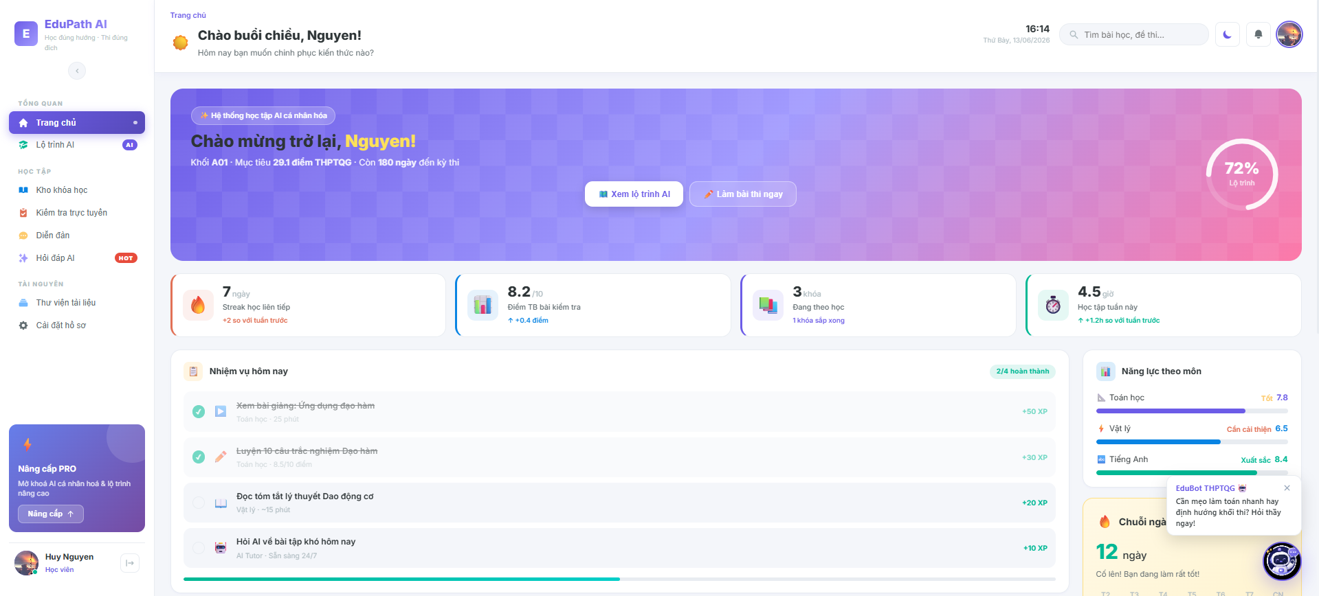

Field Name | Field Type | Description
Title | Heading | Display the primary welcome title "Chào mừng đến với EduPath AI" or platform branding slogan on the hero section.
Logo | Image/Icon | Display the system brand logo "EduPath AI" linking back to the landing page.
Nav “Trang chủ” | Link/Text | Redirection link to refresh or navigate back to the main landing page view.
Nav “Khóa học” | Link/Text | Redirection link to route users to the public course catalog workspace.
Nav “Bảng xếp hạng” | Link/Text | Redirection link to instantly focus viewport on the student leaderboard section.
Button “Đăng nhập” | Button | Action button to redirect the user to the centralized login gateway panel.
Button “Đăng ký” | Button | Action button to redirect the user to the account registration form layout.
Search Bar | Input Field | Allow guest users to input text keywords to query and search for public courses.
Button “Tìm kiếm” | Button | Trigger button to execute the text-based course search query block.
Leaderboard Title | Heading | Display the section header title "Bảng Xếp Hạng Học Viên Xuất Sắc".
Cột “Hạng” | Text | Display the dynamic chronological rank placement (1st, 2nd, 3rd...) of the top students.
Cột “Học viên” | Text | Display the public display name along with the profile avatar image of the student row.
Cột “Tổng điểm” | Text | Display the total aggregated dynamic learning points accumulated by the student profile.
Cột “Danh hiệu” | Text / Icon | Display special achievement badges, medals, or system milestones earned by the student.
Button “Xem thêm” | Button | Button to dynamically append and load more student rows onto the leaderboard grid layout.
Error Message | Text | Displays localized error messages "Không thể kết nối đến máy chủ. Vui lòng kiểm tra lại kết nối Internet" when the system fails to fetch database records.

Database Access
Table | CRUD | Description
User | R | Select public display names, roles, states, and avatar metadata of top-performing students.
LearningProgress | R | Query and aggregate lesson completion scores, quiz points, and time tracking metrics to compile leaderboard rankings.
1. Select top 10 active students with the highest cumulative scores for the leaderboard component
SELECT TOP 10
u.[DisplayName],
u.[Avatar],
SUM(lp.[TotalPoints]) AS [AggregatePoints]
FROM [dbo].[User] u
JOIN [dbo].[LearningProgress] lp ON u.[UserID] = lp.[UserID]
WHERE u.[Role] = 'Student'
AND u.[Status] = 'Active'
GROUP BY u.[UserID], u.[DisplayName], u.[Avatar]
ORDER BY [AggregatePoints] DESC;

1.2 View Course Information
Allows guests and registered users to view comprehensive public details of a selected course, including its description, syllabus structure, instructor profiles, pricing model, and student feedback ratings.
UI Design
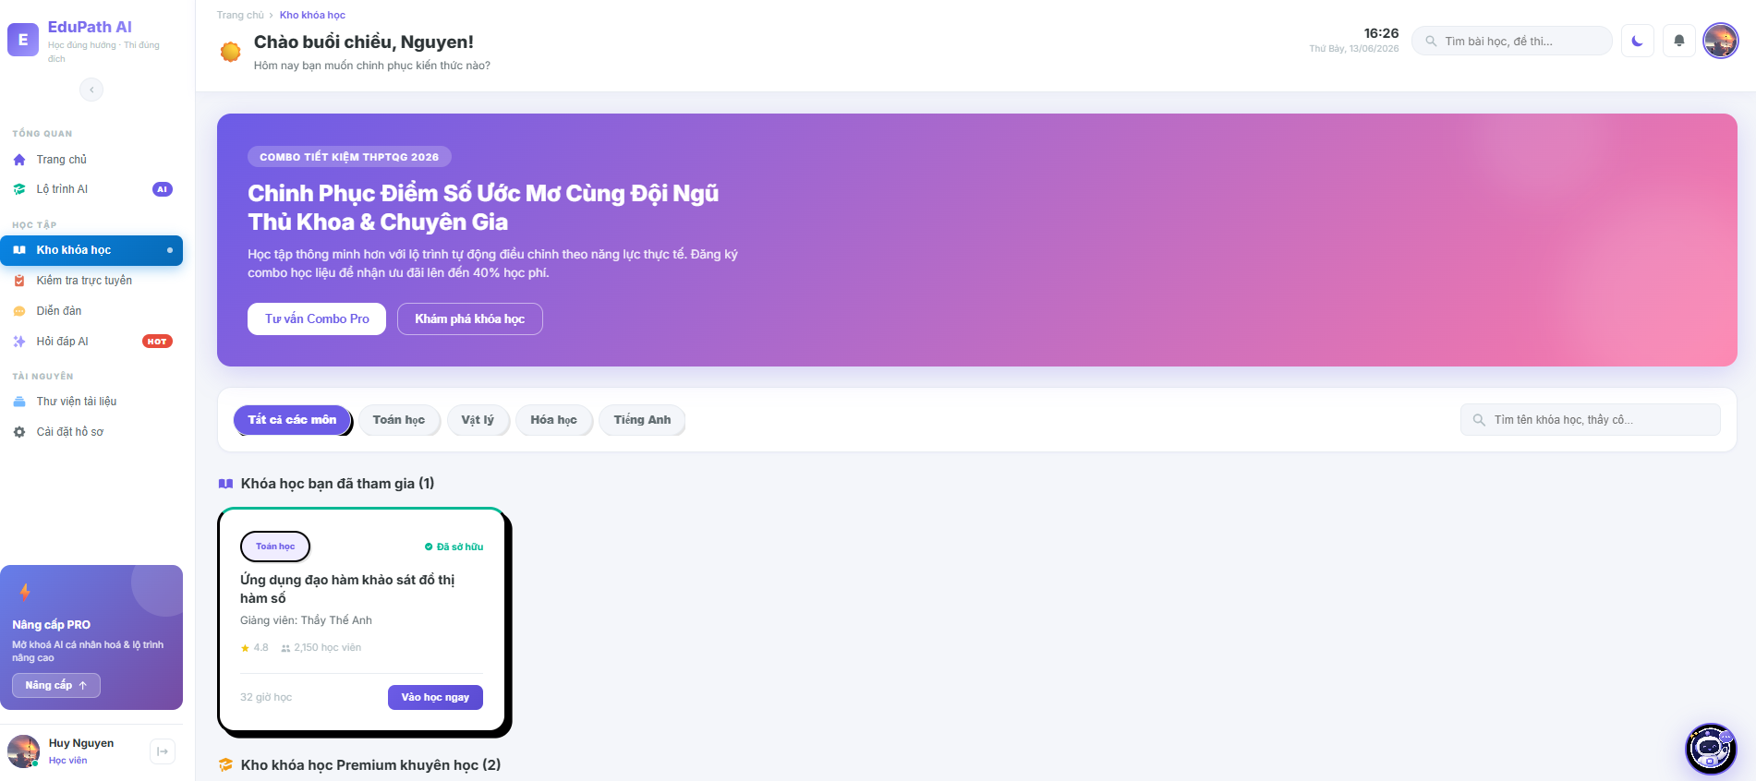

Field Name | Field Type | Description
Logo | Image/Icon | Display the system brand logo "EduPath AI" linking back to the landing page.
Navigation Bar | Layout Container | Holds navigation redirection links: "Trang chủ", "Khóa học", "Bảng xếp hạng".
Course Title | Heading | Display the full formal name of the selected course entity.
Course Cover | Image | Display the promotional graphic banner image representing the course theme.
Description | Text | Detailed paragraph detailing the target audience, learning outcomes, and requirements.
Price Tag | Text | Display the original registration cost fee of the course.
Discount Price | Text | Display the active promotional discounted price (if applicable).
Button “Mua khóa học” | Button | Action button to initialize the checkout ledger and route users to the purchase sequence page.
Instructor Name | Text/Link | Display the identity name of the teacher who authored the course, linking to their bio profile.
Syllabus Container | Accordion/List | A collapsible list layout component displaying chapters and lesson titles structured in the course.
Avg Rating | Text/Icon | Display the aggregated mathematical average calculation of student rating stars (e.g., 4.8★).
Total Reviews | Text | Numerical count of total submitted student review entries for this course node.
Error Message | Text | Displays localized error messages "Không thể kết nối đến máy chủ. Vui lòng kiểm tra lại kết nối Internet" when data access calls fail.

Database Access

Table | CRUD | Description
Course | R | Read course core fields: title, description, price, cover image, and status attributes.
User | R | Fetch teacher profile parameters (display name, avatar) linked via instructor ID keys.
Chapter | R | Query all chapter entities assigned structurally under this specific course node identity.
Review | R | Aggregate rating scores to calculate the overall public feedback metrics.
1. Select comprehensive course profile details along with teacher name, total chapters, and average review score metrics
SELECT
c.[CourseID],
c.[Title],
c.[Description],
c.[Price],
c.[CoverImage],
u.[DisplayName] AS [InstructorName],
(SELECT COUNT(*) FROM [dbo].[Chapter] ch WHERE ch.[CourseID] = c.[CourseID]) AS [TotalChapters],
ISNULL(AVG(CAST(r.[Rating] AS FLOAT)), 0) AS [AverageRating],
COUNT(r.[ReviewID]) AS [TotalReviews]
FROM [dbo].[Course] c
JOIN [dbo].[User] u ON c.[InstructorID] = u.[UserID]
LEFT JOIN [dbo].[Review] r ON c.[CourseID] = r.[CourseID]
WHERE c.[CourseID] = @TargetCourseID
AND c.[Status] = 'Published'
GROUP BY c.[CourseID], c.[Title], c.[Description], c.[Price], c.[CoverImage], u.[DisplayName];

2.Authentication
2.1 Forgot Password
Allows registered users who have forgotten their credentials to request a self-service account recovery token dispatched via secure email communications.

UI Design
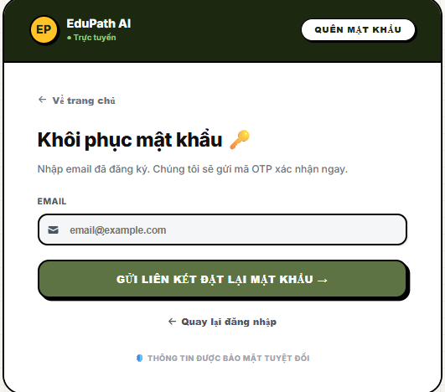

Field Name | Field Type | Description
Title | Heading | Display the subsystem layout card header text "Quên mật khẩu".
Input “Email” | Input Field | Allow user to supply their pre-registered account email target string.
Button “Gửi yêu cầu” | Button | Primary action control to validate the email format and trigger the server-side token generation routine.
Link “Quay lại đăng nhập” | Link/Text | Navigation redirect shortcut route back to the centralized login gateway panel.
Error/Success Msg | Text | Contextual inline text rendering system feedback status (e.g., "Email không tồn tại" or success notification toast).

Database Access
Table | CRUD | Description
User | R | Query verification lookup blocks to inspect if the input recovery email target exists inside active records.
PasswordResetTokens | C | Create and store a short-lived cryptographic single-use secure reset payload token mapped to the user ID.
1. Verify email existence and generate a secure, timestamped password reset token entry
SQL
-- Step 1: Verify user account node exists and is active
SELECT [UserID], [Status]
FROM [dbo].[User]
WHERE [Email] = @InputEmail AND [Status] = 'Active';

-- Step 2: Insert token lifecycle payload row into schema ledger
INSERT INTO [dbo].[PasswordResetTokens] (
[UserID],
[TokenHash],
[ExpirationTime],
[IsUsed]
)
VALUES (
@TargetUserID,
@GeneratedSecureTokenHash,
DATEADD(MINUTE, 15, GETDATE()), -- Token strictly valid for 15 minutes
0
);

2.2 Register
Allows guest users to input their credentials, satisfy system complexity rules, and register a verified account entity into the platform.
UI Design
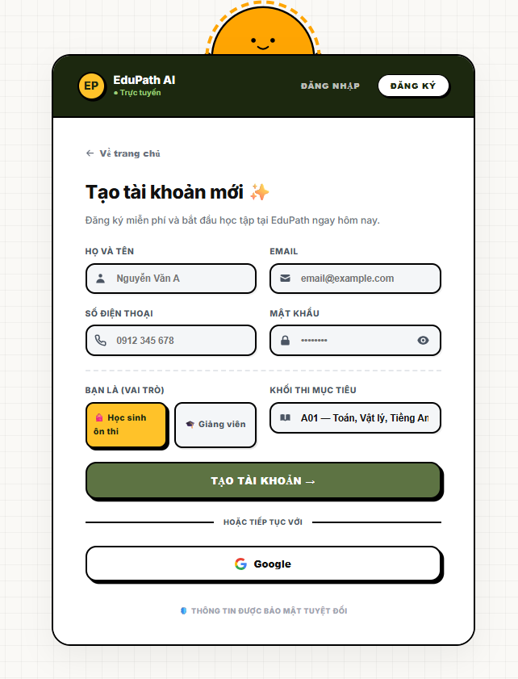
Field Name | Field Type | Description
Title | Heading | Display the section title "Đăng ký tài khoản" inside the authentication card layout.
Input “Họ và tên” | Input Field | Allow user to fill in their formal full name string parameters.
Input “Email” | Input Field | Allow user to fill in their unique email identifier string.
Input “Mật khẩu” | Input Field (Password) | Masked text field allowing users to establish their secure account password characters.
Input “Nhập lại mật khẩu” | Input Field (Password) | Masked text field to re-enter password string for client-side matching validation.
Button “Đăng ký” | Button | Primary action control to trigger client validation and dispatch user registration payload to the server layer.
Link “Đăng nhập ngay” | Link/Text | Navigation redirect shortcut route back to the centralized login gateway panel.
Error Message | Text | Displays inline or toast validation error alerts (e.g., "Email đã tồn tại", "Mật khẩu không khớp").

Database Access
Table | CRUD | Description
User | C, R | Query to verify email uniqueness (R), then insert a new active account record row into the database (C).
1. Insert a new student account record into the database during the registration event
-- Step 1: Check if email already exists
SELECT COUNT(*) FROM [dbo].[User] WHERE [Email] = @Email;
-- Step 2: Insert new user record if unique
INSERT INTO [dbo].[User] (
[DisplayName],
[Email],
[PasswordHash],
[Role],
[Status],
[CreatedAt]
)
VALUES (
@DisplayName,
@Email,
@SecurePasswordHash, -- Cryptographic hash value (e.g., BCrypt/SHA256)
'Student', -- Default role parameter
'Active', -- Default account status state
GETDATE()
);
2.3. Login
Allows registered users (Students, Teachers, and Admins) to authenticate themselves into the platform by presenting a valid email or username alongside their secure password, generating session tokens, and updating live system entry logs.
UI Design
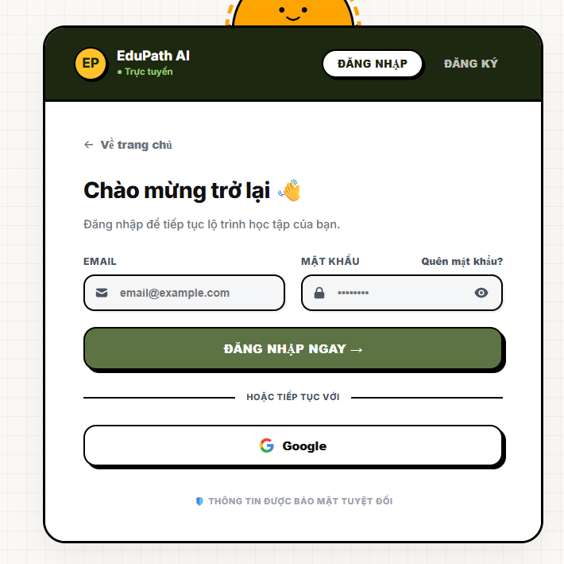

Field Name | Field Type | Description
Login Title | Heading | Displays the form layout title header text "Đăng nhập".
Input “Email / Tên đăng nhập” | Input Field (Text) | Interactive box allowing users to supply their primary email address string or unique username token.
Input “Mật khẩu” | Input Field (Password) | Masked input protecting string entry fields for secure user credentials password validation checks.
Checkbox “Ghi nhớ đăng nhập” | Checkbox | Optional checkbox component enabling persistent browser cookies token management cycles.
Link “Quên mật khẩu?” | Action Link / Text | Direct navigation link routing users to the account retrieval and token reset wizard interface (Mục Forgot Password).
Button “Đăng nhập” | Button | Primary execution trigger to initiate text constraint sanitization, hash checking, and identity handshake workflows.
Button “Đăng nhập với Google” | Button | External OAuth API trigger allowing quick identity synchronization using verified Google account tokens.
Message Box Error | Text Label | Contextual red validation label displaying rejection feedback prompts (e.g., "Tài khoản hoặc mật khẩu không chính xác" or "Tài khoản của bạn đã bị khóa").

Database Access
Table | CRUD | Description
Users | R, U | Read credentials and user roles to cross-verify password hashes (R), and update row parameter indicators like the last login timestamp (U).
SystemActivityLogs | C | Insert a fresh transactional activity line into system tracking tables to monitor account logins for network security auditing (C).
1. Query account security parameters based on email or username inputs to evaluate password validation logic
SQL
SELECT
[id] AS [UserID],
[username] AS [Username],
[email] AS [EmailAddress],
[password_hash] AS [StoredHash], -- Fetched securely to process cryptographic verification algorithms server-side
[role] AS [UserRole], -- Determines system access boundaries ('student', 'teacher', 'admin')
[status] AS [AccountStatus] -- Must check for 'active' state parameters
FROM [dbo].[Users]
WHERE ([email] = @InputCredentialOrEmail_Text OR [username] = @InputCredentialOrEmail_Text);

2. Update last login metadata metrics and log active authentication events upon successful validation
SQL
BEGIN TRANSACTION;
BEGIN TRY
-- Step 1: Update the user entity last activity clock stamp
UPDATE [dbo].[Users]
SET
[last_login_at] = GETDATE(),
[updated_at] = GETDATE()
WHERE [id] = @AuthenticatedUserID;

-- Step 2: Append audit trails logging network device metadata parameters
INSERT INTO [dbo].[SystemActivityLogs] (
[user_id],
[activity_type], -- Parameter token: 'Login_Success'
[ip_address], -- Capture user client network context
[created_at]
)
VALUES (
@AuthenticatedUserID,
'Login_Success',
@ClientIPAddress,
GETDATE()
);

COMMIT TRANSACTION;
END TRY
BEGIN CATCH
ROLLBACK TRANSACTION;
-- Dispatch diagnostic context rows to system exceptions routers
THROW;
END CATCH;

2.4 Login via Google
Executes an OAuth 2.0 single sign-on identity handshake framework utilizing Google federation services. If the synchronized email is found within the platform repository, authentication is granted immediately; if it is a new email, the subsystem dynamically invokes automated registration logic to instantiate a default student account container.
UI Design
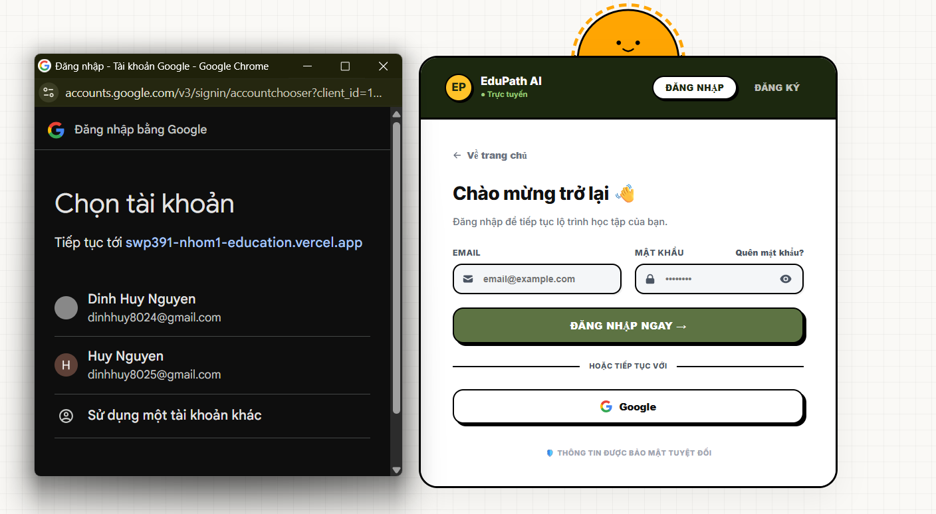
Field Name | Field Type | Description
Button “Đăng nhập với Google” | Button / API Trigger | Interactive OAuth control launching the external Google identity selection browser interface.
Redirecting Backdrop Spinner | Loading Overlay | A temporary visual modal blocking user screen interaction while server tokens are being parsed and checked.
Toast Status Banner | Snackbar Alert | Temporary layout element rendering synchronization responses (e.g., "Đăng nhập Google thành công" or "Kết nối OAuth thất bại").

Database Access
Table | CRUD | Description
Users | R, C, U | Read email records passed by Google API parameters (R); create a fresh student row container if email is missing (C); update login timestamps upon verified connection hooks (U).
SystemActivityLogs | C | Append operational logging data marking external social handshake entries for network forensic audits (C).
1. Query platform database rows to verify if the Google provider email parameter already exists
SQL
SELECT
[id] AS [UserID],
[username] AS [Username],
[email] AS [EmailAddress],
[role] AS [UserRole],
[status] AS [AccountStatus]
FROM [dbo].[Users]
WHERE [email] = @GoogleOAuthEmailAddress; -- Secure parameter decoded from verified JWT ID token passed by Google API

2. Automated registration and session initialization transaction invoked if the Google account profile does not exist
SQL
BEGIN TRANSACTION;
BEGIN TRY
-- Variable holder to trap newly materialized target key context
DECLARE @NewOAuthUserID INT;

-- Step 1: Execute look-up check constraint again within transaction boundary
IF NOT EXISTS (SELECT 1 FROM [dbo].[Users] WHERE [email] = @GoogleOAuthEmailAddress)
BEGIN
-- Step 2: Instantly create a default student role container profile
INSERT INTO [dbo].[Users] (
[username], -- Parse unique substring token derived directly from user email text prefix
[email],
[password_hash], -- Null or placeholder string asset since authentication is offloaded to Google OAuth Provider
[full_name], -- Hydrate directly using the profile name string returned by Google API payload
[avatar_url], -- Securely point row parameter to google profile hosted photo URL
[role], -- Enforce default registration class constraint parameter
[status], -- Account instantly initialized to active layout state flags
[created_at],
[last_login_at]
)
VALUES (
@AutoGeneratedUsername,
@GoogleOAuthEmailAddress,
'OAUTH_FEDERATED_GOOGLE_ACCOUNT_TOKEN',
@GoogleProfileFullName,
@GoogleProfileAvatarURL,
'student', -- Enforces initial platform accessibility bounds
'active',
GETDATE(),
GETDATE()
);

SET @NewOAuthUserID = SCOPE_IDENTITY();
END
ELSE
BEGIN
-- Step 3: If email exists unexpectedly due to rare race conditions, fetch active identity key node
SELECT @NewOAuthUserID = [id]
FROM [dbo].[Users]
WHERE [email] = @GoogleOAuthEmailAddress;

-- Update live access activity metrics clock stamps
UPDATE [dbo].[Users]
SET [last_login_at] = GETDATE()
WHERE [id] = @NewOAuthUserID;
END;

-- Step 4: Write transactional tracking metrics into security audit trail databases
INSERT INTO [dbo].[SystemActivityLogs] (
[user_id],
[activity_type], -- Mapped operational token flag: 'Google_OAuth_Login'
[ip_address], -- Track network location context rows
[created_at]
)
VALUES (
@NewOAuthUserID,
'Google_OAuth_Login',
@ClientIPAddress,
GETDATE()
);

COMMIT TRANSACTION;
END TRY
BEGIN CATCH
ROLLBACK TRANSACTION;
-- Raise exception indicators up to platform error handling API routers
THROW;
END CATCH;

2.5. Logout
Terminates the user's active system session, invalidates authentication state structures or database session tokens, writes an audit record line to log the activity event for platform security, and redirects the client viewport back to the public landing page.
UI Design


Field Name | Field Type | Description
Avatar Dropdown Trigger | Menu Link Item | Interactive navbar item containing the user's avatar image that opens the account options list.
Button “Đăng xuất” | Menu Action Button | Triggers the session termination sequence and displays the confirmation modal layout box.
Logout Modal Frame | Modal Overlay Dialog | A dark background backdrop block overlay containment window forcing emphasis onto the confirmation options.
Button “Xác nhận” | Button | Confirms session destruction, triggers backend invalidation processes, and executes a hard routing switch to the system landing page.
Button “Hủy bỏ” | Button | Dismisses the logout request sequence, hides the modal view container, and preserves the user's current working session context.

Database Access
Table | CRUD | Description
UserSessions | U, D | Update or delete active database session rows to forcefully invalidate token mapping strings (if managing server-side persistent tokens).
SystemActivityLogs | C | Append an operational log line tracking the network logout event alongside client location parameters for security compliance.
1. Update and invalidate active token entries inside server-side session tracking tables
SQL
BEGIN TRANSACTION;
BEGIN TRY
-- Soft-delete or change status flags to kill active database authentication tokens immediately
UPDATE [dbo].[UserSessions]
SET
[is_valid] = 0, -- Set boolean status parameter to false
[revoked_at] = GETDATE()
WHERE [user_id] = @CurrentUserID
AND [session_token] = @ActiveClientSessionToken; -- Matches the specific browser storage key signature passed from client

COMMIT TRANSACTION;
END TRY
BEGIN CATCH
ROLLBACK TRANSACTION;
THROW;
END CATCH;

2. Insert a fresh activity ledger row tracking the secure logout event for infrastructure audit compliance
SQL
INSERT INTO [dbo].[SystemActivityLogs] (
[user_id],
[activity_type], -- Hardcoded token flag parameter: 'Logout_Success'
[ip_address], -- Capture network infrastructure location boundaries
[created_at]
)
VALUES (
@CurrentUserID,
'Logout_Success',
@ClientIPAddress,
GETDATE()
);

3.Profile Management
3.1 Update Profile
Allows authenticated users (Students, Teachers, or Admins) to modify their personal account information, including display name, phone number, gender, date of birth, and profile biography, while validating input constraints and handling profile image upload pointers.
UI Design
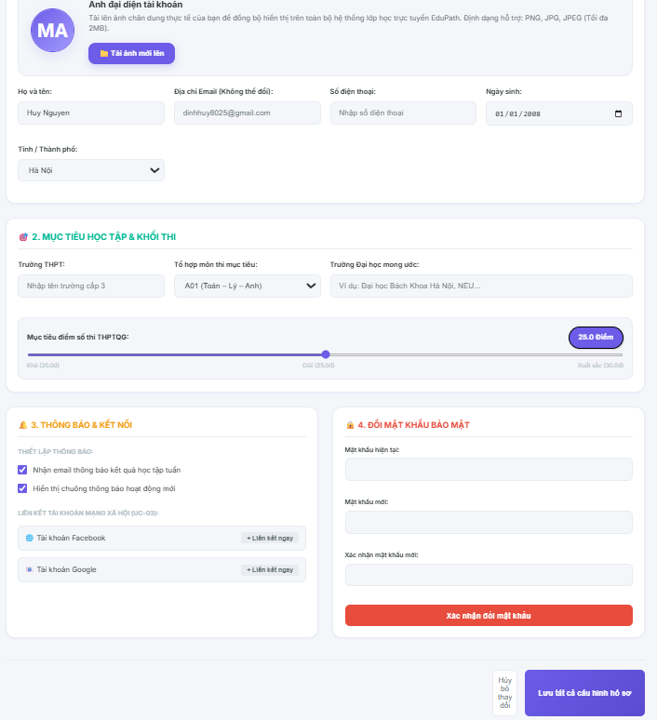

Field Name | Field Type | Description
Profile Header | Heading | Displays the contextual workspace title text "Thông tin cá nhân".
Avatar Preview Image | Image Container | Renders the active profile image thumbnail retrieved from the cloud storage bucket pointer.
Button “Thay đổi ảnh” | Button / File Uploader | Triggers the local device operating system's native file explorer dialog to select image formats (PNG, JPG).
Input “Họ và tên” | Input Field (Text) | Interactive character text area enabling users to update their formal profile display name asset.
Input “Email” | Input Field (Disabled) | Displays the user's primary registration email identifier address; locked against modification to preserve unique data integrity.
Input “Số điện thoại” | Input Field (Numeric) | Allows input of digits for phone communication records; strictly bound to regex pattern checks.
Dropdown “Giới tính” | Dropdown Select | Option selector allowing choice of predefined classification nodes (e.g., "Nam", "Nữ", "Khác").
Input “Ngày sinh” | Date Picker | Calendar date selection box mapping year-month-day structural attributes into the record profile layer.
Input “Giới thiệu bản thân” | Textarea (Multiline) | Dynamic open text area allowing teachers or students to construct a summary bio statement row.
Button “Lưu thay đổi” | Button | Primary execution trigger to initialize data validation loops and dispatch database mutation request streams.
Button “Hủy bỏ” | Button | Reversion control switch clearing memory buffer modifications and restoring the viewport to the default profile view.
Error/Success Alert | Notification Banner | Dynamic snackbar popup displaying transactional operation logs (e.g., "Cập nhật hồ sơ thành công" or "Số điện thoại không hợp lệ").

Database Access
Table | CRUD | Description
Users | R, U | Read existing account profile properties to populate input states (R), and update row column fields upon verified data submission requests (U).
SystemActivityLogs | C | Insert a fresh log record tracing the account profile update event for security compliance auditing (C).
1. Query existing profile metadata to populate the update interface workspace inputs
SQL
SELECT
[id] AS [UserID],
[username] AS [Username],
[email] AS [EmailAddress],
[full_name] AS [FullName],
[phone_number] AS [PhoneNumber],
[gender] AS [Gender],
[date_of_birth] AS [DateOfBirth],
[avatar_url] AS [AvatarURL],
[bio] AS [Biography],
[role] AS [UserRole],
[status] AS [AccountStatus]
FROM [dbo].[Users]
WHERE [id] = @CurrentUserID AND [status] = 'active'; -- Guardrail block checking for open validated user contexts

2. Update profile entity properties and write audit trails within a unified secure transaction block
SQL
BEGIN TRANSACTION;
BEGIN TRY
-- Step 1: Execute transactional update pattern on targeted user record
UPDATE [dbo].[Users]
SET
[full_name] = @InputFullName,
[phone_number] = @InputPhoneNumber,
[gender] = @InputGender,
[date_of_birth] = @InputDateOfBirth,
[avatar_url] = @InputAvatarCloudURL, -- Signed storage address path pointer passed from storage engine
[bio] = @InputBioText,
[updated_at] = GETDATE() -- Automatically stamp database transaction clock state
WHERE [id] = @CurrentUserID
AND [status] = 'active';

-- Step 2: Append audit trails logging profile modification event
INSERT INTO [dbo].[SystemActivityLogs] (
[user_id],
[activity_type], -- Parameter token: 'Update_Profile_Success'
[ip_address], -- Capture user client network context
[created_at]
)
VALUES (
@CurrentUserID,
'Update_Profile_Success',
@ClientIPAddress,
GETDATE()
);

COMMIT TRANSACTION;
END TRY
BEGIN CATCH
ROLLBACK TRANSACTION;
-- Throw error state data to backend controller application layers
THROW;
END CATCH;

3.2 Change Password

Allows authenticated users to securely update their account login credentials by verifying their active password snapshot against encrypted database records and enforcing strict complexity validation layers before committing the newly calculated password hash payload.
UI Design
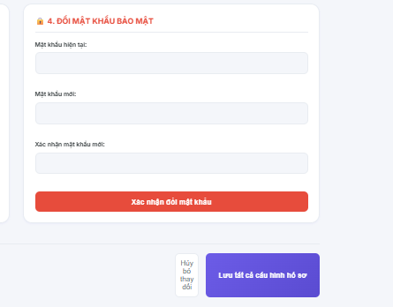
Field Name | Field Type | Description
Security Header | Heading | Displays the subsystem area container title text "Đổi mật khẩu".
Input “Mật khẩu hiện tại” | Input Field (Password) | Secure masked input component forcing entry of the user's active plaintext credential string for identity handshake checks.
Input “Mật khẩu mới” | Input Field (Password) | Secure masked input validation field bound to complexity criteria checking logic (e.g., minimum 8 characters, upper/lowercase, numbers).
Input “Xác nhận mật khẩu mới” | Input Field (Password) | Secure masked field requiring duplication of the new password string to protect users against client-side input typos.
Button “Cập nhật mật khẩu” | Button | Primary execution trigger to initialize pattern constraint validation loops and dispatch the salted password mutation request to the backend API.
Button “Hủy bỏ” | Button | Reversion control interface element to clear input field stream buffers and route viewports back to the default general summary state profile panel.
Alert Banner Container | Notification Widget | Dynamic inline card formatting operational event error strings or success responses (e.g., "Mật khẩu hiện tại không hợp lệ" or "Đổi mật khẩu thành công").

Database Access
Table | CRUD | Description
Users | R, U | Read the current encrypted hash parameters to execute server authentication validation loops (R), and rewrite the fresh salted password hash row field value (U).
SystemActivityLogs | C | Insert a structured security log row tracing the credential alteration event metadata to protect against account breach exploits (C).
1. Fetch the active account security hash string to cross-verify client token permissions
SQL
SELECT
[id] AS [UserID],
[password_hash] AS [StoredPasswordHash], -- Cryptographic hashed string asset evaluated strictly on the secure application server
[status] AS [AccountStatus]
FROM [dbo].[Users]
WHERE [id] = @CurrentUserID
AND [status] = 'active'; -- Security gate: Immediately abort transaction context loops if user node state is locked or banned

2. Commit the new salted password hash and record transaction trail events within a secure transaction block
SQL
BEGIN TRANSACTION;
BEGIN TRY
-- Step 1: Execute database record mutation on target user index row
UPDATE [dbo].[Users]
SET
[password_hash] = @NewCryptographicHash_String, -- The calculated hashed value generated securely by the server encryption engine
[updated_at] = GETDATE()
WHERE [id] = @CurrentUserID
AND [status] = 'active';

-- Step 2: Write structural infrastructure logs for security tracking audit histories
INSERT INTO [dbo].[SystemActivityLogs] (
[user_id],
[activity_type], -- Operational descriptor parameter code: 'Change_Password_Success'
[ip_address], -- Capture client browser environment connection source IP
[created_at]
)
VALUES (
@CurrentUserID,
'Change_Password_Success',
@ClientIPAddress,
GETDATE()
);

COMMIT TRANSACTION;
END TRY
BEGIN CATCH
ROLLBACK TRANSACTION;
-- Throw error indicators to application exception middleware routers
THROW;
END CATCH;

4. User Operations
4.1 Download Documents
Allows enrolled students to browse, filter, and securely download structural lecture notes, programming source codes, PDF slides, and reading materials linked to their active course modules.
UI Design
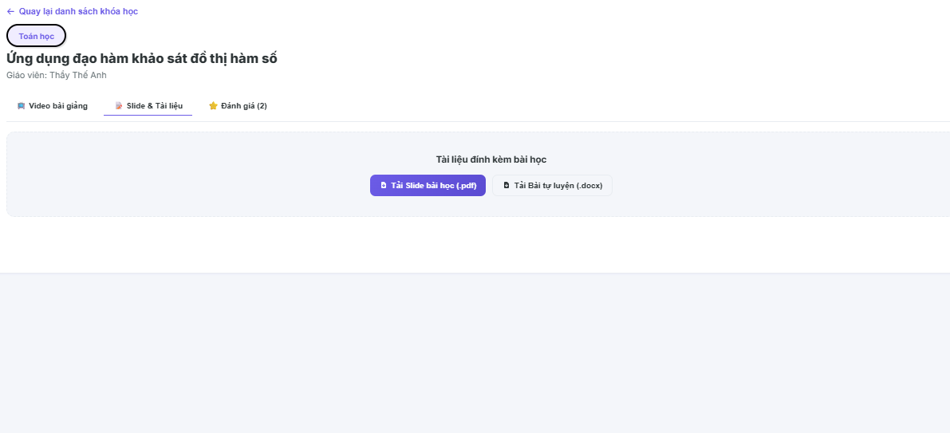

Field Name | Field Type | Description
Resource List Container | Layout Component | Grid or list layout rendering all downloadable files assigned to the active lesson node.
File Type Icon | Icon / Image | Visual representation depicting the format extensions of the file (e.g., PDF, ZIP, PPTX).
Resource Name | Text / Link | Display the user-friendly custom title label of the supplementary document.
File Size Label | Text | Display the computed memory storage size metric of the target asset file (e.g., "12.4 MB").
Button “Tải xuống” | Button / Action Icon | Interactive command control to stream the file binary stream and trigger local device download saving sequences.
Filter/Search Bar | Input Field | Optional field allowing users to quickly look up documents by typing text string keywords.
Toast Alert Message | Snackbar / Notification | Temporary banner notification displaying fetch states or errors (e.g., "Tải tệp thành công" or "Tệp tin không tồn tại").

Database Access
Table | CRUD | Description
ResourceAttachments | R | Fetch downloadable file paths, names, types, and sizing attributes connected to the target lesson.
CourseEnrollments | R | Cross-verify if the user possesses a validated, active subscription or purchase history before unlocking download nodes.
DocumentDownloadLogs | C | Optional auditing behavior to insert runtime transactional log rows mapping which user downloaded which specific asset node.
1. Fetch the absolute cloud download paths and metadata parameters for all attachments under a lesson, verified by student enrollment
SQL
SELECT
ra.[AttachmentID],
ra.[FileName],
ra ra.[FilePath], -- Cloud storage pointer (e.g., AWS S3 secure signed URL or Cloudinary path)
ra.[FileType], -- Format marker: 'pdf', 'zip', 'docx'
ra ra.[FileSize], -- Formatted string metric (e.g., '4.2 MB')
ra.[CreatedAt]
FROM [dbo].[ResourceAttachments] ra
JOIN [dbo].[Lesson] l ON ra.[LessonID] = l.[LessonID]
JOIN [dbo].[Chapter] ch ON l.[ChapterID] = ch.[ChapterID]
WHERE ra.[LessonID] = @TargetLessonID
-- Strict guardrail: Ensure user has a valid active enrollment row for this course
AND EXISTS (
SELECT 1
FROM [dbo].[CourseEnrollments] ce
WHERE ce.[CourseID] = ch.[CourseID]
AND ce.[UserID] = @CurrentUserID
AND ce.[Status] = 'Active'
);

2. Audit log creation event tracking user download transactions for security and metrics analysis
SQL
-- Assuming a logging index table exists in your design schema layout
INSERT INTO [dbo].[DocumentDownloadLogs] (
[UserID],
[AttachmentID],
[IPAddress],
[DownloadedAt]
)
VALUES (
@CurrentUserID,
@TargetAttachmentID,
@ClientIPAddress, -- Client-side network context state parameter
GETDATE()
);

4.2 View Notifications

Allows authenticated users to access a centralized notification feed, filter messages based on readout states or contextual categories (such as System updates or Course announcements), and trigger mutations to update communication tracking flags.
UI Design
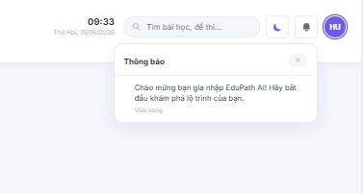
Field Name | Field Type | Description
Notification Header | Heading | Displays the module workspace view title text "Thông báo của tôi".
Filter Tabs Layout | Tab Selector | Switch components dividing layout data streams based on read status parameters (e.g., "Tất cả", "Chưa đọc").
Button “Đánh dấu đã đọc tất cả” | Button | Action trigger dispatching a massive bulk database update request to clean all active unread flags.
Notification Row Feed | Container / Row List | Chronological vertical directory directory frame embedding individual notification card elements.
Category Icon | Visual Icon | Graphical marker mapping notification source classification schemas (e.g., Book icon for courses, Gear icon for system alerts).
Notification Title Text | Text Label | Renders the primary formal heading string of the transmitted message row.
Notification Description | Text Label | Summary body paragraph containing the core localized message details dispatched to the user.
Timestamp Stamp | Text | Displays relative computed chronological elapsed clock indicators (e.g., "5 phút trước" or "12/06/2026").
Unread State Token | Status Indicator Badge | Visual colored circular badge signifying unread database records; instantly hidden upon click interactions.

Database Access
Table | CRUD | Description
Notifications | R | Read structural master messages data layout parameters, global categories, and base text payloads.
UserNotifications | R, U | Query user-specific transmission links and target read milestones (R); update read states from unread to completed status rows (U).
1. Query the chronological list of personalized and system-wide notifications for the active user session
SQL
SELECT
n.[id] AS [NotificationID],
n.[title] AS [NotificationTitle],
n.[content] AS [NotificationBody],
n.[category] AS [NotificationCategory], -- Schemes: 'System', 'Course_Update', 'Exam_Grade'
un.[is_read] AS [IsReadStatus],
n.[created_at] AS [SentTimestamp]
FROM [dbo].[UserNotifications] un
JOIN [dbo].[Notifications] n ON un.[notification_id] = n.[id]
WHERE un.[user_id] = @CurrentUserID
ORDER BY
un.[is_read] ASC, -- Prioritizes urgent unread alerts at the top of the viewport
n.[created_at] DESC; -- Displays the freshest communication data rows chronologically

2. Mutate state flags to toggle an individual unread notification card into a verified read row status
SQL
UPDATE [dbo].[UserNotifications]
SET
[is_read] = 1,
[read_at] = GETDATE()
WHERE [user_id] = @CurrentUserID
AND [notification_id] = @TargetNotificationID
AND [is_read] = 0; -- Operational guardrail: Prevents redundant executions if row is already mutated

3. Bulk update all active user communication rows to mark the complete ledger as read
SQL
UPDATE [dbo].[UserNotifications]
SET
[is_read] = 1,
[read_at] = GETDATE()
WHERE [user_id] = @CurrentUserID
AND [is_read] = 0; -- Safe bulk operation clearing buffer loops for clean client rende

5. Learning
5.1 Watch Lecture Videos
Provides an interactive multi-format video streaming interface for authenticated students to play course lessons, control playback adjustments, view hierarchical adjacent syllabus structures, and dynamically log time-based completion markers into the progress repository.

UI Design
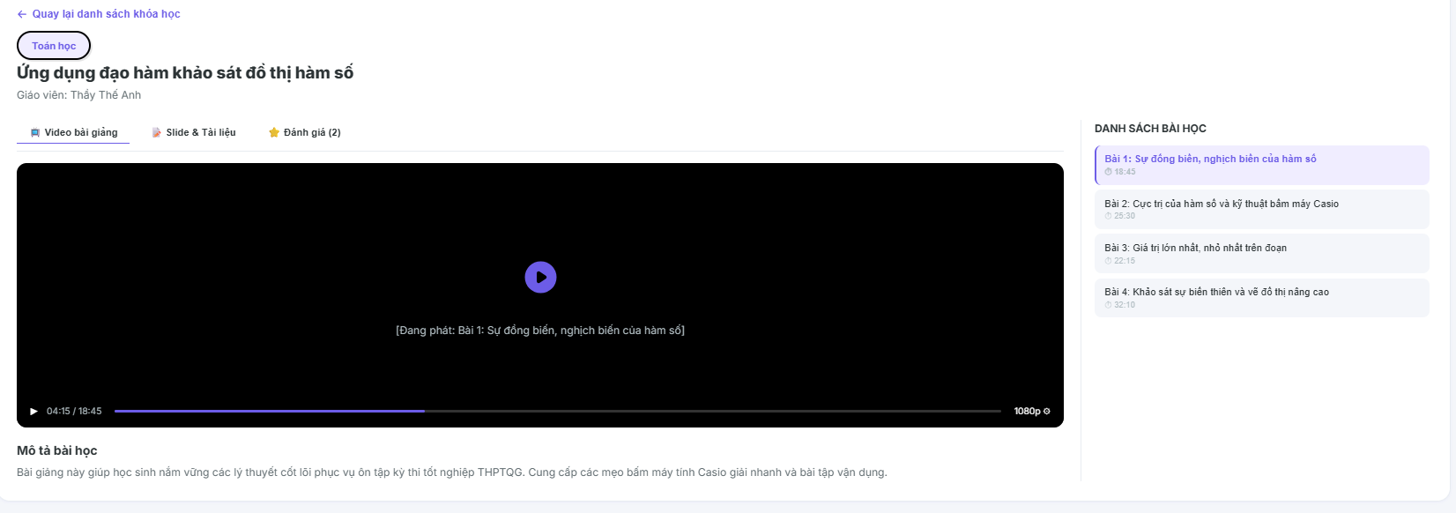
Field Name | Field Type | Description
Course Title Banner | Heading Text | Displays the formal global name layout of the active course context container.
Video Player Canvas | Media Player Component | Core responsive container hosting the encrypted lecture video streaming pipeline layer.
Play/Pause Control | Toggle Button | Standard control element to instantly suspend or resume the lecture video stream state.
Timeline Progress Scrubber | Input Range / Slider | Interactive timeline tracking current progress duration and allowing navigation across available timestamps.
Volume Control Scrubber | Slider Bar | Adjusts the audio gain amplitude configuration properties belonging to the browser video context.
Fullscreen Toggle | Interface Action Button | Expands or collapses the media display frame bounding layout parameters to match screen bounds.
Syllabus Sidebar Menu | Layout Container Panel | Right-hand side vertical panel mapping available knowledge chapters and chronological lessons.
Lesson Row Card Item | Clickable Link Element | Represents an individual lesson node; click triggers a content reload for the player layout.
Completion Check Icon | Graphical Badge | Green visual indicator ring appearing next to the lesson title row signifying a completed database status.
Button “Bài học trước” | Button Navigation Control | Moves the media player viewport back to the previous chronological lesson row index.
Button “Bài học tiếp theo” | Button Navigation Control | Slides the media player viewport forward to the next sequential lesson row index inside the database tree.

Database Access
Table | CRUD | Description
Course | R | Read structural identity details and metadata to construct top header location titles.
Chapter | R | Look up chronological structural chapter layers belonging to the active course hierarchy map.
Lesson | R | Retrieve specific lecture stream properties, title names, file attachments, and video media location URL paths.
LearningProgress | R, C, U | Query active user learning state markers (R); insert initialization row flags upon entrance (C); update verified completion bits when viewing targets are accomplished (U).
1. Query comprehensive lesson streaming properties and structural course syllabus outlines for sidebar compilation
SQL
-- Step 1: Fetch active targeted lesson streaming details
SELECT
l.[id] AS [LessonID],
l.[chapter_id] AS [ChapterID],
l.[title] AS [LessonTitle],
l.[video_url] AS [VideoCloudStreamingURL], -- Direct path pointer to cloud storage bucket deployment
l.[duration_seconds] AS [TotalDuration],
l.[sort_order] AS [ChronologicalIndex]
FROM [dbo].[Lesson] l
WHERE l.[id] = @TargetLessonID;

-- Step 2: Fetch full companion structure hierarchy to populate the side navigation deck layout
SELECT
ch.[id] AS [ChapterID],
ch.[title] AS [ChapterTitle],
l.[id] AS [SyllabusLessonID],
l.[title] AS [SyllabusLessonTitle],
l.[sort_order] AS [LessonOrder],
ISNULL(lp.[is_completed], 0) AS [HasCompletedFlag]
FROM [dbo].[Chapter] ch
JOIN [dbo].[Lesson] l ON ch.[id] = l.[chapter_id]
LEFT JOIN [dbo].[LearningProgress] lp ON l.[id] = lp.[lesson_id] AND lp.[user_id] = @CurrentUserID
WHERE ch.[course_id] = @CurrentCourseID
ORDER BY ch.[sort_order] ASC, l.[sort_order] ASC;

2. Synchronize progress milestone adjustments and commit lesson completion states into the ledger logs
SQL
IF EXISTS (
SELECT 1 FROM [dbo].[LearningProgress]
WHERE [user_id] = @CurrentUserID AND [lesson_id] = @TargetLessonID
)
BEGIN
-- Update existing tracking record to finalize lesson milestone parameters
UPDATE [dbo].[LearningProgress]
SET
[is_completed] = 1,
[completed_at] = GETDATE(),
[updated_at] = GETDATE()
WHERE [user_id] = @CurrentUserID AND [lesson_id] = @TargetLessonID AND [is_completed] = 0;
END
ELSE
BEGIN
-- Insert fresh lesson completion row container if user triggers milestone threshold on entrance
INSERT INTO [dbo].[LearningProgress] (
[user_id],
[lesson_id],
[is_completed],
[started_at],
[completed_at],
[updated_at]
)
VALUES (
@CurrentUserID,
@TargetLessonID,
1, -- Sets completion state logic parameter to true
GETDATE(),
GETDATE(),
GETDATE()
);
END;

5.2 View AI Analysis Results
Allows authenticated students to visualize their personalized multi-dimensional competency metrics computed by the machine learning layer, inspect interactive skill mastery charts (Radar chart layout), and evaluate data-driven strength and weakness indicators.
UI Design
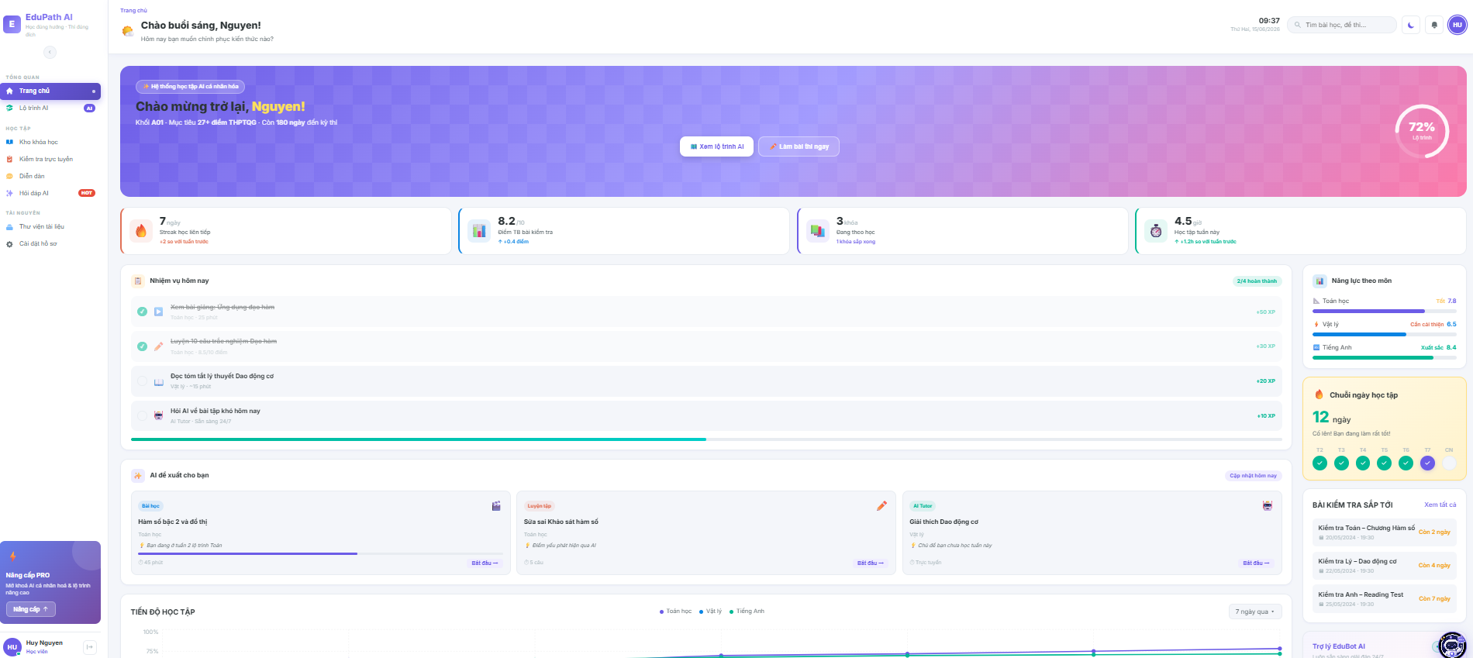
Field Name | Field Type | Description
Workspace Title | Heading | Displays the descriptive module master text "Phân tích năng lực học tập bằng AI".
Competency Radar Chart | Graphical Widget Component | Interactive multidimensional spider/radar vector framework visualizing current proficiency across domain categories (e.g., Syntax, Logic, Databases).
Topic Progress Row List | Container / Grid List | Vertical block rendering individual subject skill coverage bars.
Skill Percentage Bar | Progress Bar Data Frame | Horizontal color-coded percentage bar indicating the mathematical mastery calculation score per category row (e.g., 75%).
Strength Badge | Status Tag Indicator | Green visual chip identifier grouping high-performance knowledge domains designated as "Điểm mạnh".
Weakness Badge | Status Tag Indicator | Red visual chip identifier grouping core capability deficit domains designated as "Điểm yếu".
AI Diagnostic Narrative Panel | Text Area Card | Layout block loading the dynamic contextual text commentary written by the machine learning agent to address the student's learning gaps.
Button “Xem lộ trình gợi ý” | Button | Contextual navigation action control driving the user immediately to the personalized adaptive path layout configuration window (UC52).

Database Access
Table | CRUD | Description
SkillProficiency | R | Query calculated competency score ratios mapped to the active student ID to populate interactive radar points and completion bars.
AIGeneratedFeedback | R | Read aggregated textual narrative diagnostics evaluated by the platform's background machine learning core pipeline.
ExamAttempts | R | Look up recent structured testing scores to evaluate capability vectors chronologically.
1. Query multi-dimensional skill proficiency indices to map coordinates for the interactive radar graph layout
SQL
SELECT
sp.[topic_name] AS [KnowledgeDomain],
sp.[proficiency_score] AS [MasteryPercentage], -- Floating decimal from 0.00 to 100.00 mapping ability lines
sp.[last_evaluated_at] AS [EvaluationDate],
-- Compute status classifications natively to match UI chip rules
CASE
WHEN sp.[proficiency_score] >= 75.00 THEN 'Strength'
WHEN sp.[proficiency_score] < 50.00 THEN 'Weakness'
ELSE 'Neutral'
END AS [CompetencyClassificationToken]
FROM [dbo].[SkillProficiency] sp
WHERE sp.[user_id] = @CurrentUserID
ORDER BY sp.[proficiency_score] DESC; -- Drives user strengths to the upper grid display rows

2. Fetch the freshes AI global analytical diagnostics narrative tailored for the active student dashboard container
SQL
SELECT TOP 1
af.[id] AS [FeedbackID],
af.[feedback_text] AS [AIDiagnosticSummary], -- Contains the localized gap-filling instruction paragraphs
af.[model_version] AS [AIPipelineEngine], -- Tracks deployment iterations (e.g., 'LMS-Adaptive-v4')
af.[generated_at] AS [Timestamp]
FROM [dbo].[AIGeneratedFeedback] af
WHERE af.[user_id] = @CurrentUserID
AND af.[feedback_type] = 'Global_Dashboard_Diagnostic' -- Isolates structural generic reports from specific quiz feedback rows
ORDER BY af.[generated_at] DESC; -- Assures the client workspace loads the absolute latest

5.3 View Learning Materials
Allows authenticated students to access, read, and view supplementary non-video learning assets (such as encrypted PDF textbooks, presentation slides, or markdown lecture notes) embedded directly within a specific lesson node while updating real-time read progress markers.
UI Design
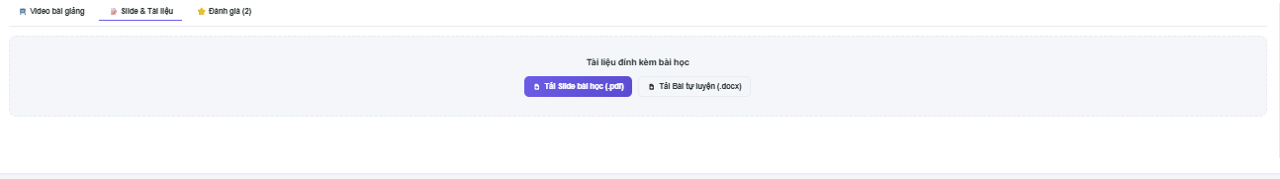
Field Name | Field Type | Description
Document Title | Heading Text | Displays the formal descriptive title of the active reading material entity.
Embedded PDF/Doc Viewer | Layout Canvas Component | An integrated document previewer wrapper rendering slide/PDF binary data streams safely on the client container.
Zoom In / Out Controls | Toolbar Button Group | Control buttons allowing users to expand or shrink the text scaling layout bounds inside the viewer canvas.
Paging Controller | Paging Text / Input | Displays active document page indices (e.g., "Trang 3 / 15") enabling fast jumping rows.
Button “Tải tài liệu” | Button / Action Trigger | Interactive download command control routing the student request handshake to the storage download core (UC10).
Syllabus Sidebar Menu | Layout Container Panel | Right-hand side vertical panel mapping available knowledge chapters and reading lessons across the active course.
Button “Bài trước” | Button Navigation Control | Moves the viewport back to the previous chronological material node inside the course syllabus tree.
Button “Bài tiếp theo” | Button Navigation Control | Slides the viewport forward to the next sequential learning item row inside the repository framework.

Database Access
Table | CRUD | Description
Lesson | R | Read base item descriptors, sorting orders, and course category mappings to frame the workspace headers.
LearningMaterials | R | Query explicit document file paths, storage pointers, and data payload contents attached underneath the active lesson identifier.
LearningProgress | R, C, U | Evaluate client interaction records (R); instantiate entry tracking codes (C); write completed milestone timestamps once the reading criteria are satisfied (U).
1. Query specific document metadata parameters and payload file pointers to construct the embedded viewer window
SQL
SELECT
l.[id] AS [LessonID],
l.[title] AS [MaterialTitle],
lm.[id] AS [MaterialID],
lm.[file_url] AS [CloudStorageFilePath], -- Direct path pointer to secure document storage buckets (PDF/Slide)
lm.[file_type] AS [DocumentTypeToken], -- Identification strings: 'PDF', 'Markdown', 'PPTX'
lm.[file_size_kb] AS [PayloadSize],
l.[sort_order] AS [ChronologicalIndex]
FROM [dbo].[Lesson] l
JOIN [dbo].[LearningMaterials] lm ON l.[id] = lm.[lesson_id]
WHERE l.[id] = @TargetLessonID
AND l.[content_type] = 'document'; -- Restricts the database look-up context loop exclusively to reading items

2. Insert or update the material completion status flag once the student completes reading the target layout node
SQL
BEGIN TRANSACTION;
BEGIN TRY
-- Check if a tracking row already maps the active user and target document lesson node
IF EXISTS (
SELECT 1 FROM [dbo].[LearningProgress]
WHERE [user_id] = @CurrentUserID AND [lesson_id] = @TargetLessonID
)
BEGIN
-- Update the completion bit and log execution timestamp parameters
UPDATE [dbo].[LearningProgress]
SET
[is_completed] = 1,
[completed_at] = GETDATE(),
[updated_at] = GETDATE()
WHERE [user_id] = @CurrentUserID
AND [lesson_id] = @TargetLessonID
AND [is_completed] = 0; -- Operational gate: Prevents redundant update transactions
END
ELSE
BEGIN
-- Initialize a fresh learning history entry log directly set to completed status
INSERT INTO [dbo].[LearningProgress] (
[user_id],
[lesson_id],
[is_completed],
[started_at],
[completed_at],
[updated_at]
)
VALUES (
@CurrentUserID,
@TargetLessonID,
1, -- Sets structural verification parameter to true
GETDATE(),
GETDATE(),
GETDATE()
);
END;

COMMIT TRANSACTION;
END TRY
BEGIN CATCH
ROLLBACK TRANSACTION;
-- Throw transaction error metrics up to the backend gateway routing middleware
THROW;
END CATCH;

6.Course Interaction
6.1 Rate Course
Allows authenticated students who have successfully enrolled in a course to submit a star-based rating score (1 to 5 stars) alongside a textual review description, handle input validation constraints, and view aggregated companion feedback logs.
UI Design
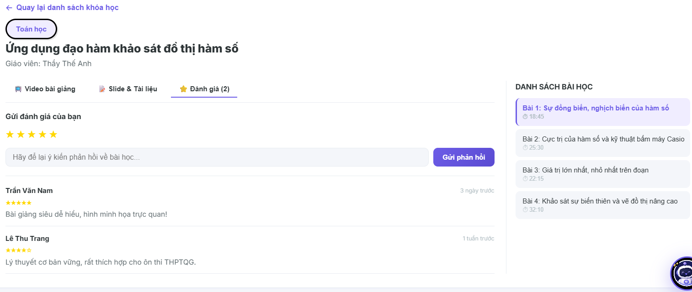
Field Name | Field Type | Description
Section Title | Heading Text | Displays the interface area title text (e.g., "Đánh giá khóa học").
Aggregate Rating Score | Visual Component | Renders the overall summary rating point and calculated average bars of the active course template.
Interactive Star Picker | Selection Control (Stars) | A set of 5 dynamic star icons tracking cursor hovering triggers to capture point parameters from 1.0 to 5.0.
Input “Nhận xét của bạn” | Textarea (Multiline) | Rich multi-line text input field enabling learners to detail their descriptive feedback commentary.
Button “Gửi đánh giá” | Button | Primary execution trigger initializing length checks and packing payload records to dispatch database mutation transactions.
Button “Hủy bỏ” | Button | Resets the interaction input buffer stream data and hides the active editing layout dialog card.
Validation Message Row | Label Text | Dynamic contextual warning string displaying client entry error codes (e.g., "Vui lòng chọn số sao đánh giá trước khi gửi").
Peer Reviews Ledger Feed | Container / Row List | A nested vertical compilation layout parsing certified non-hidden historical student comments chronologically.

Database Access
Table | CRUD | Description
Course | R | Read structural baseline course title names and refresh denormalized total average grade counters.
CourseEnrollments | R | Audit look-up check blocks to guarantee that only validated paying or registered active accounts can invoke rating events.
CourseReviews | C, R, U | Fetch historical feedback listings mapped underneath the course identity (R); insert a new review record (C); update old entries if an update request occurs (U).
1. Query baseline permissions to ensure the active student is certified to execute a rating action
SQL
SELECT
c.[id] AS [CourseID],
c.[title] AS [CourseTitle],
ce.[status] AS [EnrollmentStatus] -- Checks for 'active' row parameters
FROM [dbo].[Course] c
JOIN [dbo].[CourseEnrollments] ce ON c.[id] = ce.[course_id]
WHERE c.[id] = @TargetCourseID
AND ce.[user_id] = @CurrentUserID; -- Business Rule gate: If rows return empty, block client interface triggers immediately

2. Insert or update the student rating score metrics utilizing a secure transactional block
SQL
BEGIN TRANSACTION;
BEGIN TRY
-- Check if a rating data line already maps the active user and target course node
IF EXISTS (
SELECT 1 FROM [dbo].[CourseReviews]
WHERE [course_id] = @TargetCourseID AND [user_id] = @CurrentUserID
)
BEGIN
-- Execute a mutation update operation to overwrite old score inputs
UPDATE [dbo].[CourseReviews]
SET
[rating_score] = @InputRatingStars, -- Numeric int parameter between 1 and 5
[comment_text] = @InputCommentText,
[updated_at] = GETDATE()
WHERE [course_id] = @TargetCourseID
AND [user_id] = @CurrentUserID;
END
ELSE
BEGIN
-- Insert a completely fresh course feedback record row
INSERT INTO [dbo].[CourseReviews] (
[course_id],
[user_id],
[rating_score],
[comment_text],
[is_hidden], -- Initial visibility parameter set default to 0 (false)
[created_at],
[updated_at]
)
VALUES (
@TargetCourseID,
@CurrentUserID,
@InputRatingStars,
@InputCommentText,
0, -- Accessible to the platform context immediately
GETDATE(),
GETDATE()
);
END;

COMMIT TRANSACTION;
END TRY
BEGIN CATCH
ROLLBACK TRANSACTION;
-- Escalate execution runtime errors to application API router layers
THROW;
END CATCH;

3. Fetch the complete peer commentary history block to populate the timeline layout grid
SQL
SELECT
cr.[id] AS [ReviewID],
u.[full_name] AS [StudentName],
u.[avatar_url] AS [StudentAvatar],
cr.[rating_score] AS [StarsAwarded],
cr.[comment_text] AS [FeedbackBody],
cr.[created_at] AS [SubmissionDate]
FROM [dbo].[CourseReviews] cr
JOIN [dbo].[Users] u ON cr.[user_id] = u.[id]
WHERE cr.[course_id] = @TargetCourseID
AND cr.[is_hidden] = 0 -- Content Moderation Gate: Hides blocked or inappropriate entries from view
ORDER BY cr.[created_at] DESC; -- Delivers the freshest student remarks to the top of the i

7. Examination
7.1 Take Test
Allows authenticated students to sit for synchronized, time-restricted multiple-choice quizzes or exams, rendering questions dynamically, tracking selected options in real-time, displaying a ticking countdown timer, and triggering automated submission protocols upon session expiration.
UI Design
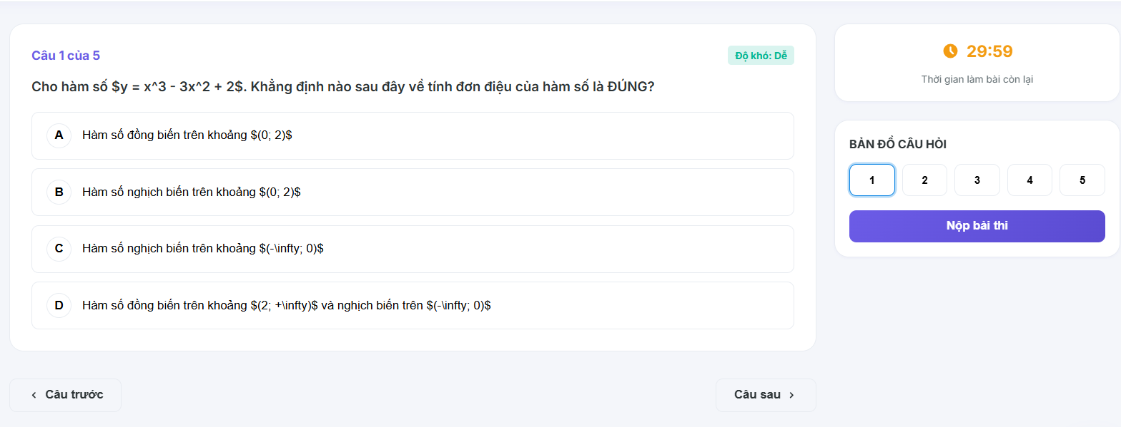
Field Name | Field Type | Description
Quiz Title | Heading | Displays the descriptive formal name of the active exam/quiz node layout.
Countdown Timer | Clock Component | Dynamic real-time ticking clock showing remaining time left (MM:SS) before session invalidation.
Question Text | Text | Renders the localized string content of the current active question entity.
Option Radio Group | Selection Control (Radio) | Container holding distinct answer choice markers, allowing only one active selection per question block.
Question Navigator Panel | Grid / Button List | A matrix panel layout of question numbers allowing students to quickly hop between test nodes.
Attempt Progress Indicator | Text | Label detailing completion status context (e.g., "Câu hỏi 1 / 10").
Button “Câu trước” | Button | Navigation control to slide the questionnaire viewport back to the previous question index.
Button “Câu tiếp theo” | Button | Navigation control to slide the questionnaire viewport forward to the next sequential question index.
Button “Nộp bài” | Button | Prominent action trigger to invoke confirmation prompts, stop timers, and calculate grading sequences.

Database Access
Table | CRUD | Description
Quizzes | R | Read quiz parameters, constraint boundaries, and authorized time limit durations.
Questions | R | Query the text items assigned underneath the active targeted quiz node identity.
QuestionOptions | R | Fetch the multiple-choice option variations belonging to the active rendered question.
ExamAttempts | C, U | Create a fresh attempt log token upon entrance (C), and update final scoring points upon submission (U).
StudentAnswers | C, U | Insert or update the real-time choice selection rows mapped per question block during execution.
1. Fetch all questions and mapped answer choices for a selected quiz layout
SQL
SELECT
q.[id] AS [QuestionID],
q.[question_text] AS [QuestionText],
q.[points_value] AS [PointsValue],
qo.[id] AS [OptionID],
qo.[option_text] AS [OptionText]
FROM [dbo].[Questions] q
JOIN [dbo].[QuestionOptions] qo ON q.[id] = qo.[question_id]
WHERE q.[quiz_id] = @TargetQuizID
ORDER BY q.[sort_order] ASC, qo.[id] ASC;

2. Initialize a fresh exam attempt row entry when the student launches the test window
SQL
INSERT INTO [dbo].[ExamAttempts] (
[user_id],
[quiz_id],
[score],
[status], -- Initial execution state: 'In_Progress'
[started_at],
[completed_at]
)
VALUES (
@CurrentUserID,
@TargetQuizID,
0.0, -- Instantiated baseline score parameter
'In_Progress',
GETDATE(),
NULL -- Session remains active until submission event
);

-- Secure the dynamic Attempt identity token key
DECLARE @CurrentAttemptID INT = SCOPE_IDENTITY();

3. Save or change user selected answer option states during the active exam session
SQL
-- Check if user already logged an answer node for this specific question row
IF EXISTS (
SELECT 1 FROM [dbo].[StudentAnswers]
WHERE [attempt_id] = @CurrentAttemptID AND [question_id] = @TargetQuestionID
)
BEGIN
-- Update choice modification
UPDATE [dbo].[StudentAnswers]
SET
[selected_option_id] = @ChosenOptionID,
[updated_at] = GETDATE()
WHERE [attempt_id] = @CurrentAttemptID AND [question_id] = @TargetQuestionID;
END
ELSE
BEGIN
-- Record fresh response parameter layout
INSERT INTO [dbo].[StudentAnswers] (
[attempt_id],
[question_id],
[selected_option_id],
[created_at],
[updated_at]
)
VALUES (
@CurrentAttemptID,
@TargetQuestionID,
@ChosenOptionID,
GETDATE(),
GETDATE()
);
END;
7.2 View Detailed Answers
Allows authenticated students to perform a post-exam audit, inspecting every single question node side-by-side with their selected response logs, right/wrong color indicators, and the certified database correct answer keys along with detailed solutions.
UI Design
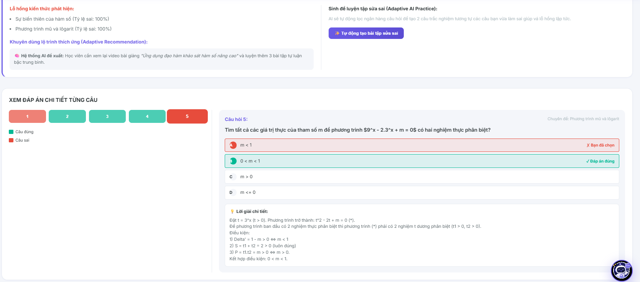
Field Name | Field Type | Description
Quiz Title Header | Heading | Displays the structural formal name of the reviewed quiz/exam entity.
Score Visual Summary | Layout Card Component | Container box rendering the final points achieved (e.g., "8.0 / 10") and completion parameters.
Evaluation Status Tag | Status Tag Badge | Highlights overall attempt result (e.g., Green "Đạt" or Red "Chưa Đạt") based on passing thresholds.
Question Audit Grid | Container / Row List | Chronological directory block rendering each test question item for granular review.
Question Body Text | Text | Displays the original localized query text string fetched from the core repository.
Student Selection Token | Text / Badge Marker | Marks the option selected by the user during the active exam window (Colored red if incorrect, green if correct).
True Database Key Marker | Visual Highlight Box | Graphically highlights the absolute certified correct answer option defined by the instructor.
Solution Explanation Block | Text View / Panel | Displays a deep-dive technical explanation text detailing why the certified key is correct.
Button “Quay lại bài học” | Button | Redirection navigation control driving the user's viewport back to the active playlist view (UC12).
Button “Lịch sử kiểm tra” | Button | Routes the student back to the complete historical list of completed test nodes (UC18).

Database Access
Table | CRUD | Description
ExamAttempts | R | Read final aggregated scores, execution duration parameters, and completion milestones.
StudentAnswers | R | Query stored granular option identifiers selected by the user to populate individual question markups.
Questions | R | Fetch original text contents and companion explanation strings bound to the quiz layout framework.
QuestionOptions | R | Evaluate value records to display choice text variations and verify structural correct bits.
1. Query calculated performance summaries for the targeted exam attempt
SQL
SELECT
ea.[id] AS [AttemptID],
ea.[score] AS [FinalScore],
ea.[started_at] AS [StartTime],
ea.[completed_at] AS [EndTime],
DATEDIFF(MINUTE, ea.[started_at], ea.[completed_at]) AS [MinutesElapsed],
q.[title] AS [QuizName],
q.[passing_score] AS [RequiredScore]
FROM [dbo].[ExamAttempts] ea
JOIN [dbo].[Quizzes] q ON ea.[quiz_id] = q.[id]
WHERE ea.[id] = @TargetAttemptID
AND ea.[user_id] = @CurrentUserID;

2. Fetch the detailed question-by-question review log, mapping user selections directly against true answer keys and text explanations
SQL
SELECT
q.[id] AS [QuestionID],
q.[question_text] AS [QuestionBody],
q.[explanation] AS [DetailedSolutionText], -- Contains step-by-step resolution logic written by teachers or generated by AI
sa.[selected_option_id] AS [StudentChosenOptionID],
qo_student.[option_text] AS [StudentChosenText],
qo_correct.[id] AS [ServerCorrectOptionID],
qo_correct.[option_text] AS [ServerCorrectText],
-- Compute binary state parameters dynamically for front-end styling tokens
CASE WHEN sa.[selected_option_id] = qo_correct.[id] THEN 1 ELSE 0 END AS [IsChoiceCorrect]
FROM [dbo].[Questions] q
JOIN [dbo].[StudentAnswers] sa ON q.[id] = sa.[question_id]
LEFT JOIN [dbo].[QuestionOptions] qo_student ON sa.[selected_option_id] = qo_student.[id]
JOIN [dbo].[QuestionOptions] qo_correct ON q.[id] = qo_correct.[question_id] AND qo_correct.[is_correct] = 1
WHERE sa.[attempt_id] = @TargetAttemptID
ORDER BY q.[sort_order] ASC; -- Guarantees chronological visual consistency matching the tes
7.3 View Test History
Allows authenticated students to view a comprehensive chronological log of all their completed quizzes and exams, inspect aggregated performance metrics (such as scores achieved, time spent, and passing status), and select a specific attempt record to navigate to the detailed review workspace.
UI Design
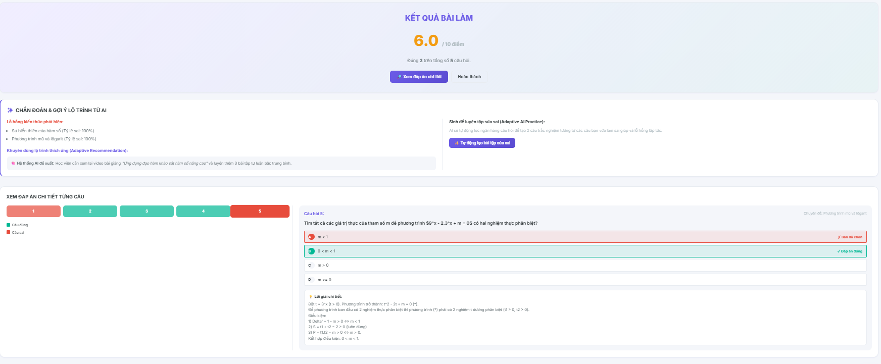
Field Name | Field Type | Description
Workspace Title | Heading | Displays the module workspace structural title text "Lịch sử kiểm tra".
Course Filter Dropdown | Dropdown Select | Allows users to filter the test log directory data stream based on a selected course boundary node.
Performance Summary Cards | Layout Grid Boxes | KPI metric blocks summarizing historical statistics (e.g., "Tổng số bài đã làm", "Điểm số trung bình").
History Data Grid | Table Container | The primary structured grid layout displaying individual historical quiz attempt rows.
Test Name Cell | Text Label (Column) | Renders the specific descriptive name string of the evaluated quiz entity.
Course Context Cell | Text Label (Column) | Displays the master course title parameter to which the quiz belongs.
Score Result Cell | Text / Badge (Column) | Displays the final score points achieved (e.g., "9.5/10") along with custom coloring metrics.
Completion Date Cell | Text (Column) | Renders the formatted calendar date-time string marking when the test submission was logged.
Status Badge | Status Tag Badge | Renders a color-coded token (e.g., Green "Đạt" or Red "Chưa Đạt") computed against passing score limits.
Button “Xem chi tiết” | Button (Row Action) | Navigation control routing the student viewport directly to the deep-dive post-exam review interface (UC17).
Pagination Controller | Paging Navigation | Interface control bar enabling users to step forward or backward across multi-page index rows.

Database Access
Table | CRUD | Description
ExamAttempts | R | Read structural history logs, captured grades, and clock-stamps compiled by the active student.
Quizzes | R | Join parameter indexes to pull formal quiz names, total score limits, and passing configurations.
Course | R | Look up and display target course descriptive titles corresponding to the quiz node tree.
1. Query the complete chronological history of finalized test attempts with multi-table joins for grid generation
SQL
SELECT
ea.[id] AS [AttemptID],
q.[title] AS [QuizTitle],
c.[title] AS [CourseTitle],
ea.[score] AS [ScoreAchieved],
q.[max_score] AS [MaxPossibleScore],
ea.[started_at] AS [TestStartTime],
ea.[completed_at] AS [SubmissionTime],
DATEDIFF(MINUTE, ea.[started_at], ea.[completed_at]) AS [DurationMinutes],
-- Compute the passing compliance token dynamically based on database configurations
CASE
WHEN ea.[score] >= q.[passing_score] THEN 'PASSED'
ELSE 'FAILED'
END AS [EvaluationStatus]
FROM [dbo].[ExamAttempts] ea
JOIN [dbo].[Quizzes] q ON ea.[quiz_id] = q.[id]
JOIN [dbo].[Course] c ON q.[course_id] = c.[id]
WHERE ea.[user_id] = @CurrentUserID
AND ea.[status] = 'Completed' -- Safely isolates unfinished 'In_Progress' session records from the grid views
AND (@FilterCourseID IS NULL OR c.[id] = @FilterCourseID) -- Dynamic interface filter parameter rule
ORDER BY ea.[completed_at] DESC; -- Places the absolute freshest test result layout at the top row cell

2. Query aggregate analytics metadata to hydrate the dashboard summary statistics widget cards
SQL
SELECT
COUNT(ea.[id]) AS [TotalQuizzesTaken],
ISNULL(AVG(ea.[score]), 0.0) AS [AverageScoreMetrics],
SUM(CASE WHEN ea.[score] >= q.[passing_score] THEN 1 ELSE 0 END) AS [TotalPassedAttempts],
-- Avoid arithmetic divide-by-zero database execution errors natively
CASE
WHEN COUNT(ea.[id]) > 0 THEN (SUM(CASE WHEN ea.[score] >= q.[passing_score] THEN 1 ELSE 0 END) * 100 / COUNT(ea.[id]))
ELSE 0
END AS [OverallPassPercentage]
FROM [dbo].[ExamAttempts] ea
JOIN [dbo].[Quizzes] q ON ea.[quiz_id] = q.[id]
WHERE ea.[user_id] = @CurrentUserID
AND ea.[status] = 'Completed';

8. AI Assistance
8.1 Receive AI Learning Suggestions
Provides an adaptive dashboard layout for authenticated students to discover personalized learning path recommendations, showing automated lesson priorities and targeted practice recommendations computed by the AI core processing engine to bridge identified knowledge gaps.
UI Design
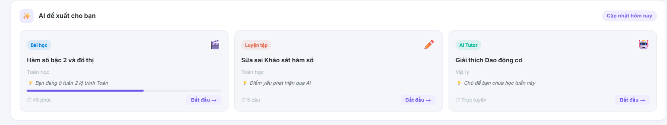
Field Name | Field Type | Description
Workspace Header | Heading | Displays the module workspace title text "Trợ lý học tập thông minh AI".
AI Prompt Summary Banner | Visual Card Component | A prominent dashboard banner summarizing the engine's active execution message (e.g., "Dựa trên bài thi vừa qua, AI khuyên bạn nên...").
Priority Level Tag | Status Chip Tag | Color-coded urgency label rendering priority weights calculated per recommendation card (e.g., Red "Ưu tiên cao", Yellow "Nên xem").
Recommended Lesson Card | Clickable Grid Asset | Dynamic presentation block loading single lesson properties (Title, Chapter, Course, Estimated time).
Skill Target Indicator | Text Label | Small text descriptor mapping why the asset is surfaced (e.g., "Bổ khuyết kỹ năng: Truy vấn SQL JOIN").
Button “Bắt đầu học ngay” | Button (Card Action) | Instantly launches the core lesson playlist workspace interface (UC12) pointing to the suggested item node.
Dismiss Recommendation Icon | Micro Control Link | Allows students to clean or mute specific suggestion blocks from their immediate active card feed stack.

Database Access
Table | CRUD | Description
SkillProficiency | R | Scan individual student capability deficiency indexes to identify domains matching critical low mastery limits.
Lesson | R | Read structural target lesson row properties (titles, content paths) matching the recommended skill tag.
LearningProgress | R | Cross-verify completed milestone histories to filter out rows already accomplished by the user session.
AIGeneratedSuggestions | R, U | Fetch real-time active recommendation cards tailored by the AI engine core pipeline (R); modify status flags when dismissed (U).
1. Query uncompleted lessons matching the student's weakest capability domains to compile the automated recommendation deck
SQL
SELECT TOP 3
l.[id] AS [LessonID],
l.[title] AS [LessonTitle],
c.[title] AS [CourseTitle],
sp.[topic_name] AS [TargetedKnowledgeDomain],
sp.[proficiency_score] AS [CurrentMasteryScore], -- Used to explain the recommendation logic on the front-end
-- Calculate priority metadata flags natively based on capability gaps
CASE
WHEN sp.[proficiency_score] < 40.00 THEN 'HIGH_PRIORITY'
ELSE 'MEDIUM_PRIORITY'
END AS [AIPriorityWeightToken]
FROM [dbo].[SkillProficiency] sp
JOIN [dbo].[Lesson] l ON sp.[topic_name] = l.[topic_tag] -- Maps content tokens to the analyzed skill schema
JOIN [dbo].[Course] c ON l.[course_id] = c.[id]
LEFT JOIN [dbo].[LearningProgress] lp ON l.[id] = lp.[lesson_id] AND lp.[user_id] = @CurrentUserID
WHERE sp.[user_id] = @CurrentUserID
AND (lp.[is_completed] IS NULL OR lp.[is_completed] = 0) -- Security perimeter: Surfaced entities must be uncompleted
ORDER BY
sp.[proficiency_score] ASC, -- Focuses heavily on worst performing metrics first
l.[sort_order] ASC;
2. Query dedicated dynamic text summaries written by the background machine learning layer for execution feed populating
SQL
SELECT
ags.[id] AS [SuggestionID],
ags.[suggestion_headline] AS [HeadlineText],
ags.[reasoning_narrative] AS [AIReasoningText], -- Explains "Why AI is suggesting this path"
ags].[created_at] AS [CalculatedTimestamp]
FROM [dbo].[AIGeneratedSuggestions] ags
WHERE ags.[user_id] = @CurrentUserID
AND ags.[is_dismissed] = 0 -- Excludes items hidden by structural interface control interactions
ORDER BY ags.[created_at] DESC;
9. Course Enrollment
9.1 Purchase Course
Allows authenticated students to review the pricing matrix of a premium course, apply promotional discount coupons, validate system prerequisites to block duplicate enrollments, and instantiate a secure pending order log in the repository before initiating the payment gateway loop.
UI Design
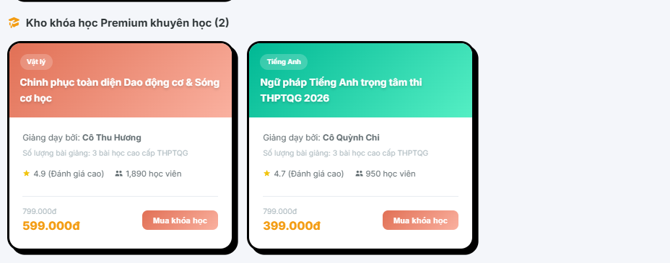
Field Name | Field Type | Description
Checkout Title | Heading | Displays the checkout workspace section header text "Xác nhận đơn hàng".
Course Summary Card | Layout Container | A nested graphical grid loading target course asset metadata (Title, Thumbnail, Instructor).
Base Price Label | Text Label | Displays the standard denormalized currency baseline value fetched from the course entity.
Input “Mã giảm giá” | Input Field (Text) | Open character cell enabling students to supply promotional discount codes to trigger cost-reduction algorithms.
Button “Áp dụng” | Button | Interacts with promotion lookup APIs to evaluate coupon expiration parameters and recalculate total amounts.
Total Payable Amount | Text Label (Bold) | Renders the final calculated financial payload cost string required to trigger the secure bank gateway.
Button “Tiến hành thanh toán” | Button | Primary execution control button initializing order state row creation loops and launching payment modal frames.
Button “Hủy bỏ” | Button | Reversion control component aborting checkout states and routing users back to the previous Course Details layout view.

Database Access
Table | CRUD | Description
Course | R | Read base price assets, dynamic course titles, and catalog structural parameters.
CourseEnrollments | R | Inspect unique compound keys (user_id, course_id) to block redundant operations if the user session has already acquired the asset.
Coupons | R, U | Validate coupon code existence, balance, status, and increment the usage logs counter if valid.
Orders | C | Create a fresh transaction registry row tracking global metadata, status flags set to 'Pending', and computing raw payload tokens.
OrderDetails | C | Populate granular child data entries detailing single item IDs mapped against the parent order key structure.
1. Query baseline price data and audit existing enrollment states to enforce strict duplication guardrails
SQL
-- Step 1: Enforce Business Rule checking if student already possesses an active enrollment row context
SELECT
ce.[id] AS [EnrollmentID],
ce.[status] AS [CurrentStatus]
FROM [dbo].[CourseEnrollments] ce
WHERE ce.[user_id] = @CurrentUserID
AND ce.[course_id] = @TargetCourseID
AND ce.[status] = 'active'; -- If a validated row is populated, client control layers must abort checkout flows instantly

-- Step 2: Fetch target product financial value schemas
SELECT
c.[id] AS [CourseID],
c.[title] AS [CourseName],
c.[price] AS [BaselinePrice],
c.[status] AS [PublishingStatus]
FROM [dbo].[Course] c
WHERE c.[id] = @TargetCourseID
AND c.[status] = 'published'; -- Guardrail block: Prevents checkouts on disabled or drafted course items

2. Initialize the master transaction infrastructure to log pending orders safely upon checkout submission
SQL
BEGIN TRANSACTION;
BEGIN TRY
-- Variable setup to maintain systemic financial recalculation logic balances
DECLARE @CalculatedFinalAmount DECIMAL(18,2) = @InputBasePrice;
DECLARE @CouponID INT = NULL;

-- Step 1: Evaluate coupon string validation parameter constraints if input is provided
IF @InputCouponCode_Text IS NOT NULL AND @InputCouponCode_Text <> ''
BEGIN
SELECT
@CouponID = cp.[id],
-- Compute reduced cost payload natively based on percentage reduction records
@CalculatedFinalAmount = (@InputBasePrice - (@InputBasePrice * cp.[discount_percentage] / 100.00))
FROM [dbo].[Coupons] cp
WHERE cp.[code] = @InputCouponCode_Text
AND cp].[status] = 'active'
AND cp.[expiry_date] >= GETDATE();
END;

-- Step 2: Instantiate the Parent Order record row utilizing temporary 'Pending' status flags
INSERT INTO [dbo].[Orders] (
[user_id],
[total_amount],
[coupon_id],
[order_status], -- Parameter classification string context: 'Pending'
[created_at],
[updated_at]
)
VALUES (
@CurrentUserID,
@CalculatedFinalAmount,
@CouponID,
'Pending', -- Locks database row integrity until payment token validation handshakes complete successfully
GETDATE(),
GETDATE()
);

-- Capture generated identity primary key pointer
DECLARE @NewOrderID INT = SCOPE_IDENTITY();

-- Step 3: Map precise item ledger parameters into child relational schemas
INSERT INTO [dbo].[OrderDetails] (
[order_id],
[course_id],
[price_charged],
[created_at]
)
VALUES (
@NewOrderID,
@TargetCourseID,
@CalculatedFinalAmount,
GETDATE()
);

COMMIT TRANSACTION;

-- Expose new identifier row properties to backend controller to coordinate gateway routing handshakes
SELECT @NewOrderID AS [GeneratedOrderID], @CalculatedFinalAmount AS [FinalPayableAmount];
END TRY
BEGIN CATCH
ROLLBACK TRANSACTION;
-- Throw standard exception diagnostics to API error controller blocks
THROW;
END CATCH;
9.2 Make Payment
Processes order payment handshakes through secure integrated third-party payment gateways (such as E-Wallets, Banking QR, or Credit Cards), records structural execution logs with strict transactional status tracking ('completed' or 'failed'), and dynamically provisions core student learning workspace authorization rows upon verified success tokens.
UI Design
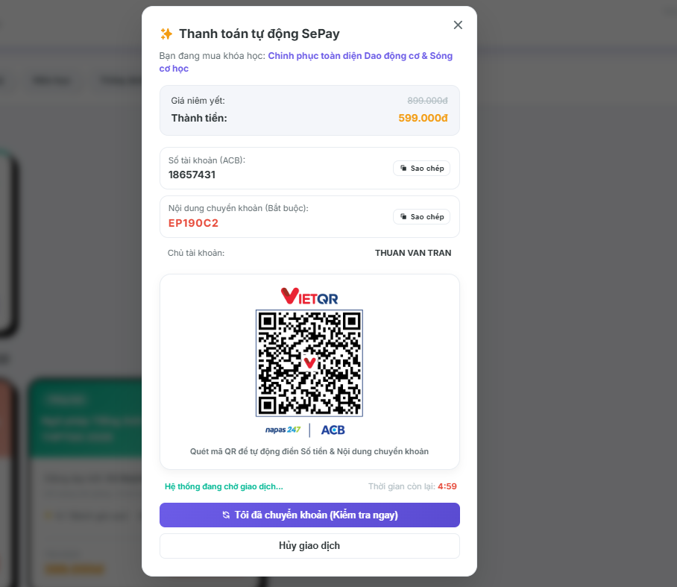

Field Name | Field Type | Description
Payment Gateway Header | Heading | Displays the transaction workspace identification header text "Cổng thanh toán an toàn".
Order ID Field | Text Label | Renders the alphanumeric master identifier string associated with the parent Order record.
Final Amount Badge | Text Badge (Highlighted) | Displays the finalized payload cost data fetched directly from the computed order row context.
Payment Method Group | Radio Button Group | Input controls grouping payment channels (e.g., "Mã QR Ngân hàng", "Ví điện tử MoMo", "Thẻ Quốc tế").
Dynamic QR Canvas | Image Container | Dynamically renders a time-restricted cryptographic payment QR string mapped to the specific gateway sandbox API payload.
Countdown Timer Box | Text / Timer Alert | Real-time ticking indicator enforcing maximum expiration bounds (e.g., "Mã QR hết hạn trong 09:59").
Button “Xác nhận thanh toán” | Button | Manually polls gateway validation webhooks to double-check transaction settlement flags before backend hooks trigger.
Button “Hủy giao dịch” | Button | Explicit transaction cancellation switch invalidating temporary tokens and rolling back order UI workspaces.
Response Error Alert | Notification Banner | Snackbar rendering payment processing exception codes (e.g., "Giao dịch thất bại hoặc đã hết hạn chuyển khoản").

Database Access
Table | CRUD | Description
Orders | R, U | Read baseline price payload parameters (R) and modify structural status indicators to 'Completed' or 'Cancelled' based on handshake data streams (U).
Payments | C, U | Create an initial transactional ledger row flag set to 'Pending' (C) and rewrite status parameters to 'completed' or 'failed' upon gateway verification signals (U).
CourseEnrollments | C | Atomically insert a fresh authorization entry row providing immediate content access vectors exclusively if the verification loop maps a success token (C).
SystemActivityLogs | C | Record network IP footprints, transaction references, and operational execution metadata for security audit clearing (C).
1. Initialize the baseline transaction footprint inside the Payments ledger table immediately upon gateway generation
SQL
INSERT INTO [dbo].[Payments] (
[order_id],
[payment_method], -- Allocation descriptor strings: 'Banking_QR', 'MoMo_Wallet', 'Credit_Card'
[transaction_reference], -- Unique alphanumeric bridge token passed by external provider API webhook
[amount_paid],
[payment_status], -- Instantiated state parameter: 'pending'
[created_at],
[updated_at]
)
VALUES (
@ActiveOrderID,
@SelectedPaymentMethod,
@GatewayTransactionReference_Token,
@OrderFinalPayableAmount,
'pending', -- Locked ledger status awaiting asymmetric cryptographic verification webhook response
GETDATE(),
GETDATE()
);

2. Atomic Transaction Handling Block: Process successful verification callback to grant content entitlements and clear order parameters
SQL
BEGIN TRANSACTION;
BEGIN TRY
-- Variable declarations to capture relational index constraints
DECLARE @TargetUserID INT;
DECLARE @TargetCourseID INT;

-- Look up core entity ownership markers tied to the verified Order context
SELECT
@TargetUserID = o.[user_id],
@TargetCourseID = od.[course_id]
FROM [dbo].[Orders] o
JOIN [dbo].[OrderDetails] od ON o.[id] = od.[order_id]
WHERE o.[id] = @ActiveOrderID;

-- Step 1: Update the Payments table status column flag to verified completed row state
UPDATE [dbo].[Payments]
SET
[payment_status] = 'completed', -- Enforces permanent successful ledger transaction record
[updated_at] = GETDATE()
WHERE [order_id] = @ActiveOrderID AND [payment_status] = 'pending';

-- Step 2: Mutate Parent Order state parameters to clean active checkout tracking states
UPDATE [dbo].[Orders]
SET
[order_status] = 'Completed',
[updated_at] = GETDATE()
WHERE [id] = @ActiveOrderID;

-- Step 3: Business Critical Rule - Dynamically provision core entitlement access row to let student enter the course
INSERT INTO [dbo].[CourseEnrollments] (
[user_id],
[course_id],
[enrollment_date],
[status] -- Instantiated access parameter flag: 'active'
)
VALUES (
@TargetUserID,
@TargetCourseID,
GETDATE(),
'active' -- Entitlement vector opens immediately for classroom streaming components
);

-- Step 4: Write comprehensive transactional trail entries into platform audit logs
INSERT INTO [dbo].[SystemActivityLogs] (
[user_id],
[activity_type], -- Operational code token: 'Payment_Enrollment_Success'
[ip_address],
[created_at]
)
VALUES (
@TargetUserID,
'Payment_Enrollment_Success',
@ClientIPAddress,
GETDATE()
);

COMMIT TRANSACTION;
END TRY
BEGIN CATCH
ROLLBACK TRANSACTION;
-- Cascade system operational diagnostics to infrastructure error logs
THROW;
END CATCH;

3. Alternate Workflow Block: Log structural transaction failure records if external sandbox flags an execution error
SQL
BEGIN TRANSACTION;
BEGIN TRY
-- Enforce security data integrity tracking by explicitly keeping record lines of failed events
UPDATE [dbo].[Payments]
SET
[payment_status] = 'failed', -- Permanently stamps failed verification metrics into systemic accounting registries
[updated_at] = GETDATE()
WHERE [order_id] = @ActiveOrderID AND [payment_status] = 'pending';

UPDATE [dbo].[Orders]
SET
[order_status] = 'Failed', -- Releases product reservation queues back to database pool blocks
[updated_at] = GETDATE()
WHERE [id] = @ActiveOrderID;

-- CRITICAL ACCESS GUARD: Note that NO row is written to CourseEnrollments table, ensuring user stays blocked.

COMMIT TRANSACTION;
END TRY
BEGIN CATCH
ROLLBACK TRANSACTION;
THROW;
END CATCH;

10 .Communication
10.1 Communicate with Teacher
Provides a live messaging workspace for authenticated students to communicate directly with course instructors, review historical message layers chronologically, transmit text payloads or file pointers, and track communication metadata.
UI Design

Field Name | Field Type | Description
Workspace Header | Heading | Displays the master contextual section title text "Hộp thư học tập".
Teacher Directory Sidebar | Container Panel | Left-hand vertical layout listing available instructors mapped to the student's active enrolled courses.
Active Chat Header | Layout Row Container | Top boundary bar displaying the target teacher's full name, profile thumbnail, and active status node.
Message Stream Area | Chat Stream Window | Core flexible viewport container rendering chronological text content blocks dynamically.
Student Message Bubble | Chat Bubble (Right) | Visual right-aligned color-coded message block hosting the text strings dispatched by the active user session.
Teacher Message Bubble | Chat Bubble (Left) | Visual left-aligned color-coded message block hosting the feedback text responses written by the instructor.
Input “Nhập tin nhắn” | Input Field (Text) | Open text entry stream field allowing students to draft their technical queries or chat statements.
Button Attachment Icon | IconButton / File Trigger | Launches native system file attachment picker grids to transmit image logs or document asset pointers (PNG, PDF).
Button “Gửi” | Button | Primary execution control processing validation checks, stamping payloads, and dispatching records to chat databases.

Database Access
Table | CRUD | Description
Users | R | Read profile thumbnails, validation states, and formal names to compile sidebar indices and chat headers.
ChatMessages | C, R | Query the chronological historical text dialogue streams mapped between targeted users (R); create a fresh transaction message row upon trigger execution (C).
CourseEnrollments | R | Audit Look-up check to guarantee that connection channels can only be opened if the student possesses a validated relationship to the teacher's course.
1. Query the chronological messaging history block to hydrate the active chat viewport layout
SQL
SELECT
cm.[id] AS [MessageID],
cm.[sender_id] AS [SenderUserID],
u_sender.[full_name] AS [SenderName],
cm.[receiver_id] AS [ReceiverUserID],
cm.[message_text] AS [MessageBodyText],
cm.[attachment_url] AS [AttachedAssetPath], -- Holds pointers to document/image uploads if verified by system
cm.[is_read] AS [ReadReceiptFlag],
cm.[created_at] AS [SentTimestamp]
FROM [dbo].[ChatMessages] cm
JOIN [dbo].[Users] u_sender ON cm.[sender_id] = u_sender.[id]
WHERE (cm.[sender_id] = @CurrentUserID AND cm.[receiver_id] = @TargetTeacherID)
OR (cm.[sender_id] = @TargetTeacherID AND cm.[receiver_id] = @CurrentUserID)
ORDER BY cm.[created_at] ASC; -- Forces structural historical continuity from past rows down to the absolute freshest message item

2. Commit a fresh transactional message record to the database ledger upon input submission
SQL
BEGIN TRANSACTION;
BEGIN TRY
-- Enforce security boundary: Double check that the connection channel aligns with valid course enrollment maps
IF EXISTS (
SELECT 1 FROM [dbo].[CourseEnrollments] ce
JOIN [dbo].[Course] c ON ce.[course_id] = c.[id]
WHERE ce.[user_id] = @CurrentUserID
AND c.[teacher_id] = @TargetTeacherID
AND ce.[status] = 'active'
)
BEGIN
-- Insert the compiled text payload and timestamp records atomically
INSERT INTO [dbo].[ChatMessages] (
[sender_id],
[receiver_id],
[message_text],
[attachment_url],
[is_read], -- Instantiated default indicator parameter set to 0 (Unread)
[created_at]
)
VALUES (
@CurrentUserID,
@TargetTeacherID,
@InputMessageText,
@InputAttachmentCloudURL, -- Nullable parameter pointer passed if a file handshake occurred
0,
GETDATE()
);

COMMIT TRANSACTION;
END
ELSE
BEGIN
-- Rollback and prevent transaction if user attempts to breach communication logic paths
ROLLBACK TRANSACTION;
RAISERROR('Unauthorized communication execution: Student is not enrolled in targeted teacher courses.', 16, 1);
END;
END TRY
BEGIN CATCH
IF @@TRANCOUNT > 0 ROLLBACK TRANSACTION;
THROW;
END CATCH;

10.2 Communicate with AI
Provides an intelligent conversational chatbot interface for authenticated students to ask academic questions, receive automated real-time contextual explanations or code fixes, review historical message layers, and manage adaptive AI support sessions.
UI Design
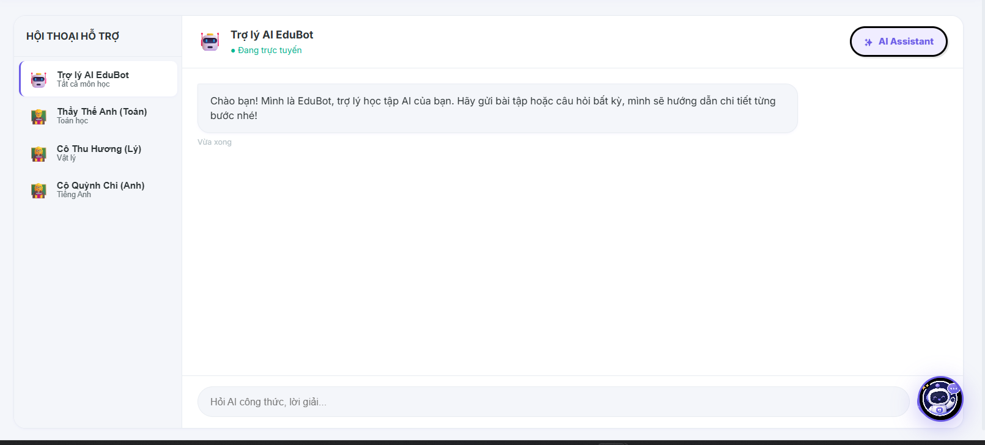

Field Name | Field Type | Description
Workspace Title Header | Heading | Displays the interface master title text "Trợ lý Học tập AI 24/7".
Chat Session Sidebar | Container Panel | Vertical left sidebar column tracking and grouping past temporal conversation sessions chronologically.
Button “Cuộc trò chuyện mới” | Button | Initializes a fresh session tracking token, clearing active viewport canvas data inputs.
Conversation Stream Deck | Scrollable Viewport | Core area rendering user prompts and markdown-parsed AI model answers chronologically.
Student Prompt Bubble | Chat Bubble (Right) | Right-aligned message text box containing the technical query string provided by the user session.
AI Intelligent Response | Chat Bubble (Left) | Left-aligned stylized response block formatting text, syntax highlights, or hints generated by the system core LLM.
Input “Nhập câu hỏi...” | Input Field (Text) | Rich single-line or expandable entry box allowing students to supply code or open questions.
Button “Gửi” | Button | Dispatches input strings to the backend controller validation pipelines and triggers the external model API call.
Button “Xóa lịch sử chat” | Button | Contextual control resetting visibility flags to clean or hide the active session trail.

Database Access
Table | CRUD | Description
AIChatSessions | C, R, U | Create a fresh conversation index token (C); query past session groups mapped to the user (R); update session properties or metadata flags (U).
AIChatMessages | C, R | Query the text dialog history rows assigned beneath a specific session ID (R); create fresh logs tracking prompt-response entries atomically (C).
1. Query the chronological list of historical messages belonging to the selected active AI Chat Session
SQL
SELECT
am.[id] AS [MessageID],
am.[session_id] AS [SessionID],
am.[sender_type] AS [SenderType], -- Constraint tokens classification: 'User' or 'AI_Bot'
am.[message_text] AS [MessagePayload], -- Rich text rows containing data markdown formatting configurations
am.[created_at] AS [LoggedTimestamp]
FROM [dbo].[AIChatMessages] am
JOIN [dbo].[AIChatSessions] asess ON am.[session_id] = asess.[id]
WHERE asess.[id] = @ActiveSessionID
AND asess.[user_id] = @CurrentUserID -- Security boundary check logic: User owns the requested resource
ORDER BY am.[created_at] ASC; -- Renders historical rows downward matching standard chat interfaces

2. Atomic Transaction Handling Block: Log user prompt text and store the corresponding AI engine response payload synchronously
SQL
BEGIN TRANSACTION;
BEGIN TRY
-- Step 1: Ensure an active valid session token exists, if not, create a new container row dynamically
IF @ActiveSessionID IS NULL
BEGIN
INSERT INTO [dbo].[AIChatSessions] (
[user_id],
[session_name], -- Dynamic snippet token (e.g., 'Hỏi về cú pháp SQL JOIN...')
[is_active],
[created_at],
[updated_at]
)
VALUES (
@CurrentUserID,
LEFT(@InputPromptText, 50), -- Automatically grab initial string snippet as layout header title
1,
GETDATE(),
GETDATE()
);

SET @ActiveSessionID = SCOPE_IDENTITY();
END;

-- Step 2: Write the Student input prompt log row into the message ledger database
INSERT INTO [dbo].[AIChatMessages] (
[session_id],
[sender_type],
[message_text],
[created_at]
)
VALUES (
@ActiveSessionID,
'User',
@InputPromptText,
GETDATE()
);

-- Step 3: Write the companion response string returned by the platform's AI orchestration engine model
INSERT INTO [dbo].[AIChatMessages] (
[session_id],
[sender_type],
[message_text],
[created_at]
)
VALUES (
@ActiveSessionID,
'AI_Bot',
@ServerAIEngineOutput_Text, -- Decoded text string block calculated by LLM model pipeline
GETDATE()
);

-- Step 4: Refresh parent session modification timestamp tracking keys
UPDATE [dbo].[AIChatSessions]
SET [updated_at] = GETDATE()
WHERE [id] = @ActiveSessionID;

COMMIT TRANSACTION;

-- Return target context index state pointers to clean up controller memory pools
SELECT @ActiveSessionID AS [ValidatedSessionID];
END TRY
BEGIN CATCH
ROLLBACK TRANSACTION;
-- Throw standard infrastructure processing failure signals to gateway middleware routers
THROW;
END CATCH;

10.3 Send Notifications
Allows authenticated administrators or course teachers to compose mass broadcast notifications, define target audience distributions (global platform-wide or specific course rosters), validate text parameter thresholds, and atomically execute high-volume message delivery routines.

UI Design
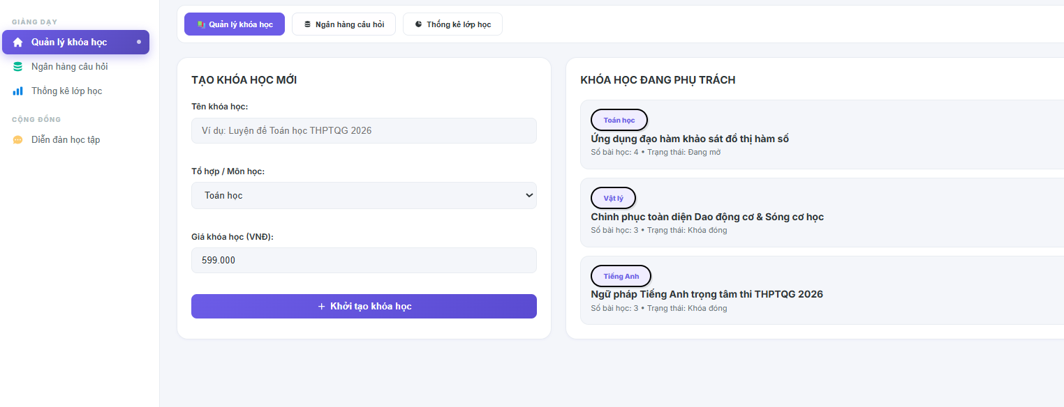
Field Name | Field Type | Description
Workspace Header | Heading | Displays the module workspace view component title text "Gửi thông báo hàng loạt".
Dropdown “Đối tượng nhận” | Dropdown Select | Sets the messaging audience scope node filtering parameter rules (e.g., "Toàn hệ thống", "Theo khóa học").
Dropdown “Chọn khóa học” | Dropdown Select | Contextual selector dynamically enabled only when audience scope equals course mode; lists targeted active courses.
Input “Tiêu đề thông báo” | Input Field (Text) | High-visibility character input field layout enabling staff to declare the notification's core message subject.
Input “Nội dung chi tiết” | Textarea (Multiline) | Rich multi-line description input field box allowing formatting of the actual core broadcast information details.
Dropdown “Loại thông báo” | Dropdown Select | Categorization token selection box mapping severity and styling codes (e.g., "System", "Course_Update", "Alert").
Button “Phát tin thông báo” | Button | Primary execution trigger to initiate text constraint sanitization, run batch insert algorithms, and dispatch logs.
Button “Hủy bỏ” | Button | Clears all text input stream memory buffers and navigates back to the main communication center deck dashboard.
Status Preview Counter | Text Badge | Displays real-time computed statistics counting how many active user nodes will receive the text message stream payload.

Database Access
Table | CRUD | Description
Notifications | C | Create a single master notification record hosting global metadata parameters, title strings, and text payloads.
UserNotifications | C | Atomically execute massive batch insert routines mapping the generated master notification ID to individual user rows.
CourseEnrollments | R | Scan and extract student identifier lists currently tied to a specific course if course-level filtering is triggered.
Users | R | Query active system user node logs to populate mass distribution list vectors for platform-wide alerts.
SystemActivityLogs | C | Append an infrastructure logging row documenting the broadcast action parameters for security auditing.
1. Query active course structures belonging to the logged instructor session to populate the selector dropdown
SQL
SELECT
c.[id] AS [CourseID],
c.[title] AS [CourseName],
(SELECT COUNT(1) FROM [dbo].[CourseEnrollments] ce WHERE ce.[course_id] = c.[id] AND ce.[status] = 'active') AS [ActiveStudentCount]
FROM [dbo].[Course] c
WHERE c.[teacher_id] = @CurrentUserID
AND c.[status] = 'published'; -- Restricts lookup context loops exclusively to live public academic items

2. Atomic Transaction Handling Block: Execute course-specific mass notification distribution to all enrolled students
SQL
BEGIN TRANSACTION;
BEGIN TRY
-- Step 1: Create the master announcement reference entry row in the central log table
INSERT INTO [dbo].[Notifications] (
[title],
[content],
[category], -- Mapped token property: 'Course_Update'
[created_by], -- Traces the executing teacher ID key pointer
[created_at]
)
VALUES (
@InputTitleText,
@InputBodyText,
'Course_Update',
@CurrentUserID,
GETDATE()
);

-- Trap the generated master structural primary key identity
DECLARE @NewNotificationID INT = SCOPE_IDENTITY();

-- Step 2: High-Performance Bulk Insert - Deliver individual message tracking rows to ALL students enrolled in this course
INSERT INTO [dbo].[UserNotifications] (
[user_id],
[notification_id],
[is_read], -- Instantiated state parameter: 0 (Unread)
[read_at]
)
SELECT
ce.[user_id],
@NewNotificationID,
0,
NULL
FROM [dbo].[CourseEnrollments] ce
WHERE ce.[course_id] = @TargetCourseID
AND ce.[status] = 'active'; -- Safeguard: Dispatches exclusively to active, paying, or verified student accounts

-- Step 3: Append structural forensic log information tracking the specialized message broadcast execution
INSERT INTO [dbo].[SystemActivityLogs] (
[user_id],
[activity_type], -- Hardcoded tracking token code: 'Broadcast_Course_Notification_Success'
[ip_address],
[created_at]
)
VALUES (
@CurrentUserID,
'Broadcast_Course_Notification_Success',
@ClientIPAddress,
GETDATE()
);

COMMIT TRANSACTION;
END TRY
BEGIN CATCH
ROLLBACK TRANSACTION;
-- Throw standard exception variables up to application controller routing layers
THROW;
END CATCH;

3. Alternate Workflow Block: Execute system-wide global notification deployment to every active account row (Admin privilege)
SQL
BEGIN TRANSACTION;
BEGIN TRY
-- Step 1: Insert the global administrative master message block metadata
INSERT INTO [dbo].[Notifications] (
[title],
[content],
[category], -- Mapped token property: 'System'
[created_by], -- Traces the executing admin user ID key
[created_at]
)
VALUES (
@InputTitleText,
@InputBodyText,
'System',
@CurrentUserID,
GETDATE()
);

DECLARE @GlobalNotificationID INT = SCOPE_IDENTITY();

-- Step 2: Massive Platform Bulk Insert - Route message references to ALL active accounts in the database cluster
INSERT INTO [dbo].[UserNotifications] (
[user_id],
[notification_id],
[is_read],
[read_at]
)
SELECT
u.[id],
@GlobalNotificationID,
0,
NULL
FROM [dbo].[Users] u
WHERE u.[status] = 'active'; -- Security grid filter: Excludes locked, banned, or unverified account records

-- Step 3: Log the admin mass broadcast event inside the infrastructure activity trails ledger
INSERT INTO [dbo].[SystemActivityLogs] (
[user_id],
[activity_type], -- Tracking code: 'Broadcast_Global_Notification_Success'
[ip_address],
[created_at]
)
VALUES (
@CurrentUserID,
'Broadcast_Global_Notification_Success',
@ClientIPAddress,
GETDATE()
);

COMMIT TRANSACTION;
END TRY
BEGIN CATCH
ROLLBACK TRANSACTION;
THROW;
END CATCH;
11. Course Management
11.1 Create Course
Allows authenticated instructors (Teacher) to initialize and register a new course record into the system database by defining its structural metadata, subject categorization, level classification, pricing matrices, and generating a unique URL slug mapping.

UI Design
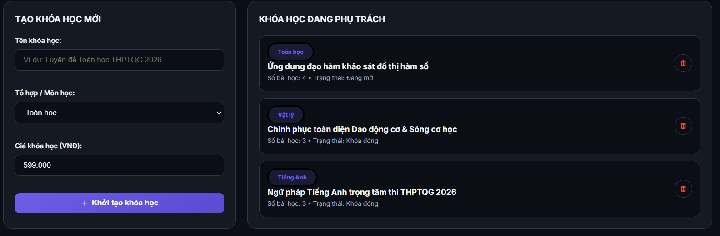
Field Name | Field Type | Description
Section Header | Heading | Displays the module workspace subtitle text "Tạo khóa học mới".
Input “Tiêu đề khóa học” | Input Field (Text) | Text box capturing the core header identifier of the course asset; maps to title (NVARCHAR(300)).
Input “Chuỗi URL định danh” | Input Field (Text) | Web safe string index identifying the custom path variable component; maps to slug (NVARCHAR(350)).
Dropdown “Môn học” | Dropdown List | Selection picker pulling from relational records inside the primary Subjects framework table.
Dropdown “Cấp độ” | Dropdown List | Selection criteria restricted by constraint logic to structural tokens: beginner, intermediate, or advanced.
Input “Giá tiền gốc” | Input Field (Numeric) | Explicit numeric decimal field identifying course access purchase tokens; maps to price.
Input “Giá khuyến mãi” | Input Field (Numeric) | Optional reduced pricing tier context applied on checkout loops; maps to discount_price.
Input “Ảnh thu nhỏ URL” | Input Field (Text) | Text box holding secure cloud computing resource web links for imagery storage; maps to thumbnail_url.
Textarea “Mô tả khóa học” | Text Area | Rich multi-line area accepting deep curriculum course syllabi information; maps to description.
Button “Lưu bản nháp” | Button | Primary execution action to trigger local asset validation, write a draft row status, and persist records.
Button “Hủy bỏ” | Button | Safe navigation fallback control to discard state parameters and redirect back to the catalog dashboard index.
Validation Error Text | Text Label | Inline dynamic warning banners tracking processing faults (e.g., "Slug đã tồn tại" or "Định dạng giá tiền không chính xác").

Database Access
Table | CRUD | Description
Courses | C, R | Reads active catalogs to maintain constraint safety (R), and executes row insertions to build a course record default state set to 'draft' (C).
Subjects | R | Queries master records to cross-verify foreign key reference dependencies prior to insertion routines (R).
1. Query to verify foreign key category integrity and ensure zero slug parameter collisions
SQL
-- Check subject validation safety boundary
SELECT
[id] AS [SubjectID],
[is_active] AS [SubjectStatus]
FROM [dbo].[Subjects]
WHERE [id] = @SelectedSubjectID
AND [is_active] = 1; -- Enforce structural liveness of reference partition

-- Prevent duplicate system errors on unique slug constraint index rows
SELECT
COUNT(1) AS [SlugCollisionCount]
FROM [dbo].[Courses]
WHERE [slug] = TRIM(LOWER(@CourseSlug)); -- Check uniqueness before processing transactional state writes

2. Transaction processing architecture to write the unified course meta entity block safely
SQL
BEGIN TRANSACTION;

BEGIN TRY
-- 1. Fail fast protection boundary validation routines
IF (@CourseTitle IS NULL OR LEN(TRIM(@CourseTitle)) = 0)
BEGIN
RAISERROR('MSG-ERR: Course title cannot be empty.', 16, 1);
END;

IF (@CourseSlug IS NULL OR LEN(TRIM(@CourseSlug)) = 0)
BEGIN
RAISERROR('MSG-ERR: Course slug parameter cannot be null.', 16, 1);
END;

-- 2. Execute atomic table insert operations directly into Courses schema ledger
INSERT INTO [dbo].[Courses] (
[teacher_id],
[subject_id],
[title],
[slug],
[description],
[thumbnail_url],
[price],
[discount_price],
[level],
[status], -- Maps default constraint tracking rules
[created_at],
[updated_at]
)
VALUES (
@CurrentUserID, -- Bound to the verified session account context identifier
@SelectedSubjectID,
TRIM(@CourseTitle),
TRIM(LOWER(@CourseSlug)),
@CourseDescription,
@CourseThumbnailUrl,
ISNULL(@CoursePrice, 0.00), -- Defaults configuration protection
@CourseDiscountPrice,
ISNULL(@CourseLevel, 'intermediate'), -- Enforces: 'beginner','intermediate','advanced'
'draft', -- Architectural design standard: Always initialize as soft draft space before submission
GETDATE(),
GETDATE()
);

COMMIT TRANSACTION;
END TRY
BEGIN CATCH
ROLLBACK TRANSACTION;
THROW;
END CATCH;

11.2 Edit Course Content
Allows authenticated instructors (Teacher) to modify the metadata properties, titles, sequence ordering, source URLs, or visibility previews of existing chapters and lessons bound to their managed courses.

UI Design
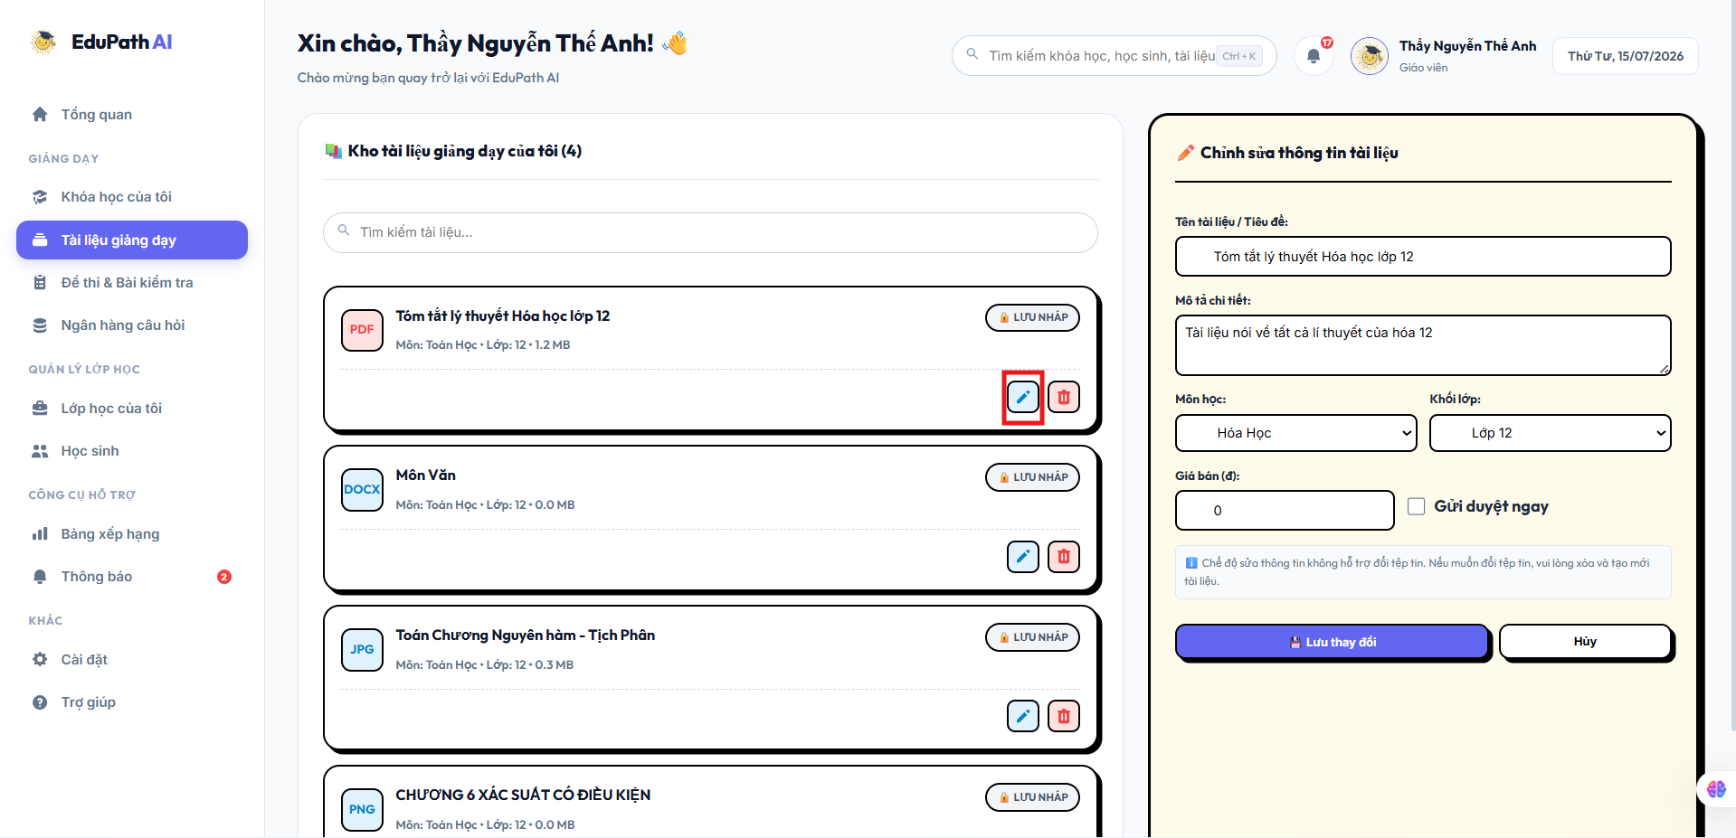
Field Name | Field Type | Description
Section Header | Heading | Displays the module workspace subtitle text "Chỉnh sửa bài học".
Input “Tên bài học” | Input Field (Text) | Captures the modified descriptive title for the targeted lesson row (title).
Dropdown “Loại nội dung” | Dropdown List | Selection component constrained to specific structural tokens (video, document, text, quiz).
Input “Đường dẫn nội dung” | Input Field (URL) | Text box updating the external cloud file path or stream link asset (content_url).
Input “Thời lượng (giây)” | Input Field (Integer) | Numeric box capturing tracking lengths for playback calculations (duration_sec).
Checkbox “Cho phép xem trước” | Checkbox | Toggle bit configuring whether guests can read the lesson without active enrollment (is_preview).
Button “Cập nhật” | Button | Main trigger to execute backend validation schemas and update the live row fields inside the database.
Button “Hủy bỏ” | Button | Closes the editing interface workspace and reverts pending structural layout states.

Database Access
Table | CRUD | Description
Lessons | R, U | Reads active lesson records to extract current parameters (R), and executes update statements to write modified content cells into the schema space (U).
Courses | R, U | Cross-checks ownership rows against the logged-in session ID (R), and updates the core tracking metadata modification timestamps (U).
1. Query to verify teacher account ownership boundaries prior to executing structural changes
SQL
SELECT
c.[id] AS [CourseID],
c.[teacher_id] AS [TeacherID]
FROM [dbo].[Courses] c
JOIN [dbo].[Chapters] ch ON ch.[course_id] = c.[id]
JOIN [dbo].[Lessons] l ON l.[chapter_id] = ch.[id]
WHERE l.[id] = @TargetLessonID; -- Boundary check: Confirm that the user executing the edit owns this course context

2. Execute transaction processing block to update lesson states and sync parent modification clocks
SQL
BEGIN TRANSACTION;

BEGIN TRY
-- 1. Perform structural update operations directly on the target Lesson identifier record
UPDATE [dbo].[Lessons]
SET
[title] = TRIM(@ModifiedTitle),
[content_url] = @ModifiedContentUrl,
[content_type] = @ModifiedContentType, -- Must pass check: 'video','document','text','quiz'
[duration_sec] = @ModifiedDurationSec,
[sort_order] = @ModifiedSortOrder,
[is_preview] = @ModifiedIsPreview,
[updated_at] = GETDATE()
WHERE [id] = @TargetLessonID;

-- 2. Synchronize and kick the update tracking clock on the top-level parent Course record
UPDATE [dbo].[Courses]
SET
[updated_at] = GETDATE()
WHERE [id] = @ParentCourseID;

COMMIT TRANSACTION;
END TRY
BEGIN CATCH
ROLLBACK TRANSACTION;
THROW;
END CATCH;

11.3 Delete Course Content
Allows authenticated instructors (Teacher) to clean up their curriculum architecture by executionally removing non-compliant, obsolete, or duplicated chapters and lessons from the persistent relational registry database.

UI Design
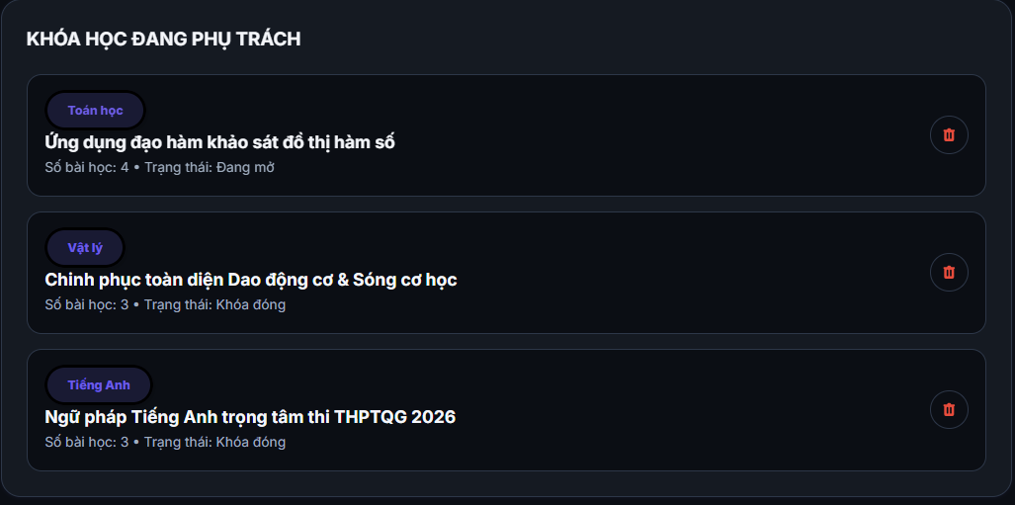
Field Name | Field Type | Description
Modal Title | Text Label | Renders the critical warning header alert block: "Xác nhận xóa nội dung".
Warning Message | Text Label | Text warning notifying instructors that sub-components and data logs will be permanently unlinked or deleted.
Button “Xác nhận xóa” | Button | Danger action control to fire backend hard-delete executions targeting the structural index data rows.
Button “Hủy bỏ” | Button | Safe abort control option to discard deletion intents and close the active structural pop-up container.

Database Access
Table | CRUD | Description
Chapters | D | Executes standard destructive SQL commands to drop targeted chapter rows from active relational data blocks (D).
Lessons | D | Performs structural hard-purges on individual lesson nodes based on incoming identifier parameters (D).
1. Execute cascading structural drop on an entire course Chapter node sequence
SQL
BEGIN TRANSACTION;

BEGIN TRY
-- Verify entity status records before running destructive table truncations
IF EXISTS (SELECT 1 FROM [dbo].[Chapters] WHERE [id] = @TargetChapterID)
BEGIN
-- Execute hard deletion. Note: foreign keys (fk_lesson_chapter) deploy ON DELETE CASCADE,
-- which automatically clears all dependent row items mapped within the Lessons table cleanly.
DELETE FROM [dbo].[Chapters]
WHERE [id] = @TargetChapterID;
END;

COMMIT TRANSACTION;
END TRY
BEGIN CATCH
ROLLBACK TRANSACTION;
THROW;
END CATCH;

2. Execute targeted hard deletion on an individual Course Lesson node record row
SQL
BEGIN TRANSACTION;

BEGIN TRY
-- Target and drop a single lesson item branch without dropping its sibling nodes or parent chapters
DELETE FROM [dbo].[Lessons]
WHERE [id] = @TargetLessonID;

COMMIT TRANSACTION;
END TRY
BEGIN CATCH
ROLLBACK TRANSACTION;
THROW;
END CATCH;

11.4 View Course Statistics
Allows authenticated instructors (Teacher) to view, monitor, and analyze real-time performance indicators, enrollment metrics, learning progress distribution rates, and evaluation scores for their specific created courses.

UI Design
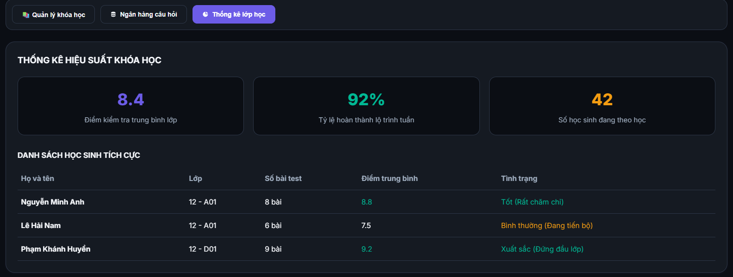
Field Name | Field Type | Description
Section Header | Heading | Displays the module workspace dashboard title text "Thống kê khóa học".
Card “Tổng số học viên” | Card / Label | Renders the cached cumulative total of registered learners; displays total_students.
Card “Đánh giá trung bình” | Card / Label | Renders the computed live or cached average review score; displays avg_rating.
Card “Tổng số đánh giá” | Card / Label | Renders the total headcount of submitted ratings; displays total_reviews.
Label “Tỷ lệ hoàn thành” | Data Label | Dynamic computed percentage showing the ratio of users who reached 100% progress.
Grid “Danh sách tiến độ” | Data Table Grid | Multi-column grid viewport displaying student names, enrollment dates, active progress percentages, and final completion status.
Button “Quay lại” | Button | Standard navigation action component to close the statistical layout view and return to the main catalog.

Database Access
Table | CRUD | Description
Courses | R | Reads the course identity parameters and optimized cached summary indicators (total_students, avg_rating, total_reviews).
CourseEnrollments | R | Scans student registration dates, progress data parameters, and completion time stamps for aggregation routines (R).
Users | R | Reads user account metadata to fetch individual student full name rows for the view grid layout (R).
1. Query to fetch the aggregated overview metrics and calculated structural KPIs for a specific course
SQL
SELECT
c.[id] AS [CourseID],
c.[title] AS [CourseTitle],
c.[total_students] AS [CachedTotalStudents], -- Reads optimized performance column
c.[avg_rating] AS [CachedAvgRating], -- Reads optimized rating summary column
c.[total_reviews] AS [CachedTotalReviews], -- Reads optimized review count column

-- Compute live real-time metrics across the active enrollment data pool
ISNULL(AVG(ce.[progress_pct]), 0.00) AS [LiveAverageProgressPercentage],
COUNT(CASE WHEN ce.[completed_at] IS NOT NULL THEN 1 END) AS [CompletedStudentsCount]
FROM [dbo].[Courses] c
LEFT JOIN [dbo].[CourseEnrollments] ce ON ce.[course_id] = c.[id]
WHERE c.[id] = @TargetCourseID
AND c.[teacher_id] = @CurrentUserID -- Ownership fence: ensure the data line belongs to the teacher session
GROUP BY c.[id], c.[title], c.total_students, c.avg_rating, c.total_reviews;

2. Query to load the structural progress tracking datagrid row collection for registered student rows
SQL
SELECT
u.[id] AS [StudentID],
u.[full_name] AS [StudentFullName],
u.[email] AS [StudentEmail],
ce.[enrolled_at] AS [EnrollmentDate],
ce.[progress_pct] AS [ProgressPercentage],
ce.[completed_at] AS [CompletionTimestamp]
FROM [dbo].[CourseEnrollments] ce
JOIN [dbo].[Users] u ON ce.[student_id] = u.[id]
WHERE ce.[course_id] = @TargetCourseID
ORDER BY ce.[enrolled_at] DESC;

12 .Exam Management

12.1 Create Test
Allows authenticated instructors (Teacher) or administrators (Admin) to initialize, configure, and register a new examination or quiz blueprint into the system database by specifying structural limits, pass thresholds, target scope mappings, and scheduling criteria.

UI Design
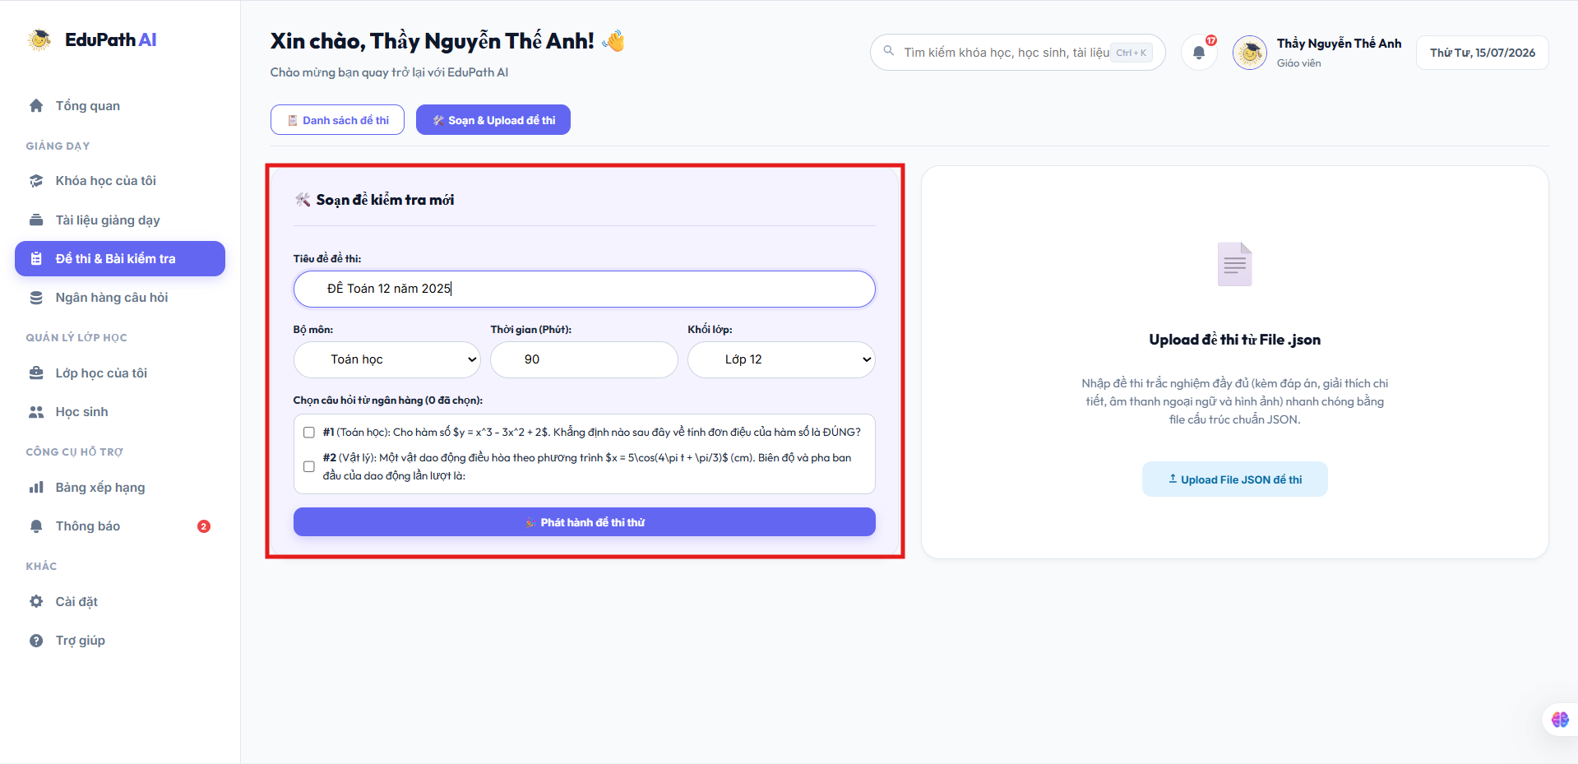
Field Name | Field Type | Description
Section Header | Heading | Displays the module workspace action title text "Tạo đề thi mới".
Input “Tiêu đề đề thi” | Input Field (Text) | Captures the structural name entry identifying the evaluation asset; maps to title (NVARCHAR(300)).
Dropdown “Loại đề thi” | Dropdown List | Selection selector bounded by check constraints to specific values: course_quiz, mock_exam, thpt_simulation, or ai_generated.
Input “Thời gian làm bài” | Input Field (Numeric) | Configures the overall active test duration stopwatch counter tracked in seconds; maps to time_limit_sec.
Input “Điểm đạt tối thiểu” | Input Field (Numeric) | Explicit decimal parameter entry configuring target baseline criteria for success flags; maps to pass_score.
Input “Số lượt thi tối đa” | Input Field (Integer) | Small integer field limiting redundant retake sessions per individual student account; maps to max_attempts.
Dropdown “Môn học liên kết” | Dropdown List | Optional relational filter grouping the exam asset underneath a primary reference directory row from the Subjects table.
Dropdown “Thuộc khóa học” | Dropdown List | Optional context selector tracing whether this test belongs to a specific parent node inside the Courses table.
Picker “Thời gian bắt đầu” | Calendar Picker | Optional datetime configuration stamp specifying when the evaluation becomes open for access sessions; maps to start_time.
Picker “Thời gian kết thúc” | Calendar Picker | Optional datetime configuration marker defining when the evaluation row access window closes; maps to end_time.
Textarea “Mô tả đề thi” | Text Area | Long-form plaintext layout area accepting general instructional guidelines or evaluation scopes; maps to description.
Button “Lưu bản nháp” | Button | Primary execution action to trigger schema input validation checks, write a 'draft' status code, and persist records.
Button “Hủy bỏ” | Button | Reversion routing controller to clear local component memory buffers and return back to the exam index data list grid.
Validation Error Text | Text Label | Contextual red validation lines providing interface error details (e.g., "Điểm đạt không được vượt quá tổng điểm" or "Thời gian đóng đề phải sau thời gian mở đề").

Database Access
Table | CRUD | Description
Exams | C, R | Reads active table indices to preserve metadata isolation (R), and writes the fresh standardized configuration metadata block into the tracking schema (C).
Subjects | R | Cross-checks foreign key domain values to ensure the selected target context is valid (R).
Courses | R | Cross-checks foreign key domain rows to validate explicit parent course tracking link attributes (R).
1. Query to verify relational context bindings before executing transaction state persistence modifications
SQL
-- Ensure subject partition row context is active if specified
IF (@SelectedSubjectID IS NOT NULL)
BEGIN
SELECT 1 FROM [dbo].[Subjects] WHERE [id] = @SelectedSubjectID AND [is_active] = 1;[cite: 1]
END;

-- Ensure parent course context maps accurately to structural course parameters if specified
IF (@SelectedCourseID IS NOT NULL)
BEGIN
SELECT 1 FROM [dbo].[Courses] WHERE [id] = @SelectedCourseID AND [status] = 'published';[cite: 1]
END;

2. Transaction processing logic block to serialize and write the configuration row data safely
SQL
BEGIN TRANSACTION;

BEGIN TRY
-- 1. Fire defensive fast-failing format protection parameter constraints
IF (@ExamTitle IS NULL OR LEN(TRIM(@ExamTitle)) = 0)
BEGIN
RAISERROR('MSG-ERR: Examination title block cannot be null or empty string tokens.', 16, 1);
END;

-- 2. Execute explicit atomic table append statement directly inside the core Exams repository ledger
INSERT INTO [dbo].[Exams] (
[creator_id],
[subject_id],
[course_id],
[title],
[description],
[time_limit_sec],
[pass_score],
[max_attempts],
[exam_type], -- Enforces database check: 'course_quiz','mock_exam','thpt_simulation','ai_generated'[cite: 1]
[status], -- Enforces database check: 'draft','published','archived'[cite: 1]
[start_time],
[end_time],
[created_at],
[updated_at]
)
VALUES (
@CurrentUserID, -- Identity token bound to active session memory
@SelectedSubjectID,
@SelectedCourseID,
TRIM(@ExamTitle),
@ExamDescription,
@TimeLimitSec,
@PassScore,
ISNULL(@MaxAttempts, 1), -- Enforces standard system execution fallback constraint defaults[cite: 1]
@ExamType,
'draft', -- Systems architectural flow default layout state tracking constraint[cite: 1]
GETDATE(),
GETDATE()
);

COMMIT TRANSACTION;
END TRY
BEGIN CATCH
ROLLBACK TRANSACTION;
THROW;
END CATCH;

12.2 Edit Test
Allows authenticated instructors (Teacher) or administrators (Admin) to modify the structural constraints, metadata configurations, scheduling timelines, or operational parameters of an existing examination or quiz blueprint within the system database.

UI Design

Field Name | Field Type | Description
Section Header | Heading | Displays the module workspace action title text "Chỉnh sửa thông tin đề thi".
Input “Tiêu đề đề thi” | Input Field (Text) | Modifies the core descriptive string identifying the evaluation; maps to title (NVARCHAR(300)).
Dropdown “Loại đề thi” | Dropdown List | Modifies evaluation categorization; strict formatting check applies tokens: course_quiz, mock_exam, thpt_simulation, or ai_generated.
Input “Thời gian làm bài” | Input Field (Numeric) | Updates the total time duration allocated for active student exam loops, stored in seconds; maps to time_limit_sec.
Input “Điểm đạt tối thiểu” | Input Field (Numeric) | Sets the revised success baseline parameters using decimal formatting metrics; maps to pass_score.
Input “Số lượt thi tối đa” | Input Field (Integer) | Small integer field defining the maximum allowable retake attempts per student profile; maps to max_attempts.
Dropdown “Môn học liên kết” | Dropdown List | Modifies or updates the structural subject categorization grouping from the master Subjects schema table.
Dropdown “Thuộc khóa học” | Dropdown List | Changes or unlinks the parent relationship mapping connected to the primary Courses registry table.
Picker “Thời gian bắt đầu” | Calendar Picker | Sets the adjusted chronological opening date and time constraint parameter window; maps to start_time.
Picker “Thời gian kết thúc” | Calendar Picker | Sets the adjusted closing timestamp barrier boundary limiting user entry sessions; maps to end_time.
Textarea “Mô tả đề thi” | Text Area | Multi-line plaintext text area component updating test overview guidelines or syllabus instructions; maps to description.
Button “Cập nhật thay đổi” | Button | Main operational trigger to invoke data-tier schema layout validation constraints and permanently write updates to the database records.
Button “Hủy bỏ” | Button | Standard navigation escape component to reset active input state allocations and return users back to the index tree.
Validation Error Text | Text Label | Contextual real-time inline script warnings indicating input rule failures (e.g., "Mã lỗi MSG-ERR: Thời gian giới hạn không thể nhận giá trị âm").

Database Access
Table | CRUD | Description
Exams | R, U | Queries the exam cluster row index to verify identity boundaries and state factors (R), and updates target parameter cells upon clean validation checks (U).
Subjects | R | Validates that any updated external subject identifier corresponds to a structurally live row entity inside the system ledger (R).
Courses | R | Cross-checks relational course identifier records to verify active publication status states before setting parent nodes (R).
1. Query to evaluate session editing authority and test structural existence prior to data write-backs
SQL
SELECT
[id] AS [ExamID],
[creator_id] AS [CreatorID],
[status] AS [CurrentStatus]
FROM [dbo].[Exams]
WHERE [id] = @TargetExamID; -- Structural fence: ensure target evaluation row exists inside active tables[cite: 1]

2. Transaction processing statement block to safely modify core test configurations
SQL
BEGIN TRANSACTION;

BEGIN TRY
-- 1. Fail-fast safety inspection checking for empty string parameters
IF (@ExamTitle IS NULL OR LEN(TRIM(@ExamTitle)) = 0)
BEGIN
RAISERROR('MSG-ERR: Examination configuration title parameters cannot be null or empty tokens.', 16, 1);
END;

-- 2. Execute explicit atomic field updates on the targeted persistent row record
UPDATE [dbo].[Exams]
SET
[subject_id] = @SelectedSubjectID,
[course_id] = @SelectedCourseID,
[title] = TRIM(@ExamTitle),
[description] = @ExamDescription,
[time_limit_sec] = @TimeLimitSec,
[pass_score] = @PassScore,
[max_attempts] = ISNULL(@MaxAttempts, 1), -- Protect data stability via constraint defaults configuration[cite: 1]
[exam_type] = @ExamType, -- Checked via constraint: 'course_quiz','mock_exam','thpt_simulation','ai_generated'[cite: 1]
[start_time] = @StartTime,
[end_time] = @EndTime,
[updated_at] = GETDATE() -- Stamping tracking database transaction history execution time
WHERE [id] = @TargetExamID
AND ([creator_id] = @CurrentUserID OR @CurrentUserRole = 'admin'); -- Administrative override privilege control boundary

COMMIT TRANSACTION;
END TRY
BEGIN CATCH
ROLLBACK TRANSACTION;
THROW;
END CATCH;

12.3 Delete Test
Allows authenticated instructors (Teacher) or administrators (Admin) to remove an examination configuration baseline from the active system platform dashboard workspace. The transactional workflow evaluates data dependency chains within the EduPath_v2_Complete.sql schema framework, ensuring that tests containing active student attempt records (UserExamResults) are safely mutated to an 'archived' state to avoid breaking system relational integrity, while unattempted test rows undergo clean physical deletion.

UI Design
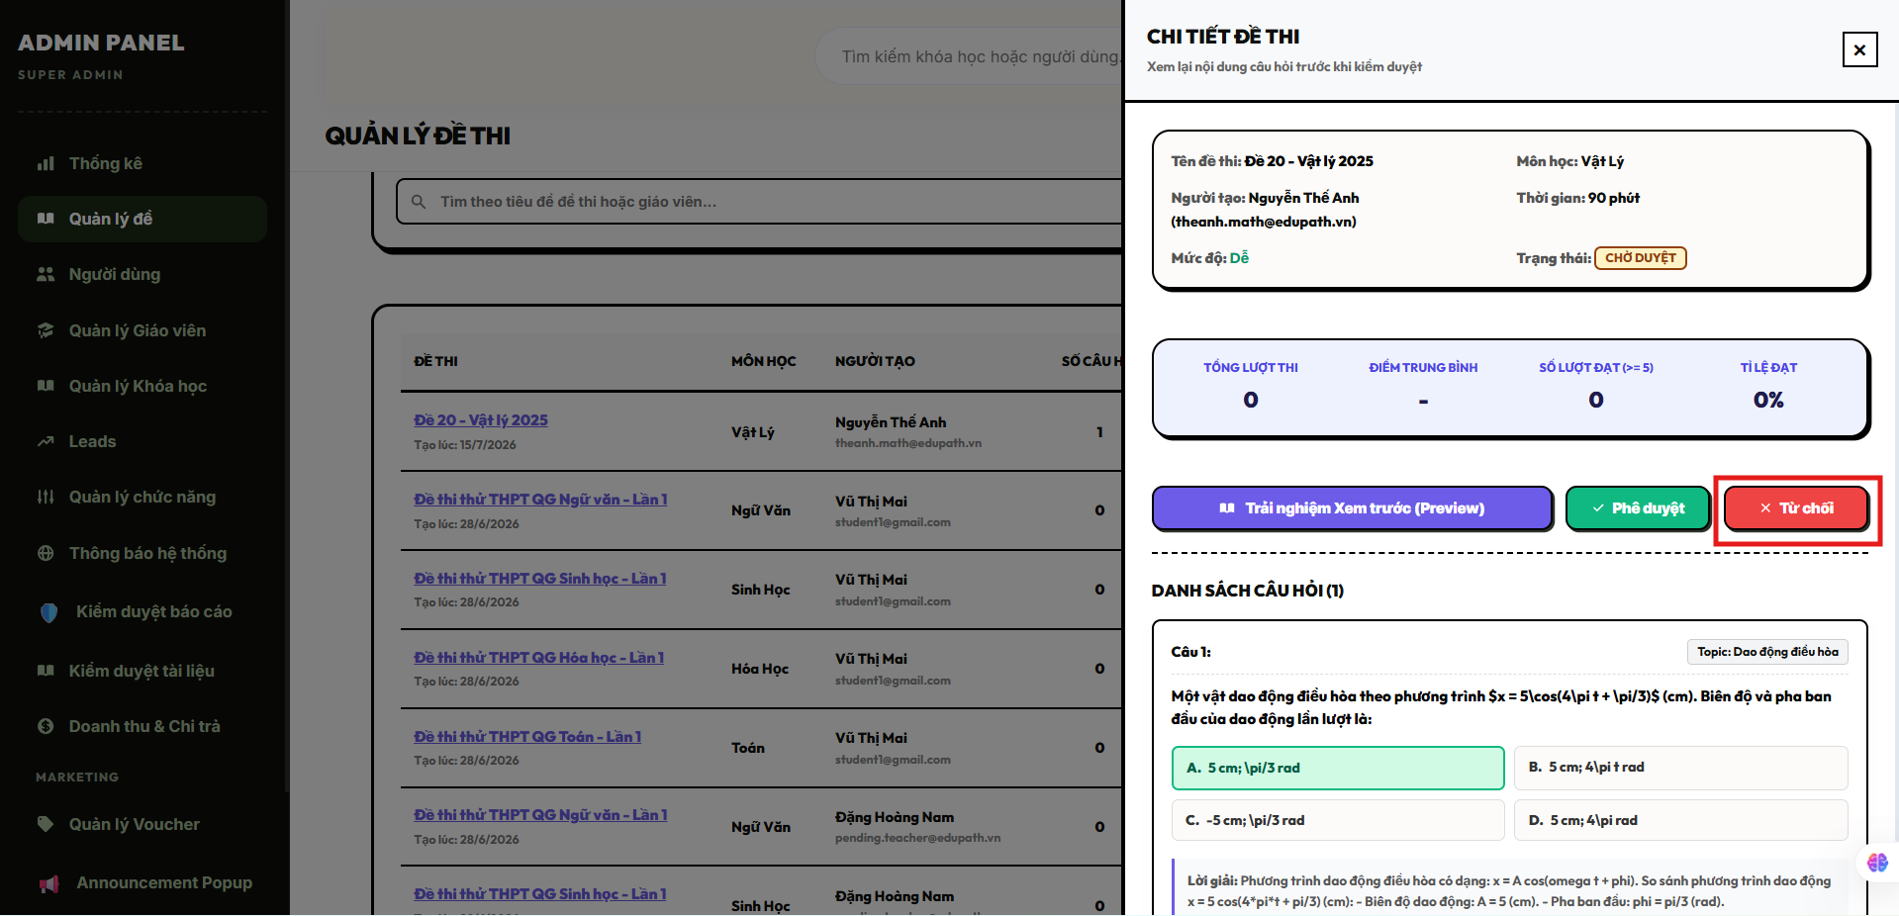
Field Name | Field Type | Description
Modal Header | Heading | Displays the critical status tracking title text "Xác nhận gỡ bỏ đề thi".
Contextual Warning Text | Text Label | Dynamic text element alerting users of system behavior types (Hard Delete vs Archive) based on background structural dependency scans.
Button “Xác nhận” | Button | Red danger button element triggering target transaction execution routines on the backend SQL database layer.
Button “Hủy bỏ” | Button | Standard cancellation component to terminate the removal intent, close the pop-up modal, and preserve current data states.

Database Access
Table | CRUD | Description
Exams | R, U, D | Reads test identity attributes (R), updates status fields to 'archived' when matching student logs are verified (U), or executes physical row purges on clean rows (D).
UserExamResults | R | Queries active registration ledger blocks to look for existing student score histories connected to the test target (R).
1. Query to evaluate active student history dependencies before deciding on table delete methods
SQL
SELECT
COUNT(1) AS [ActiveAttemptHeadcount]
FROM [dbo].[UserExamResults]
WHERE [exam_id] = @TargetExamID; -- Relational safety test: scan if any student records map to this identifier

2. Transaction processing statement block implementing conditional hard-delete or archive status mutations safely
SQL
BEGIN TRANSACTION;
BEGIN TRY
-- 1. Establish ownership boundary controls prior to executing tables alterations
IF NOT EXISTS (
SELECT 1 FROM [dbo].[Exams]
WHERE [id] = @TargetExamID
AND ([creator_id] = @CurrentUserID OR @CurrentUserRole = 'admin') -- Authorization safety shield[cite: 1]
)
BEGIN
RAISERROR('MSG-ERR: Unauthorized access or invalid examination target record identifier.', 16, 1);
END;

-- 2. Execute conditional structural routing based on the existence of student attempt records
IF EXISTS (SELECT 1 FROM [dbo].[UserExamResults] WHERE [exam_id] = @TargetExamID)[cite: 1]
BEGIN
-- Target history logs exist: Mutation update to 'archived' state preserves the relational integrity trees[cite: 1]
UPDATE [dbo].[Exams]
SET
[status] = 'archived', -- Constraint token match: 'draft','published','archived'[cite: 1]
[updated_at] = GETDATE()
WHERE [id] = @TargetExamID;
END
ELSE
BEGIN
-- Zero student history logs exist: Safe to perform deep physical removal of the target configuration row
-- Note: ExamQuestions table row elements are cleared out automatically via ON DELETE CASCADE[cite: 1]
DELETE FROM [dbo].[Exams]
WHERE [id] = @TargetExamID;
END;

COMMIT TRANSACTION;
END TRY
BEGIN CATCH
ROLLBACK TRANSACTION;
THROW;
END CATCH;

12.4 View Test
Allows authenticated users (Instructors, Administrators, or enrolled Students) to access and view the configuration profile, operational rules, instructions, and structural question layout of a specific examination or quiz dataset entry within the platform.

UI Design
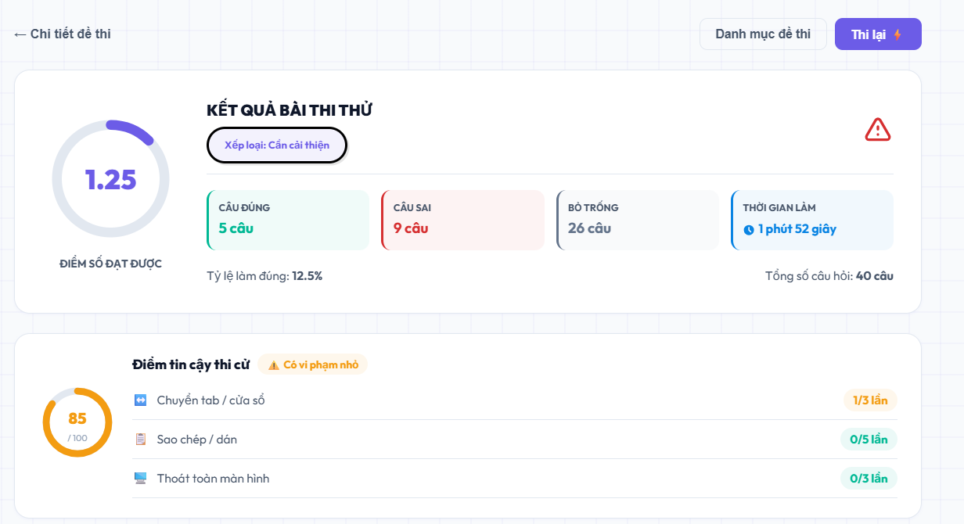
Field Name | Field Type | Description
Section Header | Heading | Displays the module workspace subtitle text "Chi tiết đề thi".
Label “Tiêu đề đề thi” | Data Label | Renders the alphanumeric title string of the test entity; displays title.
Label “Loại đề thi” | Data Label | Renders the specific evaluation blueprint category code type (course_quiz, mock_exam, thpt_simulation, ai_generated).
Label “Thời gian giới hạn” | Data Label | Displays the formatted runtime constraints derived from total tracking seconds; displays time_limit_sec.
Label “Điểm đạt yêu cầu” | Data Label | Renders the explicit pass/fail numeric target line parameter; displays pass_score.
Label “Số lượt thi tối đa” | Data Label | Renders the maximum session load allocation boundary parameter per student profile; displays max_attempts.
Label “Thời gian hiệu lực” | Data Label | Displays the scheduled calendar access window parameters (start_time to end_time).
Block “Hướng dẫn/Mô tả” | Text Area | Renders the rich informational text block defining exam criteria guidelines; displays description.
Grid “Danh sách câu hỏi” | Data Table Grid | Tabular view displaying the sequence index order (sort_order), question prompt snippets (question_text), difficulty tiers, and point values (point_value).
Button “Bắt đầu làm bài” | Button | Context-aware execution link component enabling students to launch an interactive quiz session thread.
Button “Quay lại” | Button | Standard navigation component to clear the dashboard state view layout and step back to the primary index tree.

Database Access
Table | CRUD | Description
Exams | R | Reads target examination configurations, validity schedules, constraint values, and state status tokens (R).
ExamQuestions | R | Fetches the relational matrix rows linking question entities to the parent exam blueprint array instance (R).
Questions | R | Extracts descriptive plaintext prompt data blocks, types, and cognitive levels for user display grids (R).
Users | R | Queries user profile identity rows to attach the complete full name string of the test creator (R).
1. Query to fetch the master test metadata and creator information parameters
SQL
SELECT
e.[id] AS [ExamID],
e.[title] AS [ExamTitle],
e.[description] AS [ExamDescription],
e.[time_limit_sec] AS [TimeLimitSec],
e.[pass_score] AS [PassScore],
e.[max_attempts] AS [MaxAttempts],
e.[exam_type] AS [ExamType],
e.[status] AS [ExamStatus], -- Tracks constraints: 'draft','published','archived'[cite: 1]
e.[start_time] AS [StartTime],
e.[end_time] AS [EndTime],
u.[full_name] AS [CreatorFullName][cite: 1]
FROM [dbo].[Exams] e
LEFT JOIN [dbo].[Users] u ON e.[creator_id] = u.[id][cite: 1]
WHERE e.[id] = @TargetExamID
AND e.[status] <> 'archived'; -- Privacy boundary fence: restrict direct dashboard loading of deleted/archived configurations[cite: 1]

2. Query to fetch the complete structured question distribution layout set mapping point values
SQL
SELECT
eq.[sort_order] AS [QuestionSortOrder],[cite: 1]
eq.[point_value] AS [QuestionPointValue],[cite: 1]
q.[id] AS [QuestionID],
q.[question_text] AS [QuestionTextPrompt],[cite: 1]
q.[difficulty] AS [DifficultyTier], -- Checked constraints: 'easy','medium','hard'[cite: 1]
q.[question_type] AS [QuestionType] -- Checked constraints: 'single_choice','multiple_choice','true_false','essay'[cite: 1]
FROM [dbo].[ExamQuestions] eq
JOIN [dbo].[Questions] q ON eq.[question_id] = q.[id][cite: 1]
WHERE eq.[exam_id] = @TargetExamID[cite: 1]
ORDER BY eq.[sort_order] ASC;

13. Question Bank

13.1 Create Question
Allows authenticated instructors (Teacher) or administrators (Admin) to write, format, and register a new standalone assessment item into the centralized system question repository, defining its cognitive difficulty tiers, taxonomy mappings, answer options layout, and written pedagogical explanations.

UI Design
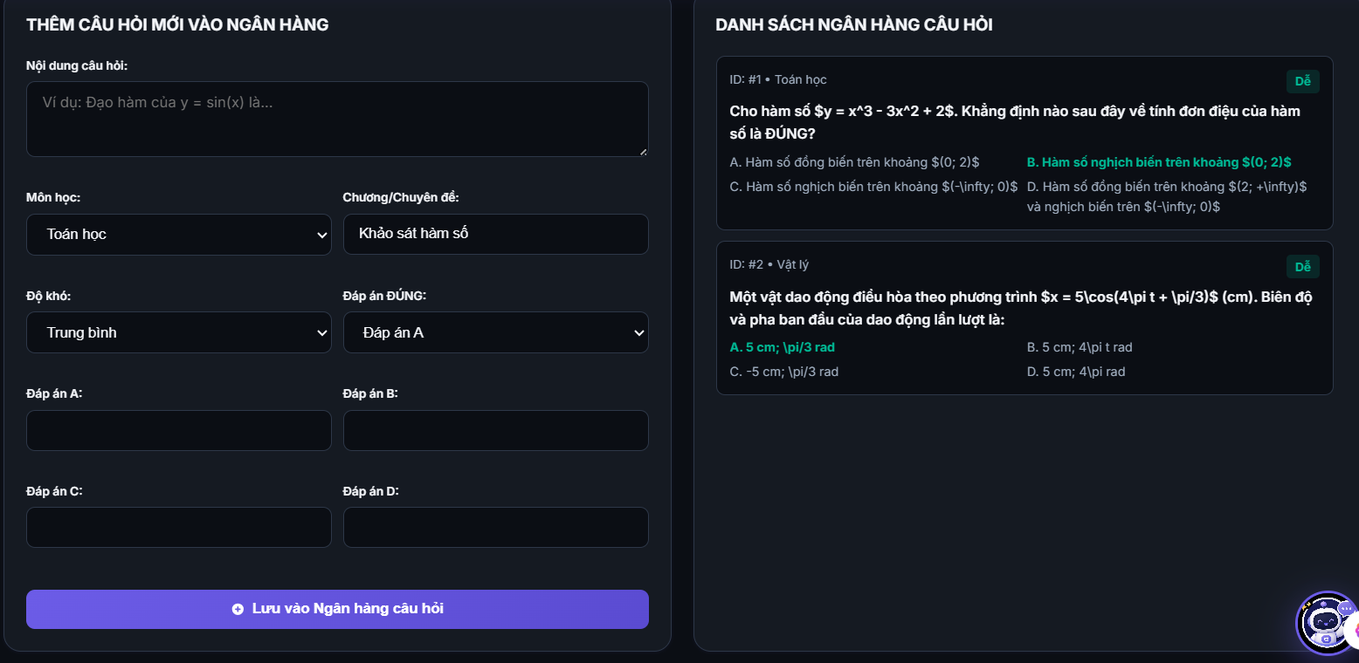
Field Name | Field Type | Description
Section Header | Heading | Displays the module workspace action subtitle text "Thêm câu hỏi mới".
Textarea “Nội dung câu hỏi” | Text Area | Captures the primary question prompt body layout text; maps to question_text (NVARCHAR(MAX)).
Dropdown “Môn học” | Dropdown List | Selection picker specifying the target master subject category from the Subjects table.
Dropdown “Chủ đề” | Dropdown List | Selection lookup list narrowing down technical taxonomy categories from the Topics table.
Dropdown “Độ khó” | Dropdown List | Evaluates cognitive complexity limits; constrained to strict tokens: easy, medium, or hard.
Dropdown “Loại câu hỏi” | Dropdown List | Controls option rendering mechanics; checked via parameters: single_choice, multiple_choice, true_false, or essay.
Input “Nội dung đáp án” | Input Field (Text) | Dynamic collection of text input components storing selection variables; maps to option_text.
Checkbox “Đáp án đúng” | Toggle / Checkbox | Configuration bit flag defining whether a specific choice solves the question prompt correctly; maps to is_correct.
Textarea “Giải thích” | Text Area | Rich plaintext components providing comprehensive step-by-step solution logic; maps to explanation.
Button “Lưu câu hỏi” | Button | Primary execution action to trigger local asset validation, write a live record, and save it to the bank ledger.
Button “Hủy bỏ” | Button | Safe navigation fallback control to reset local memory state components and step back to the bank grid index.
Validation Error Text | Text Label | Contextual red interface warnings mapping out error exceptions (e.g., "Mã lỗi: Phải chỉ định ít nhất một đáp án đúng").

Database Access
Table | CRUD | Description
Questions | C, R | Reads catalog matrices to confirm context mapping safety (R), and writes the initialized core parent question block entity (C).
QuestionOptions | C | Serializes and appends the dynamic collection list of selection choices linked directly to the parent question context (C).
Subjects | R | Reads standard validation markers to ensure the chosen master structural domain path is live and active (R).
Topics | R | Reads subject-topic dependencies to ensure structural consistency across categories (R).
1. Query to verify relational node context active statuses before executing text persistence writes
SQL
-- Confirm target subject scope is live inside active systems registries
SELECT [id], [is_active] FROM [dbo].[Subjects] WHERE [id] = @SelectedSubjectID AND [is_active] = 1;[cite: 1]

-- Confirm subtopic grouping matches the selected subject identity block context
SELECT [id], [subject_id] FROM [dbo].[Topics] WHERE [id] = @SelectedTopicID AND [subject_id] = @SelectedSubjectID;[cite: 1]

2. Multi-table transaction engine processing block to serialize parent questions and alternative option arrays safely
SQL
BEGIN TRANSACTION;
BEGIN TRY
-- 1. Fire defensive validation loops verifying that text fields are not blank
IF (@QuestionText IS NULL OR LEN(TRIM(@QuestionText)) = 0)
BEGIN
RAISERROR('MSG-ERR: Core question statement body prompt cannot be left empty.', 16, 1);
END;
-- 2. Insert master parent record variables into primary Questions repository table
DECLARE @GeneratedQuestionID BIGINT;

INSERT INTO [dbo].[Questions] (
[subject_id],
[topic_id],
[creator_id],
[question_text],
[explanation],
[difficulty], -- Enforces check constraint: 'easy','medium','hard'
[question_type], -- Enforces check constraint: 'single_choice','multiple_choice','true_false','essay'[cite: 1]
[source], -- Default system assignment standard: 'teacher'[cite: 1]
[is_active],
[created_at],
[updated_at]
)
VALUES (
@SelectedSubjectID,
@SelectedTopicID,
@CurrentUserID,
TRIM(@QuestionText),
TRIM(@ExplanationText),
ISNULL(@DifficultyTier, 'medium'),[cite: 1]
@QuestionType,
'teacher', -- Set directly to teacher creator root directory marker[cite: 1]
1,
GETDATE(),
GETDATE()
);

-- Capture system generated index key identity pointer
SET @GeneratedQuestionID = SCOPE_IDENTITY();

-- 3. Loop logic wrapper block handled via middleware to insert choice arrays into QuestionOptions
-- (The statement block below maps out a baseline structural template for an individual option insert)
INSERT INTO [dbo].[QuestionOptions] (
[question_id],[cite: 1]
[option_text],[cite: 1]
[is_correct],[cite: 1]
[sort_order][cite: 1]
)
VALUES
(@GeneratedQuestionID, TRIM(@OptionTextA), @IsCorrectA, 1),
(@GeneratedQuestionID, TRIM(@OptionTextB), @IsCorrectB, 2),
(@GeneratedQuestionID, TRIM(@OptionTextC), @IsCorrectC, 3),
(@GeneratedQuestionID, TRIM(@OptionTextD), @IsCorrectD, 4);

COMMIT TRANSACTION;
END TRY
BEGIN CATCH
ROLLBACK TRANSACTION;
THROW;
END CATCH;

13.2 Edit Question
Allows authenticated instructors (Teacher) or administrators (Admin) to modify the text prompt, cognitive difficulty tier, topic taxonomy categorization, alternative options structure, or pedagogical explanation text of an existing question asset inside the centralized repository.

UI Design

Field Name | Field Type | Description
Section Header | Heading | Displays the module workspace action title text "Chỉnh sửa câu hỏi".
Textarea “Nội dung câu hỏi” | Text Area | Displays and captures modifications to the primary question statement; maps to question_text (NVARCHAR(MAX)).
Dropdown “Môn học” | Dropdown List | Modifies the target master subject division mapping connected to the Subjects table.
Dropdown “Chủ đề” | Dropdown List | Adjusts specific curricular subtopic taxonomy mappings matching the Topics schema table.
Dropdown “Độ khó” | Dropdown List | Adjusts the calculated cognitive complexity metric tier; restricted to: easy, medium, or hard.
Dropdown “Loại câu hỏi” | Dropdown List | Configures choice evaluation parsing boundaries; values include: single_choice, multiple_choice, true_false, or essay.
Input “Nội dung đáp án” | Input Field (Text) | Dynamic field wrappers enabling modification of the alternative choice strings; maps to option_text.
Checkbox “Đáp án đúng” | Checkbox / Toggle | Flags whether the corresponding data row choice serves as a valid solution key parameter; maps to is_correct.
Textarea “Giải thích” | Text Area | Captures edited textual hints detailing step-by-step resolution logic paths; maps to explanation.
Button “Cập nhật thay đổi” | Button | Main operational trigger to run database schema constraint validations and persist updates across related tables.
Button “Hủy bỏ” | Button | Standard navigation rollback control to dump current interface changes and return back to the primary bank data grid view.
Validation Error Text | Text Label | Contextual red validation label tracking field input exceptions (e.g., "Mã lỗi: Nội dung câu hỏi không được bỏ trống").

Database Access
Table | CRUD | Description
Questions | R, U | Queries question identifiers to confirm row existence and state configurations (R), and updates content cells with modified parameter values (U).
QuestionOptions | C, D | Performs hard-purges of obsolete selection rows linked to the parent question key (D), and re-inserts updated dynamic choice alternative datasets (C).
1. Query to evaluate editing permissions and record liveness flags prior to updating values
SQL
SELECT
[id] AS [QuestionID],
[creator_id] AS [CreatorID],
[is_active] AS [LivenessStatus]
FROM [dbo].[Questions]
WHERE [id] = @TargetQuestionID; -- Safety boundary: ensure target entity exists inside current workspace rows[cite: 1]

2. Transaction processing statement block updating parent question values and refreshing choice matrices
SQL
BEGIN TRANSACTION;

BEGIN TRY
-- 1. Enforce validation boundaries on empty inputs
IF (@QuestionText IS NULL OR LEN(TRIM(@QuestionText)) = 0)
BEGIN
RAISERROR('MSG-ERR: Main question text body prompt cannot be null or blank string rows.', 16, 1);
END;

-- 2. Execute explicit field level updates on the parent Questions row entry
UPDATE [dbo].[Questions]
SET
[subject_id] = @SelectedSubjectID,
[topic_id] = @SelectedTopicID,
[question_text] = TRIM(@QuestionText),
[explanation] = TRIM(@ExplanationText),
[difficulty] = @DifficultyTier, -- Constrained via check: 'easy','medium','hard'[cite: 1]
[question_type] = @QuestionType, -- Constrained via check: 'single_choice','multiple_choice','true_false','essay'[cite: 1]
[updated_at] = GETDATE()
WHERE [id] = @TargetQuestionID
AND ([creator_id] = @CurrentUserID OR @CurrentUserRole = 'admin'); -- Authorization boundary check[cite: 1]

-- 3. Synchronize alternative selection options array entries
-- Clear out stale legacy choice rows bound to the question ID parent key
DELETE FROM [dbo].[QuestionOptions]
WHERE [question_id] = @TargetQuestionID;[cite: 1]

-- Re-populate fresh choice datasets reflecting updated client interface layouts
INSERT INTO [dbo].[QuestionOptions] (
[question_id],[cite: 1]
[option_text],[cite: 1]
[is_correct],[cite: 1]
[sort_order][cite: 1]
)
VALUES
(@TargetQuestionID, TRIM(@OptionTextA), @IsCorrectA, 1),
(@TargetQuestionID, TRIM(@OptionTextB), @IsCorrectB, 2),
(@TargetQuestionID, TRIM(@OptionTextC), @IsCorrectC, 3),
(@TargetQuestionID, TRIM(@OptionTextD), @IsCorrectD, 4);

COMMIT TRANSACTION;
END TRY
BEGIN CATCH
ROLLBACK TRANSACTION;
THROW;
END CATCH;

13.3 Delete Question
Allows authenticated instructors (Teacher) or administrators (Admin) to remove an assessment item from the active question bank workspace. The system performs a data dependency scan within the EduPath_v2_Complete.sql schema framework: if a question is already tied to active test configurations (ExamQuestions) or student historical submissions (UserAnswers), it undergoes a safe logical soft-delete by toggling its liveness flag (is_active = 0) to preserve platform integrity. Otherwise, unreferenced questions undergo a clean physical purge.

UI Design
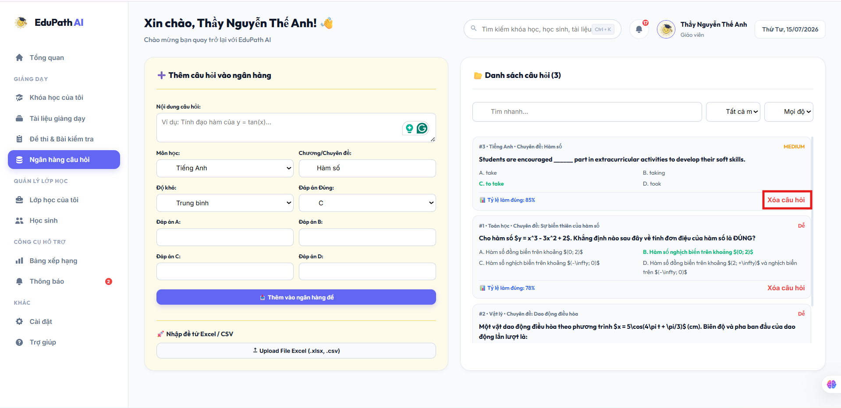
Field Name | Field Type | Description
Modal Header | Heading | Displays the structural warning safety title text "Xác nhận xóa câu hỏi".
Warning Message | Text Label | Contextual text notification layout describing whether the target row will be hard-deleted or soft-disabled based on current relational constraints.
Button “Xác nhận gỡ bỏ” | Button | Crimson danger action control components triggering validation logic and execution transactions on the backend relational layer.
Button “Hủy bỏ” | Button | Standard navigation escape path component to cancel database mutation operations and hide the modal layer.

Database Access
Table | CRUD | Description
Questions | R, U, D | Reads identity markers (R), sets the liveness state bit wrapper is_active = 0 during logical soft-purges (U), or executes hard row deletions on clean items (D).
ExamQuestions | R | Queries active exam assembly matrices to check for parent evaluation roadmap dependencies (R).
UserAnswers | R | Scans student exam paper submission sheets to prevent orphan data breaks on historical logs (R).
1. Query to scan evaluation and answer sheet record dependencies prior to choosing table modification paths
SQL
SELECT
(SELECT COUNT(1) FROM [dbo].[ExamQuestions] WHERE [question_id] = @TargetQuestionID) AS [ExamLinksCount],[cite: 1]
(SELECT COUNT(1) FROM [dbo].[UserAnswers] WHERE [question_id] = @TargetQuestionID) AS [StudentAnswersCount];[cite: 1]

2. Transaction processing statement block implementing conditional hard-purge or soft-deactivation routines safely
SQL
BEGIN TRANSACTION;

BEGIN TRY
-- 1. Establish strict permission rules boundary validation guards
IF NOT EXISTS (
SELECT 1 FROM [dbo].[Questions]
WHERE [id] = @TargetQuestionID
AND ([creator_id] = @CurrentUserID OR @CurrentUserRole = 'admin') -- Authorization safety lock
)
BEGIN
RAISERROR('MSG-ERR: Access denied or invalid question entity identifier context mapped.', 16, 1);
END;

-- 2. Execute target architectural routing based on the scanned dependency logs count
IF EXISTS (SELECT 1 FROM [dbo].[ExamQuestions] WHERE [question_id] = @TargetQuestionID)[cite: 1]
OR EXISTS (SELECT 1 FROM [dbo].[UserAnswers] WHERE [question_id] = @TargetQuestionID)[cite: 1]
BEGIN
-- Dependencies exist: Deploy logical soft-delete tracking to protect past transaction matrices integrity
UPDATE [dbo].[Questions]
SET
[is_active] = 0, -- Toggles status flag visibility matrix mapping[cite: 1]
[updated_at] = GETDATE()
WHERE [id] = @TargetQuestionID;
END
ELSE
BEGIN
-- Target is clean: Execute absolute physical removal from the persistent database tables
-- Note: QuestionOptions items are automatically dropped due to foreign key ON DELETE CASCADE settings[cite: 1].
DELETE FROM [dbo].[Questions]
WHERE [id] = @TargetQuestionID;
END;

COMMIT TRANSACTION;
END TRY
BEGIN CATCH
ROLLBACK TRANSACTION;
THROW;
END CATCH;

13.4 View Question
Allows authenticated instructors (Teacher), mentors (Mentor), or administrators (Admin) to review the structural composition, alternative option arrays, target taxonomy mappings, cognitive difficulty tiers, and technical metadata parameters of an individual question asset inside the centralized question repository.

UI Design
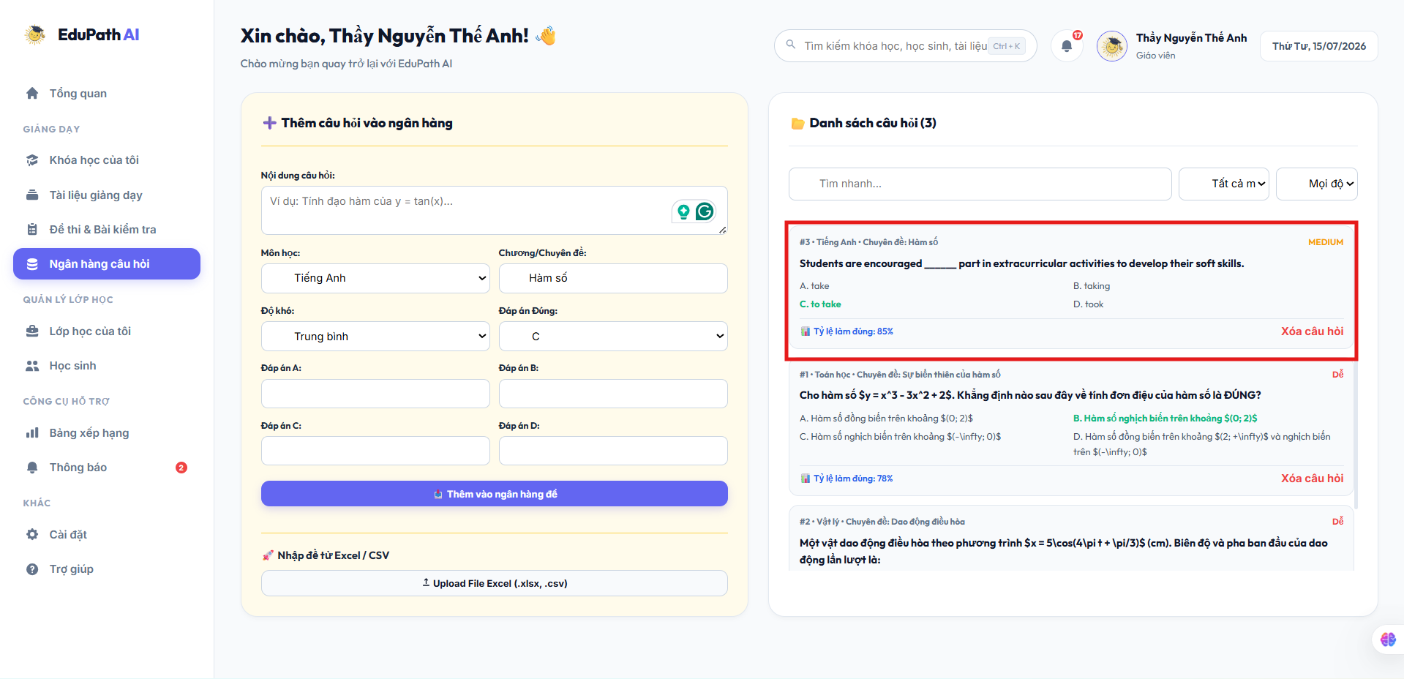
Field Name | Field Type | Description
Section Header | Heading | Displays the module workspace read-only profile title text "Chi tiết câu hỏi".
Block “Nội dung câu hỏi” | Text Viewport | Displays the core plaintext block prompt defining the assessment evaluation; displays question_text.
Label “Môn học” | Data Label | Renders the categorical master subject name identifier pulled from the Subjects table.
Label “Chủ đề” | Data Label | Renders the precise curricular node name string pulled from the Topics taxonomy table.
Label “Độ khó” | Data Label | Displays the mapped structural rating token string (easy, medium, or hard).
Label “Loại câu hỏi” | Data Label | Displays the mechanical selection format mapping parameter code (single_choice, multiple_choice, true_false, essay).
Label “Nguồn gốc” | Data Label | Identifies initial creation properties via explicit systemic markers (teacher, ai_approved, imported).
Grid “Danh sách đáp án” | Data List Grid | Renders tabular rows containing choice alternatives text (option_text), display sequencing (sort_order), and highlighted correct flag identifiers (is_correct).
Block “Lời giải thích” | Text Viewport | Renders rich text guidelines tracking detailed step-by-step solutions layout data; displays explanation.
Button “Quay lại” | Button | Standard navigation exit command to close the item inspection workspace profile and return back to the ledger catalog index tree.

Database Access
Table | CRUD | Description
Questions | R | Reads the core structural question record, context classifiers, authority keys, source tokens, and active visibility parameters (R).
Question Options | R | Fetches the complete dependent relational array of choice alternatives linked to the parent question identifier row index (R).
Subjects | R | Queries active lookup directories to map descriptive textual names to system subject identifiers (R).
Topics | R | Queries active subtopic partitions to map descriptive programmatic labels to technical topic keys (R).
1. Query to retrieve the complete core question metadata profile and parent category string mappings
SQL
SELECT
q.[id] AS [QuestionID],
s.[name] AS [SubjectName], -- Maps lookup string directly from master subject schema
t.[name] AS [TopicName], -- Maps lookup string directly from master subtopic taxonomy
q.[question_text] AS [QuestionPromptText],
q.[explanation] AS [PedagogicalExplanation],
q.[difficulty] AS [CognitiveDifficultyTier], -- Value checked: 'easy','medium','hard'
q.[question_type] AS [SelectionTypeCode], -- Value checked: 'single_choice','multiple_choice','true_false','essay'
q.[source] AS [OriginSourceType], -- Value checked: 'teacher','ai_approved','imported'
q.[is_active] AS [LivenessBitFlag],
q.[created_at] AS [CreationTimestamp],
q.[updated_at] AS [LastModificationTimestamp]
FROM [dbo].[Questions] q
LEFT JOIN [dbo].[Subjects] s ON q.[subject_id] = s.[id]
LEFT JOIN [dbo].[Topics] t ON q.[topic_id] = t.[id]
WHERE q.[id] = @TargetQuestionID; -- Data fence: loads individual specific structural row data lines

2. Query to load corresponding dynamic alternative selection options array list rows
SQL
SELECT
qo.[id] AS [OptionID],
qo.[option_text] AS [AlternativeChoiceText],
qo.[is_correct] AS [IsCorrectSolutionKey], -- Binary bit parameter validating valid answer states
qo.[sort_order] AS [LayoutSequenceOrdering] -- Enforces design structure layout consistency across user viewports
FROM [dbo].[QuestionOptions] qo
WHERE qo.[question_id] = @TargetQuestionID
ORDER BY qo.[sort_order] ASC; -- Keeps stable sequential layout rendering parameters

14 . System & Account Administration

14.1 Monitor System Activities
Allows authenticated system administrators (Admin) to inspect, filter, and track transactional activity audits, security actions, and operational modifications executed across the entire platform ecosystem by parsing structured database logs.

UI Design
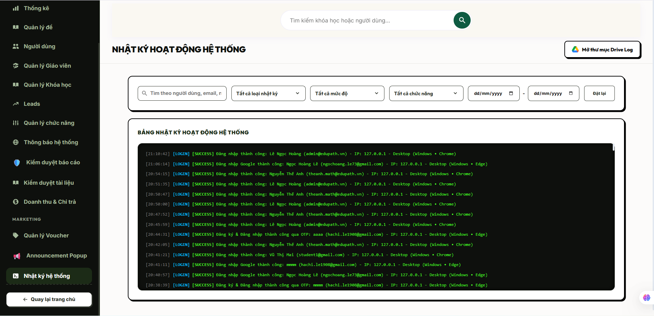
Field Name | Field Type | Description
Section Header | Heading | Displays the module workspace system oversight page title text "Giám sát nhật ký hoạt động".
Dropdown “Loại hành động” | Dropdown List | Advanced grouping lookup component enabling admins to sort rows via precise operation tags; filters by action.
Input “Mã người dùng” | Input Field (Text) | Numeric mask text box accepting exact user identifier configurations to trace user paths; filters by user_id.
Picker “Khoảng thời gian” | Date Range Picker | Calendar calendar picker array setting bounding dates to isolate specific events timeline rows; checks created_at.
Grid “Bảng nhật ký hoạt động” | Data Table Grid | Multi-column grid interface rendering the historical stream layout metadata rows mapped out directly from database storage indices.
Button “Xem chi tiết Metadata” | Button | Micro action control button initializing a readable side sheet overlaying the raw logging attributes parameter block; loads metadata.
Button “Làm mới dữ liệu” | Button | Operational interface refresh trigger to clear client side cache buffers and force reload the index state.

Database Access
Table | CRUD | Description
SystemActivityLogs | R | Reads historical operational log metrics, metadata JSON strings, execution network metrics, and timestamp arrays (R).
Users | R | Performs standard join operations to fetch user full name lines and email attributes matching log records (R).
1. Query to populate the structured monitoring data table grid utilizing system index keys
SQL
SELECT TOP 100 -- Enforces system performance throttling guidelines to prevent viewport lag layers
sal.[id] AS [LogID],
sal.[user_id] AS [UserID],
u.[full_name] AS [ActorFullName], -- Joined metadata tracing account identity
u.[email] AS [ActorEmail], -- Joined identifier proving security tracking
sal.[action] AS [ExecutedAction], -- Explicit system marker tag (e.g., 'login', 'purchase', 'approve_question')
sal.[entity_type] AS [TargetEntityType], -- Category indicator explaining object framework scope
sal.[entity_id] AS [TargetEntityID], -- Core unique foreign key tracking target records
sal.[ip_address] AS [ClientIPAddress], -- Network tracking signature capturing user entry locations
sal.[user_agent] AS [ClientUserAgent], -- Web request application descriptor string
sal.[created_at] AS [LoggedTimestamp] -- Absolute timestamp derived from server runtime database clock
FROM [dbo].[SystemActivityLogs] sal WITH (NOLOCK) -- Deploys dirty read insulation metrics to eliminate logging block locks
LEFT JOIN [dbo].[Users] u ON sal.[user_id] = u.[id]
WHERE (@FilterAction IS NULL OR sal.[action] = @FilterAction)
AND (@FilterUserID IS NULL OR sal.[user_id] = @FilterUserID)
AND (@StartDate IS NULL OR sal.[created_at] >= @StartDate)
AND (@EndDate IS NULL OR sal.[created_at] <= @EndDate)
ORDER BY sal.[created_at] DESC; -- Matches idx_sal_created indexing metrics for high speed sequencing optimization

2. Query to load deep contextual metadata attribute payload block maps for an individual row event
SQL
SELECT
[id] AS [LogID],
[metadata] AS [JSONExtraPayloadInfo] -- Pulls rich raw contextual structural details stored as flexible strings
FROM [dbo].[SystemActivityLogs]
WHERE [id] = @TargetLogID; -- Secure single unique identity point cell lookup boundary constraint

14.2 Lock/Unlock Account
Allows authenticated system administrators (Admin) to control, suspend, or restore platform access privileges for specific user accounts by mutating the state flag parameter (is_active) inside the core registry database table. This structural boundary serves as a protective enforcement layer to instantly lock out malicious or non-compliant users or securely reactivate profiles following a verified dispute resolution workflow.

UI Design
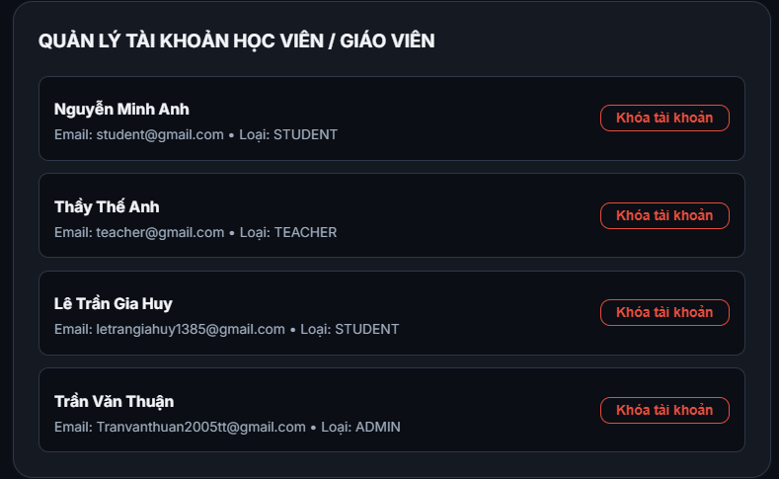
Field Name | Field Type | Description
Section Header | Heading | Displays the module modal layout administrative title text "Thay đổi trạng thái tài khoản".
Label “Thông tin người dùng” | Data Label | Clear plaintext interface indicator rendering target identity parameters; loads id, full_name, and email.
Toggle “Trạng thái kích hoạt” | Switch / Toggle | Mechanical interface switch changing the operational database bit status; maps to is_active.
Input “Lý do thực thi” | Input Field (Text) | Mandatory alphanumeric text block capturing the administrative purpose or case reference tracking description.
Button “Xác nhận thực thi” | Button | Crimson execution trigger processing formatting rules constraints, altering user flags, and pushing log tracks.
Button “Hủy bỏ” | Button | Standard safety recovery option button to dump pending inputs and exit the status configuration modal workspace.

Database Access
Table | CRUD | Description
Users | R, U | Queries baseline registration cells to verify entity existence and load active flags (R), and updates the bit parameter is_active upon command execution (U).
SystemActivityLogs | C | Generates and records an immutable chronological audit trail string capturing the enforcement details payload (C).
1. Query to inspect user details, active profile status flags, and ownership rows context
SQL
SELECT
[id] AS [UserID],
[email] AS [UserEmail],[cite: 1]
[full_name] AS [UserFullName],[cite: 1]
[is_active] AS [CurrentLivenessState] -- Returns current active state value: 1 = Active, 0 = Locked[cite: 1]
FROM [dbo].[Users]
WHERE [id] = @TargetUserID; -- Absolute primary index pointer cell lookups[cite: 1]

2. Transaction processing statement block to mutate account access parameters and write security audits
SQL
BEGIN TRANSACTION;

BEGIN TRY
-- 1. Fail-fast defensive validation barrier: Prevent administrators from locking themselves out
IF (@TargetUserID = @CurrentAdminID)
BEGIN
RAISERROR('MSG-ERR: System safety constraint violation. Administrators cannot lock their own accounts.', 16, 1);
END;

-- 2. Execute target mutation updates directly targeting the specified core account index row
UPDATE [dbo].[Users]
SET
[is_active] = @NewActiveState, -- Pushes explicit bit variables parameters: 0 for Locked, 1 for Active[cite: 1]
[updated_at] = GETDATE() -- Updates structural timestamp clock records[cite: 1]
WHERE [id] = @TargetUserID;

-- 3. Serialize contextual operational details and append metadata logs inside systemic audit tables
INSERT INTO [dbo].[SystemActivityLogs] (
[user_id],
[action], -- Maps explicit operation indicator tokens (e.g., 'lock_account' or 'unlock_account')[cite: 1]
[entity_type],
[entity_id],
[ip_address],
[user_agent],
[metadata], -- Stores raw alphanumeric JSON tracks mapping enforcement reasoning configurations[cite: 1]
[created_at]
)
VALUES (
@CurrentAdminID, -- Identifies the administrator account triggering the security enforcement action[cite: 1]
CASE WHEN @NewActiveState = 0 THEN 'lock_account' ELSE 'unlock_account' END,[cite: 1]
'user',
@TargetUserID,
@ClientIPAddress,
@ClientUserAgent,
@EnforcementMetadataJSON, -- Structured layout string mapping out custom tracking contexts
GETDATE()
);

COMMIT TRANSACTION;
END TRY
BEGIN CATCH
ROLLBACK TRANSACTION;
THROW;
END CATCH;

14.3 Configure System
Allows authenticated system administrators (Admin) to adjust global operational variables, feature toggle settings, system maintenance flags, and platform-wide parameters (such as currency defaults, layout rules, or payment method endpoints), instantly applying changes across the runtime application layer.

UI Design
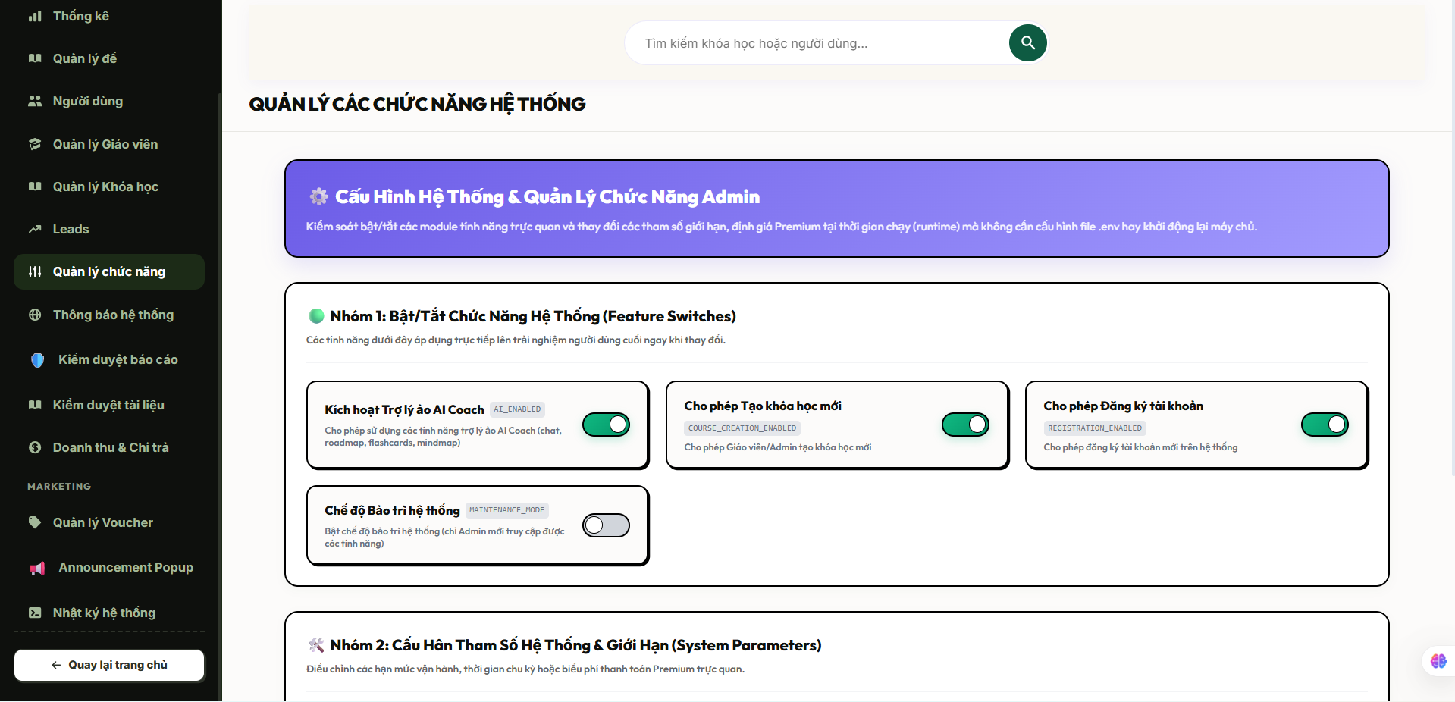
Field Name | Field Type | Description
Section Header | Heading | Displays the module workspace system management page title text "Cấu hình tham số hệ thống".
Tab Controller | Tab Component | Grouping controls separating configuration sets (e.g., "General", "Payment APIs", "Security Thresholds").
Input “Giá trị tham số” | Input Field / Text Area | Dynamic field accepting strings, numerical variables, or complex structured configuration payload cells.
Toggle “Chế độ bảo trì” | Switch / Toggle | Global system switch configuration setting; toggles the live environment state block into static backup maintenance layers.
Button “Áp dụng cấu hình” | Button | Primary execution action control to run data sanity checks, write structural system variables, and flush server caches.
Button “Khôi phục mặc định” | Button | Resets active tracking system parameters back to pre-compiled architectural default profiles.
Validation Error Text | Text Label | Contextual real-time inline script warnings indicating input rule failures (e.g., "Mã lỗi: Định dạng chuỗi cấu hình không hợp lệ").

Database Access
Table | CRUD | Description
System Configurations (Ext) | R, U | Queries global environment setup variable indicators (R), and updates specific application runtime parameter keys (U).
System Activity Logs | C | Serializes configuration mutation historical traces and writes defensive security logs for auditing loops (C).
Note on Schema Design: Global configurations are managed via an extensible key-value runtime architecture matrix table (SystemConfigurations) or global variables array registry mapped to protect cross-tenant system data logic streams.
1. Query to fetch the entire collection of active configuration parameters for admin viewports
SQL
SELECT
[config_key] AS [ConfigurationKey],
[config_value] AS [ActiveValue],
[description] AS [ParameterDescription],
[updated_at] AS [LastModifiedTimestamp]
FROM [dbo].[SystemConfigurations] WITH (NOLOCK); -- Fetches live configuration states without locking production processing lines

2. Transaction processing statement block to mutate active variables and commit audit log structures
SQL
BEGIN TRANSACTION;

BEGIN TRY
-- 1. Apply formatting validation safeguards to prevent corrupting core runtime properties
IF (@TargetConfigKey IS NULL OR LEN(TRIM(@TargetConfigKey)) = 0)
BEGIN
RAISERROR('MSG-ERR: Global configuration key identifiers cannot be null or empty.', 16, 1);
END;

-- 2. Execute explicit parameter mutation statement updates on target tracking registry row
UPDATE [dbo].[SystemConfigurations]
SET
[config_value] = TRIM(@NewConfigValuePayload),
[updated_at] = GETDATE()
WHERE [config_key] = TRIM(@TargetConfigKey);

-- 3. Append detailed trace information inside systemic metadata tracking log indices
INSERT INTO [dbo].[SystemActivityLogs] (
[user_id],
[action], -- Maps systemic operations execution token (e.g., 'update_system_config')
[entity_type],
[entity_id],
[ip_address],
[user_agent],
[metadata], -- Stores string parameters tracing both historical old values and updated configuration parameters
[created_at]
)
VALUES (
@CurrentAdminID, -- Identifies the authenticated administrator executing the setup adjustments
'update_system_config',
'system_configuration',
NULL, -- Global environment adjustments do not map to individual student or content tables entries
@ClientIPAddress,
@ClientUserAgent,
@ConfigMutationAuditJSON, -- Holds serialized parameters detailing old vs new variables layout maps
GETDATE()
);

COMMIT TRANSACTION;
END TRY
BEGIN CATCH
ROLLBACK TRANSACTION;
THROW;
END CATCH;

15. Subject Administration

15.1 Create Subject
Allows authenticated administrators (Admin) to register a new academic subject catalog domain into the centralized platform registry, specifying its official name, unique identifying code, and general curricular description.

UI Design
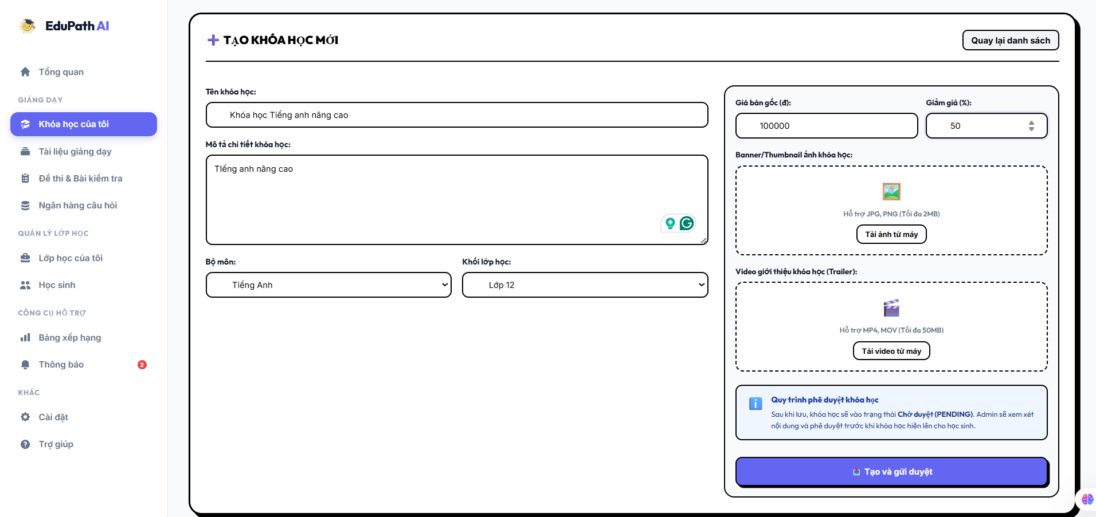
Field Name | Field Type | Description
Section Header | Heading | Displays the module workspace action subtitle text "Thêm môn học mới".
Input “Tên môn học” | Input Field (Text) | Captures the official title of the subject domain; maps directly to name (NVARCHAR(100)).
Input “Mã môn học” | Input Field (Text) | Captures the unique short alphanumeric code mapping identifier; maps to code (NVARCHAR(20)).
Textarea “Mô tả môn học” | Text Area | Accepts comprehensive plaintext notes detailing the scope of the subject; maps to description (NVARCHAR(MAX)).
Button “Lưu môn học” | Button | Primary execution trigger to validate input formats, verify constraint compliance, and persist records as active.
Button “Hủy bỏ” | Button | Safe rollback navigation link component to clear active state components and exit to the master subject index tree.
Validation Error Text | Text Label | Contextual real-time inline alerts indicating processing or indexing faults (e.g., "Tên môn học này đã tồn tại trên hệ thống").

Database Access
Table | CRUD | Description
Subjects | C, R | Scans active constraints indices to ensure data collision safety (R), and executes append routines to write the new master domain entry (C).
1. Query to evaluate name and code parameters uniqueness layout to prevent database index collisions
SQL
SELECT
COUNT(1) AS [CollisionCount]
FROM [dbo].[Subjects] WITH (NOLOCK)
WHERE [name] = TRIM(@SubjectName)
OR ([code] IS NOT NULL AND [code] = TRIM(@SubjectCode)); -- Enforces system level unique index safety[cite: 1]

2. Transaction processing architecture to initialize and write the unified subject record safely
SQL
BEGIN TRANSACTION;

BEGIN TRY
-- 1. Fast-failing data safety protection validation checks
IF (@SubjectName IS NULL OR LEN(TRIM(@SubjectName)) = 0)
BEGIN
RAISERROR('MSG-ERR: Subject name field is mandatory and cannot be left blank.', 16, 1);
END;

-- 2. Execute explicit atomic table write operations inside the master Subjects ledger
INSERT INTO [dbo].[Subjects] (
[name],
[code],
[description],
[is_active], -- Defaults to 1 via database schema specification[cite: 1]
[created_at]
)
VALUES (
TRIM(@SubjectName),
NULLIF(TRIM(@SubjectCode), ''), -- Transforms empty text rows safely into null cells[cite: 1]
TRIM(@SubjectDescription),
1, -- Enforces live system visibility by default[cite: 1]
GETDATE()
);

COMMIT TRANSACTION;
END TRY
BEGIN CATCH
ROLLBACK TRANSACTION;
THROW;
END CATCH;

15.2 Edit Subject
Allows authenticated administrators (Admin) to modify the master metadata, organizational code identifier, descriptive overview text, or system visibility lifecycle status (is_active) of an existing subject domain inside the centralized registry.

UI Design
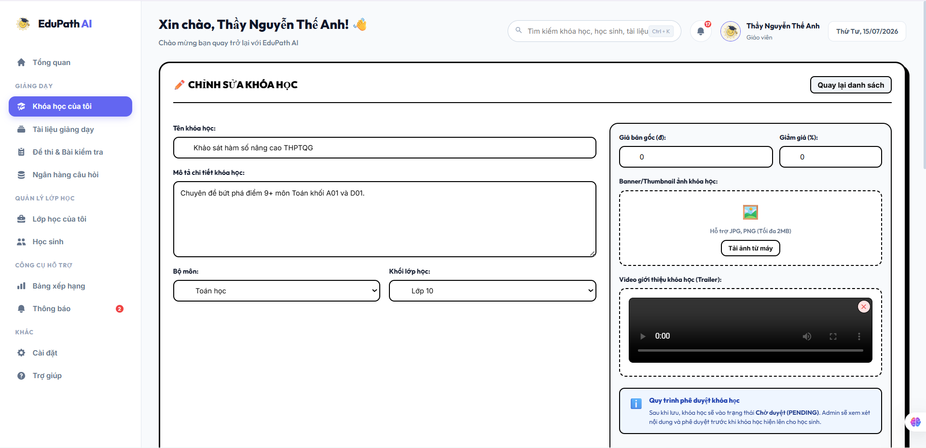
Field Name | Field Type | Description
Section Header | Heading | Displays the module workspace action subtitle text "Chỉnh sửa môn học".
Input “Tên môn học” | Input Field (Text) | Modifies the core alphanumeric name identifying the subject domain partition; maps to name.
Input “Mã môn học” | Input Field (Text) | Modifies the shorthand catalog matching identifier code; maps to code.
Textarea “Mô tả môn học” | Text Area | Accepts updated multi-line rich text guidelines describing the target curriculum; maps to description.
Toggle “Trạng thái” | Switch / Toggle | Adjusts the live active bit state wrapper regulating system-wide entity visibility; maps to is_active.
Button “Cập nhật thay đổi” | Button | Primary execution action control to run uniqueness format rules and save modified content to the database cells.
Button “Hủy bỏ” | Button | Reversion routing controller to dump pending parameters memory buffers and step back to the index tree.
Validation Error Text | Text Label | Contextual red alert banners tracing validation index faults (e.g., "Mã lỗi: Mã môn học này đã được sử dụng bởi danh mục khác").

Database Access
Table | CRUD | Description
Subjects | R, U | Queries the primary record cells to confirm entity baseline existence (R), and writes updated metadata variables into the target schema partition row (U).
1. Query to check active configuration record parameter layers prior to table write-backs
SQL
SELECT
[id] AS [SubjectID],
[name] AS [CurrentName],
[code] AS [CurrentCode],
[is_active] AS [CurrentActiveState][cite: 1]
FROM [dbo].[Subjects]
WHERE [id] = @TargetSubjectID; -- Basic primary index pointer target boundary check[cite: 1]

2. Transaction processing statement block to modify subject metadata parameters safely
SQL
BEGIN TRANSACTION;

BEGIN TRY
-- 1. Fail-fast validation rules checking for structural data collisions
IF (@SubjectName IS NULL OR LEN(TRIM(@SubjectName)) = 0)
BEGIN
RAISERROR('MSG-ERR: Core subject classification title text cannot be empty or null.', 16, 1);
END;

IF EXISTS (
SELECT 1 FROM [dbo].[Subjects]
WHERE ([name] = TRIM(@SubjectName) OR ([code] IS NOT NULL AND [code] = TRIM(@SubjectCode)))
AND [id] <> @TargetSubjectID -- Exclude the active row being updated from collision checks[cite: 1]
)
BEGIN
RAISERROR('MSG-ERR: Operational index conflict. Another subject matches the specified name or code.', 16, 1);
END;
2. Execute explicit atomic field level updates directly on the targeted registry row
UPDATE [dbo].[Subjects]
SET
[name] = TRIM(@SubjectName),
[code] = NULLIF(TRIM(@SubjectCode), ''), -- Normalizes blank fields into valid database null cells[cite: 1]
[description] = TRIM(@SubjectDescription),
[is_active] = @NewActiveState, -- Modifies the system visibility bit framework[cite: 1]
-- Note: created_at timestamp records remain unmodified to preserve historical trace timelines[cite: 1]
[updated_at] = GETDATE() -- Extensible auditing timestamp mapping configuration logic
WHERE [id] = @TargetSubjectID;[cite: 1]

COMMIT TRANSACTION;
END TRY
BEGIN CATCH
ROLLBACK TRANSACTION;
THROW;
END CATCH;

15.3 Delete Subject
Allows authenticated administrators (Admin) to remove a subject domain identifier entry from the active system workspace. The transactional architecture enforces strict integrity checks within the EduPath_v2_Complete.sql platform scheme: if the target subject row contains deep relational dependencies like connected modules (Topics), active training assets (Courses), or assessment components (Questions), it executes a soft logical deactivation by toggling its visibility state (is_active = 0) to maintain historical references safely. If the catalog partition is entirely unreferenced, a clean physical row purge is applied.

UI Design
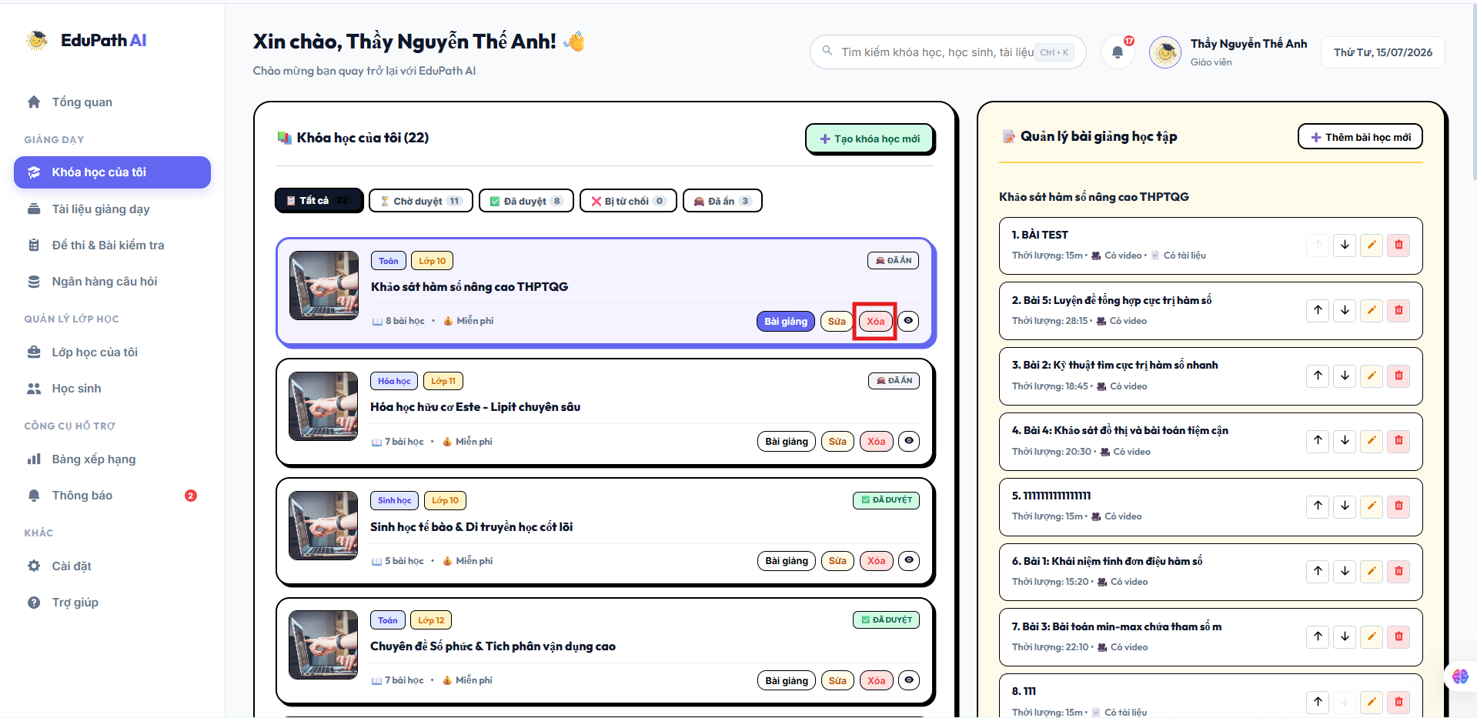
Field Name | Field Type | Description
Modal Header | Heading | Displays the module workspace system alert title text "Xác nhận gỡ bỏ danh mục môn học".
Contextual Warning Text | Text Label | Dynamic warning block tracking table constraints and instructing the admin on the outcome of the action (Hard Purge vs Soft Disable).
Button “Xác nhận xóa” | Button | Red execution button firing background schema dependency verification functions and processing row adjustments.
Button “Hủy bỏ” | Button | Standard cancellation layout component to dump deletion routines, close the modal, and protect current states.

Database Access
Table | CRUD | Description
Subjects | R, U, D | Queries item availability boundaries (R), sets the visibility state flag bit is_active = 0 during logical soft-purges (U), or executes physical row removals on clean entities (D).
Topics | R | Scans active taxonomy logs to find child structural topic chains tied to the parent subject ID (R).
Courses | R | Scans product registries to verify if any curricular courses are mapped underneath this catalog classification (R).
Questions | R | Scans standalone test bank collections to verify if assessment items map to the target domain index (R).
1. Query to count active child entity configurations tied to the target subject schema
SQL
SELECT
(SELECT COUNT(1) FROM [dbo].[Topics] WHERE [subject_id] = @TargetSubjectID) AS [ChildTopicsCount],[cite: 1]
(SELECT COUNT(1) FROM [dbo].[Courses] WHERE [subject_id] = @TargetSubjectID) AS [ChildCoursesCount],[cite: 1]
(SELECT COUNT(1) FROM [dbo].[Questions] WHERE [subject_id] = @TargetSubjectID) AS [ChildQuestionsCount];[cite: 1]

2. Transaction processing statement block executing conditional hard-delete or soft-deactivation safely
SQL
BEGIN TRANSACTION;

BEGIN TRY
-- 1. Verify primary entity row index lookup baseline integrity
IF NOT EXISTS (SELECT 1 FROM [dbo].[Subjects] WHERE [id] = @TargetSubjectID)[cite: 1]
BEGIN
RAISERROR('MSG-ERR: The targeted subject classification record does not exist inside active index blocks.', 16, 1);
END;

-- 2. Evaluate database relationship blocks to determine structural deletion paths
IF EXISTS (SELECT 1 FROM [dbo].[Topics] WHERE [subject_id] = @TargetSubjectID)[cite: 1]
OR EXISTS (SELECT 1 FROM [dbo].[Courses] WHERE [subject_id] = @TargetSubjectID)[cite: 1]
OR EXISTS (SELECT 1 FROM [dbo].[Questions] WHERE [subject_id] = @TargetSubjectID)[cite: 1]
BEGIN
-- Foreign dependencies detected: Execute soft logical modification to protect downstream platform constraints
UPDATE [dbo].[Subjects]
SET
[is_active] = 0, -- Toggles visibility bit wrapper to hide entry from client catalog layers[cite: 1]
[description] = CONCAT([description], N' (Deactivated on ', CAST(GETDATE() AS NVARCHAR(30)), N')')
WHERE [id] = @TargetSubjectID;[cite: 1]
END
ELSE
BEGIN
-- Zero dependencies mapped: Safe to issue absolute physical row termination from table storage blocks
DELETE FROM [dbo].[Subjects]
WHERE [id] = @TargetSubjectID;[cite: 1]
END;
COMMIT TRANSACTION;
END TRY
BEGIN CATCH
ROLLBACK TRANSACTION;
THROW;
END CATCH;

15.4 View Subject
Allows authenticated administrators (Admin) or instructors (Teacher) to inspect the master configurations, validation codes, and the hierarchical collection of associated sub-modules (Topics) or connected training assets (Courses) mapped under a specific subject catalog domain.

UI Design
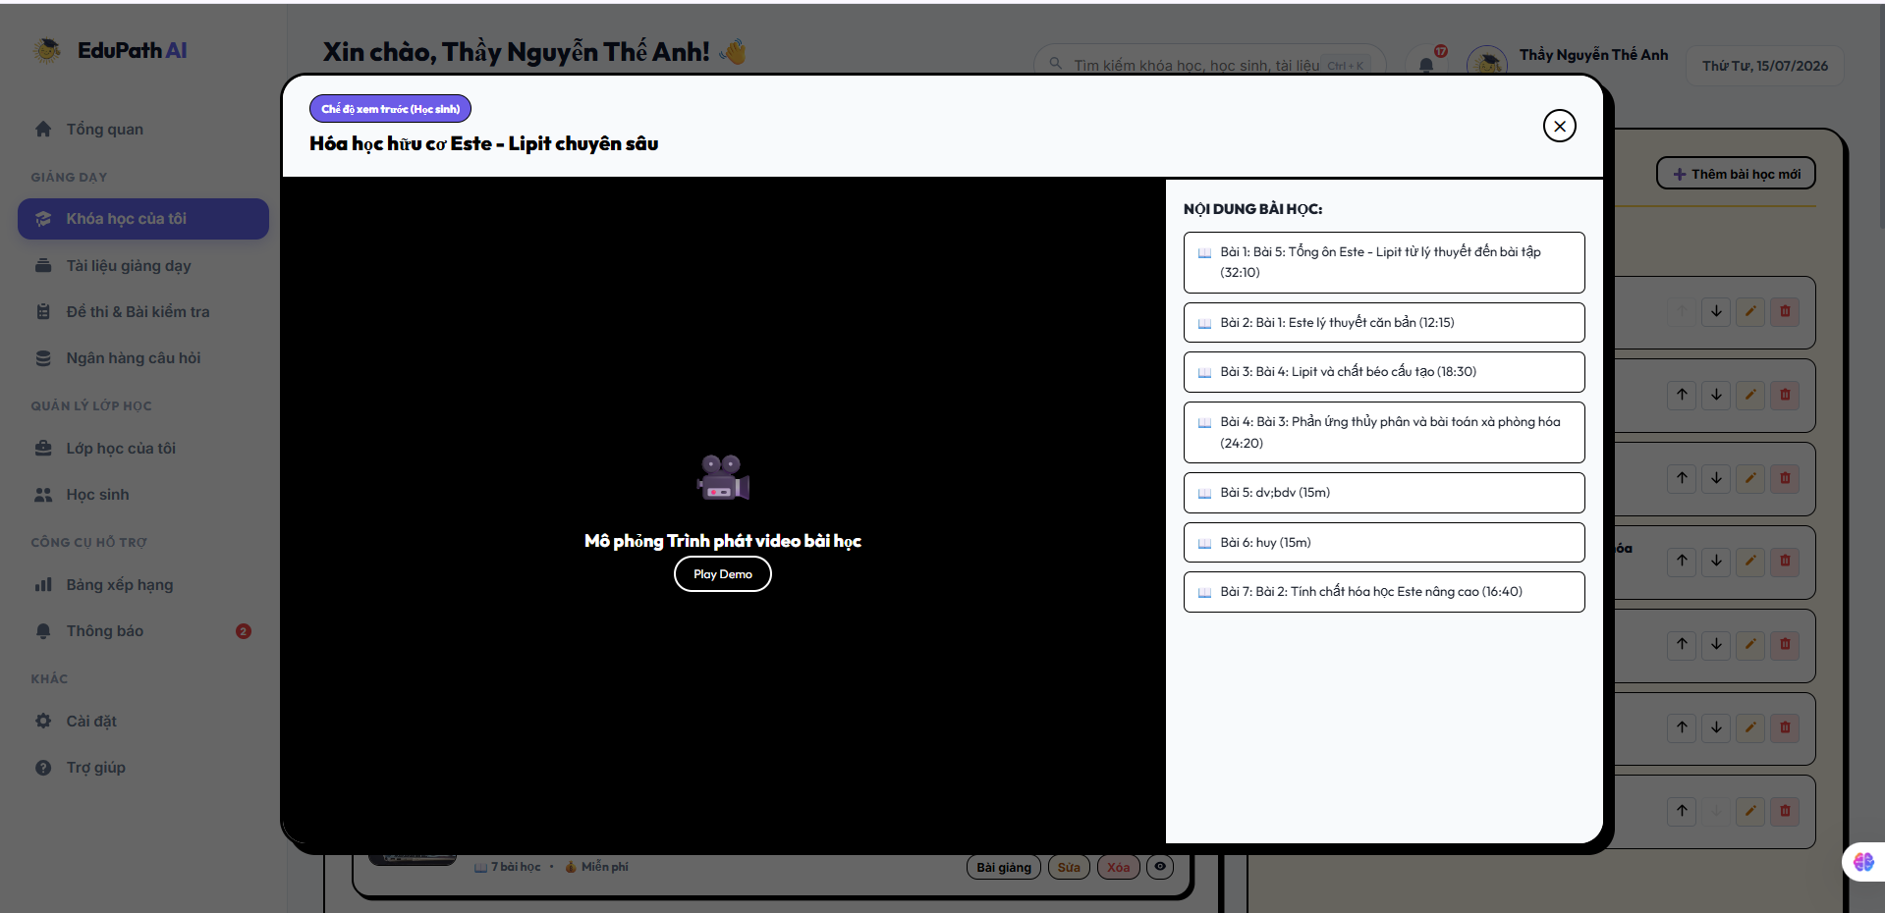
Field Name | Field Type | Description
Section Header | Heading | Displays the module workspace read-only profile title text "Chi tiết danh mục môn học".
Label “Tên môn học” | Data Label | Renders the primary alphanumeric name of the subject; displays name.
Label “Mã môn học” | Data Label | Renders the short custom indexing code of the subject partition; displays code.
Label “Trạng thái” | Data Label | Interface indicator displaying current visibility states (e.g., "Đang hoạt động" or "Bị khóa").
Block “Mô tả chi tiết” | Text Viewport | Displays long-form plaintext outlining the master curriculum scope; displays description.
Grid “Danh sách chủ đề” | Data Table Grid | Tabular layout viewport collecting child subtopic names (name) and their structural display indexes (sort_order).
Button “Quay lại” | Button | Standard navigation exit component to close the profile container and step back to the primary subject directory.

Database Access
Table | CRUD | Description
Subjects | R | Reads core subject catalog rows, unique programmatic identifiers, and live activation tracking bits (R).
Topics | R | Scans related subtopic registry matrices to load structured child node configurations matching the parent ID (R).
1. Query to load the master metadata block configuration for a specific target subject record
SQL
SELECT
s.[id] AS [SubjectID],
s.[name] AS [SubjectName],
s.[code] AS [SubjectCode],
s.[description] AS [SubjectDescription],
s.[is_active] AS [LivenessActiveStatus], -- Returns binary state: 1 = Active, 0 = Inactive
s.[created_at] AS [CreationTimestamp]
FROM [dbo].[Subjects] s
WHERE s.[id] = @TargetSubjectID; -- Target boundary constraint: fetches separate specific cell row logs

2. Query to load the corresponding child subtopic taxonomy arrays linked to the parent domain
SQL
SELECT
t.[id] AS [TopicID],
t.[name] AS [TopicName],
t.[description] AS [TopicDescription],
t.[sort_order] AS [DisplaySortOrder] -- Ordering key mapping user interface structural layouts
FROM [dbo].[Topics] t
WHERE t.[subject_id] = @TargetSubjectID -- Relational context fence: maps directly underneath the active subject ID
ORDER BY t.[sort_order] ASC; -- Keeps stable sequential presentation inside client data grids

16. Exam Administration

16.1 Override Exam Status
Allows authenticated system administrators (Admin) to review, override, and manually update the lifecycle status configuration state (status) of any examination blueprint distributed across the global platform ecosystem. This operational bypass ensures compliance, enforces curriculum quality baselines, and allows instant system remediation by switching non-compliant evaluations from a live visibility status directly into soft draft closures or permanent archive lockouts.

UI Design

Field Name | Field Type | Description
Section Header | Heading | Displays the module administrative control title text "Ghi đè trạng thái đề thi hệ thống".
Label “Thông tin đề thi” | Data Label | Renders specific operational tracking elements of the selected asset; loads id, title, and exam_type.
Dropdown “Trạng thái mới” | Dropdown List | Advanced administrative override selection; constrained to specific status tokens (draft, published, archived).
Textarea “Nhật ký lý do” | Text Area | Mandatory alphanumeric text block capturing the administrative reasoning or violation log justification.
Button “Áp dụng thay đổi” | Button | Administrative execution control component running validation checks, rewriting status tokens, and creating system trace logs.
Button “Hủy bỏ” | Button | Standard cancellation layout component to abort database mutations and revert interface layout states.

Database Access
Table | CRUD | Description
Exams | R, U | Queries global examination configuration records (R), and executes administrative status overrides on target row parameters (U).
SystemActivityLogs | C | Appends an unalterable tracking log block string detailing the override event for permanent audit records (C).
1. Query to inspect any target examination row states from a global system perspective
SQL
SELECT
e.[id] AS [ExamID],
e.[title] AS [ExamTitle],
e.[status] AS [CurrentStatus], -- Returns code status: 'draft','published','archived'
u.[full_name] AS [CreatorTeacherName]
FROM [dbo].[Exams] e
LEFT JOIN [dbo].[Users] u ON e.[creator_id] = u.[id]
WHERE e.[id] = @TargetExamID; -- Global lookup index: clears teacher tenancy blocks

2. Transaction processing statement block executing administrative status mutations and writing trace audits
SQL
BEGIN TRANSACTION;

BEGIN TRY
-- 1. Perform global administrative status update on target index cell row
UPDATE [dbo].[Exams]
SET
[status] = @AdminOverrideStatus, -- Must pass check constraints layout: 'draft','published','archived'
[updated_at] = GETDATE() -- Stamp runtime server clock
WHERE [id] = @TargetExamID;

-- 2. Commit detailed administrative trace actions into system security logs
INSERT INTO [dbo].[SystemActivityLogs] (
[user_id],
[action], -- Maps explicit operation indicator token: 'admin_exam_override'
[entity_type],
[entity_id],
[ip_address],
[user_agent],
[metadata], -- Serializes alphanumeric JSON payloads containing admin comments and old vs new status tokens
[created_at]
)
VALUES (
@CurrentAdminID, -- Identifies the administrator account triggering the manual state override action
'admin_exam_override',
'exam',
@TargetExamID,
@ClientIPAddress,
@ClientUserAgent,
@AdminOverrideAuditJSON, -- Serialized tracking parameters string
GETDATE()
);
COMMIT TRANSACTION;
END TRY
BEGIN CATCH
ROLLBACK TRANSACTION;
THROW;
END CATCH;

16.2 View Exam
Allows authenticated system administrators (Admin) to search, filter, and inspect the complete global catalog and detailed architectural configurations of all examination blueprints created by any instructor across the platform, bypassing standard multitenant ownership isolation boundaries to perform compliance reviews.

UI Design
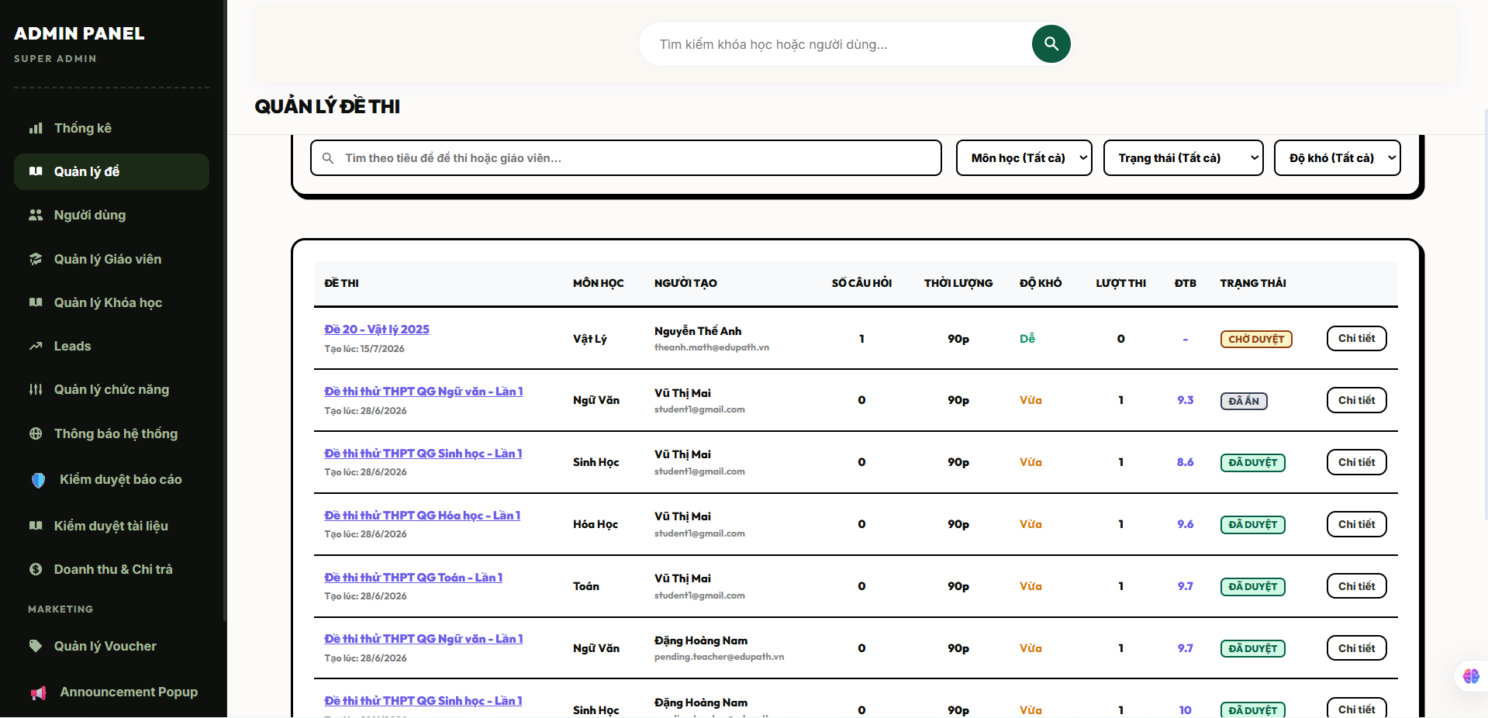
Field Name | Field Type | Description
Section Header | Heading | Displays the module workspace management dashboard title text "Quản lý đề thi toàn hệ thống".
Input “Tìm kiếm đề thi” | Input Field (Text) | Free text box to search exam headers by keyword matches; parses string segments against title.
Dropdown “Người tạo” | Dropdown List | Dynamic selection list displaying active system instructors to filter blueprints by their specific creator_id.
Dropdown “Trạng thái” | Dropdown List | Filters the target layout results by database status tokens: draft, published, or archived.
Grid “Danh sách đề thi” | Data Table Grid | Multi-column grid viewport sorting and rendering every exam blueprint block registered inside the persistent system database.
Button “Xem chi tiết” | Button | Action link control component to trigger a read-only configuration viewport container for the selected row item.

Database Access
Table | CRUD | Description
Exams | R | Reads global test metadata properties, constraint markers, scheduling records, and validation states across all creator pools (R).
Users | R | Performs join routines to fetch the complete full name strings of the respective instructor accounts (R).
Subjects | R | Reads primary category directories to attach descriptive academic subject name labels to the data rows (R).
1. Query to populate the global system exam administration list with advanced filter parameters
SQL
SELECT
e.[id] AS [ExamID],
e.[title] AS [ExamTitle],
e.[exam_type] AS [ExamType], -- Value checked: 'course_quiz','mock_exam','thpt_simulation','ai_generated'
e.[status] AS [ExamStatus], -- Value checked: 'draft','published','archived'
e.[time_limit_sec] AS [TimeLimitSec],
e.[created_at] AS [CreationDate],
u.[full_name] AS [TeacherFullName], -- Traces the original creator account profile
s.[name] AS [SubjectName], -- Maps lookup category name from master subject schema
(SELECT COUNT(1) FROM [dbo].[ExamQuestions] eq WHERE eq.[exam_id] = e.[id]) AS [TotalQuestionsCount] -- Calculates live distribution density
FROM [dbo].[Exams] e WITH (NOLOCK) -- Utilizes dirty reads to prevent transaction locks on student testing rows
LEFT JOIN [dbo].[Users] u ON e.[creator_id] = u.[id]
LEFT JOIN [dbo].[Subjects] s ON e.[subject_id] = s.[id]
WHERE (@SearchKeyword IS NULL OR e.[title] LIKE '%' + TRIM(@SearchKeyword) + '%')
AND (@FilterCreatorID IS NULL OR e.[creator_id] = @FilterCreatorID)
AND (@FilterStatus IS NULL OR e.[status] = @FilterStatus)
ORDER BY e.[created_at] DESC; -- Sort order layout index to surface the latest system configurations

2. Query to load deep read-only inspection metadata attributes for a selected exam record
SQL
SELECT
e.[id] AS [ExamID],
e.[title] AS [ExamTitle],
e.[description] AS [ExamDescription],
e].[time_limit_sec] AS [TimeLimitSec],
e.[pass_score] AS [PassScore],
e.[max_attempts] AS [MaxAttempts],
e.[start_time] AS [StartTimeWindow],
e.[end_time] AS [EndTimeWindow],
u.[email] AS [CreatorEmail]
FROM [dbo].[Exams] e
JOIN [dbo].[Users] u ON e.[creator_id] = u.[id]
WHERE e.[id] = @TargetExamID; -- Explicit administrative bypass control: no teacher tenancy checks applied

17 .Moderation & Workflow Approval

17.1 Approve Course
Allows authenticated system administrators (Admin) to inspect, moderate, and approve course metadata portfolios submitted by instructors (Teacher), verifying curricular alignment, taxonomy constraints, and formatting behaviors before shifting the lifecycle state to 'published' to render the course asset visible across the public student catalog index.

UI Design
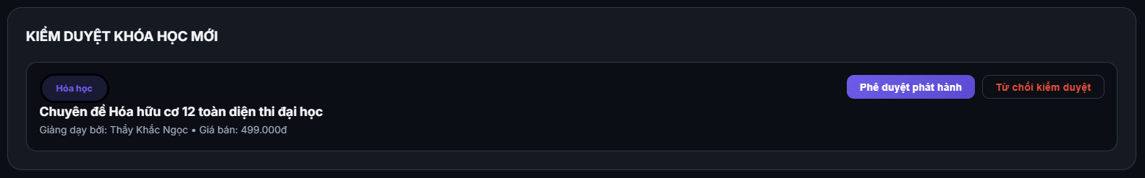
Field Name | Field Type | Description
Section Header | Heading | Displays the workflow moderation profile subtitle text "Phê duyệt & Xuất bản khóa học".
Block “Hồ sơ khóa học” | Read-Only Labels | Static dashboard elements rendering the pending course configurations; maps to title, level, price, and description.
Label “Giảng viên đề xuất” | Data Label | Plaintext block displaying the profile details of the creator account; loads full_name and email of the teacher.
Radio/Dropdown “Quyết định” | Action Selector | Toggle routing state choices; maps out state tokens to execute database updates (Approve to 'published' or Reject).
Input “Ghi chú kiểm duyệt” | Text Area | Mandatory alphanumeric text container capturing moderation review notes or reason parameters for rejection loops.
Button “Xác nhận quyết định” | Button | Execution workflow controller validating feedback inputs, firing data mutations, and logging systemic security histories.
Button “Hủy bỏ” | Button | Standard safety escape button to discard pending interface state structures and step back to the moderation queue grid.

Database Access
Table | CRUD | Description
Courses | R, U | Queries the targeted pending course record attributes (R), and updates the system lifecycle parameter cell status = 'published' upon verification (U).
Users | R | Reads the creator profile data to cross-reference identity matrices and account authorizations (R).
SystemActivityLogs | C | Serializes and registers an unalterable structural audit log block documenting the moderation event payload (C).
1. Query to fetch the pending course data block and owner account mappings for admin analysis
SQL
SELECT
c.[id] AS [CourseID],
c.[title] AS [CourseTitle],
c.[price] AS [CoursePrice],
c.[discount_price] AS [CourseDiscountPrice],
c.[level] AS [CourseLevel], -- Checks check constraint bounds: 'beginner','intermediate','advanced'
c.[status] AS [CurrentStatus], -- Inspects current state tracking index
u.[full_name] AS [TeacherFullName],
u.[email] AS [TeacherEmail],
s.[name] AS [SubjectCategoryName]
FROM [dbo].[Courses] c
JOIN [dbo].[Users] u ON c.[teacher_id] = u.[id]
LEFT JOIN [dbo].[Subjects] s ON c.[subject_id] = s.[id]
WHERE c.[id] = @TargetCourseID; -- Secure unique identification row lookup pointer

2. Transaction processing statement block to mutate course lifecycle parameters and persist approval logs
SQL
BEGIN TRANSACTION;

BEGIN TRY
-- 1. Fail-fast protection verification: Enforce review comment submission for non-approval routes
IF (@ModerationDecision = 'rejected' AND (@ModerationFeedback IS NULL OR LEN(TRIM(@ModerationFeedback)) = 0))
BEGIN
RAISERROR('MSG-ERR: Content moderation rejection requires explicit textual reasoning notes.', 16, 1);
END;

-- 2. Execute explicit transaction update targeting the course status cell
UPDATE [dbo].[Courses]
SET
[status] = CASE WHEN @ModerationDecision = 'approved' THEN 'published' ELSE 'draft' END, -- Shifts to live published space or returns to teacher draft container
[updated_at] = GETDATE()
WHERE [id] = @TargetCourseID;

-- 3. Commit structured system activity trail within permanent audit tables
INSERT INTO [dbo].[SystemActivityLogs] (
[user_id],
[action], -- Maps operational identifier flags: 'approve_course' or 'reject_course'
[entity_type],
[entity_id],
[ip_address],
[user_agent],
[metadata], -- Serializes alphanumeric JSON payloads detailing feedback strings and historical status changes
[created_at]
)
VALUES (
@CurrentAdminID, -- Identifies the moderator account triggering the transaction
CASE WHEN @ModerationDecision = 'approved' THEN 'approve_course' ELSE 'reject_course' END,
'course',
@TargetCourseID,
@ClientIPAddress,
@ClientUserAgent,
@CourseModerationAuditJSON, -- Holds serialized parameters string detailing old vs new states
GETDATE()
);
COMMIT TRANSACTION;
END TRY
BEGIN CATCH
ROLLBACK TRANSACTION;
THROW;
END CATCH;

17.2 Approve Teacher Requests
Allows authenticated system administrators (Admin) to review, evaluate, and approve or reject role upgrade applications submitted by users seeking Teacher status. Upon approval, the system executes an atomic database role update, elevating the applicant's account privileges to grant access to course creation and exam design workspaces.

UI Design
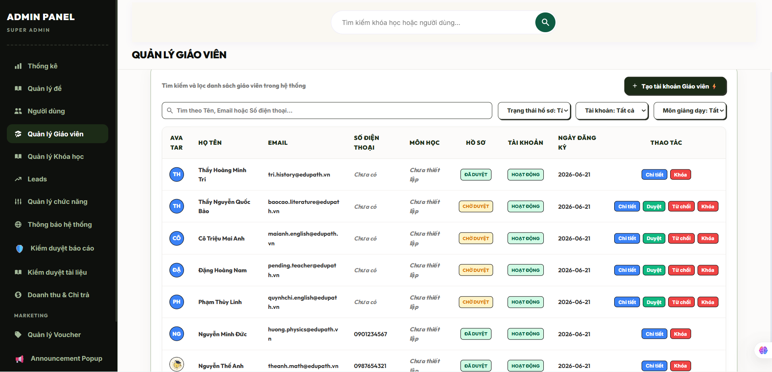
Field Name | Field Type | Description
Section Header | Heading | Displays the verification workflow workspace title text "Phê duyệt tài khoản Giảng viên".
Block “Hồ sơ ứng viên” | Read-Only Labels | Static dashboard elements rendering applicant account profiles; displays full_name, email, and account creation dates.
Label “Tài liệu đính kèm” | Hyperlink | Interactive document redirection layout node loading uploaded credentials, PDFs, or professional curriculum vitae metrics.
Radio/Dropdown “Quyết định” | Action Selector | Toggle control mapping administrative destination flags (Approve to upgrade role or Reject).
Input “Lý do xét duyệt” | Text Area | Mandatory alphanumeric text container capturing verification insights, review logs, or rejection justifications.
Button “Xác nhận nâng cấp” | Button | Main verification transaction controller validating feedback lengths, executing role mutations, and pushing system tracks.
Button “Quay lại” | Button | Standard navigation layout component to clear active component states and return to the global verification queue grid.

Database Access
Table | CRUD | Description
Users | R, U | Queries the applicant registration metadata and active statuses (R), and mutates the role column cell directly to 'teacher' upon successful admin verification (U).
SystemActivityLogs | C | Appends an immutable chronological tracking row capturing the security role-elevation parameters for compliance auditing (C).
Note on Lifecycle Design: Teacher application logs are managed either via a specialized state queue registry or directly mediated through active user validation flags mapping security roles checks inside the core tenant engine.
1. Query to load the pending profile metadata record of an applicant for admin verification loops
SQL
SELECT
[id] AS [ApplicantUserID],
[full_name] AS [ApplicantFullName],
[email] AS [ApplicantEmail],
[role] AS [CurrentRoleCode], -- Verifies baseline role status (e.g., 'student' or 'pending_teacher')
[is_active] AS [AccountActiveBit], -- Ensures account is live and not suspended prior to privilege modifications
[created_at] AS [RegistrationTimestamp]
FROM [dbo].[Users] WITH (NOLOCK)
WHERE [id] = @TargetUserID; -- Primary unique index cell identity pointer

2. Transaction processing statement block to execute account role updates and serialize system security logs
SQL
BEGIN TRANSACTION;

BEGIN TRY
-- 1. Enforce validation boundaries preventing empty reviews upon rejection routes
IF (@VerificationDecision = 'rejected' AND (@ReviewFeedback IS NULL OR LEN(TRIM(@ReviewFeedback)) = 0))
BEGIN
RAISERROR('MSG-ERR: Administrative rejection actions require explicit written justification details.', 16, 1);
END;

-- 2. Execute explicit conditional system role elevation on target user row cell
UPDATE [dbo].[Users]
SET
[role] = CASE WHEN @VerificationDecision = 'approved' THEN 'teacher' ELSE [role] END, -- Promotes account or preserves baseline role parameters
[updated_at] = GETDATE()
WHERE [id] = @TargetUserID;

-- 3. Commit unalterable workflow history tracking logs inside core system activity registries
INSERT INTO [dbo].[SystemActivityLogs] (
[user_id],
[action], -- Maps explicit operation indicator tokens: 'approve_teacher_role' or 'reject_teacher_role'
[entity_type],
[entity_id],
[ip_address],
[user_agent],
[metadata], -- Serializes alphanumeric JSON payloads detailing validation comments and role mutation maps
[created_at]
)
VALUES (
@CurrentAdminID, -- Identifies the administrator account authorizing the security privilege modification
CASE WHEN @VerificationDecision = 'approved' THEN 'approve_teacher_role' ELSE 'reject_teacher_role' END,
'user',
@TargetUserID,
@ClientIPAddress,
@ClientUserAgent,
@RolePromotionAuditJSON, -- Holds serialized parameters detailing structural state transformations
GETDATE()
);

COMMIT TRANSACTION;
END TRY
BEGIN CATCH
ROLLBACK TRANSACTION;
THROW;
END CATCH;

17.3 View/Delete Comments
Allows authenticated system administrators (Admin) to inspect, audit, and moderate user-generated discussions or feedback items across the platform. This function breaks through conversational silos, enabling administrators to track community interaction pipelines globally, view localized chat threads, and hard-purge or soft-deactivate toxic, non-compliant, or spam messages to preserve an orderly and safe digital learning environment.

UI Design
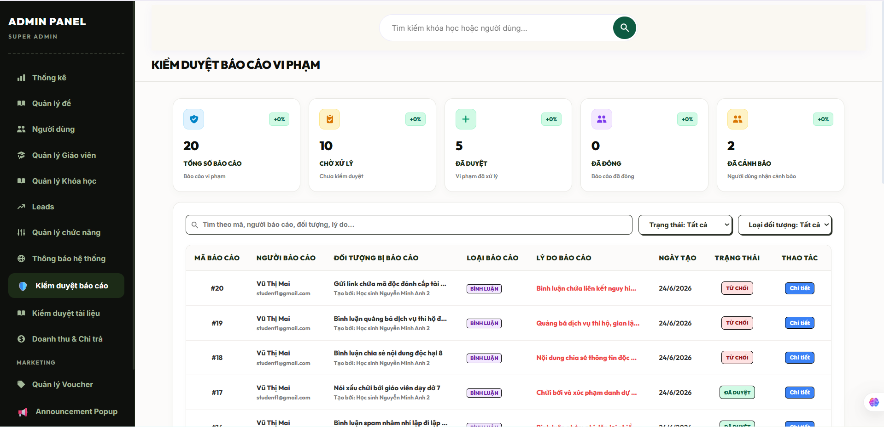
Field Name | Field Type | Description
Section Header | Heading | Displays the module workflow moderation title text "Quản lý và kiểm duyệt bình luận".
Input “Tìm kiếm nội dung” | Input Field (Text) | Free text field allowing administrators to search through raw message strings; filters by message text tokens.
Dropdown “Thuộc khóa học” | Dropdown List | Advanced dictionary lookup enabling moderators to isolate conversation log arrays belonging to a specific target course asset.
Grid “Bảng quản lý bình luận” | Data Table Grid | Multi-column tabular interface sorting and rendering active comment rows collected directly from the live database memory layers.
Button “Xóa bình luận” | Button | Red trash bin action control button initiating validation checks and launching the removal execution transaction pipeline.
Button “Làm mới” | Button | Interface command controller to flush local client state cache structures and sync with the latest backend records.

Database Access

Table | CRUD | Description
CourseComments (Ext) | R, D, U | Reads textual user messages and foreign indexing bindings (R), performs physical purges (D), or executes soft-deactivations on reported content cells (U).
Users | R | Performs standard join operations to map full name lines and email attributes to individual comment records (R).
Courses | R | Cross-references target course identity indices to map plaintext titles to structural comment entries (R).
SystemActivityLogs | C | Appends an unalterable monitoring track recording the comment moderation and removal parameters (C).
Note on Schema Design: Depending on the database setup, comments are stored in an entity table like CourseComments or Comments. The following queries assume a standardized CourseComments relational index structure.
1. Query to load the global system comments moderation list with advanced filter routing parameters
SQL
SELECT TOP 100 -- Enforces system query performance throttling rules
cc.[id] AS [CommentID],
cc.[content] AS [CommentText],
cc.[created_at] AS [CreationTimestamp],
u.[id] AS [AuthorUserID],
u.[full_name] AS [AuthorFullName],
u.[email] AS [AuthorEmail],
c.[id] AS [CourseID],
c.[title] AS [CourseTitle]
FROM [dbo].[CourseComments] cc WITH (NOLOCK) -- Deploys dirty read mechanics to keep application pipelines unblocked
JOIN [dbo].[Users] u ON cc.[user_id] = u.[id]
JOIN [dbo].[Courses] c ON cc.[course_id] = c.[id]
WHERE (@SearchKeyword IS NULL OR cc.[content] LIKE '%' + TRIM(@SearchKeyword) + '%')
AND (@FilterCourseID IS NULL OR cc.[course_id] = @FilterCourseID)
AND (@FilterUserID IS NULL OR cc.[user_id] = @FilterUserID)
ORDER BY cc.[created_at] DESC;

2. Transaction processing statement block to physically remove a non-compliant comment item and record security audits
SQL
BEGIN TRANSACTION;

BEGIN TRY
-- 1. Scan and preserve comment parameters metadata context prior to executing physical table drops
DECLARE @LogCommentText NVARCHAR(MAX);
DECLARE @LogAuthorID BIGINT;
DECLARE @LogCourseID BIGINT;

SELECT
@LogCommentText = [content],
@LogAuthorID = [user_id],
@LogCourseID = [course_id]
FROM [dbo].[CourseComments]
WHERE [id] = @TargetCommentID;

IF (@LogCommentText IS NULL)
BEGIN
RAISERROR('MSG-ERR: The targeted comment entry log does not exist or has already been modified.', 16, 1);
END;

-- 2. Execute absolute physical removal from the persistent database tables
-- Note: Child nested comment replies are dropped automatically if foreign keys have ON DELETE CASCADE configurations
DELETE FROM [dbo].[CourseComments]
WHERE [id] = @TargetCommentID;

-- 3. Serialize contextual operational details and append metadata logs inside systemic audit tables
DECLARE @ModerationAuditJSON NVARCHAR(MAX);
SET @ModerationAuditJSON = (
SELECT
@TargetCommentID AS [DeletedCommentID],
@LogAuthorID AS [ViolatorUserID],
@LogCourseID AS [ContextCourseID],
TRIM(@LogCommentText) AS [PurgedContentSnippet]
FOR JSON PATH, WITHOUT_ARRAY_WRAPPER
);

INSERT INTO [dbo].[SystemActivityLogs] (
[user_id],
[action], -- Maps explicit administrative execution tag: 'delete_toxic_comment'
[entity_type],
[entity_id],
[ip_address],
[user_agent],
[metadata], -- Stores raw alphanumeric JSON tracks mapping enforcement reasoning configurations
[created_at]
)
VALUES (
@CurrentAdminID, -- Identifies the administrator account triggering the content moderation clean up
'delete_toxic_comment',
'course_comment',
@TargetCommentID,
@ClientIPAddress,
@ClientUserAgent,
@ModerationAuditJSON,
GETDATE()
);
COMMIT TRANSACTION;
END TRY
BEGIN CATCH
ROLLBACK TRANSACTION;
THROW;
END CATCH;

18. Reporting

18.1 View Revenue Statistics
Allows authenticated system administrators (Admin) or financial management roles to track, analyze, and generate visual analytics reports on platform financial streams, including total sales volume, course purchase logs, subscription renewals, and transaction pipeline distribution variations across selected chronological periods.

UI Design
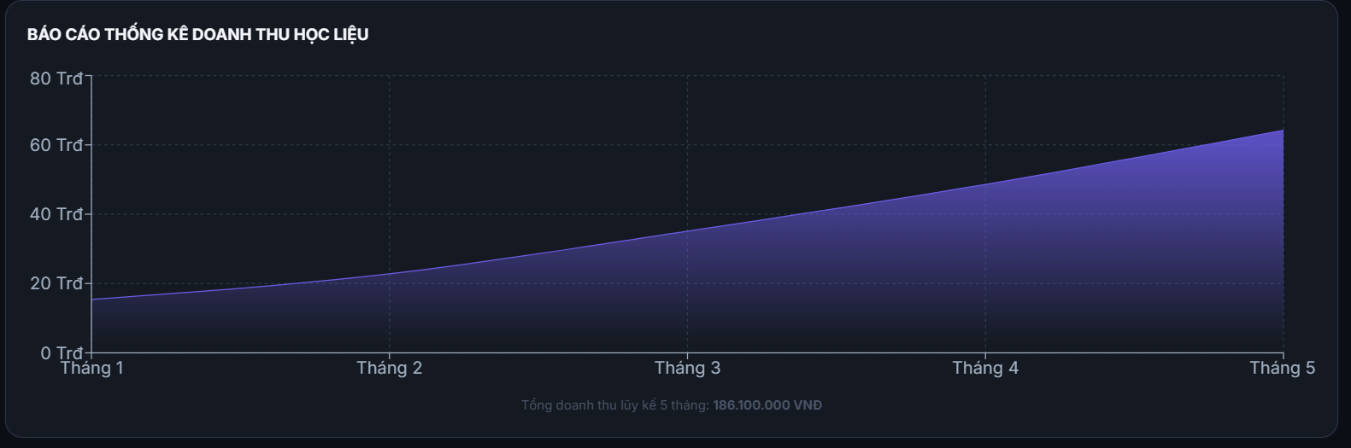
Field Name | Field Type | Description
Section Header | Heading | Displays the data analytical workspace overview title text "Báo cáo thống kê doanh thu hệ thống".
KPI Metrics Panel | Summary Cards | Layout components calculating aggregate metrics values including absolute monetary accumulation and currency counters.
Picker “Khoảng thời gian” | Date Range Picker | Calendar tool bounding timeline query rows; filters data clusters using purchase transaction timestamps.
Chart Viewport | Visualization Box | Graphical charts layout engine plotting chronological revenue trends (e.g., daily aggregates or monthly trajectories).
Grid “Chi tiết doanh thu” | Data Table Grid | Tabular interface collecting specific transaction rows, course titles, instructor allocations, payment gateways, and row totals.
Button “Xuất báo cáo” | Button | Operational command component to compile current dataset blocks into external spreadsheets (CSV/Excel format options).

Database Access
Table | CRUD | Description
Orders / Payments | R | Scans transaction records, billing amounts, gateway tokens, timestamps, and payment completion status codes (R).
Courses | R | Joins with course item identifiers to map financial records back to descriptive course catalog title strings (R).
Users | R | Extracts teacher user entities rows to attribute structural payment allocations to their respective creator profiles (R).
Note on Schema Consistency: Financial transactions and processing pipelines are logged within the core ledger registries (Orders or Payments) where successful billing actions map to strict state barriers (status = 'completed' or 'success').
1. Query to aggregate master financial KPI configurations and periodic revenue trend variations
ORDER BY [TransactionDate] ASC; -- Linear sequencing required to render temporal tracking views properly

2. Query to generate product breakdown distributions to analyze sales density by course items
SQL
SELECT TOP 50 -- Controls query overhead performance bounds during large statistical processing runs
c.[id] AS [CourseID],
c.[title] AS [CourseTitle],
u.[full_name] AS [InstructorName],
COUNT(o.[id]) AS [TotalUnitsEnrolledCount], -- Tracks total user purchase density profiles
ISNULL(SUM(o.[total_amount]), 0.00) AS [TotalGeneratedRevenue]
FROM [dbo].[Orders] o WITH (NOLOCK)
JOIN [dbo].[Courses] c ON o.[course_id] = c.[id]
JOIN [dbo].[Users] u ON c.[teacher_id] = u.[id]
WHERE o.[status] = 'completed'
AND (@FilterSubjectID IS NULL OR c.[subject_id] = @FilterSubjectID)
GROUP BY c.[id], c.[title], u.[full_name]
ORDER BY [TotalGeneratedRevenue] DESC; -- Surfaces high performing curriculum catalog elements first

18.2 View Reports
Allows authenticated system administrators (Admin) to query, generate, and analyze comprehensive multi-dimensional platform performance reports. This analytical module compiles critical business metrics—such as student course enrollment growth velocities, course completion rate thresholds, instructor performance matrices, and exam pass-fail distributions—allowing data-driven strategic planning and quality assurance audits across the global platform ecosystem.

UI Design

Field Name | Field Type | Description
Section Header | Heading | Displays the module workspace data overview title text "Trung tâm báo cáo & Thống kê phân tích".
Dropdown “Loại báo cáo” | Dropdown List | Selection picker specifying the target metrics pipeline execution category (e.g., enrollment trends, completion stats).
Picker “Khoảng thời gian” | Date Range Picker | Calendar control setting temporal boundary checkpoints to restrict log calculations; checks created_at.
Chart Visualization Box | Interface Graphic | Real-time charting container mapping out computed statistical trends and data ratios dynamically.
Grid “Bảng tổng hợp dữ liệu” | Data Table Grid | Multi-column grid layout rendering raw analytical aggregates, tracking categories, totals, and percent ratios.
Button “Xuất file Excel” | Button | Operational command button converting the active grid dataset block into an external downloadable spreadsheet format.
Button “Tải bản PDF” | Button | Triggers a server-side print sequence layout to bundle structural graphics and tables into a clean document.

Database Access
Table | CRUD | Description
Users | R | Scans student and instructor registration timelines and system role codes to verify user base growth metrics (R).
UserCourses (Ext) | R | Queries user enrollment logs and course access history blocks to calculate progress tracking metrics (R).
Courses | R | Reads master educational metadata profiles to align tracking statistics with specific content catalog layers (R).
UserExamResults | R | Processes student assessment score distributions to compute systemic pass-fail threshold rates (R).
Note on Reporting Architecture: Complex data reporting suites aggregate records across multiple application transaction logs. Utilizing isolation level hints like WITH (NOLOCK) prevents locking heavy read streams during active testing windows.
1. Query to compile student enrollment velocity metrics and completion rate indices per course item
SQL
SELECT
c.[id] AS [CourseID],
c.[title] AS [CourseTitle],
s.[name] AS [SubjectCategoryName],
COUNT(uc.[user_id]) AS [TotalEnrolledStudentsCount], -- Calculates active customer density matrix
SUM(CASE WHEN uc.[progress_percent] >= 100 THEN 1 ELSE 0 END) AS [TotalCompletedStudentsCount], -- Completion check
CAST(
(SUM(CASE WHEN uc.[progress_percent] >= 100 THEN 1.0 ELSE 0.0 END) /
NULLIF(COUNT(uc.[user_id]), 0)) * 100 AS DECIMAL(5,2)
) AS [CourseCompletionRatePercentage] -- Critical curriculum quality benchmark calculation
FROM [dbo].[Courses] c WITH (NOLOCK)
LEFT JOIN [dbo].[Subjects] s ON c.[subject_id] = s.[id]
LEFT JOIN [dbo].[UserCourses] uc ON c.[id] = uc.[course_id] -- Relational link mapping learner registrations
WHERE (@FilterSubjectID IS NULL OR c.[subject_id] = @FilterSubjectID)
GROUP BY c.[id], c.[title], s.[name]
ORDER BY [TotalEnrolledStudentsCount] DESC; -- Surfaces the most popular learning paths in the admin grid layout

2. Query to evaluate platform assessment health reports by calculating passing averages across exam blueprints
SQL
SELECT
e.[id] AS [ExamID],
e.[title] AS [ExamBlueprintTitle],
e.[exam_type] AS [ExamTypeMarker], -- Code checked: 'course_quiz','mock_exam','thpt_simulation'
e.[pass_score] AS [BaselinePassingRequirement],
COUNT(uer.[id]) AS [TotalAttemptCount], -- Summary population workload log
ISNULL(AVG(uer.[score]), 0.00) AS [MeanPlatformScore], -- Identifies structural assessment difficulty levels
SUM(CASE WHEN uer.[score] >= e.[pass_score] THEN 1 ELSE 0 END) AS [TotalPassedCount],
CAST(
(SUM(CASE WHEN uer.[score] >= e.[pass_score] THEN 1.0 ELSE 0.0 END) /
NULLIF(COUNT(uer.[id]), 0)) * 100 AS DECIMAL(5,2)
) AS [PassRatePercentage] -- Success threshold indicator monitored closely by administrators
FROM [dbo].[Exams] e WITH (NOLOCK)
JOIN [dbo].[UserExamResults] uer ON e.[id] = uer.[exam_id] -- Maps core test engine records
WHERE uer.[status] = 'submitted' -- Isolates finished test runs, filtering out incomplete or disconnected states
AND (@StartDate IS NULL OR uer.[submitted_at] >= @StartDate)
AND (@EndDate IS NULL OR uer.[submitted_at] <= @EndDate)
GROUP BY e.[id], e.[title], e.[exam_type], e.[pass_score]
ORDER BY [PassRatePercentage] ASC; -- Highlights struggling topics first so admins can inspect question structures

19. AI Core System Logic

19.1 Analyze Learning Performance
Allows authenticated students to inspect their personal learning velocity, cognitive mastery trends, and historical evaluation progress metrics. It also permits instructors (Teacher) and administrators (Admin) to view aggregated performance snapshots of individual learners to identify learning gaps, track curriculum engagement, and offer targeted pedagogical mentoring.

UI Design
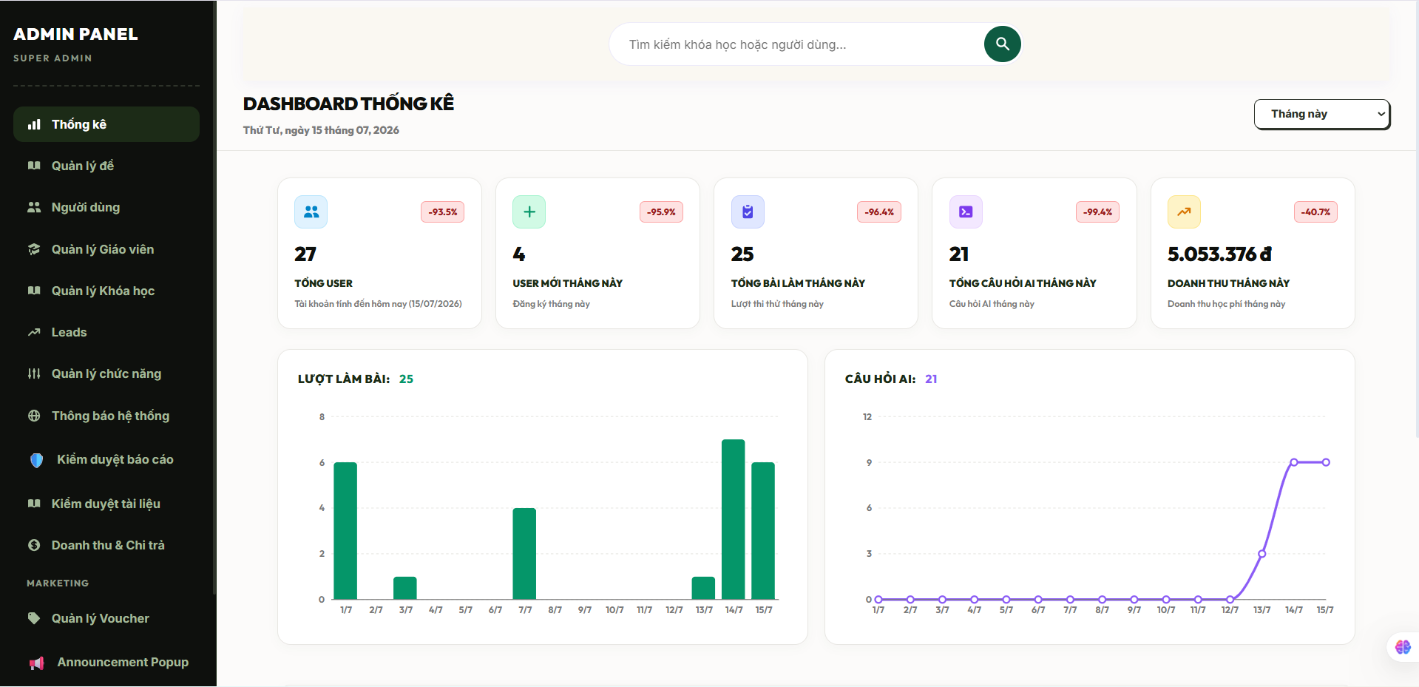
Field Name | Field Type | Description
Section Header | Heading | Displays the module workspace analytics title text "Báo cáo xu hướng & Năng lực học tập".
Summary Cards Panel | KPI Block | Interactive summary elements compiling computed averages for course progression and total evaluation scores.
Score Trend Graph | Graphical Chart | Line chart visualizing the chronological timeline of exam score percentages to track performance stability.
Topic Mastery Chart | Graphical Chart | Bar layout mapping out correct answer ratios divided by taxonomy subject areas to pinpoint weak skills.
Grid “Lịch sử đánh giá” | Data Table Grid | Multi-column grid interface rendering the historical stream layout of testing attempts, active scores, and duration metrics.
Button “Xuất dữ liệu” | Button | Action command link allowing users to extract their personal performance raw logs into a clean downloadable file.

Database Access
Table | CRUD | Description
UserCourses | R | Queries active user course registration rows, interaction timestamps, and individual progress tracking milestones (R).
UserExamResults | R | Extracts structural examination scores, correct answer counts, and session durations to map temporal trends (R).
Exams | R | Reads core evaluation parameters and pass line targets to align student statistics with baseline boundaries (R).
Topics | R | Joins with question taxonomy maps to calculate conceptual mastery percentages across specific study modules (R).
1. Query to aggregate master overview learning KPIs for a specific student profile
SQL
SELECT
u.[id] AS [StudentID],
u.[full_name] AS [StudentFullName],
-- Calculate structural progress across all enrolled course catalogs
ISNULL(AVG(uc.[progress_percent]), 0.00) AS [AverageCourseProgressPercent],
-- Compute global grading average over finished assessment sheet models
ISNULL(AVG(uer.[score]), 0.00) AS [GlobalMeanExamScore],
COUNT(DISTINCT uc.[course_id]) AS [TotalRegisteredCoursesCount],
COUNT(DISTINCT uer.[exam_id]) AS [TotalExamsAttemptedCount]
FROM [dbo].[Users] u WITH (NOLOCK) -- Employs clean dirty reads to guarantee fast loading layers under production load
LEFT JOIN [dbo].[UserCourses] uc ON u.[id] = uc.[user_id]
LEFT JOIN [dbo].[UserExamResults] uer ON u.[id] = uer.[user_id] AND uer.[status] = 'submitted'
WHERE u.[id] = @TargetStudentID
GROUP BY u.[id], u.[full_name];

2. Query to calculate granular topic mastery indices based on historical answer statistics
SQL
SELECT
t.[id] AS [TopicID],
t.[name] AS [TopicTaxonomyName],
-- Tracks the absolute density of question entities encountered by the learner
COUNT(ua.[id]) AS [TotalQuestionsAnsweredCount],
-- Computes exact binary success ratios to build the mastery chart visualization layouts
SUM(CASE WHEN ua.[is_correct] = 1 THEN 1 ELSE 0 END) AS [TotalCorrectAnswersCount],
CAST(
(SUM(CASE WHEN ua.[is_correct] = 1 THEN 1.0 ELSE 0.0 END) /
NULLIF(COUNT(ua.[id]), 0)) * 100 AS DECIMAL(5,2)
) AS [TopicMasterySuccessRatePercentage]
FROM [dbo].[UserAnswers] ua WITH (NOLOCK) -- Scans itemized answer rows mapped out directly from database logs
JOIN [dbo].[Questions] q ON ua.[question_id] = q.[id]
JOIN [dbo].[Topics] t ON q.[topic_id] = t.[id]
WHERE ua].[user_id] = @TargetStudentID -- Limits calculation rows securely to the targeted student boundary fence
GROUP BY t.[id], t.[name]
HAVING COUNT(ua.[id]) >= 1 -- Isolates topics that have active evaluation benchmarks assigned to prevent empty layout graphs
ORDER BY [TopicMasterySuccessRatePercentage] DESC;

19.2 Recommend Learning Path
Provides an adaptive, AI-driven recommendation engine that processes a learner's calculated cognitive mastery deficits (such as weak topic areas derived from 19.1) alongside their target professional milestones. The engine dynamically maps out a personalized learning sequence, isolating critical skills gaps and highlighting specific unpurchased courses or module paths to accelerate the student's mastery trajectory.

UI Design
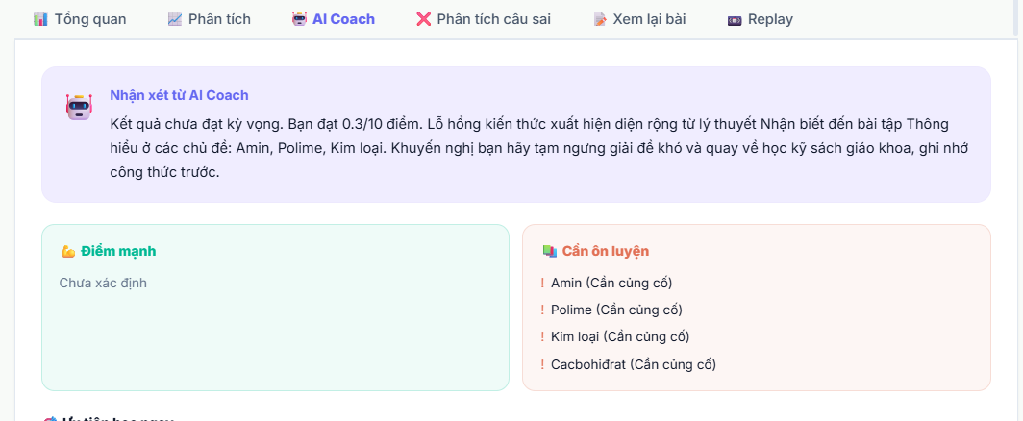
Field Name | Field Type | Description
Section Header | Heading | Displays the module adaptive workspace navigation title text "Lộ trình học tập đề xuất riêng cho bạn".
Dropdown “Mục tiêu nghề nghiệp” | Dropdown List | Interactive taxonomy selection picker defining target career profile nodes (e.g., "Fullstack Web Developer").
Path Visualization Node | Timeline Graph | Visual graphical components representing chronological sequencing nodes of recommended topic paths.
Course Suggestion Card | Container Card | Layout grouping containing recommended course titles (title), price points, and active registration action keys.
Button “Đăng ký khóa học” | Button | Conversion action control handling quick processing checks to launch enrollment checkout flows.
Button “Cập nhật lộ trình” | Button | Command control trigger running active performance analytics syncs to rebuild the adaptive recommendation tree.

Database Access
Table | CRUD | Description
UserAnswers | R | Scans answer sheets logs to evaluate personal accuracy margins across individual specialized concepts (R).
Topics | R | Reads the global hierarchical structural taxonomy definitions to find modules matching weak scores (R).
Courses | R | Queries active public catalogs to match un-enrolled course assets with specific weak topic dimensions (R).
UserCourses | R | Validates existing active profile registrations to filter out items the student has already purchased (R).
UserLearningPaths (Ext) | C, R | Stores the verified custom generated personalized recommendation maps inside persistence tracking directories (C, R).
1. Query to dynamically detect weak topics (success rate less than 60%) and isolate top recommended un-enrolled courses
SQL
-- Step 1: Isolate the student's weak curriculum topic domains based on answer logs metrics
WITH StudentWeakTopics AS (
SELECT
q.[topic_id],
CAST(SUM(CASE WHEN ua.[is_correct] = 1 THEN 1.0 ELSE 0.0 END) / COUNT(ua.[id]) * 100 AS DECIMAL(5,2)) AS [SuccessRate]
FROM [dbo].[UserAnswers] ua WITH (NOLOCK)
JOIN [dbo].[Questions] q ON ua.[question_id] = q.[id]
WHERE ua.[user_id] = @TargetStudentID
GROUP BY q.[topic_id]
HAVING COUNT(ua.[id]) >= 5 -- Ensures statistical significance before triggering system changes
AND (SUM(CASE WHEN ua.[is_correct] = 1 THEN 1.0 ELSE 0.0 END) / COUNT(ua.[id])) < 0.60 -- Target: accuracy less than 60%
)
-- Step 2: Extract top-rated active public course catalog items mapped to those exact deficits that the learner does not own
SELECT TOP 5
c.[id] AS [RecommendedCourseID],
c.[title] AS [CourseTitle],
c.[price] AS [CoursePrice],
c.[level] AS [CourseDifficultyLevel], -- Value: 'beginner','intermediate','advanced'
swt.[SuccessRate] AS [StudentCurrentTopicAccuracyPercentage],
s.[name] AS [SubjectCategoryName]
FROM [dbo].[Courses] c WITH (NOLOCK)
JOIN StudentWeakTopics swt ON c.[subject_id] = (SELECT TOP 1 [subject_id] FROM [dbo].[Topics] WHERE [id] = swt.[topic_id]) -- Maps root domains
LEFT JOIN [dbo].[Subjects] s ON c.[subject_id] = s.[id]
WHERE c.[status] = 'published' -- Quality lock: restricts visibility to fully validated active items
AND c.[id] NOT IN (
SELECT [course_id] FROM [dbo].[UserCourses] WHERE [user_id] = @TargetStudentID -- Excludes already purchased tracking rows
)
ORDER BY c.[price] ASC, [StudentCurrentTopicAccuracyPercentage] ASC; -- Surfaces highly relevant, cost-effective interventions first

2. Transaction statement block to save a newly computed personalized learning path configuration
SQL
BEGIN TRANSACTION;

BEGIN TRY
-- 1. Ensure the user profile targets are fully formatted and safe to log
IF (@TargetStudentID IS NULL OR @TargetCareerGoal IS NULL)
BEGIN
RAISERROR('MSG-ERR: Core optimization tracking variables cannot be left unassigned.', 16, 1);
END;

-- 2. Deactivate previous adaptive path tracks to maintain clear presentation hierarchies
-- (Assuming an extensible UserLearningPaths tracking registry table manages active roadmaps)
UPDATE [dbo].[UserLearningPaths]
SET [is_active] = 0,
[updated_at] = GETDATE()
WHERE [user_id] = @TargetStudentID AND [is_active] = 1;

-- 3. Persist the updated unified sequence path descriptor block directly into system registers
INSERT INTO [dbo].[UserLearningPaths] (
[user_id],
[path_name],
[target_goal],
[serialized_structure_json], -- Stores the complete node sequence array as a flexible parameters string
[is_active],
[created_at],
[updated_at]
)
VALUES (
@TargetStudentID,
CONCAT(N'AI Adaptive Path - ', TRIM(@TargetCareerGoal)),
TRIM(@TargetCareerGoal),
@GeneratedPathJSONPayload,
1, -- Immediately set as the live active roadmap guide
GETDATE(),
GETDATE()
);

COMMIT TRANSACTION;
END TRY
BEGIN CATCH
ROLLBACK TRANSACTION;
THROW;
END CATCH;

19.3 Suggest Suitable Lessons
Provides an automated micro-learning recommendation layer that targets individual lecture files and practice activities within the student's already enrolled courses. By parsing real-time mistake patterns from recent quiz submissions, the system automatically isolates the specific underlying lessons that match the failed cognitive concepts and flags them as "Critical Review" priorities to guide the learner's immediate study sessions.

UI Design
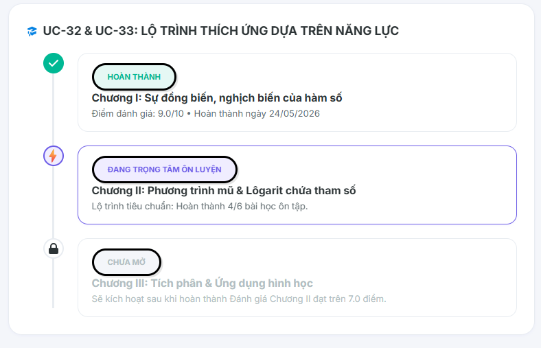
Field Name | Field Type | Description
Section Header | Heading | Displays the module contextual title text "Bài học đề xuất ôn tập trọng tâm".
Suggestion Container | Layout Panel | Responsive grid grouping individual dynamic lesson components based on recent mistake tracking logs.
Lesson Target Card | Component Card | Individual card layout displaying the lesson title (title), parent course context, and estimated completion duration.
Deficit Alert Tag | Text Label | Contextual color-coded label explaining the pedagogical trigger behind the recommendation (e.g., "Hỗ trợ lỗ hổng kiến thức").
Button “Học ngay” | Button | Direct navigation action control launching the course video player or text content viewport layer for that specific lesson.

Database Access
Table | CRUD | Description
Lessons (Ext) | R | Queries content records, resource references, and video duration metrics matching target topic filters (R).
UserAnswers | R | Analyzes itemized submission rows to compute recent error distribution patterns across active topic keys (R).
UserCourses | R | Verifies active student course ownership boundaries to ensure suggested lessons belong to already purchased catalogs (R).
UserLessonProgress (Ext) | R, U | Checks if individual micro-lessons have already been cleared (R) and tracks active status updates during remediation cycles (U).
Note on Schema Consistency: Lessons are organized under sections or topics linked directly to the parent master course blueprint. The recommendation engine scans for incomplete lesson units (is_completed = 0) that map to the student's lowest-performing concept matrices.
1. Query to locate incomplete lessons from active enrolled courses matching the student's highest mistake density areas
SQL
-- Step 1: Pinpoint the top 3 topics where the student has committed the most errors in their recent 50 answers
WITH RecentStudentMistakes AS (
SELECT TOP 3
q.[topic_id],
COUNT(ua.[id]) AS [ErrorCount]
FROM [dbo].[UserAnswers] ua WITH (NOLOCK)
JOIN [dbo].[Questions] q ON ua.[question_id] = q.[id]
WHERE ua.[user_id] = @TargetStudentID
AND ua.[is_correct] = 0 -- Isolates failed item rows exclusively
GROUP BY q.[topic_id]
ORDER BY [ErrorCount] DESC -- Sorts to identify the absolute highest weakness matrices first
),
-- Step 2: Identify the courses the student currently has active access rights to
EnrolledActiveCourses AS (
SELECT [course_id]
FROM [dbo].[UserCourses] WITH (NOLOCK)
WHERE [user_id] = @TargetStudentID
)
-- Step 3: Extract suitable uncompleted lessons matching the weak topics inside those enrolled courses
SELECT TOP 4
l.[id] AS [SuggestedLessonID],
l.[title] AS [LessonTitle],
l.[duration_min] AS [EstimatedDurationMinutes],
c.[title] AS [SourceCourseTitle],
t.[name] AS [TargetTopicName],
rsm.[ErrorCount] AS [RelatedConceptErrorDensityCount]
FROM [dbo].[Lessons] l WITH (NOLOCK)
JOIN [dbo].[Topics] t ON l.[topic_id] = t.[id]
JOIN [dbo].[Courses] c ON t.[subject_id] = c.[subject_id] -- Aligns structural category bindings safely
JOIN RecentStudentMistakes rsm ON t.[id] = rsm.[topic_id] -- Filters down to the specific weak concept profiles
WHERE c.[id] IN (SELECT [course_id] FROM EnrolledActiveCourses) -- Safety gate: forces lesson to be within owned catalogs
AND l.[id] NOT IN (
SELECT [lesson_id]
FROM [dbo].[UserLessonProgress]
WHERE [user_id] = @TargetStudentID AND [is_completed] = 1 -- Filters out lessons the student cleared successfully
)
ORDER BY rsm.[ErrorCount] DESC, l.[sort_order] ASC; -- Surfaces corrective blocks for the worst-performing skills first

2. Query to load specific media parameters and logging references to initialize the suggested lesson video player
SQL
SELECT
l.[id] AS [LessonID],
l.[title] AS [LessonTitle],
l.[content_text] AS [LessonBodyContent],
l.[video_url] AS [StreamingMediaEndpoint],
l.[duration_min] AS [DurationMinutes],
ulp.[progress_percent] AS [SavedCurrentProgressPoints]
FROM [dbo].[Lessons] l WITH (NOLOCK)
LEFT JOIN [dbo].[UserLessonProgress] ulp ON l.[id] = ulp.[lesson_id] AND ulp.[user_id] = @TargetStudentID
WHERE l.[id] = @TargetSuggestedLessonID;

19.4 Generate Practice Questions
Provides students with an adaptive self-assessment layer that builds on-demand, customized practice quizzes. By evaluating a student’s current cognitive gaps or taking explicit configuration parameters (such as topic boundaries and difficulty tiers), the engine performs a randomized relational query to pull unencountered or historically failed assessment items, creating a transient sandbox for low-stakes skills reinforcement.
To see how this configuration operates at runtime before finalizing the structural code guidelines, you can interact with the dynamic interface prototype below to simulate topic selection, adjustment thresholds, and question delivery states.

UI Design
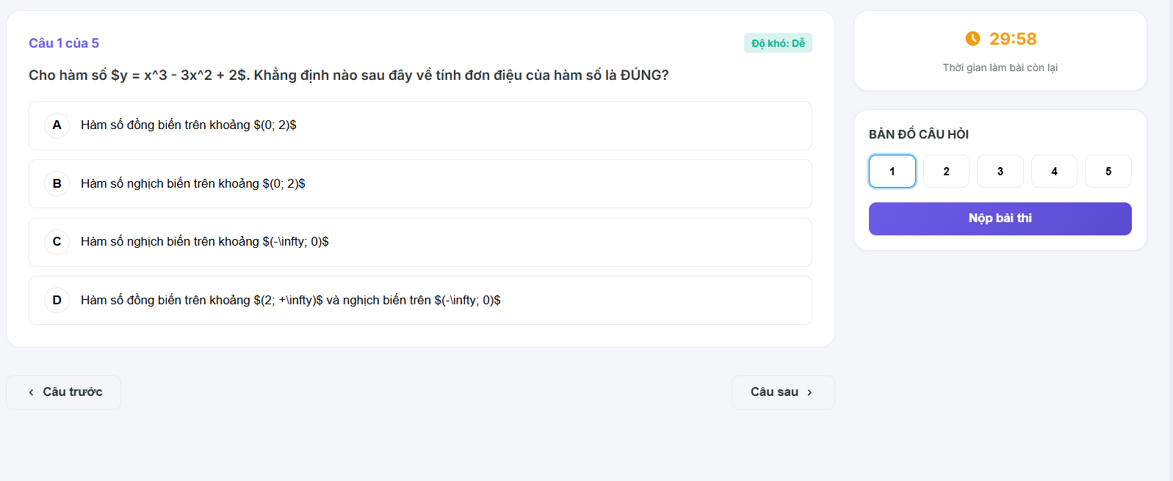
Field Name | Field Type | Description
Topic Selector | Dropdown List | Dictionary lookup matching active database classifications; filters rows against topic_id or subject_id.
Difficulty Segment | Toggle Group | Mapped input choosing the targeting evaluation rating; filters by string tokens (easy, medium, hard).
Volume Controller | Slider Component | Numerical integer bounding mask restricting total question query limits; configures the TOP clause variable.
Button “Bắt đầu luyện tập” | Button | Primary transaction command compiling custom parameters, verifying anti-join rules, and building the viewport layout.
Progress Tracker Bar | Progress Indicator | Real-time fractional completion gauge tracking the current index pointer against total compiled session rows.

Database Access
Table | CRUD | Description
Questions | R | Scans active metadata definitions, parent subject taxonomy keys, and difficulty ratings to match configuration parameters (R).
QuestionOptions | R | Loads the dependent arrays of choice options linked directly to the randomly fetched parent question rows (R).
UserAnswers | R | Evaluates historical submission logs to implement anti-join filters, protecting students from immediate duplicate question re-runs (R).
UserPracticeSessions (Ext) | C, R, U | Instantiates an extensible persistent log row tracking initialization parameters, completion status indicators, and final accuracy metrics (C, R, U).
1. Query to retrieve randomized, unmastered questions matching configuration matrices
SQL
SELECT TOP (@QuestionVolume) -- Enforces the slider count constraint to keep test workloads controlled
q.[id] AS [QuestionID],
q.[question_text] AS [QuestionPromptText],
q.[question_type] AS [SelectionTypeCode],
q.[difficulty] AS [CognitiveDifficultyTier]
FROM [dbo].[Questions] q WITH (NOLOCK) -- Deploys dirty read isolation to minimize indexing overhead
WHERE q.[subject_id] = @TargetSubjectID
AND q.[difficulty] = @TargetDifficulty
AND q.[is_active] = 1 -- Validation safety gate: prevents deactivated or soft-deleted rows from entering
AND NOT EXISTS (
-- Relational anti-join: eliminates items the student has already correctly answered in past exams
SELECT 1
FROM [dbo].[UserAnswers] ua WITH (NOLOCK)
WHERE ua.[question_id] = q.[id]
AND ua.[user_id] = @TargetStudentID
AND ua.[is_correct] = 1
)
ORDER BY NEWID(); -- Standard safe random distribution logic to ensure unique practice variations across sessions

2. Transaction block to instantiate a tracked practice session context
SQL
BEGIN TRANSACTION;

BEGIN TRY
-- 1. Validate data structure constraints before opening a persistent tracking instance
IF (@TargetStudentID IS NULL OR @TargetSubjectID IS NULL OR @QuestionVolume <= 0)
BEGIN
RAISERROR('MSG-ERR: Invalid operational arguments mapped for practice session generation.', 16, 1);
END;

-- 2. Create the practice record tracking entry cell
-- (Assuming an extensible tracking directory manages transient self-assessment records)
INSERT INTO [dbo].[UserPracticeSessions] (
[user_id],
[subject_id],
[difficulty_tier],
[total_questions],
[status], -- Mapped check state: 'started', 'completed'
[created_at]
)
VALUES (
@TargetStudentID,
@TargetSubjectID,
@TargetDifficulty,
@QuestionVolume,
'started',
GETDATE()
);

-- 3. Capture and pass back the scope identity marker to connect answers on subsequent client cycles
SELECT SCOPE_IDENTITY() AS [NewPracticeSessionID];

COMMIT TRANSACTION;
END TRY
BEGIN CATCH
ROLLBACK TRANSACTION;
THROW;
END CATCH;

19.5 Generate Mock Exams Automatically
Allows authenticated students to instantiate a full-length, standardized mock examination or evaluation blueprint dynamically tailored to professional curriculum baselines or competitive testing frameworks (such as the national thpt_simulation model rules). The backend engine processes structural distribution targets, executes randomized multi-tier relational queries to split cognitive difficulty tiers precisely, initializes a custom row record inside the primary execution schema, and compiles the dynamic assessment matrix.

UI Design
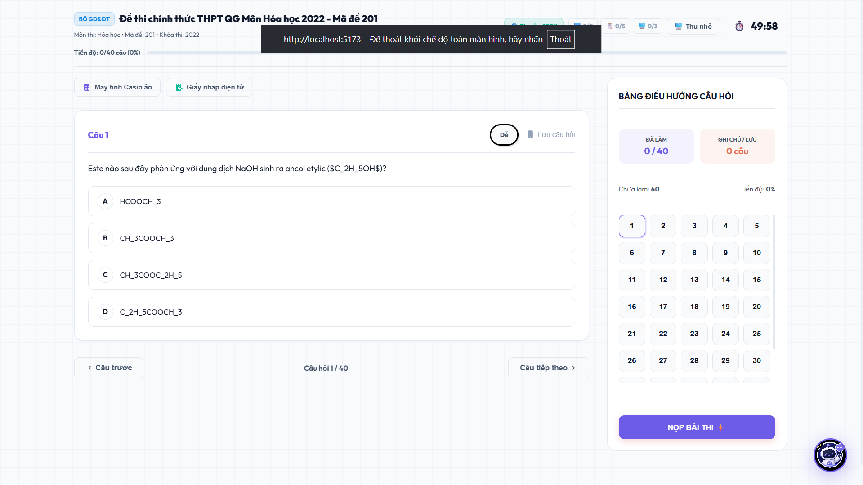
Field Name | Field Type | Description
Section Header | Heading | Displays the module workflow wizard title text "Khởi tạo đề thi thử mô phỏng tự động".
Dropdown “Môn học mục tiêu” | Dropdown List | Dictionary lookup picker pulling relational records directly from the live Subjects schema framework.
Dropdown “Cấu trúc mô phỏng” | Dropdown List | Structural selection picking the targeting assembly configuration standard (e.g., thpt_simulation or mock_exam).
Label “Tổng số câu hỏi” | Data Label | Read-only structural counter parameter parsed instantly from the selected blueprint configuration framework rules.
Label “Thời gian làm bài” | Data Label | Read-only duration tracker specifying the running countdown stopwatch limitation in minutes or seconds.
Button “Khởi tạo đề thi” | Button | Main operational workflow trigger executing randomized difficulty splits, writing relational rows, and launching the test canvas layer.
Button “Quay lại” | Button | Standard safety recovery option button to clear active inputs and return back to the general learner dashboard.

Database Access
Table | CRUD | Description
Exams | C | Creates a fresh, custom-built test configuration record marked with explicit operational type parameters (exam_type = 'thpt_simulation' or 'ai_generated').
ExamQuestions | C | Serializes and persists the randomized, balanced array distribution of assessment keys linked back to the newly generated exam parent key.
Questions | R | Scans active catalog indices to pool clean, unencountered question assets according to structural difficulty constraint ratios.
Subjects | R | Validates that the selected catalog identifier maps accurately to a live and active system directory row.
1. Query logic framework using Common Table Expressions (CTEs) to isolate a precisely balanced randomized question distribution grid
SQL
-- Simulate a standardized 40-question blueprint assembly structure: 20 Easy, 15 Medium, 5 Hard
WITH BalancedQuestionPool AS (
SELECT
[id] AS [QuestionID],
[difficulty],
-- Generates unique sequential ordering counters partitioned across separate cognitive difficulty tiers
ROW_NUMBER() OVER (PARTITION BY [difficulty] ORDER BY NEWID()) AS [RandomSequenceIndex]
FROM [dbo].[Questions] WITH (NOLOCK)
WHERE [subject_id] = @TargetSubjectID
AND [is_active] = 1 -- Validation safety guard: prevents obsolete items from breaking test layouts
),
TargetedBlueprintSpecification AS (
-- Collect exactly 20 Easy assessment items from the random pool
SELECT [QuestionID], [difficulty], 1 AS [BaseWeight] FROM BalancedQuestionPool WHERE [difficulty] = 'easy' AND [RandomSequenceIndex] <= 20
UNION ALL
-- Collect exactly 15 Medium assessment items from the random pool
SELECT [QuestionID], [difficulty], 2 AS [BaseWeight] FROM BalancedQuestionPool WHERE [difficulty] = 'medium' AND [RandomSequenceIndex] <= 15
UNION ALL
-- Collect exactly 5 Hard assessment items from the random pool
SELECT [QuestionID], [difficulty], 2.5 AS [BaseWeight] FROM BalancedQuestionPool WHERE [difficulty] = 'hard' AND [RandomSequenceIndex] <= 5
)
SELECT
[QuestionID],
[difficulty] AS [DifficultyTierCode],
[BaseWeight] AS [AssignedPointValue],
ROW_NUMBER() OVER (ORDER BY [BaseWeight] ASC, NEWID()) AS [CalculatedSortOrder] -- Generates structured layout sequencing
FROM TargetedBlueprintSpecification;

2. Core multi-table transaction processing engine to persist the mock exam metadata profile and insert structural question mappings
SQL
BEGIN TRANSACTION;
BEGIN TRY
-- 1. Initialize parent mock examination row inside the global Exams repo database
DECLARE @NewGeneratedExamID BIGINT;
DECLARE @ExamTitleLayout NVARCHAR(300);
SET @ExamTitleLayout = CONCAT(N'Đề thi thử mô phỏng tự động #', CAST(CAST(NEWID() AS BINARY(4)) AS INT), N' - System Generated');

INSERT INTO [dbo].[Exams] (
[creator_id], -- Tied securely to the requesting student profile identifier token
[subject_id],
[course_id], -- Self-generated mock tests remain unlinked to specific course nodes (NULL)
[title],
[description],
[time_limit_sec], -- Explicit standard constraint duration: e.g., 3000 seconds for 50 minutes
[pass_score], -- Set standard default pass line criteria thresholds
[max_attempts],
[exam_type], -- Enforces database check constraints boundary: 'thpt_simulation' or 'ai_generated'
[status], -- Set directly as 'draft' or private container to bypass instructor catalog feeds
[created_at],
[updated_at]
)
VALUES (
@TargetStudentID,
@TargetSubjectID,
NULL,
@ExamTitleLayout,
N'Hệ thống tự động biên soạn dựa trên cấu trúc phân phối độ khó tiêu chuẩn.',
@ConfigTimeLimitSec,
@ConfigPassScore,
1, -- Private simulation runs restrict duplicate execution sessions to 1 attempt loop
@SelectedExamType, -- Maps 'thpt_simulation' or 'ai_generated' tokens safely
'draft', -- Keeps item private from public catalog streams
GETDATE(),
GETDATE()
);
SET @NewGeneratedExamID = SCOPE_IDENTITY();

-- 2. Bulk insert compilation rows mapping out layout definitions inside the ExamQuestions linkage ledger
-- (The query sequence below outlines the middleware iteration template block for appending mapped items)
INSERT INTO [dbo].[ExamQuestions] (
[exam_id],
[question_id],
[sort_order],
[point_value]
)
SELECT
@NewGeneratedExamID,
[CompiledSourceQuestionID], -- Passed array parameter elements collected from the balance query process loop
[TargetSequenceIndex],
[CalculatedPointWeight]
FROM @CompiledBlueprintItemsArray; -- Table-valued variable or structural array parameters payload dataset

-- 3. Return the runtime structural indicator to client layers to open the verification testing loop
SELECT @NewGeneratedExamID AS [SuccessfullyGeneratedMockExamID];
COMMIT TRANSACTION;
END TRY
BEGIN CATCH
ROLLBACK TRANSACTION;
THROW;
END CATCH;

19.6 Generate Learning Progress Reports
Allows authenticated students, instructors (Teacher), or system administrators (Admin) to aggregate, compile, and export an official learning profile summary document. The reporting architecture collects all core metrics—including curriculum progress percentages, course completion histories, test performance distributions, and milestone achievements—formatting them into a structured file template (such as PDF or Excel spreadsheet) for academic portfolio building or administrative review loops.

UI Design
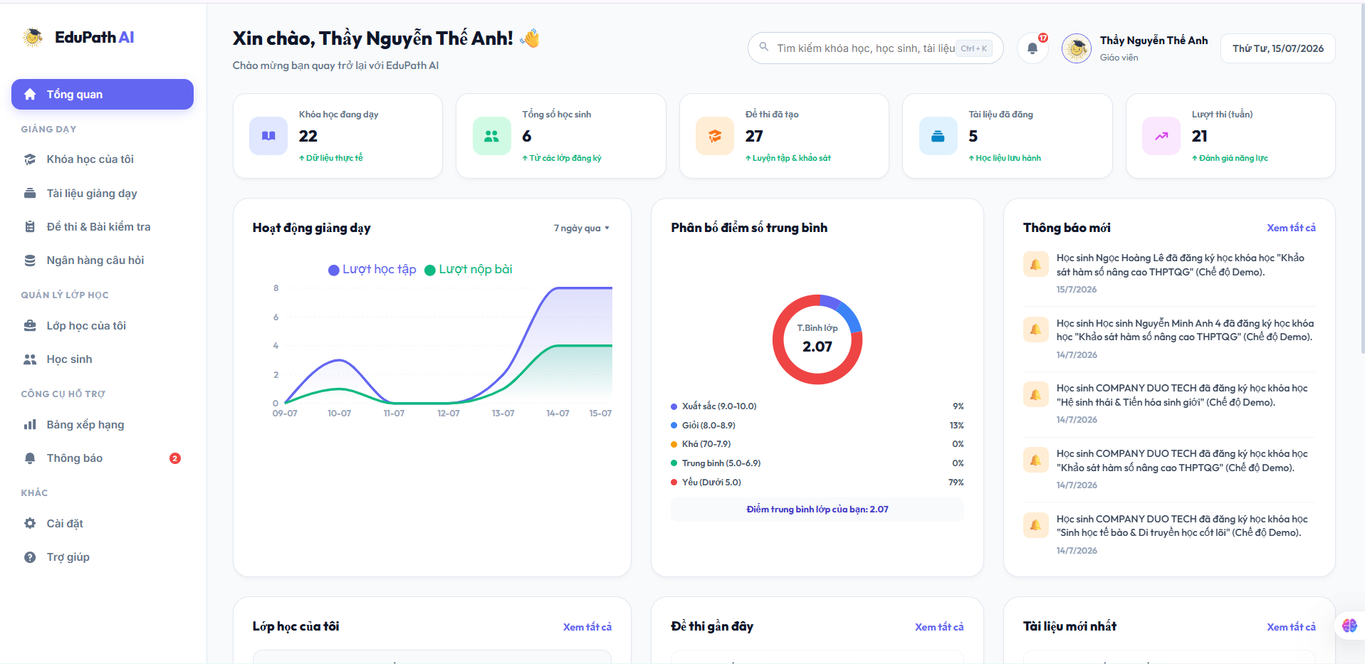
Field Name | Field Type | Description
Dropdown “Mẫu báo cáo” | Dropdown List | Selection component choosing the reporting aggregation target layout template structure.
Picker “Khoảng thời gian” | Date Range Picker | Calendar tool bounding timeline query rows; filters academic activities using execution logging clocks.
Radio “Định dạng xuất” | Segmented Option | Selector switch defining the target document compiler processing engine type (PDF or Excel formats).
Preview Container | Document Canvas | Live layout grid previewing page layouts, corporate signature headers, and data tables prior to running downloads.
Button “Tải xuống báo cáo” | Button | Main operational execution trigger running compilation data queries, initializing stream pipes, and saving the file.
Button “Hủy bỏ” | Button | Standard safety cancellation control component to dump transient export setups and clear out modal memory frames.

Database Access
Table | CRUD | Description
Users | R | Reads target student account metadata profiles, enrollment times, and registry codes (R).
UserCourses | R | Processes complete catalog registration lifecycles and historical module clearance progress ratios (R).
Courses | R | Joins target academic identifiers to map descriptive course titles to the data report lines (R).
UserExamResults | R | Compiles absolute scoring records, grading states, and attempt timelines to build performance charts (R).
1. Query to gather the unified structural learning summaries required to populate the master report portfolio context
SQL
SELECT
u.[id] AS [StudentID],
u.[full_name] AS [StudentFullName],
u.[email] AS [StudentEmail],
u.[created_at] AS [AccountRegistrationDate],
-- Accumulate total active classroom allocations under ownership layers
(SELECT COUNT(1) FROM [dbo].[UserCourses] uc WHERE uc.[user_id] = u.[id]) AS [TotalEnrolledCoursesCount],
-- Calculate precise completed curriculum milestones
(SELECT COUNT(1) FROM [dbo].[UserCourses] uc WHERE uc.[user_id] = u.[id] AND uc.[progress_percent] >= 100) AS [TotalCompletedCoursesCount],
-- Compute global test scoring evaluation benchmarks
ISNULL((SELECT AVG(uer.[score]) FROM [dbo].[UserExamResults] uer WHERE uer.[user_id] = u.[id] AND uer.[status] = 'submitted'), 0.00) AS [PortfolioExamScoreAverage],
-- Trace the total count of passed test certificates
ISNULL((SELECT COUNT(1) FROM [dbo].[UserExamResults] uer
JOIN [dbo].[Exams] e ON uer.[exam_id] = e.[id]
WHERE uer.[user_id] = u.[id] AND uer.[status] = 'submitted' AND uer.[score] >= e.[pass_score]), 0) AS [TotalAssessmentsPassedCount]
FROM [dbo].[Users] u WITH (NOLOCK) -- Deploys dirty read isolation to prevent blocking concurrent live testing runs
WHERE u.[id] = @TargetStudentID; -- Security boundary constraint: locks compilation strictly to target profile row
2. Query to load the chronological module timeline activity history for itemized report details tables
SQL
SELECT
uc.[course_id] AS [CourseID],
c.[title] AS [CourseTitle],
s.[name] AS [SubjectCategoryName],
uc.[progress_percent] AS [CurrentProgressPoints],
uc.[created_at] AS [EnrollmentDateMarker],
uc.[updated_at] AS [LastActiveTimestamp],
CASE
WHEN uc.[progress_percent] >= 100 THEN N'Đã hoàn thành'
ELSE N'Đang học'
END AS [CurriculumClearanceStatusText]
FROM [dbo].[UserCourses] uc WITH (NOLOCK)
JOIN [dbo].[Courses] c ON uc.[course_id] = c.[id]
LEFT JOIN [dbo].[Subjects] s ON c.[subject_id] = s.[id]
WHERE uc.[user_id] = @TargetStudentID
AND (@StartDate IS NULL OR uc.[updated_at] >= @StartDate)
AND (@EndDate IS NULL OR uc.[updated_at] <= @EndDate)
ORDER BY uc.[updated_at] DESC;

IV. Appendix

1. Assumptions & Dependencies
Assumptions:
- AS-1: Users (Students, Teachers, and Admins) possess a stable internet connection environment to facilitate uninterrupted lecture video streaming and live interactive communication pipelines.
- AS-2: Course content, multimedia lecture files, and examination questions uploaded by Teachers are verified, accurate, and comply entirely with copyright and academic integrity regulations.
- AS-3: System Administrators execute teacher identity verifications and course publication moderation workflows promptly to prevent bottlenecks in the platform onboarding lifecycle.
- AS-4: Students engage with the AI chatbot components and complete automated evaluation exams in a legitimate manner to avoid skewing the telemetry data arrays and personalized recommendations profiles.
- AS-5: Users possess basic digital literacy to navigate the platform interface, execute course purchases, and operate common browser functionalities effectively.
Dependencies:
- DE-1: The platform relies heavily on the uninterrupted operational availability and rapid API response handshakes of external AI infrastructure models (such as OpenAI or Google Gemini APIs) to process learning path analysis and automated question generation routines.
- DE-2: The execution of checkout orders and course premium access activations depends entirely on the uptime, secure handshakes, and callback webhook verification speeds of integrated third-party Payment Systems.
- DE-3: High-capacity media streaming and asset distribution operations for lecture materials require constant bandwidth availability from external Cloud Storage Providers (such as AWS S3 or Cloudinary).
- DE-4: The backend software relies on robust database management engines (such as SQL Server or MySQL) to manage continuous transactional operations, maintain system logs, and secure student profile records.
- DE-5: The customer-facing web application depends on client-side browser environments that fully permit and support encrypted session token data tracking, local storage blocks, and standard web security protocols.

2. Limitations & Exclusions
LI-1: Mobile Application: The initial release will not include a dedicated mobile application; the platform will be accessible only via web browsers.
LI-2: Offline Functionality: The platform requires a continuous internet connection; local downloading of course assets or offline testing is not supported.
LI-3: Live Streaming: Built-in virtual classrooms or real-time streaming capabilities are excluded; the system only supports pre-recorded lecture videos.
LI-4: External System Integration: The platform operates standalone and will not integrate with third-party Student Information Systems (SIS) or corporate HR software.
LI-5: Multi-Modal AI Analysis: AI capabilities are strictly limited to text and performance data logs, excluding webcam attention tracking or audio analysis.
LI-6: Reward Marketplace: The system will not support trading or converting gamification points into real-world financial rewards or physical merchandise.

3. Business Rules
ID | Category | Rule Definition
BR-01 | Constraints | The maximum number of failed login attempts is 5 consecutive times within a rolling 10-minute window. If exceeded, the account will be temporarily locked for 30 minutes to prevent Brute Force attacks (UC05).
BR-02 | Facts | The registered email address must be unique across the entire system and cannot be modified after the account is successfully created (UC04, UC08).
BR-03 | Constraints | A pending course purchase transaction invoice (Pending Order) has a maximum price lock and operational validity duration of exactly 15 minutes. After this time frame, the system automatically cancels the order (UC21).
BR-04 | Facts | Students are strictly prohibited from re-purchasing a course they already own or a course that is currently in a pending payment state (UC20).
BR-05 | Computations | Total order payment amount = (Original Course Base Price * (1 - Coupon Discount Rate)) + Applicable Taxes (if any). The final computed result is rounded to the nearest integer currency unit (VND) (UC20, UC21).
BR-06 | Constraints | New courses created by Teachers must undergo Admin moderation (status transitions from Draft to Published) before becoming publicly visible on the Marketplace catalog (UC24, UC38).
BR-07 | Constraints | For examinations with strict time limits (Timebox), the system will automatically execute an auto-submit action the exact millisecond the countdown timer reaches 0, regardless of whether the student has filled in all answers (UC16).
BR-08 | Computations | The final score for a multiple-choice examination is calculated using the formula:  $$Score = \left(\frac{\text{Number of Correct Answers}}{\text{Total Number of Questions}}\right) \times 10$$  . The result is rounded to 2 decimal places (UC16, UC51).
BR-09 | Facts | Students are only allowed to view detailed answer keys and step-by-step explanations after they have successfully submitted their exam and the overall exam duration has officially concluded (UC17).
BR-10 | Constraints | Students are only permitted to submit a rating and review comment for a course if they have successfully purchased it and completed a minimum of 10% of the overall learning progress path (UC15).
BR-11 | Constraints | User comments or reviews containing profanity or terms listed in the system-configured word blacklist will be automatically hidden and routed to the Admin moderation queue for manual review (UC50).
BR-12 | Facts | AI learning path recommendations and lesson tracking suggestions are only triggered after the student completes at least 1 diagnostic entry placement test or finishes the immediate preceding lesson block (UC52, UC53).
BR-13 | Constraints | Teachers only possess authorization rights to edit or delete questions that they personally created within the Question Bank. Modifying or deleting question entities belonging to other instructors is structurally blocked (UC30, UC31).
BR-14 | Constraints | The system automatically executes a daily cron job to permanently purge system notification logs older than 30 days to optimize database index storage capacity (UC11).
BR-15 | Computations | Net Revenue displayed on the Teacher's statistical report dashboard = Total gross amount paid by students for that course - Platform commission fee based on the percentage rate configured within the system administration panel (UC46).
BR-16 | Facts | Users registering an account via external third-party authorization providers (Login via Google) are granted the Student role by default. They must submit a formal application request for administrative approval to upgrade their account clearance to a Teacher role (UC06, UC48).

4. Application Messages List

# | Message Code | Message Type | Context | Content
1 | MSG01 | In line | Password validation failure due to mismatch with system complexity criteria (minimum 8 characters, letters, and digits). | Mật khẩu phải chứa tối thiểu 8 ký tự, bao gồm cả chữ và số.
2 | MSG02 | Toast message | Account registration aborted because the submitted email identifier already exists inside the database profiles. | Email này đã được đăng ký trên hệ thống. Vui lòng sử dụng email khác.
3 | MSG03 | Toast message | Cryptographic token generated and password reset link dispatched successfully to user's registered routing endpoint. | Hệ thống đã gửi liên kết khôi phục mật khẩu đến Email của bạn.
4 | MSG04 | In line | Authentication request intercepted and rejected due to cryptographic hash mismatch during password string verification routines. | Tài khoản hoặc mật khẩu không chính xác. Vui lòng kiểm tra lại.
5 | MSG05 | Toast message | User session initialized successfully using external third-party credential parameters via Google OAuth API channel. | Đăng nhập bằng tài khoản Google thành công!
6 | MSG06 | Toast message | Student triggers checkout workflow for a course node that already holds an active ownership row in the enrollment tracking table. | Bạn đã sở hữu khóa học này rồi. Vui lòng kiểm tra lại trong danh sách khóa học của bạn.
7 | MSG07 | Dialog box | Gateway transaction session lookup fails because the operational lifespan verification loop passes the 15-minute threshold. | Phiên giao dịch đã hết thời gian phản hồi (15 phút). Vui lòng thực hiện lại giao dịch.
8 | MSG08 | Toast message | Secure database transaction block successfully commits payment callback tokens received from external Payment System endpoint. | Thanh toán thành công! Khóa học đã được kích hoạt trong tài khoản của bạn.
9 | MSG09 | In line | Resource block upload process terminates because file volume parameters transcend the 50MB system storage allocation boundary. | Dung lượng tài liệu học tập vượt quá giới hạn cho phép (Tối đa 50MB).
10 | MSG10 | Toast message | Numerical score and feedback text parameters successfully captured and serialized inside the course review storage array. | Cảm ơn bạn đã gửi đánh giá và nhận xét cho khóa học này!
11 | MSG11 | Toast message | Review pipeline aborted because user progress logging indicators reside strictly below the required 10% completion baseline. | Bạn cần hoàn thành tối thiểu 10% tiến độ khóa học để kích hoạt quyền đánh giá.
12 | MSG12 | Dialog box | Examination timebox session countdown runs out, automatically locking client views and running backend data persistence commands. | Hết giờ làm bài! Hệ thống đang tự động khóa bài thi và lưu lại bài nộp của bạn.
13 | MSG13 | Toast message | Dynamic evaluation script completes and commits multi-choice answer array structures cleanly into the transaction database. | Nộp bài kiểm tra thành công! Kết quả làm bài của bạn đã được ghi nhận.
14 | MSG14 | Toast message | Request for structural solution details is intercepted and blocked since overall test session timelines have not concluded yet. | Đáp án chi tiết và lời giải chỉ hiển thị khi toàn bộ thời gian của đề thi kết thúc.
15 | MSG15 | Toast message | AI telemetry process finishes checking log entries and updates user weak-knowledge vector records inside the profiling module. | Hệ thống AI đã hoàn tất phân tích. Báo cáo đánh giá năng lực của bạn đã sẵn sàng.
16 | MSG16 | Toast message | Adaptive logic successfully creates an optimal roadmap sequence by mapping target node prerequisites onto student capability variables. | Lộ trình học tập cá nhân hóa đã được AI tối ưu hóa dựa trên kết quả của bạn.
17 | MSG17 | In line | Real-time input string length breaks maximum token capacity thresholds allocated per LLM inference processing block. | Câu hỏi quá dài hoặc vượt quá giới hạn xử lý dữ liệu. Vui lòng tóm tắt lại nội dung.
18 | MSG18 | Toast message | Automated testing unit runs query blocks on weak performance indices to compile a custom practice test structure. | AI đã bốc đề thi thử tự động dựa trên vùng kiến thức bạn cần cải thiện.
19 | MSG19 | In line | Prompt streaming blocks are aborted instantly after safety filters detect blacklist terms or sensitive keywords. | Yêu cầu bị từ chối do chứa từ ngữ không phù hợp hoặc vi phạm chính sách của hệ thống.
20 | MSG20 | Toast message | Real-time connection request fails because the specific account identifier has used up its daily AI API token quota. | Bạn đã sử dụng hết hạn mức (quota) tương tác với trợ lý AI trong ngày hôm nay.
21 | MSG21 | Toast message | Instructor saves a course skeleton node, updating its relational state parameter field to 'pending approval' inside the moderation queue. | Khóa học đã được gửi lên hệ thống để chờ Ban quản trị kiểm duyệt nội dung.
22 | MSG22 | In line | Transcoding pipeline throws a codec exception because the uploaded material fails backend file signature checks. | Định dạng video bài giảng không hợp lệ. Hệ thống chỉ hỗ trợ các file .mp4 hoặc .mkv.
23 | MSG23 | Toast message | New item configuration parameters match schema criteria and update target indices in the question repository ledger. | Cập nhật câu hỏi mới vào ngân hàng câu hỏi thành công.
24 | MSG24 | Dialog box | Middleware block intercepts the transaction session because the active account profile node holds a status parameter marked as suspended. | Tài khoản này đã bị khóa do vi phạm điều khoản nền tảng. Vui lòng liên hệ Admin.
25 | MSG25 | Toast message | Relational mapping queries complete and save a new row entity within the master subject definition table. | Đã khởi tạo danh mục môn học mới thành công trên toàn hệ thống.
26 | MSG26 | Toast message | Administrative deletion action cascades through tables to clear bad text fields and rebuild database indexes. | Bình luận vi phạm tiêu chuẩn cộng đồng đã được gỡ bỏ thành công.

